St Monica’s Church
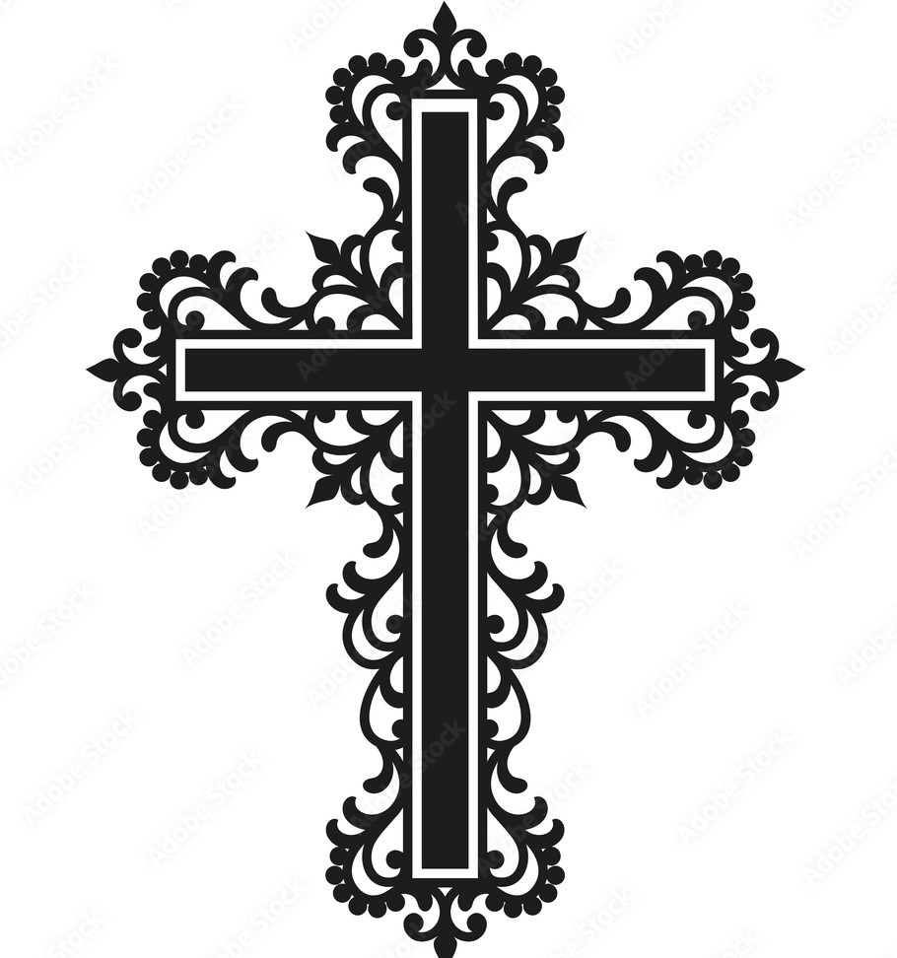
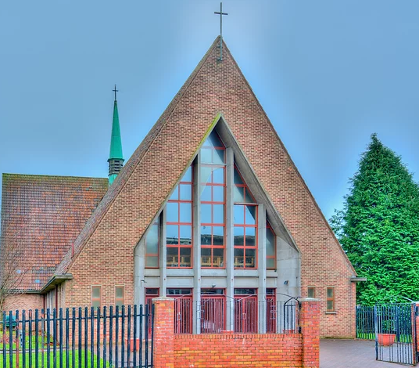
Sharp Avenue, Coatbridge ML5 5RP
Telephone: 01236 421750 Mobile: 07747259800
Diocese of Motherwell
Charity No. SC011041
Email: stmonica@rcdom.org.uk
Website: http://saint-monica.org.uk
Facebook/You Tube: St Monica’s Parish Coatbridge
Parish Hall: Email: stmonicashall@outlook.com
Tele: - 07464254377
Parish Priest: Father Ghislain B. Mulumanzi

Twenty Seventh Sunday in Ordinary Time - C
2nd October, 2022

Holy Mass (Services marked in red will be live streamed)
Mon – Fri: - 10am
Saturday: - 10am, 4pm (Vigil)
Sunday: - 10am 12 Noon & 5pm
Children’s Liturgy 12 Noon Mass 2nd October
Eucharistic Adoration: -Mon – Sat 9am – 9.55am
Divine Mercy Novena: Mon 2pm
Confessions: Mon - Sun 9.30am – 9.55am
Baptisms & Marriage: - To arrange a baptism or marriage please contact Father Ghislain

Mass Liturgy - Year C
Parish Mass Book Page 82
First Reading: Hab 1: 2-3; 2-4
Responsorial Psalm: O that today you would listen to his voice, Harden not your hearts
Second Reading:1:6-8.13-14
Gospel: Lk 17:5-10
Weekly Collection
Please support your parish through the weekly collection, our income relies solely on the donations of our parishioners.
Last Week’s Collection - £795.31
Building Fund – £608.63
There will be a second collection next weekend for our Building Fund

500 Club Winners
1st Prize No.240 A Gillick
2nd Prize No. 134 M Hannigan
3rd Prize No. 565 M Kelly

We welcome Grace McGoldrick who is to be Baptised this weekend
We implore God’s blessing upon her and her family as we welcome her into our parish community

Recently Deceased: Mary (Jeffrey) McGhee

Sick: Ann & John McShane & Family, Linda Webb, Isobel Reilly, Carol McGuinness, Pauline O’Rourke, Anne Marie Snodden, James Donnelly, Patricia McGhee, Bernadette Homer, Kelly Noble, Michael McGarrity, Sadie McBride, Mary Torbett, Sharon, Elizebeth McKenna, Alex Cooper, Mary Toal (Bishop Toal’s mother) Sr Kathleen Owens

Month’s Mind: Frank & Agnes Wilson, James, Elizabeth & Sadie Prunty, Rev Father Cornelius O’Leary, Helen, Margaret & Agnes Docherty, William & Patrick Docherty, Anna & Joseph Pearson, Mary & Edward Drummond, Alex Thain
Anniversaries: John Wilson, Hugh & Margaret McStay

Please also remember the souls who have
no-one to pray for them.

Can you help for children liturgy?
We have a shortage of children liturgy leaders. Can you help? A Children's Liturgy Leader/Volunteer leads children in a separate liturgy of the word in the sacristy during the Sunday 12 noon Mass. He/she is expected to provide age-appropriate liturgical readings to the children from approximately age 3 up. We are aware that many have other responsibilities so your commitment will be requested just once a month on Sunday at noon mass. Literature will be made available to you and training will be provided. If you would like to help, speak to Father Ghislain.

Happy Silver Wedding Anniversary
Martin & Linda Kennedy
Congratulations on your 25th Anniversary! We wish you both lifelong happiness and togetherness on your special day! We wish for your prosperity and longevity and many God’s blessings on you and your family.
Altar Servers Meeting/Training Every First Tuesday of the Month starting 4 October at 6pm
Reasons for becoming an Altar Server
You’ve most likely seen the altar servers at Mass, up by the altar, helping the priest to keep the Mass running smoothly. Their age ranges from eight upwards and they’re normally wearing robes which look very similar to that of the priests, but have you ever considered doing the same? Here are seven reasons why becoming an altar server might be one of the best things you could choose to do.
1. You can learn a lot about the Mass by serving at the altar
Sure, swinging the censer (the smelly incense thing) is kind of fun but why is it that we do it? By becoming an altar server, you begin to learn these things and it makes all the symbols of the Mass so much more understandable and interesting.
2. You get fully involved in the Mass and get more out of it
3. Altar serving can lead to making lots of new friends!
4. Altar serving can teach you lots of valuable skills
Communication, teamwork, perceiving what needs to be done and doing it, punctuality, self-confidence, and the list goes on.
5.You can get to know your community better through altar serving
You can meet and chat with every time you go to mass and make you feel truly at home in your church.
6. It helps you discern your vocation better. Whether marriage, consecrated singlehood, religious life or priesthood, altar serving can help you understand your vocation. Altar Serving is a great way to begin to see that beauty more fully in both priesthood and religious life.
7. It gives you a greater appreciation of the priesthood
Even if you are not discerning priesthood, by altar serving you learn so much more about the priest you work with.

October Devotions
Join us every Monday at 6pm to pray the Holy Rosary

Why is October referred to as the Month of the Rosary? The short answer is this: October is dedicated as the Month of the Rosary because we celebrate the memorial of Our Lady of the Rosary each year on October 7. To understand this feast, we need to go back in time. In the 16th century, the Islamic Ottoman Empire presented a serious military threat to western Europe and sent a fleet of ships to attack Christian defences in southern Europe. Pope Pius V recognised the grave danger and organized a fleet called the Holy League to confront the navy of the Ottoman Turks. On October 7, 1571, the two navies engaged in a pivotal battle that would determine who controlled maritime traffic in the Mediterranean, Adriatic and Aegean seas. The fate of western Europe depended upon the success of Christians in this navy battle, which involved more than 400 warships (it was the largest naval battle in Western history for centuries). Pius V knew he needed more than just military strength to defend Christian Europe, so he asked that all the faithful pray the rosary, requesting the intercession of the Blessed Mother. At the end of the Battle of Lepanto, the Holy League was victorious and the maritime expansion of the Ottoman Empire was permanently prevented. The next year, Pius V established a feast on October 7 in honour of the Blessed Mother, originally called Our Lady of Victory. After a few centuries, the name was changed to Our Lady of the Rosary to more clearly recognise that prayer was the greatest power at work that day on the seas.

28th Week of the Year – C

Monday  October Devotions | 10am  6pm | Holy Mass  Rosary
Tuesday  St Francis of Assisi – Memorial | 10am | Holy Mass
Wednesday | 10am | Holy Mass
Thursday | 10am | Holy Mass
Friday  Our Lady of The Rosary – Memorial | 10am | Holy Mass
Saturday | 10am  4pm | Holy Mass  Vigil Mass
Sunday  28th Sunday of the Year - C | 10am,  12 Noon & 5pm | Holy Mass

