St Monica’s Church
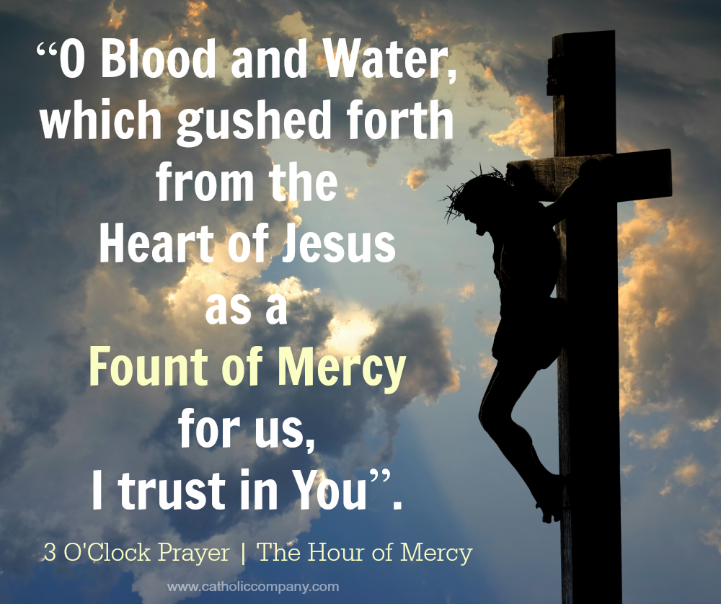
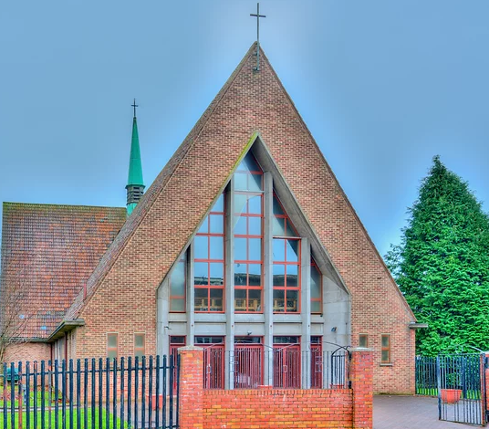
Sharp Avenue, Coatbridge ML5 5RP
Telephone: 01236 421750
Diocese of Motherwell
Charity No. SC011041
Email: stmonica@rcdom.org.uk
Website: http://saint-monica.org.uk
Facebook/You Tube: St Monica’s Parish Coatbridge
Parish Hall: Email: stmonicashall@outlook.com
Tele: - 07549042450 Mary Cope
Parish Priest: Father Ghislain B. Mulumanzi

Sunday of Pentecost– Year A. 28st May 2023
Holy Mass & Services
Mon - Fri: 10am
Saturday: 10am, 4pm (Vigil)
Sunday: 10am, 12 Noon & 5pm
Children’s Liturgy 12 Noon Mass
Eucharistic Adoration: -Mon – Sat 9am – 9.55am
Divine Mercy Novena: Mon 2pm
Confessions: Mon - Sun 9.30am – 9.55am
Baptisms & Marriage: - To arrange a baptism or marriage please contact Father Ghislain

Mass Liturgy - Year A
Parish Mass Book, Page 22
- First Reading: Acts 2:1-11
- Responsorial Psalm: Send forth your Spirit, O Lord, and renew the face of the earth
- Second Reading: 1 Cor 12: 3-7.12-13
- Gospel: Jn 20:19-23

Weekly Collection

Please support your parish through the weekly collection, our income relies solely on the donations of our parishioners.
Last Week’s Collection
First Collection: £987.91

There will be a second collection next Sunday for our Church Building Fund

Thank you for your generosity.

500 club Winners!
1st prize - 69 B Docherty
2nd Prize – 277 M Gollogly
3rd Prize – 119 E Battersby

Please keep in your prayers

Sick: Ann & John McShane & Family, Linda Webb, Isobel Reilly, Carol McGuinness, Pauline O’Rourke, Anne Marie Snodden, James Donnelly, Patricia McGhee, Bernadette Homer, Kelly Noble, Michael McGarrity, Sadie McBride, Mary Torbett, Sharon, Elizabeth McKenna, Alex Cooper, Sr Kathleen Owens, Ann Smith, Helen Smith, Margaret Gallagher, Alice Kilmurry, Danny Dick, Peter Alexander, Ann McAlinden, Mary Cunningham, Theresa Docherty, Patricia McGhee, Margaret Wallace, Irene Leckie, Jenny Divine, Kay McDonagh, Daniel McAuley, Mary Glasgow.

RIP: John Dillon, Teresa Docherty, Gerry McNab

Month’s Mind: Mary Thomson, Edward & Annie McQuillan, Annie & Frank McCue, Agnes McQuillan, Margaret Tiffney, Mary Crozier, Edward McQuillan, George & Cathie Thomson, Christine Thomson, John Donohue, Mary Robertson, Walter Clarke, John Brady, Flo, Alf & Brian Longyear, Betty Haney, Meg & Annie Smith, Lawrence & Mary Brankin, William, Ellen & Annie Brankin, John, Anna & Kevin McGrath, Kathleen Smith, David Hayton, Joseph, Agnes, Eddie & Joe Mina, Brian, Patricia & Brian Jnr Sharkey, Mary McSwiggan, Tom Sharp, Margaret & Jim McAuley, Ita Bolton, Sam Black, May & Jim McLaughlin, Kathleen & Peter Dolan, Tilly & Marie Clarke, Mattie, Tommy & Thomas Collins, Jim Boyle, Sadie Slowey, Patsy Robertson, Eamon & Ryan Gallagher, Arthur, Sadie & Ann Craig, Anne Holmes, & Fr Frank Kelly
Anniversary: Joseph Thomson, William Brankin Snr
Birthday Remembrance: Gerry Gallagher
Please also remember the souls who have no-one to pray for them.

A NOVENA TO THE HOLY SPIRIT FOR THE RENEWED LIFE OF OUR PARISH

PRAYER TO THE HOLY SPIRIT (St. Augustine)

Breathe into me, Holy Spirit, that my thoughts may be holy.
Move in me, Holy Spirit that my work, too, may be holy.
Attract my heart, Holy Spirit, that I may love only what is holy.
Strengthen me, Holy Spirit that I may defend all that is holy.
Protect me, Holy Spirit, that I may always be holy.
”Live by the Spirit...The fruit of the Spirit is love, joy, peace, patience, kindness, goodness, trustfulness, gentleness and self-control.
And those who belong to Christ Jesus have crucified the flesh with its desires and passions. If we live by the Spirit, let us also be guided by the Spirit.” Galatians 5:22-25
Holy and eternal Trinity, we pray for our Parish of St Monica and the whole Church. Sanctify its life; empower its witness; heal its divisions; make visible its unity.
Lead us, brothers and sisters, towards communion in faith, life and witness, one in body and Spirit. Amen.



Reflection
Pentecost Sunday A. Language is a great tool of communication. For the most part it is by means of words that human beings express their needs, laws, transactions, intentions, thoughts, emotions, longings, hopes and creeds. Yet words are such elusive symbols. How rarely a simple statement conveys the same meaning to two people. Language of itself is not enough to bring people together. In fact, words are a source of misunderstanding. Just because we use the same language doesn’t mean we are one or that we understand each other. There may still not be a meeting of minds and hearts. But the opposite can happen too. People may speak different languages, they may be strangers to one another, yet a bond can be created among them, so that they become not only comrades, but brothers and sisters. On day of great joy or of great sorrow, whatever, we stand shoulder to shoulder. We find ourselves of one mind and one heart.
There are other ways of communicating besides words. In Luke’s account of Pentecost, we find two powerful symbols- wind and fire, both symbols of energy. Still, language is hugely important. We are told that on Pentecost day everyone understood the apostles. It wasn’t that they spoke a completely new language. It was one all of us are familiar with but which, alas, we tend to forget or leave unused. This new language is the language of peace rather than of war; the language of reconciliation rather than of conflict; the language of co-operation rather than of competition; the language of forgiveness rather than of vengeance; the language of hope rather than of despair; the language of tolerance rather than of bigotry; the language of friendship rather than of hostility; the language of unity rather than of division; the language of love rather than of hate, the language of mutual acceptance rather than of rejection. This new language gave rise to a new community, the Church, the community of those who believe in Jesus- a community of faith and love. According to the Acts of the Apostles, the first followers of Jesus were of ‘one mind and heart’.
Through the gift of the Holy Spirit, people of many languages learned to profess the one faith, to the praise and glory of God. That is the real miracle of Pentecost. And it is a miracle which, thankfully, still happens. On this day, the infant church took its first steps. It is made up not of the saints but of sinners, called to speak the language of love. Down the ages it has had its share of problems and setbacks. But it is still being built. Part of it is assembled in your homes today. We assemble here not as rivals but as friends, daughters and sons of God. Factors which normally divide people-such as class, colour, age, wealth- count for nothing here. Here we are one family under God.

Month of May dedicated to the Blessed Virgin Mary
Pease join us for the Holy Rosary and Solemn Benediction on Monday 29 of May at 7pm.

CONFIRMATION
Congratulations to children who received the Sacrament of Confirmation on Thursday 25th of May 2023 at 7pm, by Bishop Joe Toal.

Annual Pilgrimage to Scalan
Fr Michael Briody advises that the Annual Pilgrimage to Scalan takes place on Sunday 2nd July with Mass outdoors at The Scalan beginning promptly at 4.00pm. Scalan can be found a mile beyond Chapeltown of Glenlivet. An approximate postcode is AB37 9JS. Coaches need to stop half a mile beyond Chapeltown. Cars and minibuses can park very near and are usually willing to take anyone needing a lift.

Organ Recital - The Cathedral, Motherwell
From John Pitcathley: On Friday 2nd June at 7:30 we will be privileged to welcome to the diocese Dr Crista Miller, Organist and Director of Music at the Roman Catholic Cathedral in Houston, Texas, to give an organ recital for us, as part of her concert tour of the United Kingdom.
Please take this opportunity to hear an outstanding performer on our magnificent 4-manual pipe organ.
JOURNEYING WITH MARY – Prayer Service in Preparation for the Synod. Carfin Grotto - Feast of the Visitation Wednesday 31st May 2023 7pm
At the invitation of Pope Francis, the Bishops’ Conference of Scotland is hosting an hour of prayer at the National Marian Shrine, Carfin, for the success of the Synod. All are most welcome. Personal reflections will be shared on four aspects of Mary’s life interspersed with silence, hymns and the Rosary while pilgrims journey between various Marian stations. Tea etc. will be available at 8pm. The Prayer Service will be livestreamed on beingCatholic.com. On the Feast of the Visitation Pope Francis has also encouraged prayer at diocesan and parish level for the success of the Synod. The National Liturgy Commission will share some materials which you may wish to use in your parish.
Scottish Faith Leaders Declaration on Fair Pay in the Social Care Sector
We believe in the importance of human dignity. We honour those people who serve, care for and support others so that this dignity can be respected and that all may have fullness of life. We thank them for their time, hard work and compassion.
We believe in fairness and justice, and believe that all staff working in social care in Scotland today should be paid fairly for this fundamentally important work. We recognise the challenges today facing social care staff and providers, following the difficult years of the Covid-19 pandemic, the cost of living crisis and the current challenges with recruitment.
We call on church and faith communities to encourage and support advocacy and fundraising for better social care in Scotland. We recognise recent commitment made to the Adult Care Workforce but call on the Scottish Government to do everything within its power to ensure all frontline social care workers be paid a minimum of £12 per hour immediately, and that the appropriate funding is made available which allows all social care staff to be recognised for their skills, experience and contributions, in whichever role they serve.

FIRST HOLY COMMUNION
The First Communions will be taking place on Saturday 10th of June 2023 in St. Monica’s Church. The service starts at 12 noon. There will be a photographer available 1 hour before Mass. Please refrain from taking photographs during the service. If you choose not to have a photo, the children should be seated in the Church no later than 10 minutes before Mass begins.
Communicants are encouraged to attend weekend mass.

All communicants and their families are invited to attend the procession and Adoration of Corpus Christi on Sunday 11 June at 12 Noon. Children are welcome to wear their communion attire for the procession.

Baptism
We welcome Anna McGhee who is to be Baptised this weekend. We implore God’s blessing upon her and her family as we welcome her into our parish community.

Saints of the Week

Monday 29th May, The Blessed Virgin Mary, Mother of the Church – Memorial. Pope Francis inscribed the Memorial of the Blessed Virgin Mary, Mother of the Church in the Roman Calendar in 2018 to remind all Christ’s disciples that, if they want to grow and be filled with the love of God, it is necessary to plant their lives firmly on the three great realities: the Cross, the Eucharist, and the Mother of God.

Wednesday 31 May, The Visitation of the Blessed Virgin Mary – Feast. The Gospel of St Luke (1:39-45) describes the Visitation of the Blessed Virgin Mary to her cousin St Elizabeth, both expectant mothers. It is the meeting of four people, not two. This feast is the day chosen for the Day of Life. When we think of who their unborn children were, it should arouse in us love and respect for all unborn children and a determination to protect them.

Thursday 1 June, St Justin – Memorial. St Justin was born in Palestine, probably of Roman stock. From his youth he was passionate about philosophy, and this led him to become a Christian. He went to Rome and set up his own philosophy school which became a prominent place of engagement with pagan thinkers. When the Emperor Marcus Aurelius started a persecution against Christians, Justin was an obvious target. He was martyred with some students.

Saturday 3 June, St Charles Lwanga and Companions – Memorial. St Charles Lwanga (1860-1886) became a Catholic while serving as a major-domo to local king Mwanga in Uganda who had an immoral interest in his young attendants. Several had become Catholics and resisted his advances, and St Charles protected them. Infuriated, the king had St Charles and a large group marched out, bound in flammable material to Namugongo, where they were burnt to death. The youngest was St Kizito, aged twelve. Young Anglicans were also put to death at the same time. Others were martyred between 1885 and 1887.

Help needed
In preparation for our Corpus Christi Procession, we are looking for volunteers to come and help tidy up the church grounds.

If you can spare some time, please come along any time you are free and help with some weeding, cutting the grass and general grounds maintenance.

St Monica’s Parishioners Activity Day
Mondays 2pm to 4pm
Church Hall

Fund raising for Fr Bernard
Fr Bernard will be returning to Coatbridge from Saturday 27th May – 26th June.
A fund- raiser night will be held for Fr Bernard to assist with some of his Zambia projects
“PALAIS NIGHT”
In aid of Fr Bernard – Zambia projects
VENUE: BANKS SOCIAL CLUB
DATE: MONDAY 19th JUNE 7PM – LATE
TICKETS: £10.00 (Incl. Pie and Peas)
ON SALE at the back of Church from this weekend
Or Available from Isabella/Alex
01236 428493/07967112568

Wishing you all A HAPPY SUNDAY

