**How to add the git project in eclipse by eclipse plugin**

Add the git repo to view.

# Open the git repositories directory

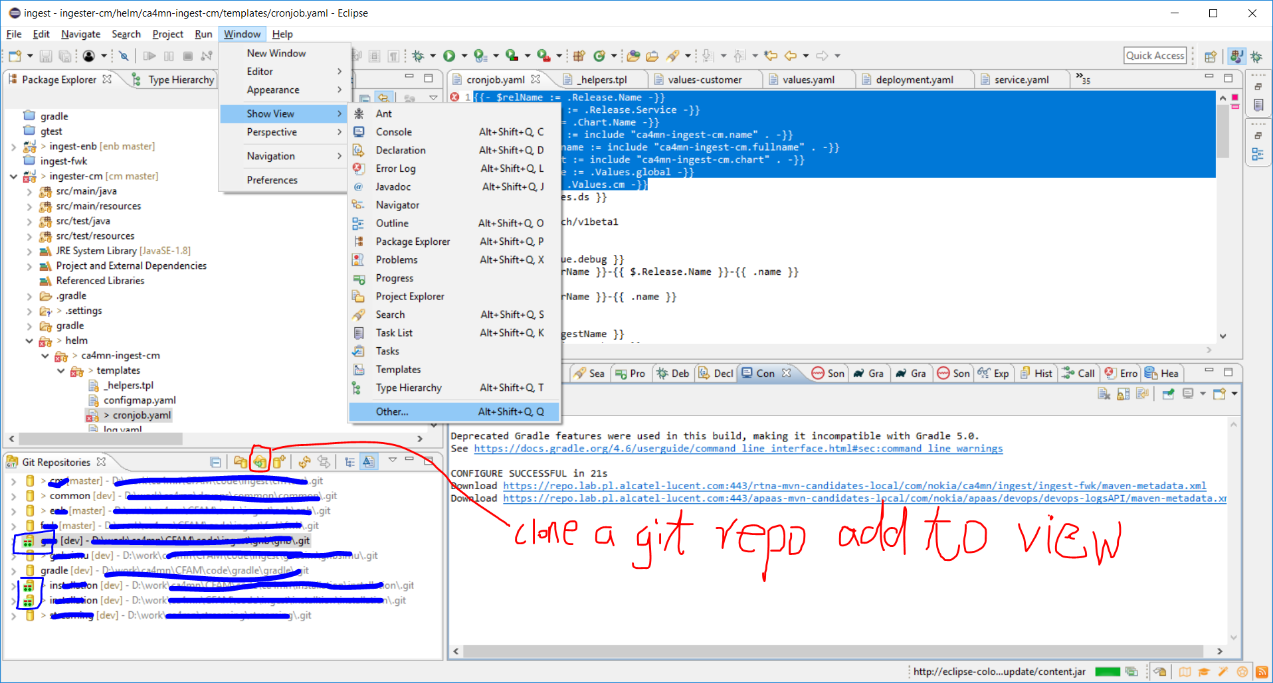

**Figure 1 total parts**

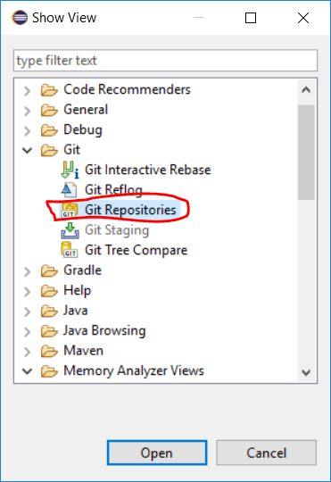

**Figure 2 show view**

Window->show view->others->git repositories. Choose the git repositories as **Figure 2** shows The git repo will show at **Figure 1** left below parts. Click the **Figure 1 total parts** left button circled by red line. Will pop out the **Figure 3 clone git repository into local view** as below

# Clone the git repository from remote gerrit server to local dirctory

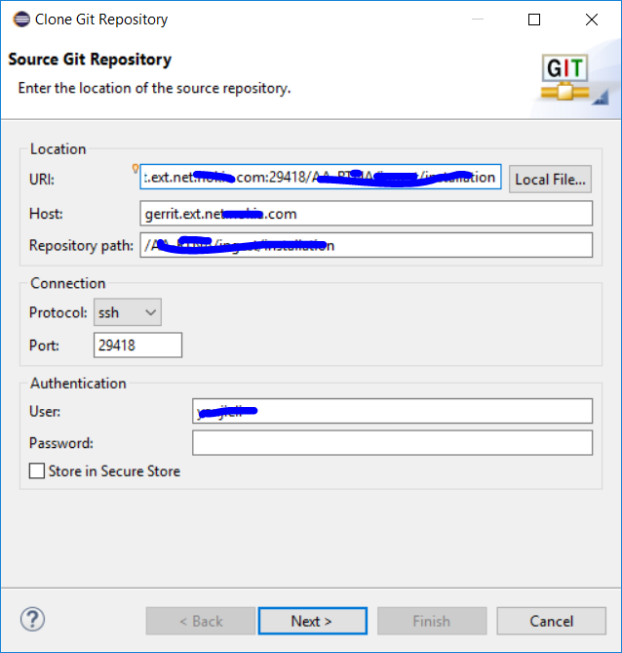

**Figure 3 clone git repository into local view**

URI, Input the ssh url into the **Figure 3** URI:, the git plugin will separate the string automatically, the only blank need you manually input is Authentication password.

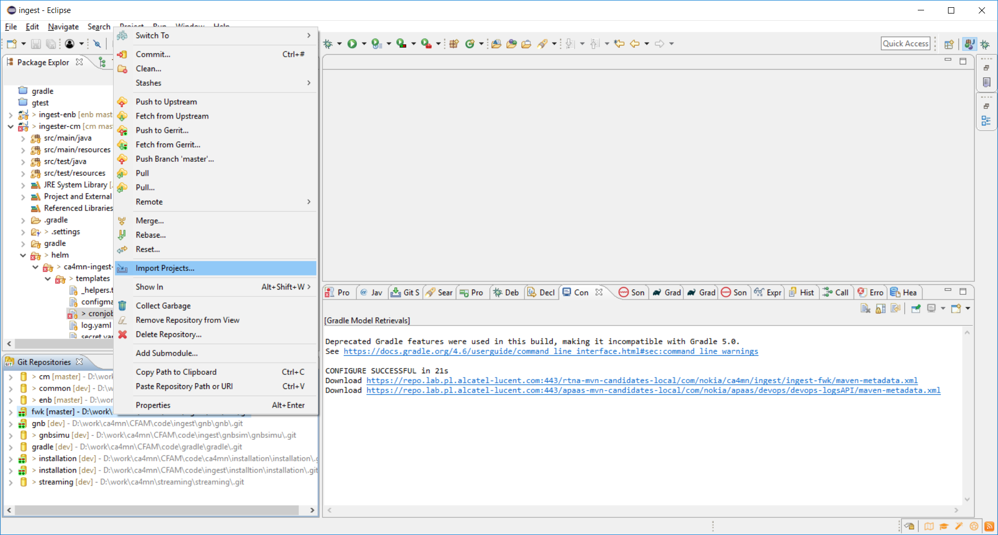

**Figure 4**