**ANDROID QUIZ**

* **Introduction:**

This application also conducts a quiz to the user who is interested in a particular technology for checking their knowledge of the subject. This application conducts a quiz in the form of multiple choice questions. After the completion of the quiz the application generates reports based on the quiz conducted. The user can also test their knowledge on those technologies based on a timed quiz, we can include the above technology questions on this application. We can give a time frame for each question and all the questions are to be answered in that specified time period. Say for example we can give 20 seconds to answer a question. If the user gives an incorrect answer he will be exited out of the quiz.

* **Literature Survey:**

In an educational context, a quiz is usually a form of a student assessment, but often has fewer questions of lesser difficulty and requires less time for completion than a test. This use is typically found in the United States, Canada and some colleges in India.

* **Proposed Project:**

This Web Application provides facility to conduct online examination world wide.  It saves time as it allows number of students to give the exam at a time and displays the results    as the test gets over, so no need to wait for the result. It is automatically generated by the server. Administrator has a privilege to create, modify and delete the test papers and its particular questions. User can register, login and give the test with his specific id, and  can see the results as well.

* **Mobile Quiz Modules**

Given are the modules for mobile quiz through wifi project system:

1. **Admin Module:**

All the quizzes update, news update and all the relevant communication with the user is done by admin module. Admin module is the main module which manages all other module as well in the given system. All the actions are mainly handled by the admin only.

**2.) Player Module:**

Players can make their account in this module and can play quizzes and score the game in this module. This module will be designed for the player’s easiness. If subscribe, players can get all the updates via email also.

**3.) Quiz Database Module:**

All the questions, answers, new and old quizzes and other relevant details related to quizzes are maintained in this module.

**4.) Score Module:**

Scores of all the quizzes of all the users are maintained in this module and ranking are being also displayed in this module.

* **Feasibility Study**
* **Technical**
* **Hardware Requirement:**

|  |  |
| --- | --- |
| **NAME** | **DETAILS** |
| Processor | Pentium processor and above |
| RAM | 256 MB and above |
| Hard Drive |  |

* **Software Requirement:**

|  |  |
| --- | --- |
| **NAME** | **DETAILS** |
| Operating system | Windows XP and above |
| Platform | Android |
| Tool | Java Eclipse |
| Language | JAVA |

* **Time**

|  |  |  |
| --- | --- | --- |
| Sr. No | Task | No of Days |
| 1 | Information Gathering |  |
| 2 | Requirement Analysis |  |
| 3 | Designing Analysis |  |

* **Cost**

|  |  |
| --- | --- |
| **Development cost** | **Rs20000** |

* **Advantages**

1. This Application helps you to test your knowledge based on a particular subject.
2. If you failed once it helps you to prepare more so, that you can gain over knowledge of a particular subject.
3. This application is portable so we can apply for Quiz anytime we want.

* **Disadvantages**

1. In this application for each Quiz there is limited time span in which we have to finish our Quiz exam so, time is Limited.
2. The contestant can apply for exam he/she has android based phone.
3. If suddenly some problem arises in between your quiz, then the contestant has to restart the quiz again.
4. Whenever you apply for quiz every time you have to enter your identity and password.

* **UML diagrams**

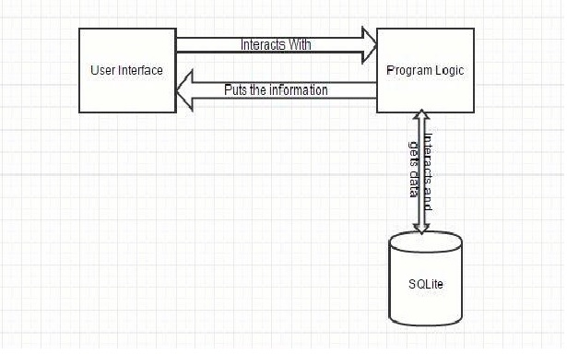

* **DFD & Flowchart**
* **Class Diagram**

|  |
| --- |
| **+ login** |
| **+admin login**  **+user login** |

|  |
| --- |
| **+admin login** |
| **+change pass**  **+update ques**  **+add subject** |

|  |
| --- |
| **+user login** |
| **+register**  **+select subject**  **+perform quiz**  **+display results** |

* **Use Case Diagram**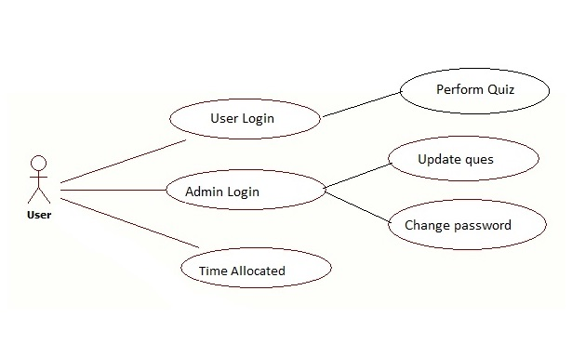
* **Sequence Diagram**

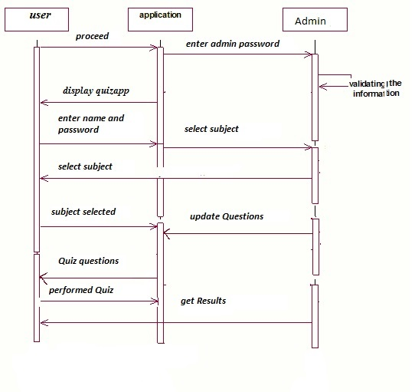

* **Component Diagram**
* **Deployment Diagram**
* **Screen Shots**
* **References**