2014-CH-01-EN Log Patterns
0 ---- | I: ---- | II: hard | III: medium | IV: easy

Answer Type: Select image Mandatory for: none

Body

One starts with a single big log. It is replaced first by a specific sequence of small logs. Then again, each small log is replaced by the exact same specific sequence with very small logs. Here are some examples:

Start | 1st replacement | 2nd replacement
 | 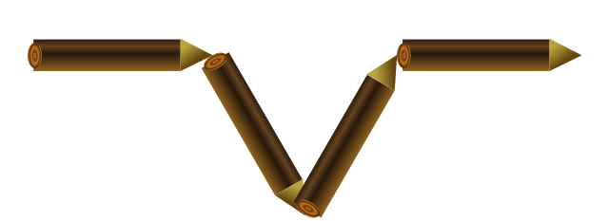 | 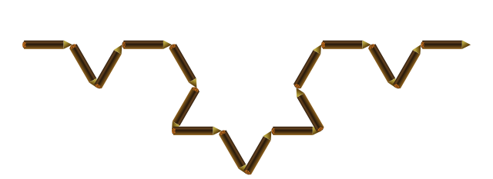
 | 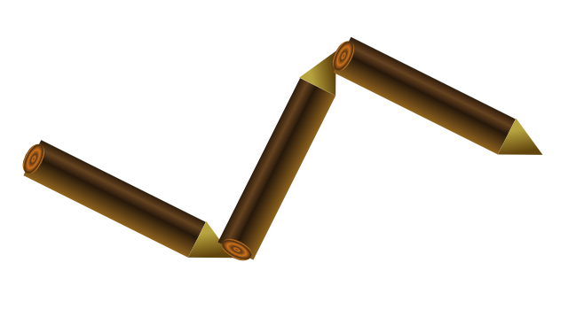 | 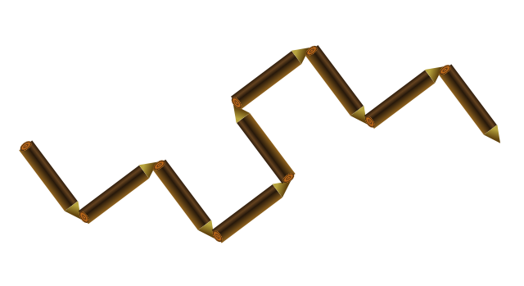
 | 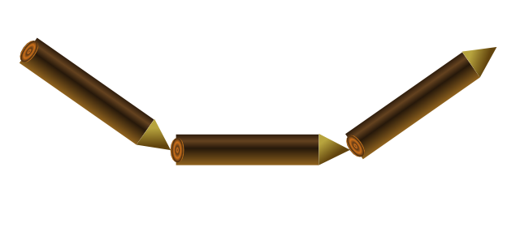 | 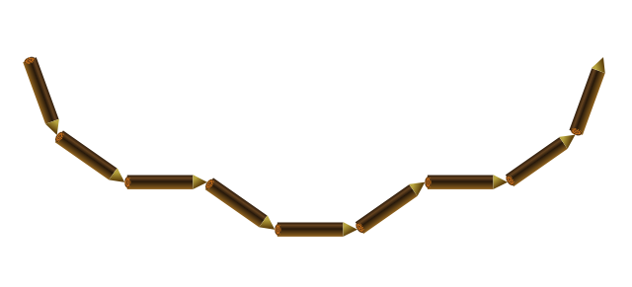

Question

Which 1st replacement leads to this following 2nd replacement?
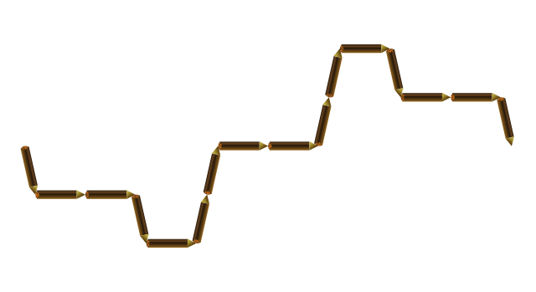

Answer

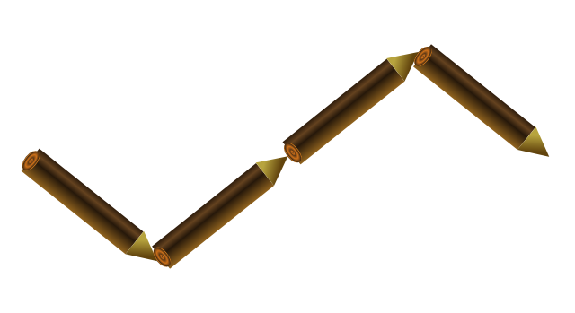  A | 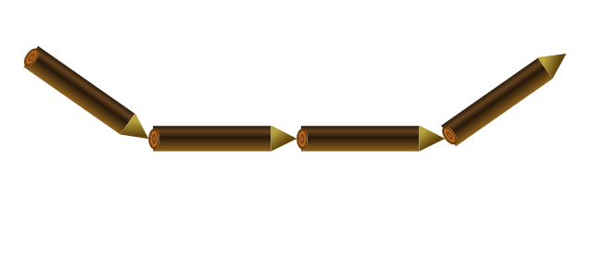  B | 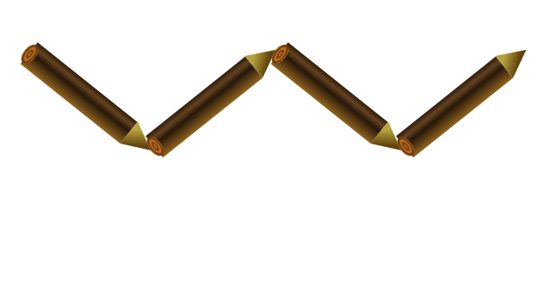  C | 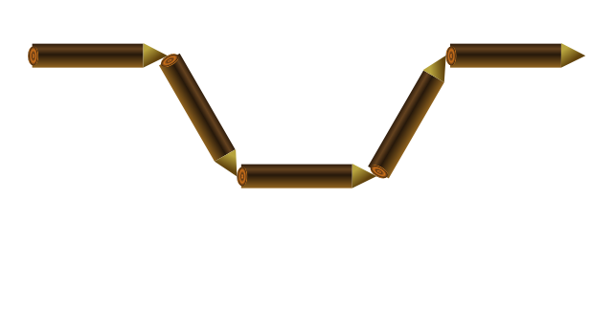  D

Explanation

A is correct:
  Start | 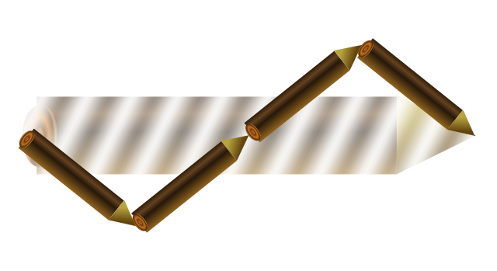  1st replacement | 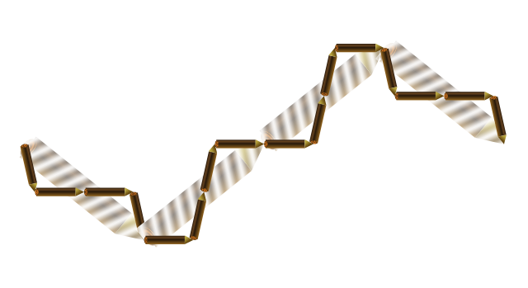  2nd replacement
The other sequence would look like as follows:
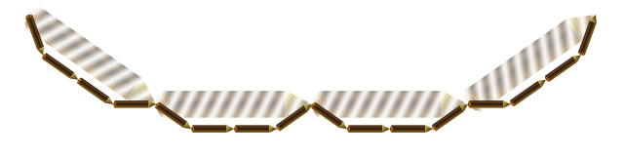
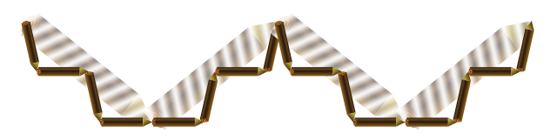
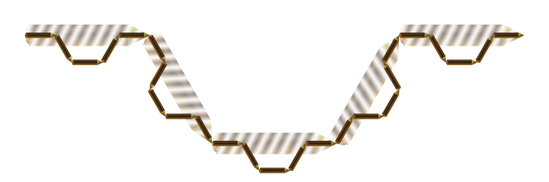

It's informatics

Computer programs function according to rules specified by a programmer. Even very simple rules can lead to complex behavior if applied repeatedly. This is particularly true when producing so called fractals with a computer. Even simple rules can lead to stunningly beautiful graphics.

Keywords

Fractals, Koch-curve, L-Systems, Turtle-Graphics

Websites

http://en.wikipedia.org/wiki/Koch_snowflake
http://www.kevs3d.co.uk/dev/lsystems/ (interactive)

Internal Use

Wording

Log, small logs, very small logs.
Specific sequence
Start, 1st replacement, 2nd replacement.

Comments

Ivo Blöchliger, ivo@bloechligair.ch, 2014-03-02:
There are many more graphics provided. You may generate different tasks of different difficulty by asking for the 2nd replacement (probably easier) or replace the question by some other graphics (may be easier or harder). Choose your distractors (wrong answers) carefully.
Make tip also “pseudo”-3D.
Make a single image out of table, remove vertical bars, add horizontal arrows to indicate direction.

Graphics

All svg-graphics are produced by the following Ruby-Script:
graphics/2014-CH-01-ruby-graphics.rb
All currently available graphics can be viewed by opening
graphics/all.html
Feel free, to add even more examples. If you do, please let me know (ivo@bloechligair.ch).

Files

All additional files for this task (graphics, scripts, etc.)
2014-CH-01-EN.odt (this file)
graphics/2014-CH-01-ruby-graphics.rb (Ruby-Script for generating all graphics)
graphics/*iter-?.svg (graphics for each iteration, possibly with blurred out logs as explanation)

Authorship

List all authors who have contributed to this Document, with e-mail and country.
Ivo Blöchliger, ivo@bloechligair.ch, Switzerland, initial proposal 2014-03-02
Ivo Blöchliger, ivo@bloechligair.ch, Switzerland (CH) & Caroline Bösinger, caroline.boesinger@gmx.ch, Switzerland (CH) & Christian Datzko, christian@datzko.ch, Switzerland (CH) at Swiss Workshop

License

Copyright © 2014 Bebras – International Contest on Informatics and Computer Fluency. This work is licensed under a Creative Commons Attribution-NonCommercial-ShareAlike 3.0 Unported License (CC BY-NC-SA 3.0). Visit: http://creativecommons.org/licenses/by-sa-sa/3.0/

