2014-CH-04-EN.odt Logic circuit
0 ---- | I: --- | II: hard | III: hard | IV: medium

Answer Type: Multiple Choice Mandatory for: none

Body

Logic gates have one or two inputs on the left, and one output on the right. They switch ON or OFF a current on the output, depending on the currents of the inputs
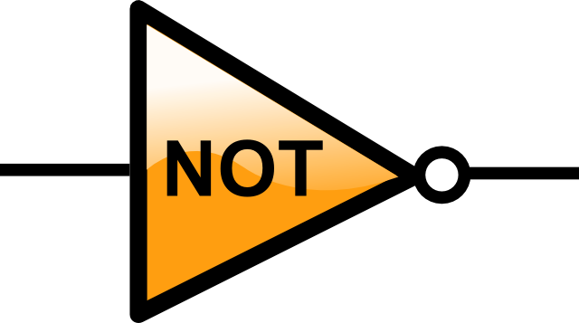 | If the input is ON, the output is OFF.  If the input is OFF, the output is ON.
 | The output is ON, except if both inputs are OFF.
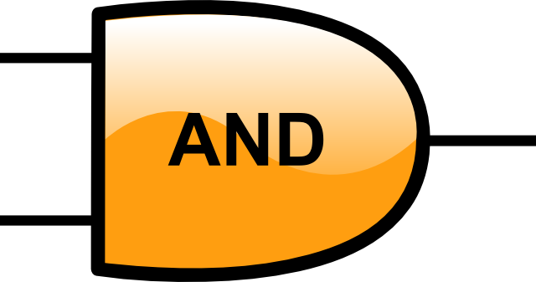 | The output is ON only when both inputs are ON.

Question

If input A is OFF, and inputs B and C are ON, what will the outputs X and Y be?

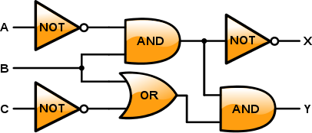

a) X is OFF, Y is OFF
b) X is OFF, Y is ON
c) X is ON, Y is OFF
d) X is ON, Y is ON

Answer

b)

Explanation

b) is the correct answer:
Lines OFF remain black, line ON are marked yellow/black.

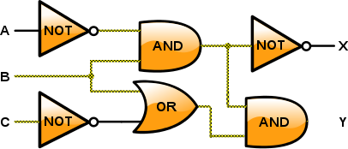

It's informatics

Logic gates are the fundamental building blocks of digital electronics, like computer processors. Zeroes and Ones are represented by switching on or off electrical currents. In todays processors, billions of such gates are fitted together to make a computer work.
The analysis of such networks can be done using boolean algebra. One can for instance show, that input C has no effect in the above network.

Keywords

Logic gates
Boolean algebra

Websites

http://en.wikipedia.org/wiki/Logic_gate
http://en.wikipedia.org/wiki/Boolean_algebra
http://en.wikibooks.org/wiki/A-level_Computing/AQA/Computer_Components,_The_Stored_Program_Concept_and_the_Internet/Fundamental_Hardware_Elements_of_Computers/Logic_Gates

Internal Use

Wording

input, output, ON, OFF,

Comments

Initial version by Paul Miotti, Switzerland
Completely revised by Ivo Blöchliger, ivo.bloechliger@gmail.com, Switzerland

NOTE: There is a more difficult variation on this taks in 2014-CH-08

Sarah Hobson, Australia, sarah.hobson@goodnews.qld.edu.au and Rostyslav Shpakovych, Ukraine, rshpakovych@gmail.com:
This task is difficult. We suggest 1: hard, 2: hard 3: medium 4: medium

Sher Minn Chong, Malaysia sherminn.chong@mail.com, rework graphics to prevent 'jumping' wires

Graphics

The logic gates are based on work by Arturo Urquizo, see http://es.wikipedia.org/wiki/Usuario:Arturo_Urquizo/Graficos
All graphics were compiled by Ivo Blöchliger, using Inkscape.

Files

All additional files for this task (graphics, scripts, etc.)
2014-CH-04-EN.odt (this file)
Logic gates:
2014-CH-04-AND.svg
2014-CH-04-NOT.svg
2014-CH-04-OR.svg

All elements required to draw circuits:
2014-CH-04-elements.svg

Question and Solution:
2014-CH-04-task.svg
2014-CH-04-task-solution.svg

All png-file are generated from the above svg.

Authorship

List all authors who have contributed to this Document, with e-mail and country.
Paul Miotti (original idea), Switzerland
Ivo Blöchliger, ivo@bloechligair.ch, Switzerland (CH) & Caroline Bösinger, caroline.boesinger@gmx.ch, Switzerland (CH) & Christian Datzko, christian@datzko.ch, Switzerland (CH) at Swiss Workshop
Ivo Blöchliger, ivo.bloechliger@gmail.com, Switzerland

License

Copyright © 2014 Bebras – International Contest on Informatics and Computer Fluency. This work is licensed under a Creative Commons Attribution-NonCommercial-ShareAlike 3.0 Unported License (CC BY-NC-SA 3.0). Visit: http://creativecommons.org/licenses/by-sa-sa/3.0/

