2014-JP-01-EN Traveling upriver
0 ---- | I: hard | II: medium | III: medium | IV: easy

Answer Type: Multiple Choice Mandatory for: none

Body
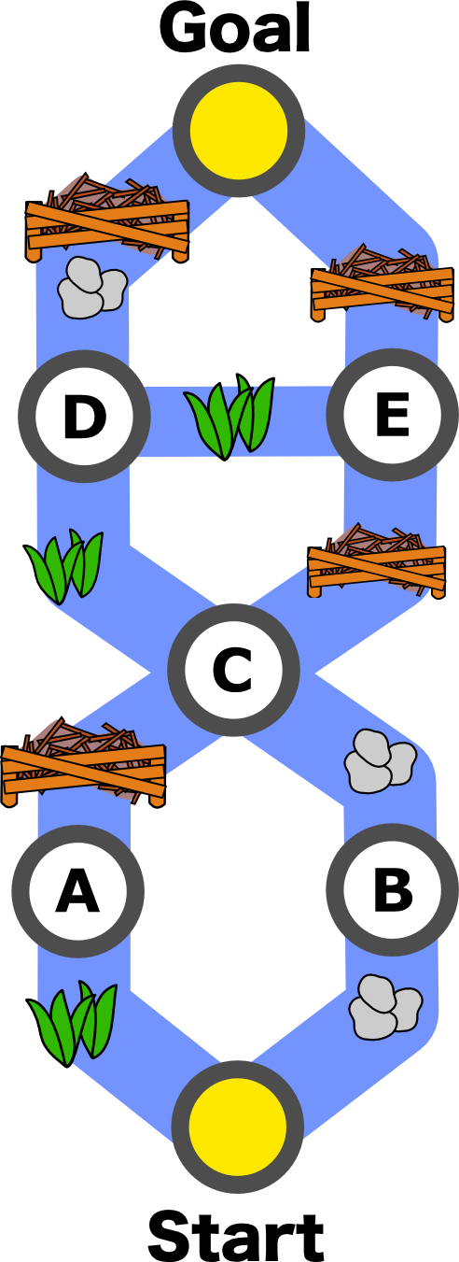
A beaver tries to go up a river.

As in the figure, the river has some branches and there are some obstacles in the river.
- Getting over a grassy area reduces his health corresponding to two twigs.
- Removing rocks reduces his health corresponding to three twigs.
- Getting over a dam reduces his health corresponding to five twigs.
He will start after he fills his health to eat 15 twigs.

Question

Which routes can he reach the goal?

Start → A → C → E → Goal
Start → A → C → E → D → Goal
Start → B → C → D → E → Goal
Start → B → C → D → Goal

Answer

Start → B → C → D → E → Goal

Explanation

Start → A → C → E → Goal: 2+5+5+5 = 17
Start → A → C → E → D → Goal: 2+5+5+2+3+5 = 22
Start → B → C → D → E → Goal: 3+3+2+2+5 = 15
Start → B → C → D → Goal: 3+3+2+3+5 = 16
If the beaver chooses “Start → B → C → D → E → Goal: 3+3+2+2+5”, he can reach the goal.
Otherwise he should lose more than 15 health points.

It's informatics

The problem of finding a shortest path between two nodes in a graph, Shortest Path Problem, is one of the most basic problems in graph theory. For the problem, several efficient algorithms are known, for example, Dijkstra's algorithm and Warshall-Floyd Algorithm. Algorithms for Shortest Path Problem are applied in many fields. Car navigation system is a typical example. This problem is a variety of Shortest Path Problem. It can be viewed as finding a path in a directed acyclic graph such that sum of the weight of its edges is less than or equal to 15.

Keywords

Shortest path problem.

Websites

Indicate websites (in English and other languages) which offer further information on the particular domain of informatics mentioned in the “It's informatics” part. Wikipedia is often a good start.

Internal Use

Wording

List of word used to name important things in the task body (concepts, definitions, objects, names, etc.) This is to ensure the consequent use of terms in the task body and facilitates translation.

Comments

Author, e-mail, Date (YYYY-MM-DD), Comment.

Graphics

All figures are drawn by Maiko Shimabuku ( shimabuku.m@gmail.com , Japan).
The figure is licensed under a Creative Commons Attribution-ShareAlike 2.1 Japan License (CC BY-SA 2.1 JP).

Files

All additional files for this task (graphics, scripts, etc.)
2014-JP-01-EN.odt (this file)
2014-JP-01-fig.svg
2014-JP-01-fig.png
2014-JP-01-fig-alt.svg
2014-JP-01-fig-alt.png

Authorship

Hiroyuki Nagataki (Japan) nagataki@cc.okayama-u.ac.jp

License

Copyright © 2014 Bebras – International Contest on Informatics and Computer Fluency. This work is licensed under a Creative Commons Attribution-NonCommercial-ShareAlike 3.0 Unported License (CC BY-NC-SA 3.0). Visit: http://creativecommons.org/licenses/by-sa-sa/3.0/

