2015-SP-01-EN Defense
0 ---- | I: easy | II: ---- | III: ---- | IV: ----

Answer Type: Open Integer Mandatory for: none

Body

Beavers are playing a new strategy game called “Defense of a Kingdom”.
The kingdom is represented by a rectangular grid of cells. The player has some rooks to protect the cells of the kingdom. Each rook defends all the cells in its row and in its column. The rooks cannot share the same row or column.
The player has to find the best position for his rooks to defend as much cells as possible in the grid.
The penalty of the position of the rooks is the number of cells in the largest undefended rectangle.
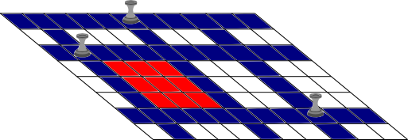
In this figure, we can see a kingdom of 8x11 cells with 3 rooks. In this position, the largest undefended rectangle is the red one, with 9 cells; so, the penalty would be 9.

Question

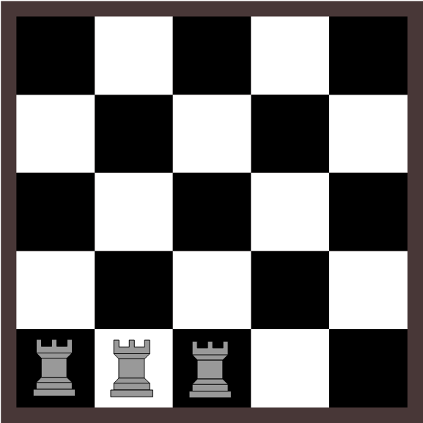

Which is the minimum penalty that the beavers can obtain in this kingdom playing with three rooks?

Answer

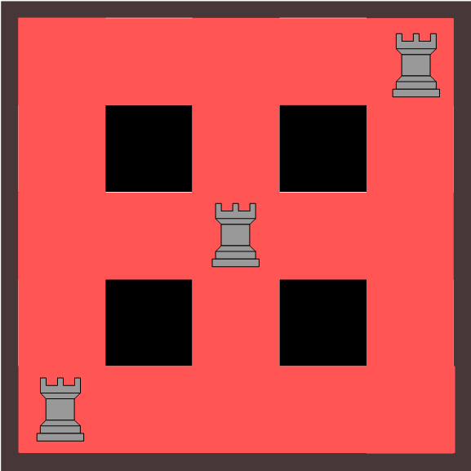
The solution is ONE.
Here you have the position of the rooks and the cells undefended by them (in black color).

Explanation

If the rows and the columns where rooks are positioned are together, it will be more probable that the largest undefended rectangle will be larger. Remember: divide et impera.

It's informatics

It is a process when the position of one rook influences on the position of the other rooks.

Keywords

Give some keywords, useful to find further information on the web. The target are the teachers and interested students.

Websites

Indicate websites (in English and other languages) which offer further information on the particular domain of informatics mentioned in the “It's informatics” part. Wikipedia is often a good start.

Internal Use

Wording

Grid, cell, rook, largest undefended rectangle, penalty.

Comments

Javier Bilbao, javier.bilbao@ehu.es, 2014-04-29: The task can be change its difficulty with different number of cells and different number of rooks.
It is an interactive task.

Graphics

Please indicate:
- Source of the all used images to produce the task image(s): author is Eugenio Bravo.
- Licence of all the individual images: CC BY-NC-SA 3.0

Files

All additional files for this task (graphics, scripts, etc.)
2014-SP-01-EN-Defense.odt (this file)
Example_towers.png
Example_towers.svg
towers 5x5 solution.svg
towers 5x5.svg

Authorship

Eugenio Bravo, eugenio.bravo@ehu.es, Spain
Javier Bilbao, javier.bilbao@ehu.es, Spain

License

Copyright © 2014 Bebras – International Contest on Informatics and Computer Fluency. This work is licensed under a Creative Commons Attribution-NonCommercial-ShareAlike 3.0 Unported License (CC BY-NC-SA 3.0). Visit: http://creativecommons.org/licenses/by-sa-sa/3.0/

