2015-AZ-02-EN.odt Shebeke
0 -- | I: -- | II: hard | III: medium | IV: easy

X

Answer Type: Open integers. Mandatory for: none

Body

The robot Shekebe creates windows from coloured pieces of glass. Every window pane has the exact same pattern:
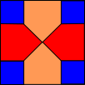

A 3-column-window is made of 5 panes and looks as follows: | A 5-column-window looks as follows:
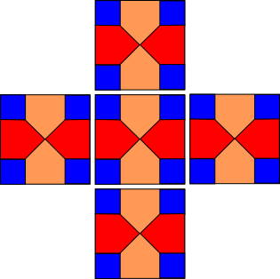 | 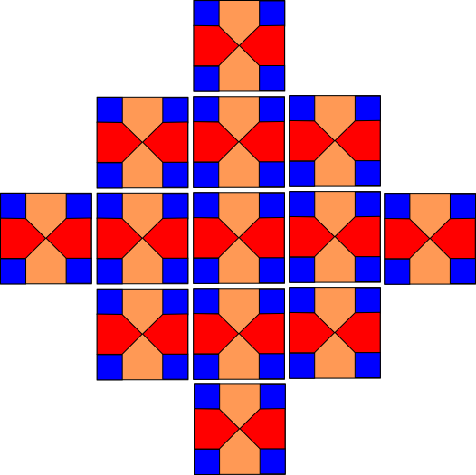

Question

How many blue pieces  are needed to decorate a 7-column-window?

Answer

Open integer number

Explanation

The correct answer is 100.

One of possible methods of how to find correct solution is to understand how cells are added during making a window bigger.
If we want to resize a small window to the next bigger by adding two columns (e.g. from 3 columns to 5 ones or from 5 columns to 7 ones), we should:
1. add 4 cells to the 4 main directions from the centre of the window (left, right, up, down)
2. add one cell to each corner (where this new cell will touch sides of two cells of the smaller window). A 5-column-window contains 8 such corners.
So we need to add 4 + 8 = 12 new cells to existing 13 cells. So 7-column-window contains 25 cells.
Every cell needs 4 rectangular pieces so there is 100 rectangular pieces in the 7-column-window.

If we want to count number of rectangular pieces of such a window of any size, we can use mathematical formula: SUM( (i-1)*2+1 ) * 2 + N
Let W (number windows) =
Then number of rectangular pieces will be W x 4

the non mathematical way of figuring this out is:
3 columns: 1 + 3 + 1 panes
5 columns: 1 + 3 + 5 + 3 + 1 panes
7 columns: 1 + 3 + 5 + 7 + 5 + 3 + 1 panes = 25 panes. Each pane has 4 blue squares. Ergo 4 x 25 = 100 blue squares.

It's informatics

A robot is acting on a program. This functionality of the program is described here only by the output of small examples. You have to be able to read functional specifications and turn them into a program. This task wants you to do this in your head.

Keywords

Functional design

Websites

http://en.wikipedia.org/wiki/Shabaka_(window)
http://www.programmingbasics.org/en/beginner/while.html
https://www.youtube.com/watch?v=8KLwama1Gr4

Internal Use

Wording

Comments

Task is rephrased, by the author and by several members of working group I.

Graphics

All graphics are created by myself (Adil Aliyev) using inkscape. Everybody is free to use them for any purpose.

Files

cell_pattern.png
glass_1.png
glass_2.png
glass_3.png
shebeke_window.png_5.png
shebeke_window.png_3.png
drawings.svg
2015-AZ-02-EN.odt (this file)

Authorship

Adil Aliyev, adilaliev@gmail.com, Azerbaijan
Rashad Aliyev, gmanras@gmail.com, Azerbaijan

License

Copyright © 2014 Bebras – International Contest on Informatics and Computer Fluency. This work is licensed under a Creative Commons Attribution-NonCommercial-ShareAlike 3.0 Unported License (CC BY-NC-SA 3.0). Visit: http://creativecommons.org/licenses/by-sa-sa/3.0/

