2015-BE-01-EN Choose a meal
0 ---- | I: ---- | II: hard | III: medium | IV: easy

Answer Type: Multiple Choice Mandatory for: none

Body
Mother beaver prepared five lunch boxes with different ingredients and special sauces for Beaver Alexis to choose from.

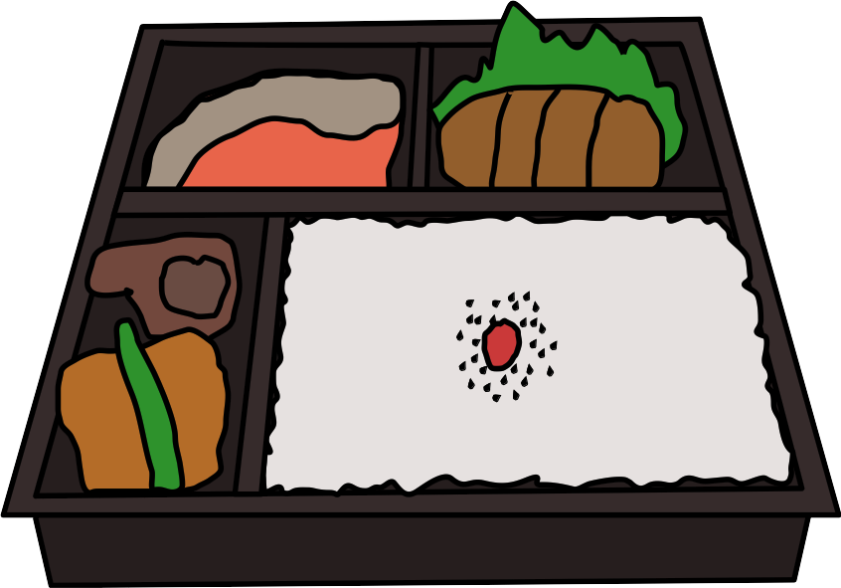

The main ingredients and taste of the special sauces of each lunch box are as follows:

Lunch box | Main Ingredient | Taste of Special Sauces
A | Rice, Fruits | Sweet, Bitter
B | Salmon, Crab | Salty
C | Rice, Pork | Sweet, Salty
D | Anchovy | Bitter, Salty
E | Rice, Bean, Fruits | Salty

Question

Beaver Alexis lunch preference resulted in selecting either lunch box A, C or E. What is Beaver Alexis's lunch preference?

Answer

A. No anchovy and likes having sweet or salty sauces
B. Likes rice and likes having salty sauce
C. Likes fruits or likes having sweet and salty sauces
D. Likes rice and crab or likes having sweet sauce

Explanation

Correct answer is C. Boxes A and E have fruits and Box C contains Sweet and Salty sauce.

Answer A would also included box B.
Answer B would only have box E.
Answer D would only have A and C, but no E.

It's informatics

This tasks introduces to the execution of a query on a database, and to logic operators. It is a simplified situation where the database consists of a set of labels and where requests combine those label with simple operators, namely AND, OR and NOT operators.

Keywords

Logic operators, database queries.

Websites

http://en.wikipedia.org/wiki/Boolean_algebra
http://en.wikipedia.org/wiki/Logical_connective

Internal Use

Wording

Pay attention to the keyword “likes” which is used to indicate the order of evaluation (acts like the parenthesis).

Comments

Graphics

Image coming from Openclipart:
- https://openclipart.org/detail/202270/bento-lunchbox

Files

All additional files for this task (graphics, scripts, etc.)
2015-BE-01-EN.odt (this file)
2015-BE-01-bentolunch.svg (lunchbox)

Authorship

Sébastien Combéfis, sebastien.combefis@csited.be, Belgium.

Revised @ 2015 Bebras Workshop
Greg Lee, leeg@csie.ntnu.edu.tw, Taiwan

License

Copyright © 2014 Bebras – International Contest on Informatics and Computer Fluency. This work is licensed under a Creative Commons Attribution-NonCommercial-ShareAlike 3.0 Unported License (CC BY-NC-SA 3.0). Visit: http://creativecommons.org/licenses/by-sa-sa/3.0/

