2015-CA-01-Popularity Popularity
0 ---- | I: ---- | II: medium | III: easy | IV: ----

Answer Type: Multiple Choice Mandatory for: none

Body

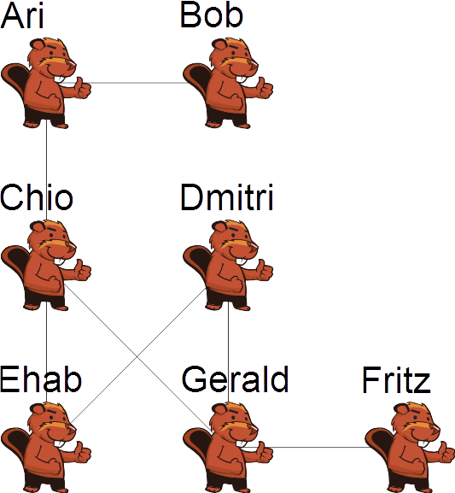
Seven beavers are in an online social network where they can see the photos only on their own and their friends pages. The graph on the right side shows who is friends with whom. After the Summer holidays they each post a picture of themselves on all of their friends' pages.

Question

Which beaver's picture will be seen the most?

Answer

- Ari
- Bob
- Chio
- Dmitri
- Ehab
- Fritz
- Gerald

Explanation

The correct answer is Chio.

In order to find the beaver whose picture gets seen by most beavers, you have to count the beavers that are at most two steps away. The beavers one step away are those on whose page the pictures will be posted and the beavers two steps away are those who can see these pages. Of course any beaver can only be counted once.

The following table shows the names of these beavers starting from each beaver.
Beaver | Direct Friends | Friends' Friends (that have not yet been named) | Total number of beavers reached
Ari | Bob, Chio | Ehab Gerald | 4
Bob | Ari | Chio | 2
Chio | Ari, Ehab, Gerald | Bob, Dmitri, Fritz | 6
Dmitri | Ehab, Gerald | Chio, Fritz | 4
Ehab | Chio, Dmitri | Ari, Gerald, Fritz | 5
Fritz | Gerald | Chio, Dmitri | 3
Gerald | Chio, Dmitri, Fritz | Ari, Ehab | 5

It's informatics

Many social networks use larger and more complicated versions of this concept, while it is not always obvious that by posting something on someone else's page it might be available to people the original poster does not know or is not a friend of.

Social networks themselves are incredibly powerful tools in today's world. Computing statistics on their users and pages is useful to marketers and anyone else trying to understand a person or group of people.

This social network could also be interpreted as a model of a miniature internet, with the beavers being websites and being friend as “linked to”. Search engines typically rank these websites by some measure of popularity or importance, at least by the number of links to and from the website.

A widely used way to find the result by using a computer is to use the flood fill algorithm, in this case restricted by the fact that only two iterations have been shown.

Keywords

Social Network, PageRank Algorithm, Graph

Websites

https://en.wikipedia.org/wiki/Social_network
http://en.wikipedia.org/wiki/PageRank
https://en.wikipedia.org/wiki/Flood_fill

Internal Use

Wording

follows, followers, popularity, points

Comments

J.P. Pretti, jpretti@uwaterloo.ca, 2015-04-01, could make more difficult by making scores distinct and asking for full order of beavers by score
Christian Datzko, christian@datzko.ch, 2015-05-27: We decided to supply the graph, but we changed it so it isn't too easy. We also changed the story to make it more realistic and to avoid negative stigmas (if there is someone very popular there has to be someone who is not very popular).
Christian Datzko: the picture could be erratic, in OOo it shows a black square in the upper right corner.

Graphics

Self made, the beaver is from the Swiss Bebras challenge.

Files

2015-CA-01-Popularity.odt (this file)
graph.svg: the graph of the body.

Authorship

J.P. Pretti, jpretti@uwaterloo.ca, Canada
Christian Datzko, christian@datzko.ch, Switzerland
Sarah Hobson, sarah.hobson@goodnews.qld.edu.au, Australia

License

Copyright © 2014 Bebras – International Contest on Informatics and Computer Fluency. This work is licensed under a Creative Commons Attribution-NonCommercial-ShareAlike 3.0 Unported License (CC BY-NC-SA 3.0). Visit: http://creativecommons.org/licenses/by-sa-sa/3.0/

