2015-CH-01-eng Postfix Calculating Machine
0 ---- | I: ---- | II: hard | III: medium | IV: easy

Answer Type: Open Text Mandatory for: none

Body

Here is a simple calculating machine. It stacks the boxes coming from the right until a box with an operating sign (+,-,* or /) appears. Then this calculation is carried out with the three topmost boxes and they are replaced by one single box containing the result of the calculation. Using this calculating machine, expression must entered differently. For examples:
- 2+3 must be entered as 2 3 +
- 10-2 must be entered as 10 2 -
- 5*2+3 must be entered as 5 2 * 3 +
- 5+2*3 must be entered as 5 2 3 * +
- (8-2)*(3+4) must be entered as 8 2 - 3 4 + *

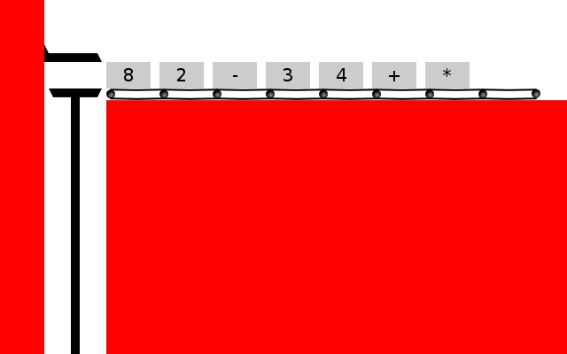

Question

Write out the expression for computing 4*(8+3)-2 using the above calculating machine.

Answer

The correct answer is 4 8 3 + * 2 -.

However, the following answers are also acceptable as they all produce the correct output.
- 4 3 8 + * 2 -
- 8 3 + 4 * 2 -
- 3 8 + 4 * 2 -
These input all lead to the same result, even though the order of the operators and operations are not the same as intended in the given expression.

Explanation

From left to right, we first have 4*(8+3), so we need 4 and the result of 8+3 on the stack. We achieve that by writing
4 8 3 +
We then have 4 and 11 on the stack, so we add a * to multiply the two numbers. We now have 44 on the stack, we add a 2 and a – for the final subtraction.

It's informatics

The usual notation for arithmetic expression is not the easiest to understand for a computer, or rather, it takes a more complicated program to process such expressions. However writing a program to analyze expressions in postfix notation (as done by this machine) is much much easier. This is one reason why on some early handheld calculators this notation had to be used. Another reason is, that the postfix notation does not require any parenthesis, no matter how complex the expression.

Keywords

Postfix notation, Reverse Polish notation, Stackmachine

Websites

http://en.wikipedia.org/wiki/Reverse_Polish_notation
http://en.wikipedia.org/wiki/Stack_machine

Internal Use

Wording

box, calculation

Comments

Author, e-mail, Date (YYYY-MM-DD), Comment.

Greg Lee, leeg@csie.ntnu.edu.tw, 2015-05-26
Can make this interactive task a multiple choice task with the following choices.
A. 4 8 3 2 * + -
B. 4 8 3 * + 2 -
C. 4 * 8 3 + 2 -
D. 4 8 3 + * 2 -

Expression in D is the correct answer.
Note multiple choice question without interactivity makes this task a little harder.

Graphics

in the graphics folder:
background.svg
stackCrusher.svg (lever coming from the top)
stackHolder.svg (lever supporting the stack)
Those files are encoded to base64 to be included directly in JavaScript

Files

All additional files for this task (graphics, scripts, etc.)
2015-CH-01-eng.odt (this file)
2015-CH-01.js (javascript for the animation, images are included directly)
2015-CH-01.html (interactive part of the task, try it out!)
graphics/background.svg
graphics/stackCrusher.svg
graphics/stackHolder.svg
graphics/Makefile (convert svg to base64)
Makefile (include base64-encoded images into javascript)

Authorship

List all authors who have contributed to this Document, with e-mail and country.
Ivo Blöchliger, ivo@bloechligair.ch, Switzerland

Revised at 2015 Bebras Workshop
Greg Lee, leeg@csie.ntnu.edu.tw, Taiwan

License

Copyright © 2014 Bebras – International Contest on Informatics and Computer Fluency. This work is licensed under a Creative Commons Attribution-NonCommercial-ShareAlike 3.0 Unported License (CC BY-NC-SA 3.0). Visit: http://creativecommons.org/licenses/by-sa-sa/3.0/

