2015-ES-01-EN Flowers on the path.
0 ---- | I: ---- | II: medium | III: easy | IV: ----

Answer Type: Multiple Choice Mandatory for: none

Body

Flowers on the path.
There is a park in Beaver City.
The gardener has left baskets with flowers to decorate a circular path.
A young beaver saw that the baskets were placed randomly. The beaver decided to order the baskets based on the number of flowers in each basket.

Baskets were ordered in the following way:
1. The beaver walks along the path in a clockwise direction and checks the baskets one by one.
2. If a basket has fewer flowers than the previous one, the beaver swaps them and continues walking (from the place where the basket with the fewer flowers was).
3. While everything is fine, the beaver continues walking along the path.
4. The beaver stops when the baskets are sorted correctly.
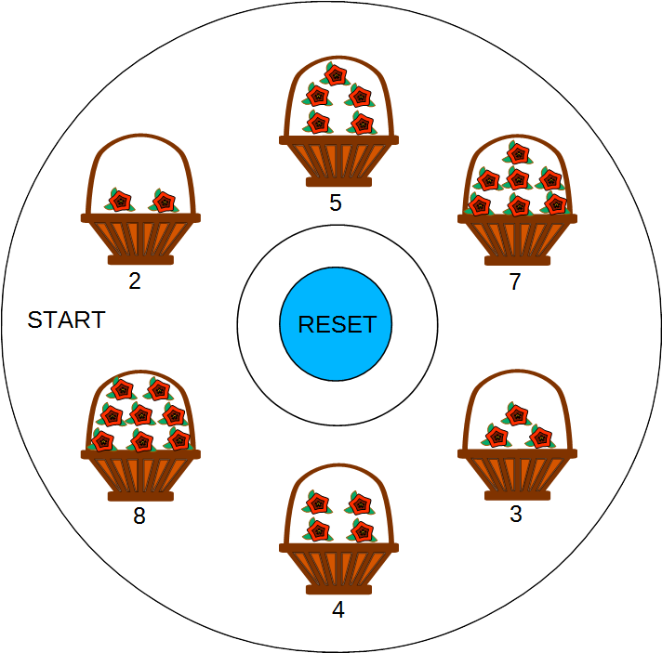

The graph above represents the order in which the gardener left the baskets along the path.

Question

What is the minimum number of times the beaver changes basket positions to get the baskets correctly sorted?

Answer

A) 2
B) 3
C) 4
D) 5

Explanation

Sorting Algorithm
It is a simple sorting algorithm that repeatedly steps though the list to be sorted, compares each pair of adjacent items and swaps them if they are in the wrong order.

Correct Answer: C is the correct answer. Four swaps will be performed: {7 ~ 3}, {7 ~ 4}, {5 ~ 3}, {5 ~ 4}

It's informatics

Sorting algorithms are some of the most important and commonly used in computer science algorithms. Handling large amount of data is used in spreadsheets, databases, etc.

In this case the algorithm is a special sorting algorithm called Bubble Sort, because it looks like the bigger items float upwards like bubbles. This sorting algorithm isn't the fastest in most cases, other sorting algorithms like Quicksort are faster.

Keywords

Sorting algorithm, Bubble sort, Quicksort

Websites

https://en.wikipedia.org/wiki/Bubble_sort
https://en.wikipedia.org/wiki/Sorting_algorithm
https://en.wikipedia.org/wiki/Quicksort

Internal Use

Wording

Basket, Clockwise

Comments

Author, e-mail, Date (YYYY-MM-DD), Comment.
Edited by: Rashad Aliyev (gmanras@gmail.com), Filiz Kalelioglu (filizk@baskent.edu.tr): This task should be made interactive. Students could play and experiment before choosing the correct answer. Actions: Clicking on any basket will replace it with the one to the left of it (counter clockwise); Clicking on reset in the center will reset the baskets to initial positions.
An alternative question could be used for this task:
How many circles along the path does the beaver make to get the baskets correctly sorted?
A) 1
B) 2
C) 3
D) 4

Answer: B is the correct answer. The beaver will make two circles to get the baskets sorted.

Graphics

Based on graphics from OpenClipart

Files

2015-ES-01-EN.odt (this file)
Baskets_and_flowers.svg

Authorship

Eugenio Bravo, eugenio.bravo@ehu.es, Spain
Filiz Kalelioglu (filizk@baskent.edu.tr), Turkey
Rashad Aliyev (gmanras@gmail.com), Azerbaijan
Christian Datzko (christian@datzko.ch), Switzerland
Sarah Hobson, sarah.hobson@goodnews.qld.edu.au, Australia

License

Copyright © 2014 Bebras – International Contest on Informatics and Computer Fluency. This work is licensed under a Creative Commons Attribution-NonCommercial-ShareAlike 3.0 Unported License (CC BY-NC-SA 3.0). Visit: http://creativecommons.org/licenses/by-sa-sa/3.0/

