2015-JP-01-eng Woodwork
0 ---- | I: hard | II: hard | III: medium | IV: easy

Answer Type: Multiple Choice Mandatory for: none

Body
Beavers Bitaro and Bibako sit at a river building wooden toys. They share one hammer, one pair of scissors and one saw. They take a tool from a sandbank when they need it and they return it to the sandbank when they are done using it. If a tool they need is not on the sandbank, they wait until it is returned.
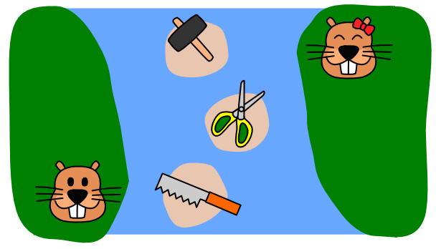
There are situations when both beavers need a tool being used by the other beaver. When this happens, they stop building toys and go for a swim.

Question

In which one of the following situations will the beavers definitely take a swim?



A) Bitaro has the and needs the . Bibako has the and needs the .
B) Bitaro has the and needs the . Bibako has the and needs the .
C) Bitaro has the and needs the . Bibako has the and needs the .
D) Bitaro has the and needs the . Bibako has the and needs the .

Answer

B

Explanation

In situations A, C and D one of the beavers can acquire the missing tool, finish its toy and finally return both tools. At that moment the other beaver can get the missing tool and finish his toy.

In the situation B, they will have to wait each other forever after they carried the first tool each.
In other situations, they may have to wait for a while, but they can get tools sooner or later.

It's informatics

Acquiring the tool means locking it.
This situation is called ‘deadlock’. When programs access sharing resources, the order of locking is important to prevent the deadlock.
Many programs are running concurrently in networks and in computers.
Sharing resources and preventing deadlock are both important.

Keywords

Deadlock, Exclusion Control, Concurrent processing

Websites

Internal Use

Wording

Share a tool, need a tool, take a tool, return a tool

Comments

2015-05-27 Hans-Werner Hein: Improvement of text and graphics.
Group7, 2015-05-28, in translation be careful, that in the questions it will be clear that beaver have (possess) one tool and they now need the other one.

Graphics

Source in the graphics folder 2015-JP-01.svg not copyrighted.

Files

All additional files for this task (graphics, scripts, etc.)
2015-JP-01-eng.odt (this file)
2015-JP-01-eng.pdf (pretty print)
graphics/2015-JP-01_river.svg
graphics/2015-JP-01_river.png
graphics/2015-JP-01_hammer.png
graphics/2015-JP-01_saw.png
graphics/2015-JP-01_scissor.png

Authorship

List all authors who have contributed to this Document, with e-mail and country.
Susumu Kanemune, kanemune@acm.org, Japan
Maiko Shimabuku, shimabuku.m@gmail.com, Japan

License

Copyright © 2015 Bebras – International Contest on Informatics and Computer Fluency. This work is licensed under a Creative Commons Attribution-NonCommercial-ShareAlike 3.0 Unported License (CC BY-NC-SA 3.0). Visit: http://creativecommons.org/licenses/by-sa-sa/3.0/

