2015-LT-01-EN Building a chip I

0 ---- | I: ---- | II: ---- | III: hard | IV: medium

Answer Type: Multiple Choice Mandatory for: none

Body

Nowadays, integrated circuits (chips) are used in all electronic equipment and they have revolutionized the world of electronics. A chip can be made very compact, having up to several billion transistors and other components in an area the size of a fingernail.
A small plate contains many transistors arranged in a grid (marked as dots) and few partitions (marked as line segments). Transistors can be connected using segments of connectors. Connectors can be built vertically or horizontally and cannot touch any partition.
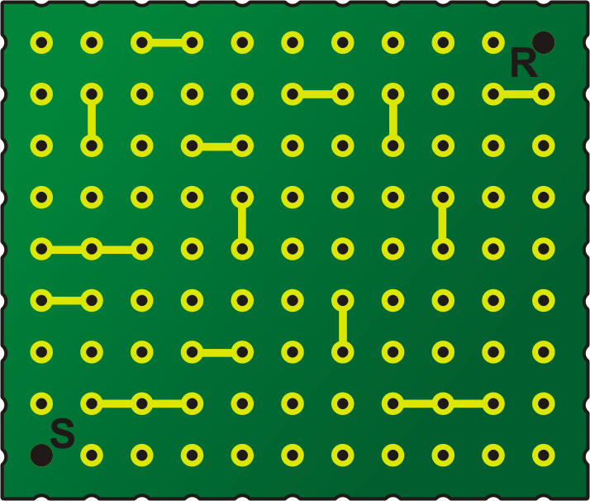

Question

How many segments do we need at least in order to connect S and R?

Answer

A 18

B 20
C 21
D 22

Explanation

We can try a few paths and find the shortest one, or we can use breadth-first search to find distances from S to each dot until we reach R:
14 | 15 | # | # | 14 | 15 | 16 | 17 | 18 | 19 | 20
13 | # | 11 | 12 | 13 | # | # | # | 17 | # | #
12 | # | 10 | # | # | 11 | 12 | # | 18 | 17 | 16
11 | 10 | 9 | 8 | # | 10 | 11 | 12 | # | 16 | 15
# | # | # | 7 | # | 9 | 10 | 11 | # | 15 | 14
# | # | 5 | 6 | 7 | 8 | # | 12 | 13 | 14 | 13
2 | 3 | 4 | # | # | 7 | # | 15 | 14 | 13 | 12
1 | # | # | # | 5 | 6 | 7 | # | # | # | 11
0 | 1 | 2 | 3 | 4 | 5 | 6 | 7 | 8 | 9 | 10

It's informatics

Finding shortest path is a common problem in informatics, and breadth-first search is usually used for it with unweighted graphs. In addition, the theme is about chips, and without them all informatics would be just a theory.

Keywords

graph, shortest path, search algorithm, breadth-first search, wire routing algorithm

Websites

Internal Use

Wording

Comments

Graphics

Please indicate:
- Source of the all used images to produce the task image(s): (Url and/or author)
- Licence of all the individual images

Note: If it is not clear where the images are from, they might be copyrighted and cannot be used in the task.

Files

Mikroschema11x9a.png
2015-LT-01-EN.odt (this file)

Authorship

Valentina Dagienė, valentina.dagiene@mii.vu.lt, Lithuania

License

Copyright © 2014 Bebras – International Contest on Informatics and Computer Fluency. This work is licensed under a Creative Commons Attribution-NonCommercial-ShareAlike 3.0 Unported License (CC BY-NC-SA 3.0). Visit: http://creativecommons.org/licenses/by-sa-sa/3.0/

