2015-LT-02-EN Building a chip II

0 ---- | I: ---- | II: ---- | III: hard | IV: hard

Answer Type: Multiple Choice Mandatory for: none

Body

A small chip is composed of a grid of contacts (marked as dots). Some are already connected (marked as line segments). Connectors are always only between adjacent contacts, horizontally or vertically. We want to connect S and R with a continuous sequence of connectors, which do not touch any already connected contacts.
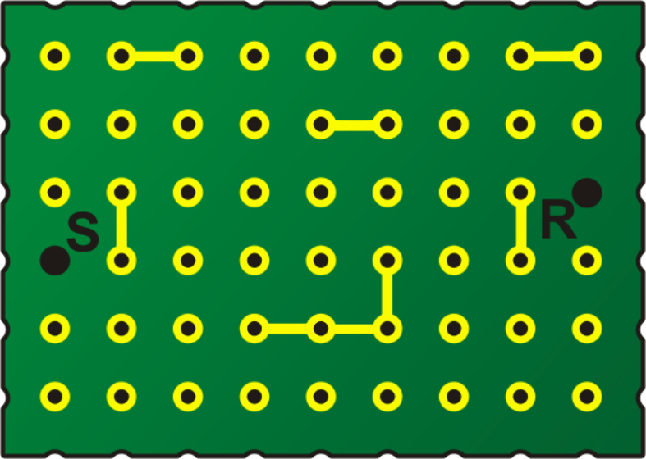

Question

How many different ways are there to connect S and R with the least possible number of connectors?

Answer

A 5
B 13
C 15
D 16

Explanation

It is not difficult to find some shortest path (sequence of connectors). You can imagine a wave spreading over the board, one contact at a time, starting at S and moving toward R. When the wave reaches a contact, it certainly took the least possible number of connectors (“steps” of the wave).

The table shows the wave midway through filling in. The numbers show the order in which the wave reached them, and the blacked out cells indicate the connectors we cannot connect to. They are also the length of the shortest path to the respective contact. The highest numbers are the current edge of the wave.

3 | # | # | 6 |  |  |  | # | #
2 | 3 | 4 | 5 | # | #
1 | # | 5 | 6 |  |  |  | # | R
S | # | 4 | 5 | 6 | # |  | #
1 | 2 | 3 | # | # | #
2 | 3 | 4 | 5 | 6

But if you try to find all the shortest paths, you can easily get lost. Luckily, you do not really need to, you are just interested in the number of paths. So how to break this task down to some smaller pieces?

Realize this: A shortest path to any given contact must go through one of the adjacent contacts, which is exactly one connector closer to the start. If there are more such contacts, any of them can be used. So if you want to know the number of possibilities, you need to sum the possibilities to get to these adjacent contacts. The number of shortest paths to a certain contact is the sum of the numbers of the shortest paths to the adjacent contacts which are one connector closer to the start.

This allows you to follow a procedure, which will reliably give you the final number of shortest paths. You can proceed similarly as with finding the shortest path, filling in the table like a wave. Start at S. The contacts next to it can be reached in only one way. Then add the next contacts along the wave edge and always sum up the neighbour numbers from the previous step.

The resulting table looks like this, where we have also shown the order in which the cells are filled in by way of the table on the right, which is the completely filled in “shortest path” table discussed above:
  1 | # | # | 1 | 1 | 1 | 1 | # | #
  1 | 1 | 1 | 1 | # | # | 6 | 6 | 6
  1 | # | 2 | 4 | 5 | 5 | 5 | # | 15
  S | # | 1 | 1 | 1 | # | 8 | # | 9
  1 | 1 | 1 | # | # | # | 3 | 6 | 9
  1 | 2 | 3 | 3 | 3 | 3 | 3 | 3 | 3
  3 | # | # | 6 | 7 | 8 | 9 | # | #
  2 | 3 | 4 | 5 | # | # | 10 | 11 | 12
  1 | # | 5 | 6 | 7 | 8 | 9 | # | R
  S | # | 4 | 5 | 6 | # | 10 | # | 12
  1 | 2 | 3 | # | # | # | 9 | 10 | 11
  2 | 3 | 4 | 5 | 6 | 7 | 8 | 9 | 10

The correct answer is 15.

It's informatics

Nowadays, integrated circuits (chips) are used in all electronic equipment and they have revolutionized the world of electronics. A chip can be made very compact, having up to several billion transistors and other components in an area the size of a fingernail. Without them all informatics would be just a theory.

The chips are very crowded and hence not easy to design. Computer scientists use many clever algorithms to do that. When deciding where to put two components, one criterion can be the number of paths between them: the more paths available, the less constraint for the rest of the board, because some third component will block these two components easily.

Finding the shortest path is a common problem in informatics. The described “wave” procedure is actually called “breadth-first search”. Here it was adapted to count all the shortest paths. We did not have to check all the possible paths, because we proceeded systematically from the start. This approach is called dynamic programming.

Keywords

graph, shortest path, search algorithm, breadth-first search, dynamic programming, wire routing algorithm

Websites

Internal Use

Wording

contact, connector, connection

Comments

Dan Lessner:
Shortened the body, circuitry goes to explanation. Functionality not important for the solution, so we simplified the terminology (transistors, partitions).
Explanation: much more detailed. First I talk about shortest path, basically to prepare the student to the more advanced issue of counting the paths.
Alternatives: ways differentiating obstacles only, length of the optimal way, correct answer, correct answer+1
Image: connecting two connectors, so it is clearer that it IS allowed to connect connections together, they just do not touch with other “circuits” (adjusted by Ahmad Nubli Muhammad)

Graphics

Graphics made by Vaidotas Kinčius from Valentina's team, released for our (Bebras) needs freely under CC.

Files

mikroschema9x6a.png
2015-LT-02-EN.odt (this file)

Authorship

Valentina Dagienė, valentina.dagiene@mii.vu.lt, Lithuania
Dan Lessner, lessner@ksvi.mff.cuni.cz, Czechia

License

Copyright © 2014 Bebras – International Contest on Informatics and Computer Fluency. This work is licensed under a Creative Commons Attribution-NonCommercial-ShareAlike 3.0 Unported License (CC BY-NC-SA 3.0). Visit: http://creativecommons.org/licenses/by-sa-sa/3.0/

