2015-MY-01-EN Bracelet
0 medium | I: easy | II: easy | III: ---- | IV: ----

Answer Type: Multiple Choice Mandatory for: none

Body

Emily the Beaver has a favorite bracelet made out of colorful beads with different shapes. One day, her bracelet breaks. The broken bracelet looks like this:


Question

Your task is to help Emily find a new bracelet. Which one of these bracelets could have been the same as Emily's?

Answer

A: C:
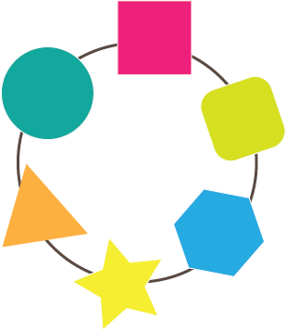


B: D:
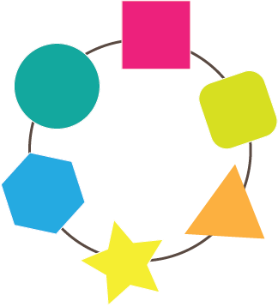


Explanation

The correct answer is B. Bracelet B follows the beads in the same order as the broken bracelets. In bracelet A, the orange triangle and yellow star are swapped. In bracelet C, the orange triangle and blue hexagon beads are in the wrong place. In bracelet D, the yellow star and green oblong beads are in the wrong place.

It's informatics

In informatics it is important to be able to recognize patterns which may be useful to us. Recognizing patterns helps us find similarities in things that may look different at first, but have something in common. When we detect that a new problem is similar to another problem we have already solved, we can apply a similar solution to solve the new problem: this is true for mathematics, scientific study or informatics problems.

This task also deals with verifying a proposed solution: the possible answers need to be checked against the original bracelet to see if they meet the required order of the shapes. The same process of verifying a solution is important in informatics in order to determine if the output of a program is correct.

Keywords

Pattern recognition

Websites

http://en.wikipedia.org/wiki/Pattern_matching

Internal Use

Wording

Bracelet, beads

Comments

Sher Minn Chong, sherminn.chong@gmail.com, 2015-04-14

Graphics

Graphics are of my own creation
- 2015-MY-01-broken-bracelet_A.png
- 2015-MY-01-broken-bracelet_B.png
- 2015-MY-01-broken-bracelet_C.png
- 2015-MY-01-broken-bracelet_D.png
- 2015-MY-01-broken-bracelet_broken-bracelet.png

Files

All additional files for this task (graphics, scripts, etc.)
2015-MY-01-EN.odt (this file)

Authorship

List all authors who have contributed to this Document, with e-mail and country.
Sher Minn Chong, sherminn.chong@gmail.com, 2015-04-14 (initial draft)
Violetta Lonati, Troy Vasiga (Italy/Canada), troy.vasiga@uwaterloo.ca, lonati@di.unimi.it, 2015-05-26

License

Copyright © 2014 Bebras – International Contest on Informatics and Computer Fluency. This work is licensed under a Creative Commons Attribution-NonCommercial-ShareAlike 3.0 Unported License (CC BY-NC-SA 3.0). Visit: http://creativecommons.org/licenses/by-sa-sa/3.0/

