2015-SE-01-EN Drawing stars
0 medium | I: easy | II: ---- | III: ---- | IV: ----

Answer Type: Multiple choice Mandatory for: none

Body

Stella Beaver loves to draw stars. She has devised a system for labeling her stars according to their shape. For that, she uses two numbers:
- A number of dots of the star.
- A number which indicates if a line from a dot is drawn to the nearest dot (the number is 1), the second closest dot (the number is 2), etc.

Here are four examples of Stella's labeling system:
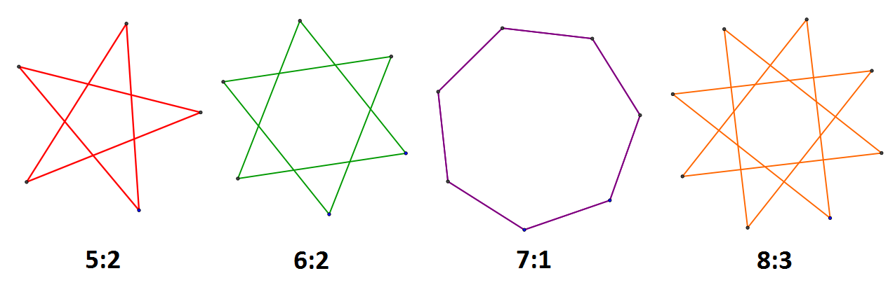

Question

How would Stella label the following star?



Answer

- 9:3
- 9:4
- 10:4
- 10:5

Explanation

10:4 is correct. The star has 10 dots and it is possible to draw a line to the fourth nearest dot.

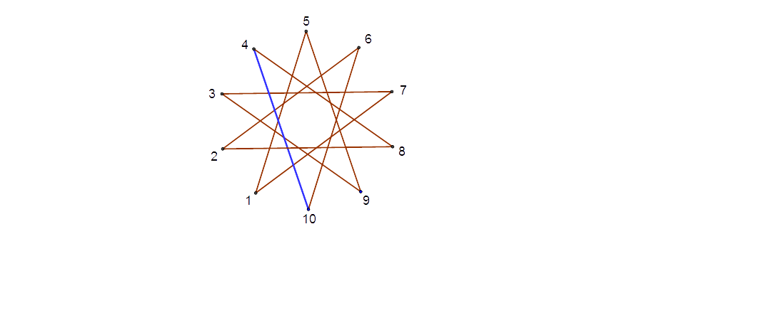

It's informatics

Computers need simple representations of objects to be able to work with them. The fact that a complex and beautiful object such as a regular star polygon can be described by only two integers is an example of a simple representation.

Keywords

Regular star polygon, Schäfli symbol

Websites

http://en.wikipedia.org/wiki/Star_polygon

Internal Use

Wording

vertex, line, skip-factor

Comments

Arnheidur Gudmundsdottir, 26-05-15, wording of explanation and body
Jiří Vaníček, 26-05-15, New vector images created

Graphics

Images created by author.

Files

All additional files for this task (graphics, scripts, etc.)
2015-SE-01-EN.odt (this file)
star10-4explanation.svg
star10-4.svg,
star5-2.svg, star6-2.svg, star7-1.svg, star8-3.svg
stars.png (4 stars constellation)

Authorship

Pär Söderhjelm, Sweden, par.soderhjelm@bpc.lu.se, 2015-04-26

License

Copyright © 2014 Bebras – International Contest on Informatics and Computer Fluency. This work is licensed under a Creative Commons Attribution-NonCommercial-ShareAlike 3.0 Unported License (CC BY-NC-SA 3.0). Visit: http://creativecommons.org/licenses/by-sa-sa/3.0/

