2015-SK-01 Two drawing robots
0 ---- | I: ---- | II: hard | III: medium | IV: medium

Answer Type: Multiple Choice Mandatory for: none

Body

James created two drawing robots that can execute commands:
move - robot goes 1 step forward
turn - robot turns by 90 degrees

James puts robots on the floor, and send them three commands to each robot:
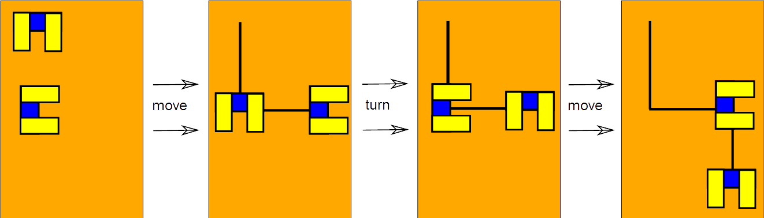
James noticed that one robot interprets the turn command as turning 90 degrees to the right, but the second one interprets it as turning 90 degrees to the left.

Then James tried to paint many pictures by putting each robot to a different place on the floor but giving both of the always the same set of commands. Also the robots can't be in one place at any point of time.

Question

Which picture could not to drawn by the two robots?

Answer

A)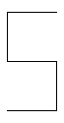 B) 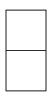 C) 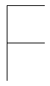 D) 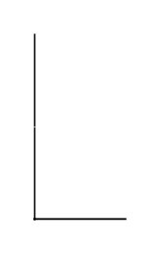

Explanation

The correct answer: D) The letter 'L' is impossible to draw.

Firstly, let's show how we can find the way to paint each of them:
A)
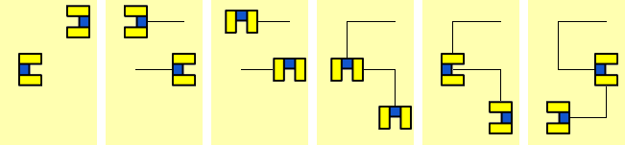
B)
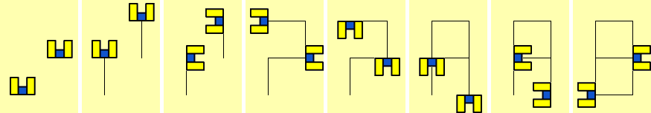
C)
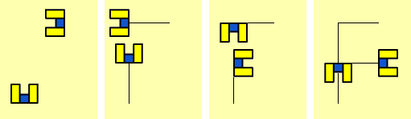
You can find the GIF animations of each solution in the corresponding GIF files.

Now to the impossibility proof for 'L':
Firstly, the left line of 'L' can't be drawn by the same robot, because the other robot can't do 2 consecutive moves (since he must turn after 1 move). We need to do at least 1 turn to either draw the rest of the left line, or to draw the bottom line, but as soon as the any part of left line is drawn, the other robot becomes unable to do any turn other than 180 degrees, since the second robot can't go left or right. Therefore we can't draw an 'L', because we can't make turns at all.

Hard version: I've confirmed that the letter 'E' also cannot be drawn by writing a bruteforce, but I can't prove it without a lot of casework. So if anyone can provide nice and short proof, I can replace the 'L' with 'E' (it's more interesting than 'L'). Bruteforce code can be found in the contrib folder named robots.cpp.

It's informatics

The instructions for robots are an example of an algorithm.
The use of the instructions by two robots that have differences in understanding one command create a not so usual situation.
The ability to understand the effect of instructions even in unusual situations is an important constituent of algorithmic thinking.

Keywords

Robots, Instructions, Symmetry

Websites

Internal Use

Wording

Move, turn, robot, commands

Comments

Author, e-mail, Date (YYYY-MM-DD), Comment.
Miras Myrzakerey, miras.myrzakerey@nu.edu.kz, 2015-05-27, replaced the old example with a new one, added the impossible case and its proof.
Suggestion: one can make this task harder by asking to check which pictures can be drawn, instead of can't, and make it a multi-answer problem.

Graphics
All graphics drawn by the author, Peter Tomcsányi and Miras Myrzakerey.
License as the whole document.

Files

All additional files for this task (graphics, scripts, etc.)
2015-SK-01.odt (this file)
2015-SK-01_2robots.svg
2015-SK-01_A.svg
2015-SK-01_B.svg
2015-SK-01_C.svg
2015-SK-01_solution_A.png
2015-SK-01_solution_B.png
2015-SK-01_solution_C.png
2015-SK-01_solution_A.gif - animated solution
2015-SK-01_solution_B.gif - animated solution
2015-SK-01_solution_C.gif - animated solution

Authorship

Author: Monika Tomcsányiová, ti, Slovakia
It's informatics, translation adjustments and graphics adjustments: Peter Tomcsányi tomcsanyi@slovanet.sk, Slovakia
Miras Myrzakerey, miras.myrzakerey@nu.edu.kz, Kazakhstan

License

Copyright © 2014 Bebras – International Contest on Informatics and Computer Fluency. This work is licensed under a Creative Commons Attribution-NonCommercial-ShareAlike 3.0 Unported License (CC BY-NC-SA 3.0). Visit: http://creativecommons.org/licenses/by-sa-sa/3.0/

