2015-TR-02-Patterns-in-Cells.odt Colourful Cells

0 ----Medium | I: Easy | II: ---- | III: ---- | IV: ----

STRUC

Answer Type: Multiple Choice Mandatory for: none

Body

Beaver has put a pattern the columns of his spreadsheet as shown in the picture below.

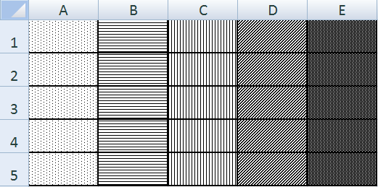

Question

He wants to select five cells so that all of the selected cells have a different pattern.
Each answer shows five selected cells. Select the answer where those selected cells all have a different pattern.

Answer

- A2, A4, C4, D3, E5
- A1, B3, B4, C3, D4
- A2, B4, E1, C3, D3
- A2, B2, C3, D3, D4

Explanation

SOLUTION: C is correct because every item in C is in a different column. And all cells in one column have the same pattern.

It's informatics

It's a bit informatics because you have to be able to figure out the labelling scheme for cells. This is done a spreadsheets and other software applications. You also have to be able to recognize the patterns in the cells.

Keywords

spreadsheet

Websites

Pattern matching
spreadsheet

Internal Use

Wording

List of word used to name important things in the task body (concepts, definitions, objects, names, etc.) This is to ensure the consequent use of terms in the task body and facilitates translation.

Comments

Yasemin Gülbahar, ysmnglbhr@gmail.com, 2015-04-14
Filiz Kalelioğlu, filizk@baskent.edu.tr, 2015-04-14.
Adil added some comments for solution explanation.
Jiří Vaníček, 2015-05-27, image changed from colours to cell patterns, original spredsheet file attacched (appologize for using MS Excel but LibreOffice does not have patterns of cell background).

Graphics

Task images are produced by improvers at the Workshop.

Files

2015-TR-02-Patterns-in-Cells.odt (this file)
cells.png
cells.xlsx (original graphics)

Authorship

Erman Yükseltürk, eyukselturk@gmail.com, Turkey
Yasemin Gülbahar, ysmnglbhr@gmail.com, Turkey
Filiz Kalelioğlu, filizk@baskent.edu.tr, Turkey
Soner Yıldırım, soner@metu.edu.tr, Turkey

License

Copyright © 2014 Bebras – International Contest on Informatics and Computer Fluency. This work is licensed under a Creative Commons Attribution-NonCommercial-ShareAlike 3.0 Unported License (CC BY-NC-SA 3.0). Visit: http://creativecommons.org/licenses/by-sa-sa/3.0/

