2015-TW-01-EN Taking Water
0 hard | I: medium | II: easy | III: ---- | IV: ----

Answer Type: Multiple Choice Mandatory for: none

Body

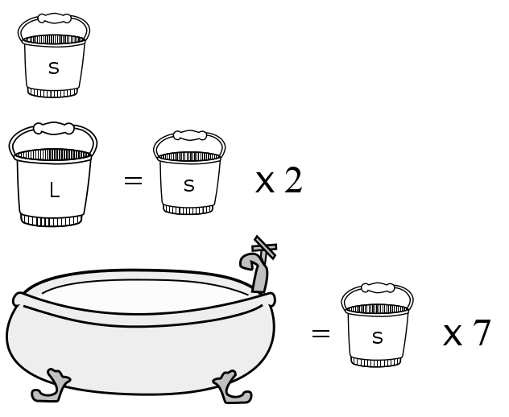
Every day after school, Sam fills his bathtub with water.

He has two buckets and uses them to bring water from the water station. The big bucket holds twice the water as the small bucket. The bathtub holds seven small buckets of water.

It takes Sam 3 minutes to walk from his home to the water station with an empty bucket. When he returns with a small or large bucket full of water, it takes him 4 and 5 minutes respectively.

Question

How long at very least does Sam need to fill the bathtub with water from the water station?

Answer

(A) 19 minutes
(B) 31 minutes
(C) 28 minutes
(D) 49 minutes

Explanation

The correct answer is B, 31 minutes. One trip with a big bucket takes 8 minutes, two trips with small buckets take 7 + 7 = 14 minutes, but in both cases Sam gets the same amount of water. Therefore, the least time is achieved when Sam fills the tub with 3 large buckets and 1 small bucket, i.e. 31 minutes.

It's informatics

The task can be viewed as a special case of the Knapsack Problem. To solve it we first evaluated the speed of filling the bathtub for each bucket. When Sam uses the small bucket, the filling speed is 1/7 small buckets in a minute. The big bucket gives the speed 2/8 = 1/4 small buckets in a minute. The second speed is faster, so we use the big bucket each time it is possible.
Such type of an algorithm is called greedy, because each time we choose the variant that seems best for us for this time. In general case such algorithms do not provide an optimal solution.
Suppose, we added an extra bucket that is three times larger than the small one. And let it take 10 minutes for Sam to bring water in it. Its speed is 3/10 small buckets in a minute. This is the fastest bucket, so we will use it two times and then bring water in the small bucket. It takes 10 + 10 + 7 = 27 minutes.
But if we used it only once, and then used a large bucket two times, then it would have taken 10 + 8 + 8 = 26 minutes, that is better that 27 minutes.
Greedy Solution | Extra bucket | Extra bucket | Small bucket | total
Greedy Solution | 3 | 3 | 1 | 7
Greedy Solution | 10 min | 10 min | 7 min | 27 min
Better Solution | Extra bucket | Large bucket | Large bucket | total
Better Solution | 3 | 2 | 2 | 7
Better Solution | 10 min | 8 min | 8 min | 26 min

Keywords

Knapsack problem, Optimization, Discrete optimization, Bathtub, bucket

Websites

Knapsack problem — http://en.wikipedia.org/wiki/Knapsack_problem
Optimization — http://en.wikipedia.org/wiki/Mathematical_optimization

Internal Use

Wording

A bucket or a bathtub holds the water, the filling speed

Comments

Seiichi Tani and Ilya Posov (Gr. 3), tani.seiichi@nihon-u.ac.jp, iposov@gmail.com, 2015-05-27,
We shortered the statement, rewrote II part (made it about a knapsack and greedy algorithms)
Simona Feiferyte, simona@bebras.lt, 2015-05-28. Original answers were changed by more distracted answers.

Graphics

2015-TW-01.png is hopefully self-drawn (we don't know).
2015-TW-01_b.{svg,png} is drawn by Seiichi Tani with using public domain pictures.
http://publicdomainvectors.org/en/free-clipart/Bucket-line-art-vector-illustration/24537.html
http://publicdomainvectors.org/en/free-clipart/Vector-graphics-of-old-style-bath-tub/17357.html

Files

All additional files for this task (graphics, scripts, etc.)
2015-TW-01-EN.odt (this file)
2015-TW-01.png (the graphics)
2015-TW-01_b.png
2015-TW-02_b.svg

Authorship

Chun-Han Lin, chlin@csie.ntnu.edu.tw, Taiwan
Seiichi Tani, tani.seiichi@nihon-u.ac.jp, Japan
Ilya Posov, iposov@gmail.com, Russian Federation

License

Copyright © 2014 Bebras – International Contest on Informatics and Computer Fluency. This work is licensed under a Creative Commons Attribution-NonCommercial-ShareAlike 3.0 Unported License (CC BY-NC-SA 3.0). Visit: http://creativecommons.org/licenses/by-sa-sa/3.0/

