Agile: It is a software development approach to build software incrementally using short iterations

Advantages of agile:

Divide and interact over process and tools

React to change

Team up over agreement arrangements

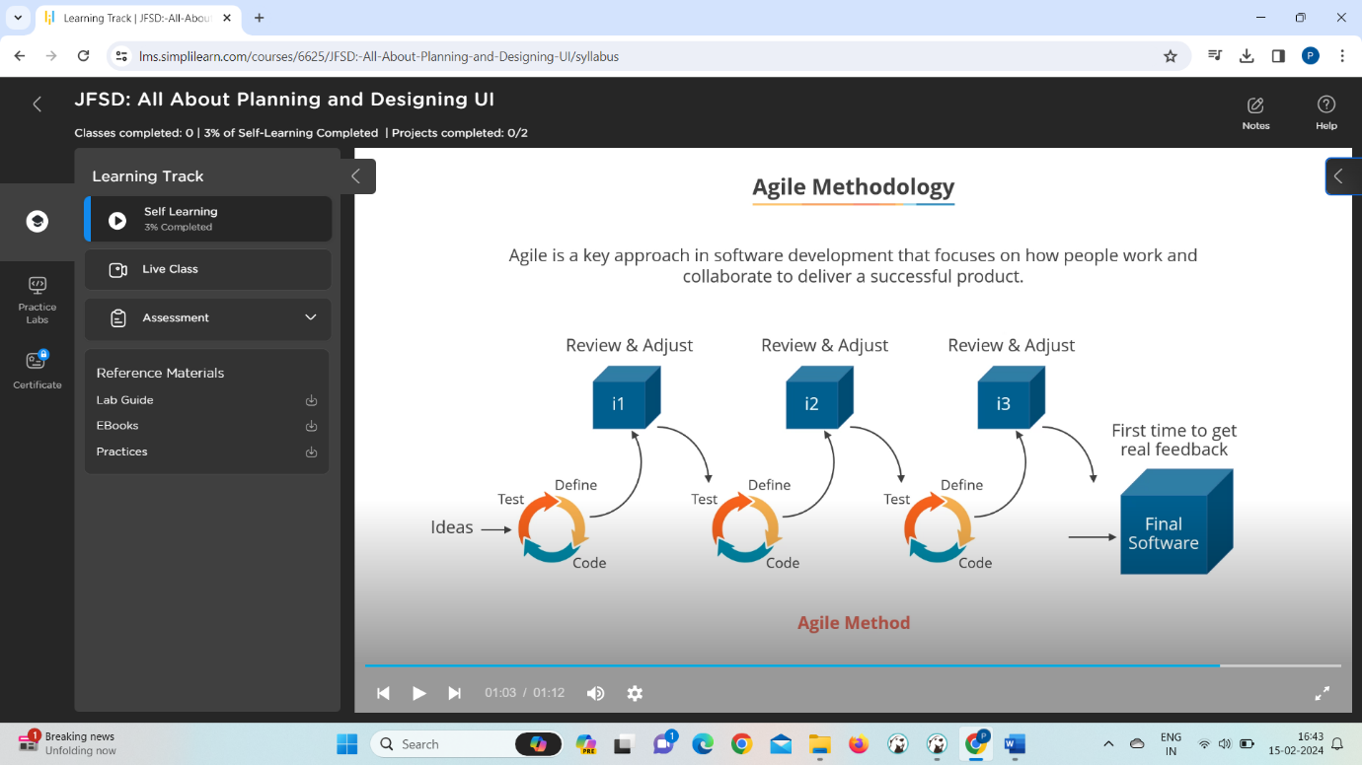

Principles:

Customer satisfaction

Changing requirements

In time delivery

Collaboration: scrum master, project owner and developers should collaborate during the

Project dev phase

Motivating team members

Exchange information

Maintaining const phase

Measuring progress

Monetering