Angular:

It is js framework

Developed by google

It is written in typescript

Single page application

Required software:

Node JS

Angular CLI(command line interface)

Vs code

Commands:

node -v

ng --version (if not installed give below command)

npm install -g @angular/cli

npm config delete proxy

npm config delete https-proxy

E:\Demo Angular>ng new demo

Component:

Html+css+js+testcases

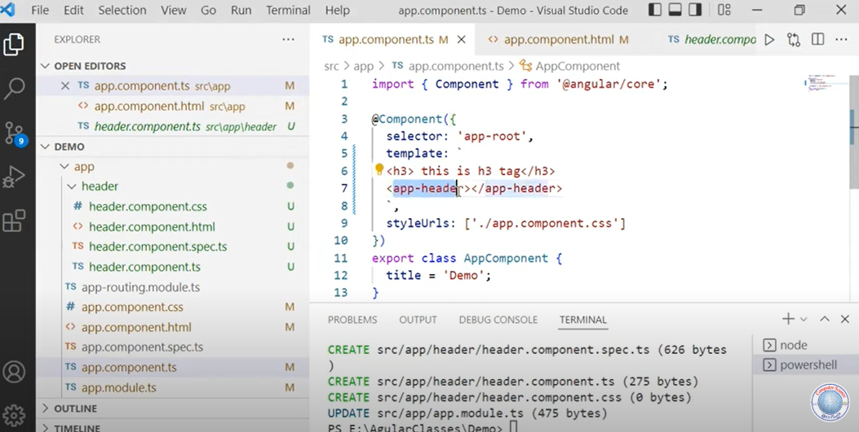

Project structure:

.vscode->contains vs code connections

Node_modules->all librieries of node

Src-> contains default module i.e app module

Assets->we can place images etc

Environments->we can specify the details of configurations,server details

Main.ts->which module should be executed can be decided here

Polyfills.ts-> when we click on ngserve it will convert that to the javascript. To convert to js which are the settings needed can be provided in polyfills

DataBinding:

The communication between ts and html file.

Oneway db:

Passing data from either one to one file is called one way db.

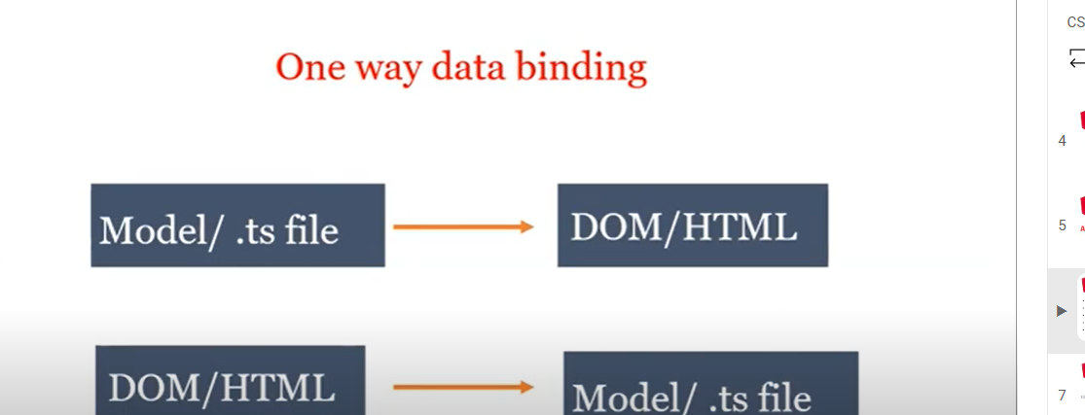

Two way db:

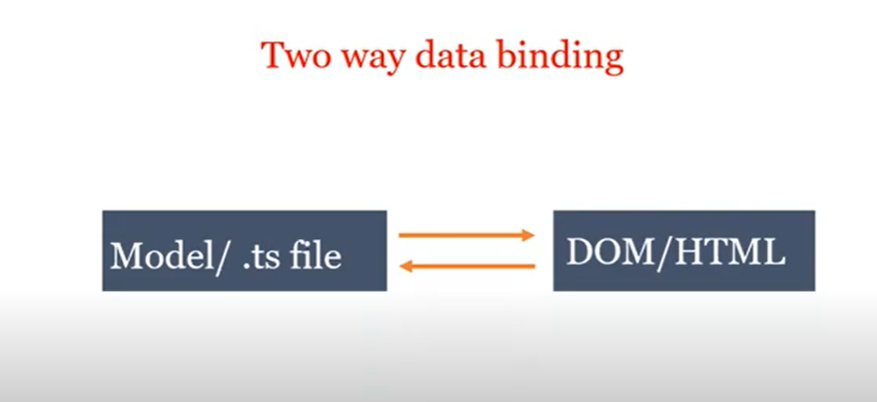

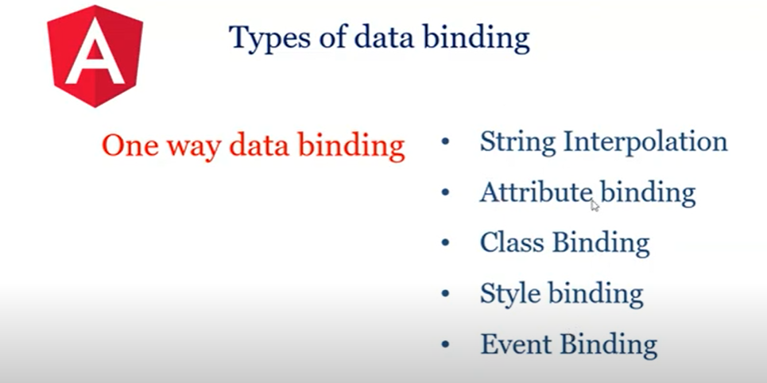

Component.html:

<h1>ram</h1>

{{items.length}}

<div *ngFor="let item of items">

    {{item.wishlist}}

</div>

<div class="container" >

    <input type="text" name="new-wish-text" [(ngModel)]="newWishtype">

    <button type="submit" (click)="addNewWish()">submit</button>

    <div *ngIf="items.length===0; then noItems else showItems"></div>

    <ng-template #noItems>

        There is noItems to Display1.

    </ng-template>

    <ng-template #showItems>

        <ul class="wish-list" type="none">

            <li *ngFor="let item of items;index as ii" >

                <div class="form-check">

                    <label class="form-check-label">

                        <input class="checkbox" type="checkbox" [attr.data-index]="ii" [checked]="item.flag" (click)="toggleItem()">{{item.wishlist}}

                    </label>

                </div>

            </li>

        </ul>

    </ng-template>

</div>

<h1>String Interpolation examples</h1>

<h1>{{title}}</h1>

<h1>{{city}}</h1>

<p class={{cname}}>green</p>

<p>{{date}}</p>

<p>{{date1}}</p>

<p>{{date2}}</p>

<p>{{date3}}</p>

<p>{{date4}}</p>

<h1>property binding examples</h1>

<p [class]=cname>property demo</p>

Name:<input type="text">

<button [disabled]=flag1>submit</button>

<button [disabled]=flag2>submit</button>

<input type="text" [hidden]=flag1>

<input type="text" [hidden]=flag2>

<button [disabled]=flag2>submit</button>

<h1>class binding examples</h1>

<h1 [class]="isactive?'active':'inactive'">Ramcharan</h1>

<p [class]="{c1:flag3,active:isactive}">Pawan Kalyan</p>

<h1 [class]="['c1','active']">Chiranjeevi</h1>

<h1>style binding</h1>

<h1 [style]={color:color1}>Sai</h1>

<h1 [style]="ram">bheem</h1>

---------------------------------------------------------------------------------------------<br>

<h1>Event binding</h1><br>

<button type="button" (click)="increment()">Increment</button><br>

<br>

<button type="button" (click)="decrement()">Decrement</button><br>

{{count}}

<br>

Name:<input type="text" (input)="in($event)"><br>

{{name}}<br>

<input (keyup)="onKeyUp($event)">

<p>{{text}}</p>

City:<input type="text" [(ngModel)]="City"><br>

<p>{{City}}</p>

<button (click)="updateCity()">update</button>

-------------------------------------------------------------------------------------------

<h1>ngIF Ways</h1>

<h1 *ngIf="0">This is heading</h1>

<h1 *ngIf="1">This is heading1</h1>

<h1 *ngIf="'ram'">This is heading2</h1>

<h1 *ngIf="!Data">loading</h1>

<h1 *ngIf="Data">{{Data}}</h1>

<h1 *ngIf="!ifflag2;else sample2">False using if else</h1>

<h1 *ngIf="!ifflag2; then sample1 else sample2">False using if else</h1>

<ng-template #sample1>

    <h1>flase flag</h1>

</ng-template>

<ng-template #sample2>

    <h1>true flag</h1>

</ng-template>

<h1>NGFOR SAMPLE</h1>

<div *ngFor="let ele of arr1">{{ele}}</div>

<table border="1">

    <tr>

        <td>id</td>

        <td>name</td>

        <td>price</td>

        <td>ram</td>

        <td>storage</td>

    </tr>

    <tr *ngFor="let e of mobile">

        <td>{{e.id}}</td>

        <td>{{e.name}}</td>

        <td>{{e.price}}</td>

        <td>{{e.ram}}</td>

        <td>{{e.storage}}</td>

    </tr>

</table>

<h1>NGSWITCH</h1>

<input type="text" [(ngModel)]="operator">

{{operator}}<br>

<div [ngSwitch]="operator">

    <div *ngSwitchCase="'+'">{{num1}}+{{num2}}={{num1+num2}}</div>

    <div *ngSwitchCase="'-'">{{num1}}-{{num2}}={{num1-num2}}</div>

    <div *ngSwitchCase="'*'">{{num1}}*{{num2}}={{num1*num2}}</div>

    <div *ngSwitchCase="'/'">{{num1}}/{{num2}}={{num1/num2}}</div>

    <div *ngSwitchDefault="'+'">gibe in +,-,*,/</div>

</div>

<h1>pipes</h1>

<h1>{{pipestr|uppercase}}</h1>

<h1>{{pipestr|lowercase}}</h1>

<h1>{{pipestr|titlecase}}</h1>

<h1>{{pipecurr|currency}}</h1>

<h1>{{pipecurr|currency:'INR'}}</h1>

<h1>{{obj5|json}}</h1>

<h1>{{date1}}</h1>

<h1>{{date1|date}}</h1>

<h1>{{date1|date:'dd'}}</h1>

<h1>{{date1|date:'dd/yyyy'}}</h1>

<h1>{{date1|date:'dd/yyyy/MM'}}</h1>

<h1>{{date1|date:'dd/MM/yy'}}</h1>

<h1>{{date1|date:'dd/MM/yyyy'}}</h1>

<h1>{{val|percent}}</h1>

<h1>{{pipestr|slice:0:8}}</h1>

App.component.ts:

import { Component } from '@angular/core';

import { WishItem } from './sharable/wishtem';

@Component({

  selector: 'app-root',

  templateUrl: './app.component.html',

  styleUrl: './app.component.css'

})

export class AppComponent {

  title = 'my-first-app';

  items=[new WishItem("ram is first"),new WishItem("bheem is second",true),new WishItem("raj is third")];

  toggleItem() {

    console.log('clicked');

  }

  newWishtype='';

  addNewWish(){

    this.items.push(new WishItem(this.newWishtype));

    this.newWishtype=''

  }

  city:string="DELHI";

  path:string="download.jpeg";

  cname:string="special";

  date:Date=new Date();

  date1:any=new Date().toDateString();

  date2:any=new Date().toLocaleDateString();

  date3:any=new Date().toLocaleTimeString();

  date4:any=new Date().toLocaleString();

  flag1=true;

  flag2=false;

  isactive=true;

  flag3=true;

  color1='green';

  color2='yellow';

  ram = {

    color: "red",

    background: "yellow",

  };

  count=0;

  name="xyz";

  increment(){

    this.count+=1;

  }

  decrement(){

    this.count-=1;

  }

  in(e:any){

    this.name=e.target.value;

  }

  text="xyz another";

  onKeyUp(e:string){

    this.text="key pressed";

  }

  City="hyderabad";

  updateCity(){

    this.City="bangalore";

  }

  Data="ram";

  ifflag1=true;

  ifflag2=false;

  arr1=[1,2,3,4,5,6,7,8,9,10]

  obj5={

    a:"apple",

    b:'bat',

    c:'car'

  }

  mobile=[{id:1,name:'one plus yash',price:525000,ram:'8gb',storage:'128gb'},

    {id:2,name:'Samsung',price:325000,ram:'6gb',storage:'128gb'},

    {id:3,name:'Lava',price:125000,ram:'4gb',storage:'128gb'},

    {id:4,name:'Micromax',price:125000,ram:'16gb',storage:'128gb'}

  ]

  operator=''

  num1=10;

  num2=4;

  pipestr="I am KING of MY life"

  pipecurr=67787;

  val=0.98

}