Given database design (BMS)

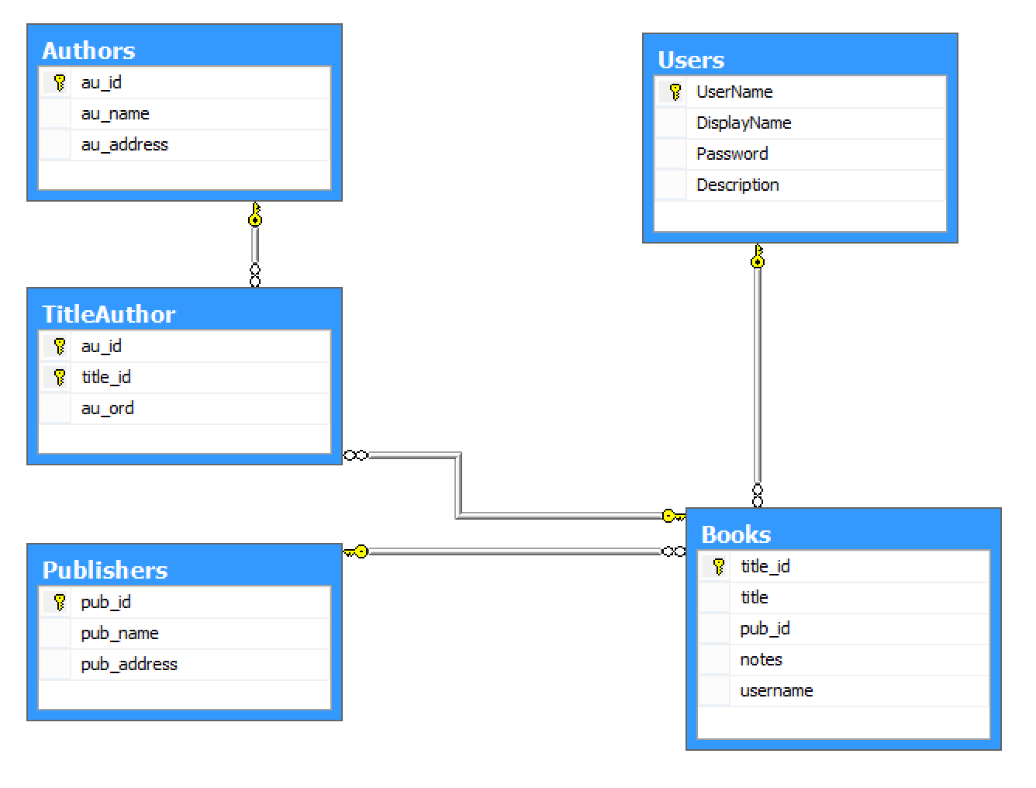

**Starting your coding:**

1. Check out the structure of our project (this one is given to you)**,** there are some packages:

* **com.context**: contains code for open database connection
* **com**.**controller**: controller layer which receive requests/commands from users and use needed classes/packages to get the result and return to the view
* **com**.**dal**: work directly with database, including some operations like insert/delete/update and select
* **com.entity:** contains some entities of our problem like Book, Author, Publisher…
* **com.ui:** this is the view, it use to output data/result to users.

Let starts coding these packages

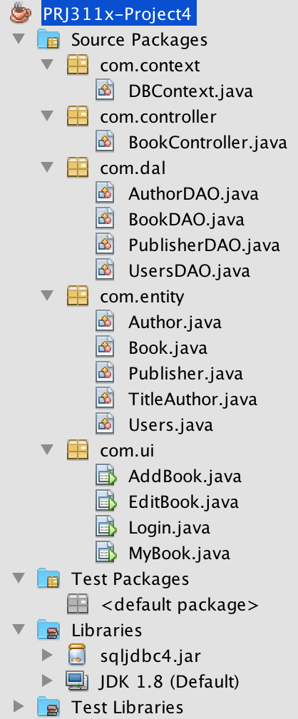

1. Finally, enjoy your code. We expect to have application with data flow as below.
2. Login to system first

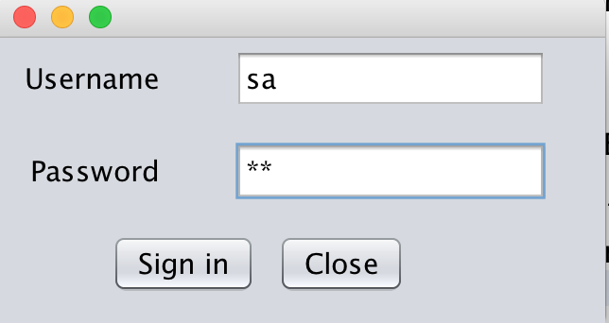

7.2 Start the main form if the login is valid

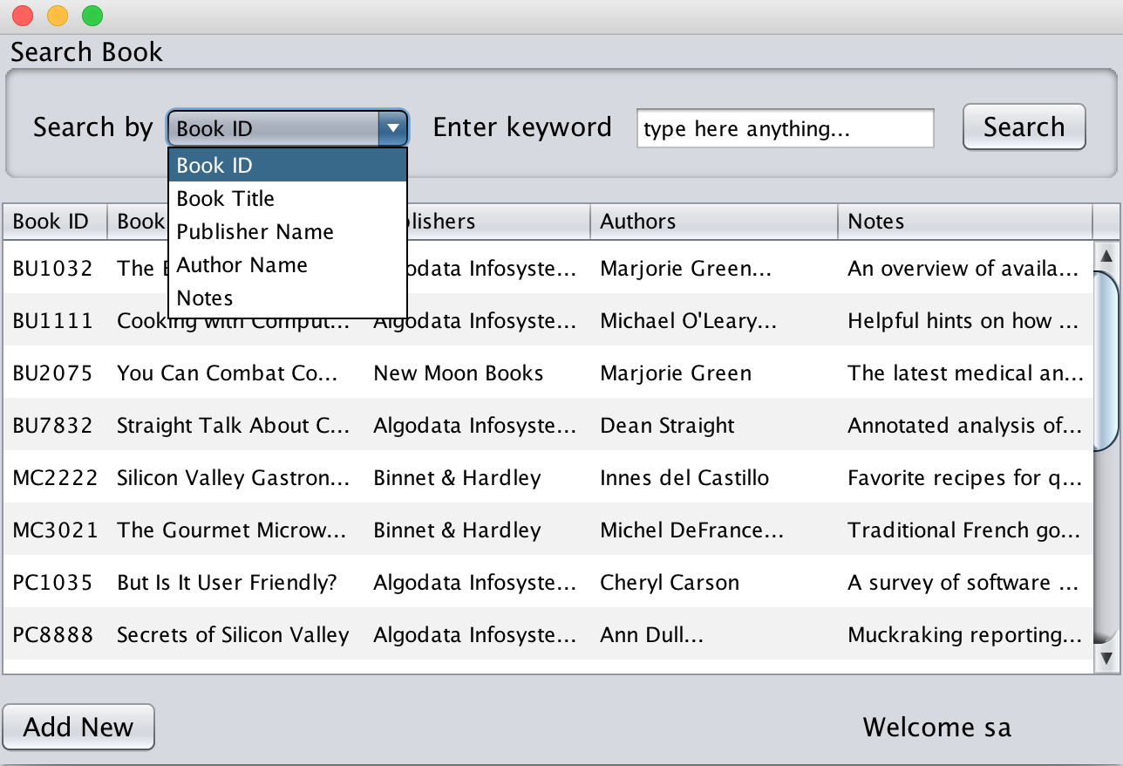

By default, output information of all Books in the system, users are allowed to search any book by different criterial like Book ID, Book Titlte, Publisher Name…

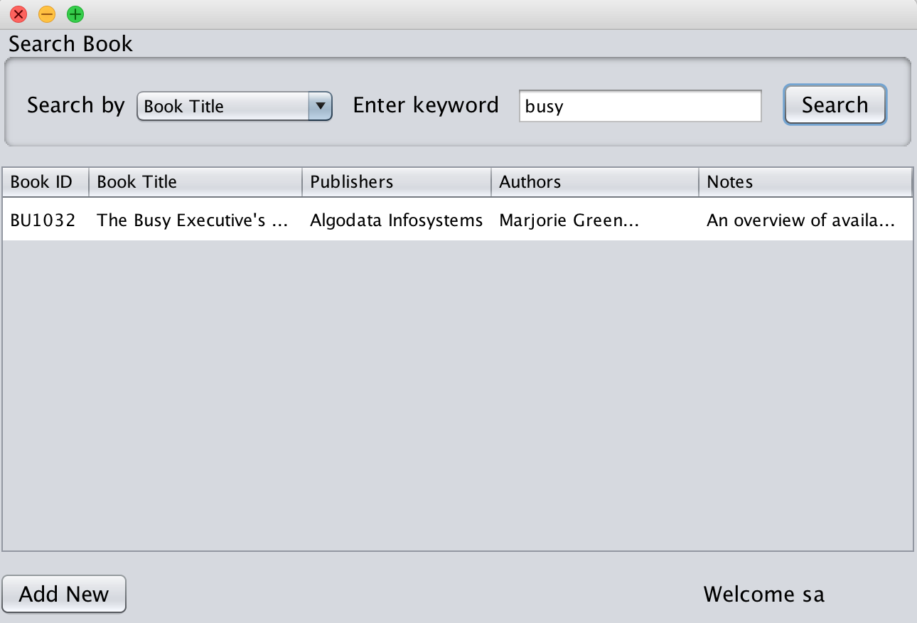

7.3. To insert a new Book, click on button “**Add new**”

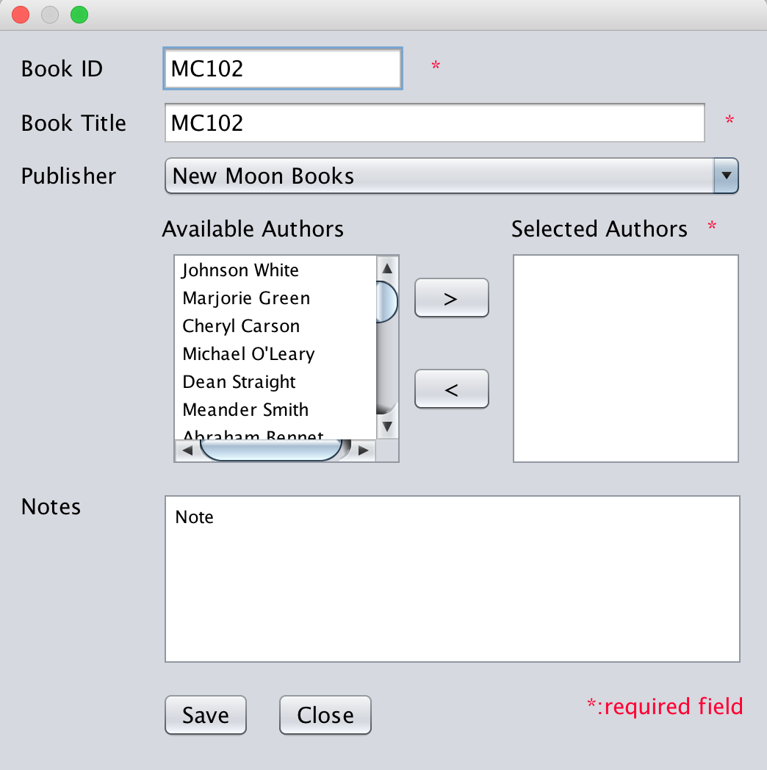

**Requirements**:

* Load all publishers to dropdownlist, output publisher name
* Load all authors to left list, output author name
* Users can select any authors from left list and add to right list, just to say that these authors are written entered book.
* When users enter information for book and click save, make sure that all required fields are valid and insert that book to our database – Since a book is written by many authors, you need to consider your insertion code (make sure that you will insert into 2 tables).
* After your insertion, you need to update the list of all books to be able to see the inserted one.
* To close the insertion form, just click on “**Close”** button

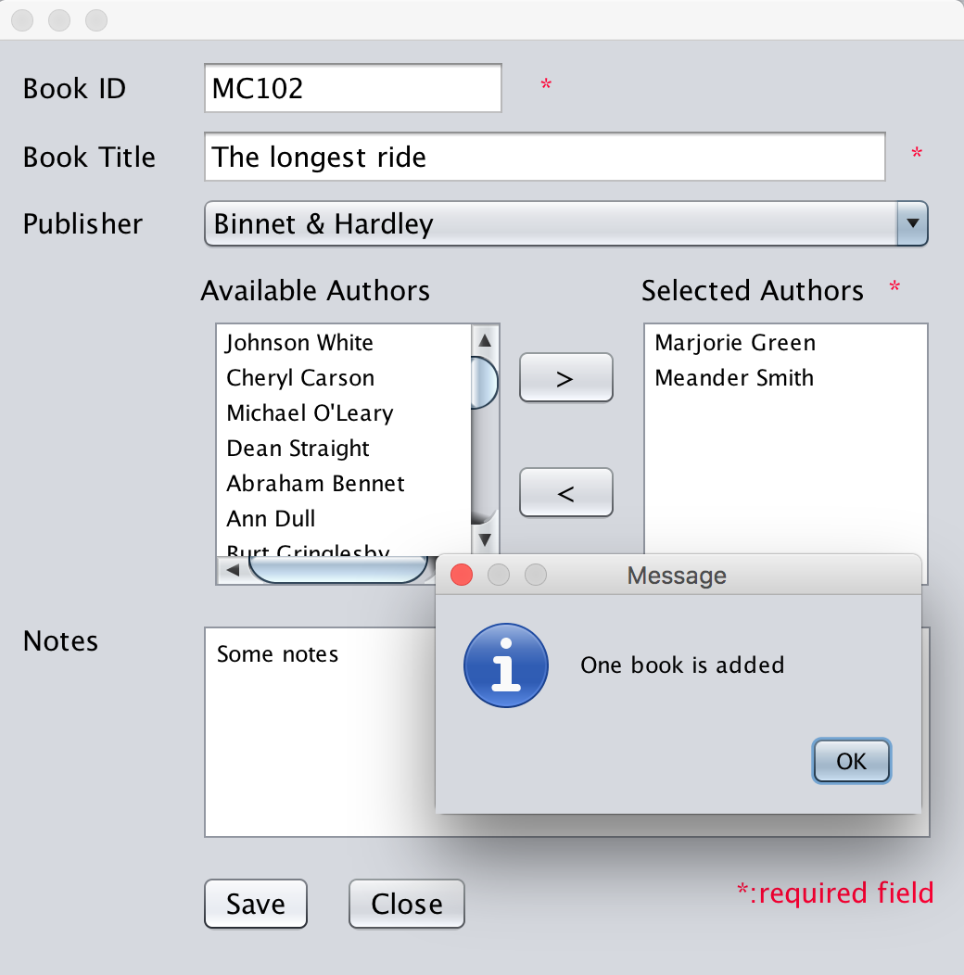

7.4. To view information of a Book or Update or Delete a Book, firstly select a book from the list and double click on it, a new window is opened and output information of selected book

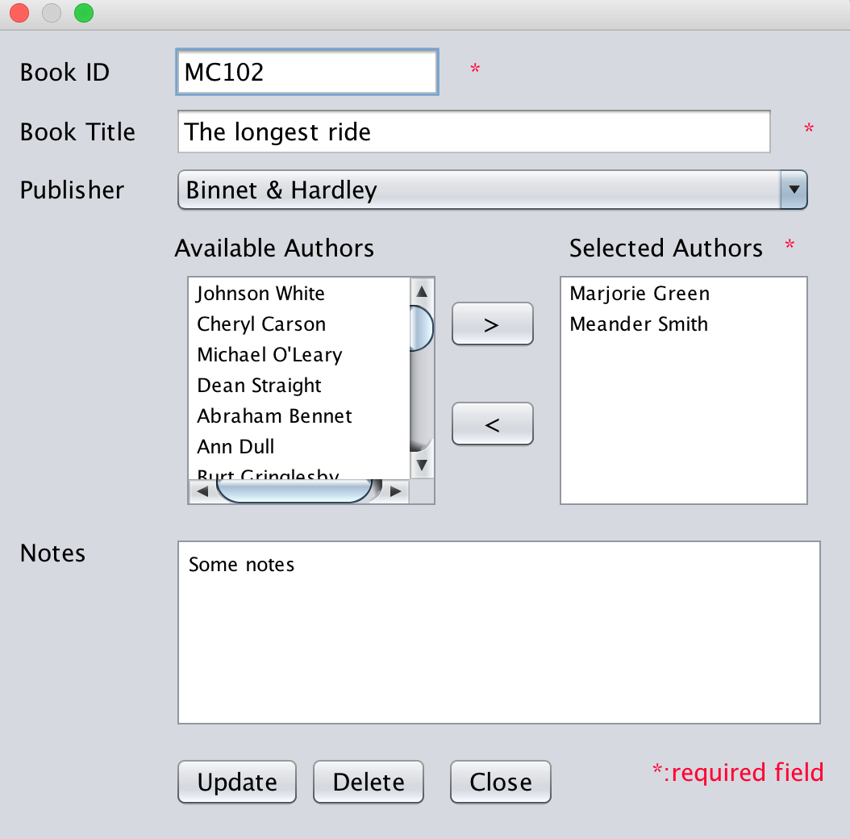

Now you can view, update information of selected book or just delete that book, remember to confirm to users before your deletion.

1. **You are free to add more classes/methods/interface (if needed).**