Long Lin

<https://github.com/superironpanda/Question4SE>

Code:

Main.java

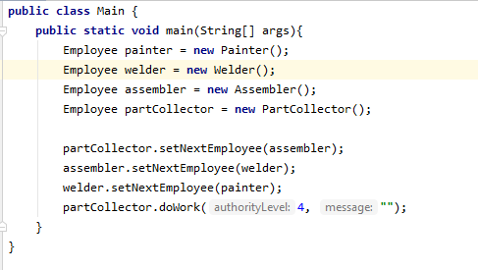

Employee.java

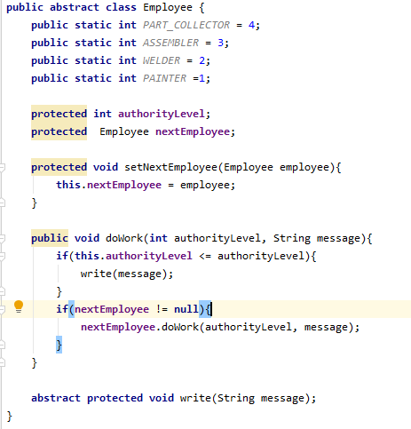

PartCollector.java

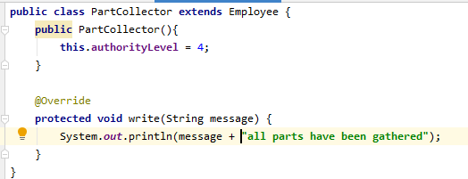

Assembler.java

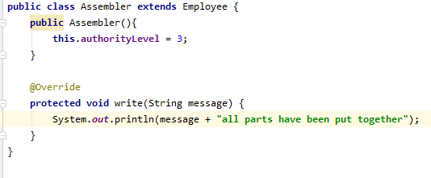

Welder.java

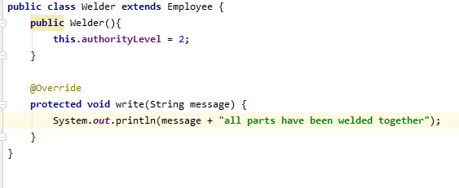

Painter.java

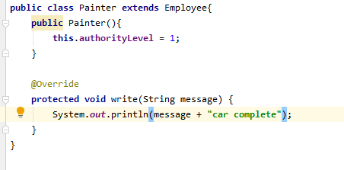

Output:

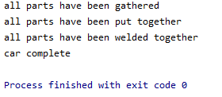

In this question, the Employee abstract class is given, I have implemented 4 classes that extends the Employee class with constructors that sets the authority level for each task, and printing out corresponding message when each concrete Employee is called from the line doWork() with 4 and an empty string as the parameter from the beginning of the chain, partCollector.

In the main function, I instantiated all 4 types of employees, and set the next employee on each one of them except the last one, Painter, since that’s the last step of the chain.

From partCollector, it will print out what is has done, then move to the next employee and the next employee do the same thing over and over until no more employees needed.