BENDY v0.99

CORPTRON GAMES CORP 2024

Updated Nov 22nd, 2024

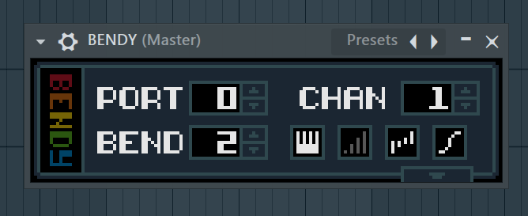

BENDY is a simple native FL Studio plugin created to allow Third Party VST plugins and external Synthesizers to use Piano Roll bends/panning. It supports virtually any VST/Synthesizer, as long as the instrument supports pitch bend or panning.

**Back up your projects and save often! This plugin is still in development! Please send any issues to superjoebob@hotmail.com**

# Installing

Installing BENDY is so easy to do. Just double click 'install_bendy.exe' (you may have to run as administrator):

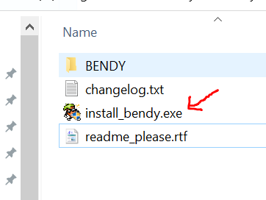

This should automatically install the plugin into FL Studio, and if it works, you will get a message like this:

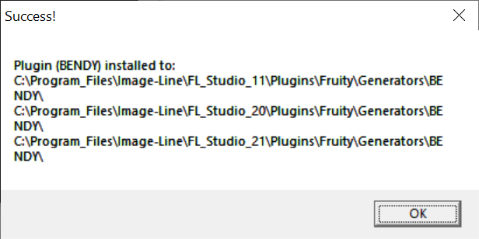

If it *does not* work for some reason, or if you have multiple versions of FL Studio and it's not appearing in the one you use, don’t worry! You can install it manually.

1. Open up your FL Studio plugins folder (<FL Studio Install>\Plugins\Fruity\Generators)
2. Create a new folder in there called BENDY
3. Copy BENDY.dll and BENDY_x64.dll into it.

You should now be able to launch FL Studio and find BENDY in the plugin browser.

*Note: If you don’t want the new version of BENDY to replace the old one, just install manually and rename the folder and the DLL (Including the _x64 if necessary): Generators\BENDY_NEW\BENDY_NEW_x64.dll*

# How To Use

Using BENDY is meant to be easy! BENDY works as a delegate, and sends MIDI data to your VST/Synthesizer similar to FL's MIDI OUT plugin. If you've ever controlled an external synthesizer via FL then you've probably already used MIDI OUT. These screenshots are using FL Studio 20, but the process remains the same in FL 10/11/12/24 etc.

To start, create a new project in FL Studio and add an instance of the BENDY plugin. Next, add an instance of your favorite VST or plugin your synthesizer to a MIDI port:

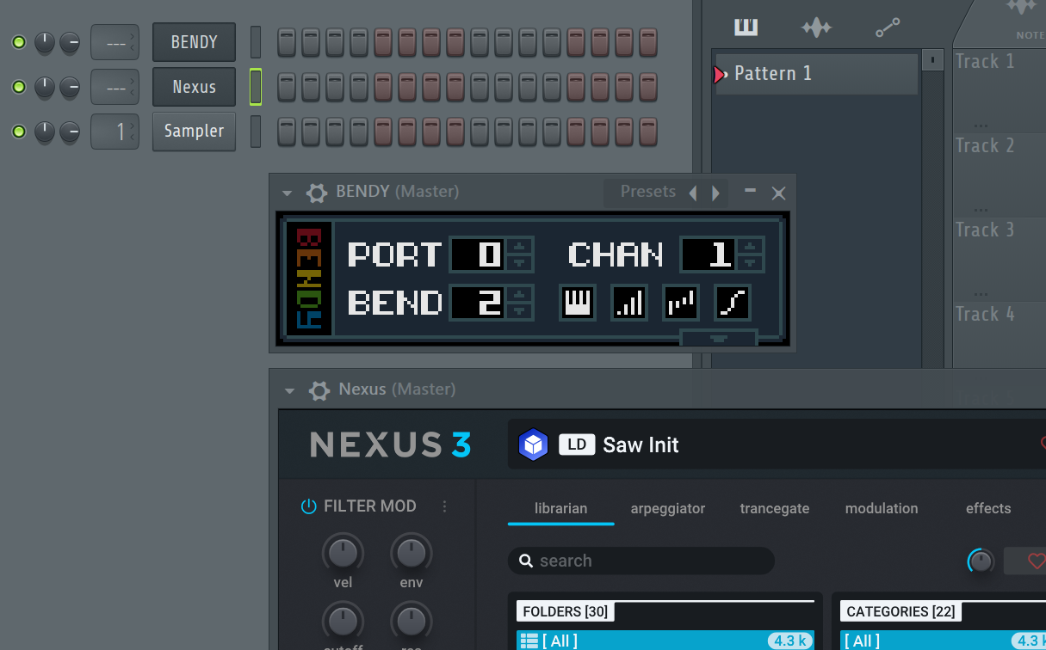

In order for BENDY to communicate with your VST, its MIDI input port must be set to the same port displayed in the BENDY UI. To set the input port, press the gear in the top left corner of your VST window:

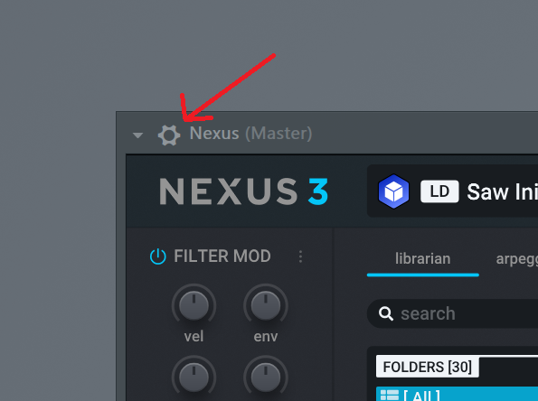

Next, set the 'Input port' parameter to '0' (or to whatever Portvalue you have set in BENDY):

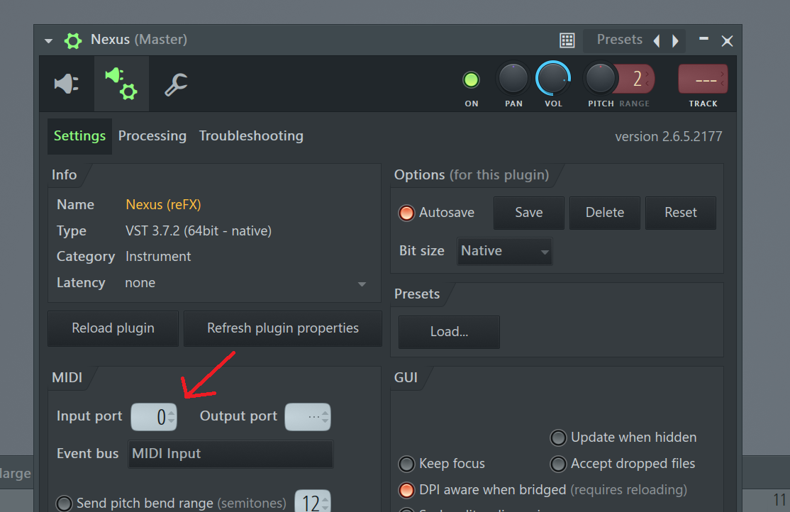

And that's it, for starters! You should now be able to play notes into BENDY, or enter them through BENDY's Piano Roll and the VST will respond and play the same notes. In most plugins, you should now be able to do Piano Roll note panning, as well as Piano Roll note bends one whole tone up or down from the original note. You may need to adjust BENDY's BEND parameter to have bends work properly, and you may need to adjust your VST/Synth to get the most out of it. We cover this in the next section, *Configuring Pitch Bend Range*.

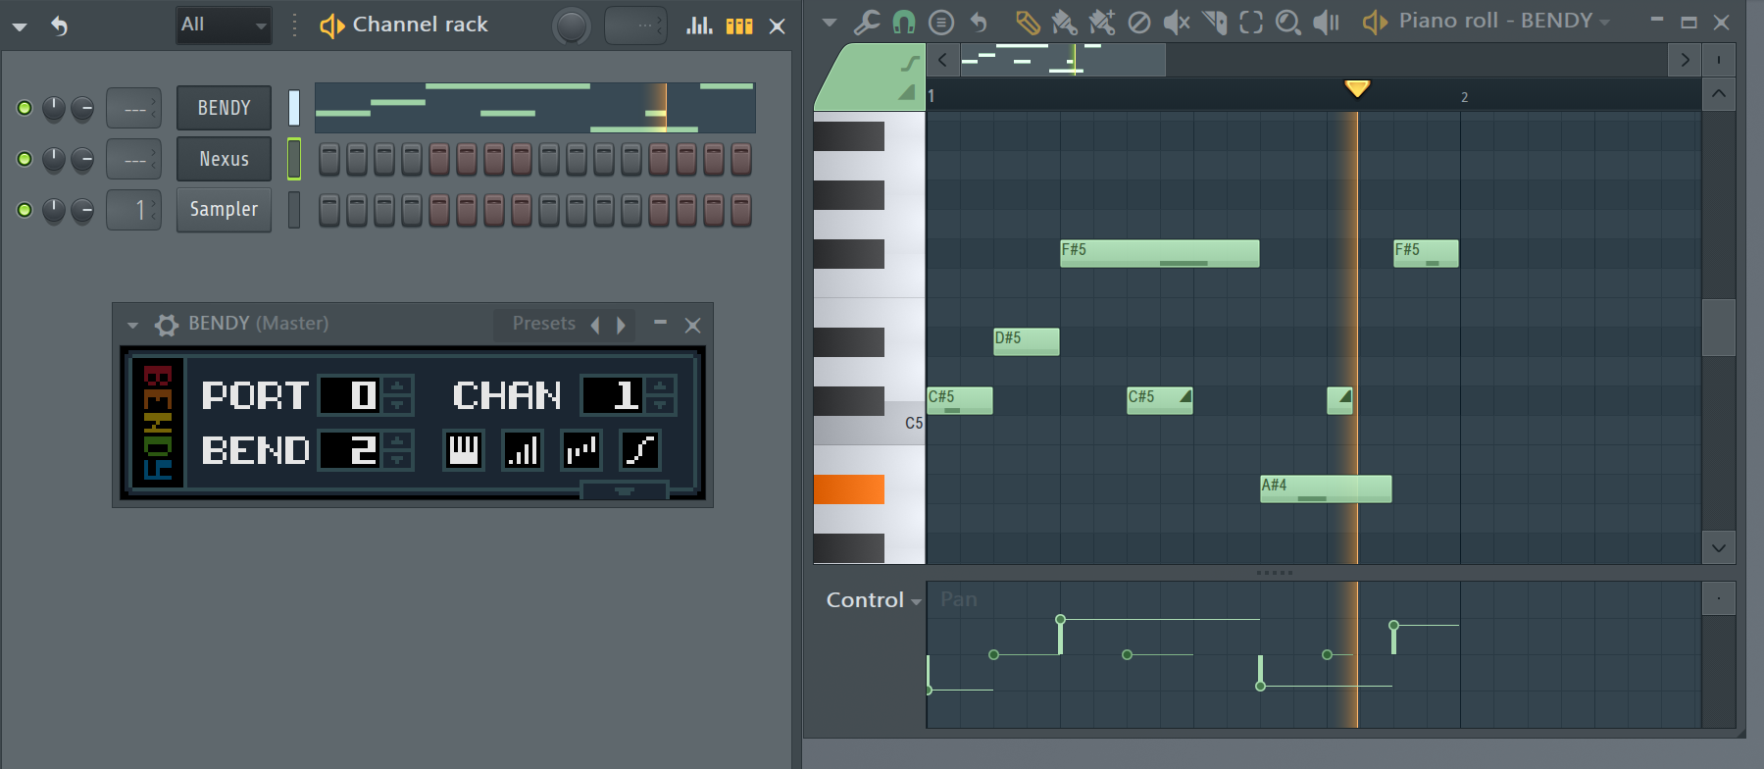

Note: Do not play notes into your plugin, play them into BENDY!

Note: Read the next section to get the most out of this plugin!

# Configuring Pitch Bend Range

You may notice that the notes don’t slide to the correct pitch. In order for BENDY to work correctly, you may need to adjust the BENDparameter to match the Pitch Bend Range setting in your VST/Synth if the bend range message that BENDY sends isn’t supported by the plugin. If you want to do larger bends, you may also want to increase the bend range of your VST/Synth.

Most VST/Synthesizers will have their own way to configure their pitch bend ranges. How it's done from thing to thing will vary, and you'll have to figure out how this works with your plugin. As an example, here's what Refx's NEXUS plugin looks like when it's configured for one whole octave of note bending in BENDY:

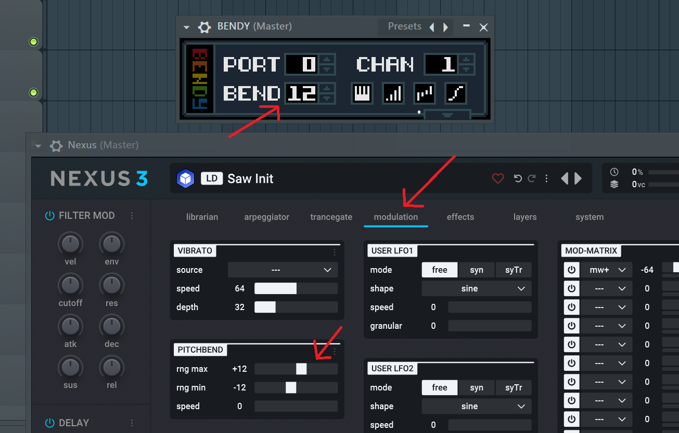

Also recommended when configuring a plugin for use with BENDY, is to set the Pitch bend speed value to be as high as possible. Some plugins may have a setting like this and some may not. Here's how you do it in NEXUS:

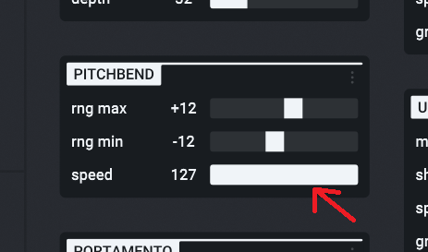

If you don't set the speed, you may find that notes played after doing a bend might make a bit of a quack while their pitch value interpolates back to zero.

# Controlling MIDI CC Values

If you press the little arrow at the bottom of BENDY, a bunch of new settings will appear. These can be used to send MIDI CC messages to your plugin for controlling things like filter cutoffs, instrument numbers, etc. This is very similar to FL Studio's built in MIDI OUT plugin, but BENDY comes with the advantage of having a few presets on hand and one ASDR style envelope layout. Here's what it looks like with the built-in Nexus preset selected: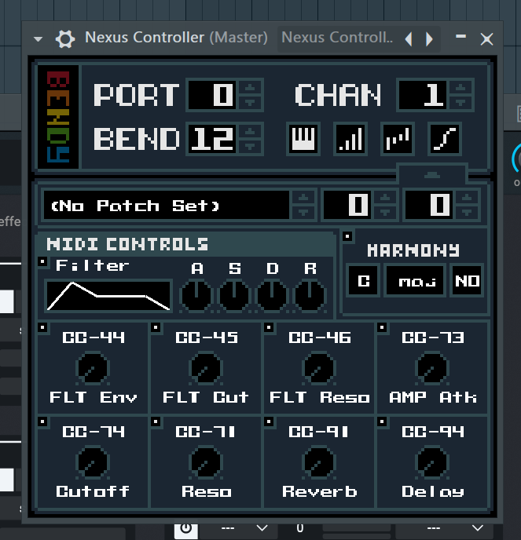

If you click the CC text, you can change the MIDI CC number that each knob uses. If you click the name below each knob, you can change it's label:

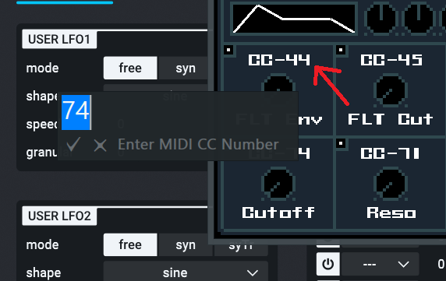

You can also change the CC values of the ASDR envelop knobs by clicking the letters A, S, D and R respectively:

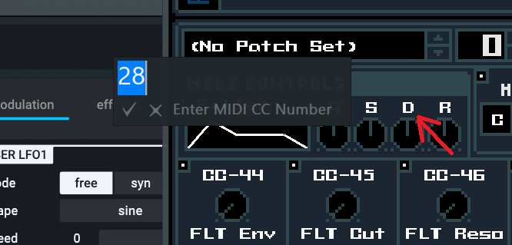

Note: BENDY does not currently support RPN or NRPN MIDI messages, sorry!

# Controlling External Synthesizers

There's really nothing special about using BENDY with a Hardware VS. Software synth. Just set the Portand Channelparameters to the values that correspond to the physical MIDI port that your synth is plugged into and you should be able to control via BENDY it as you would a VST.

# Assigning Note Controls

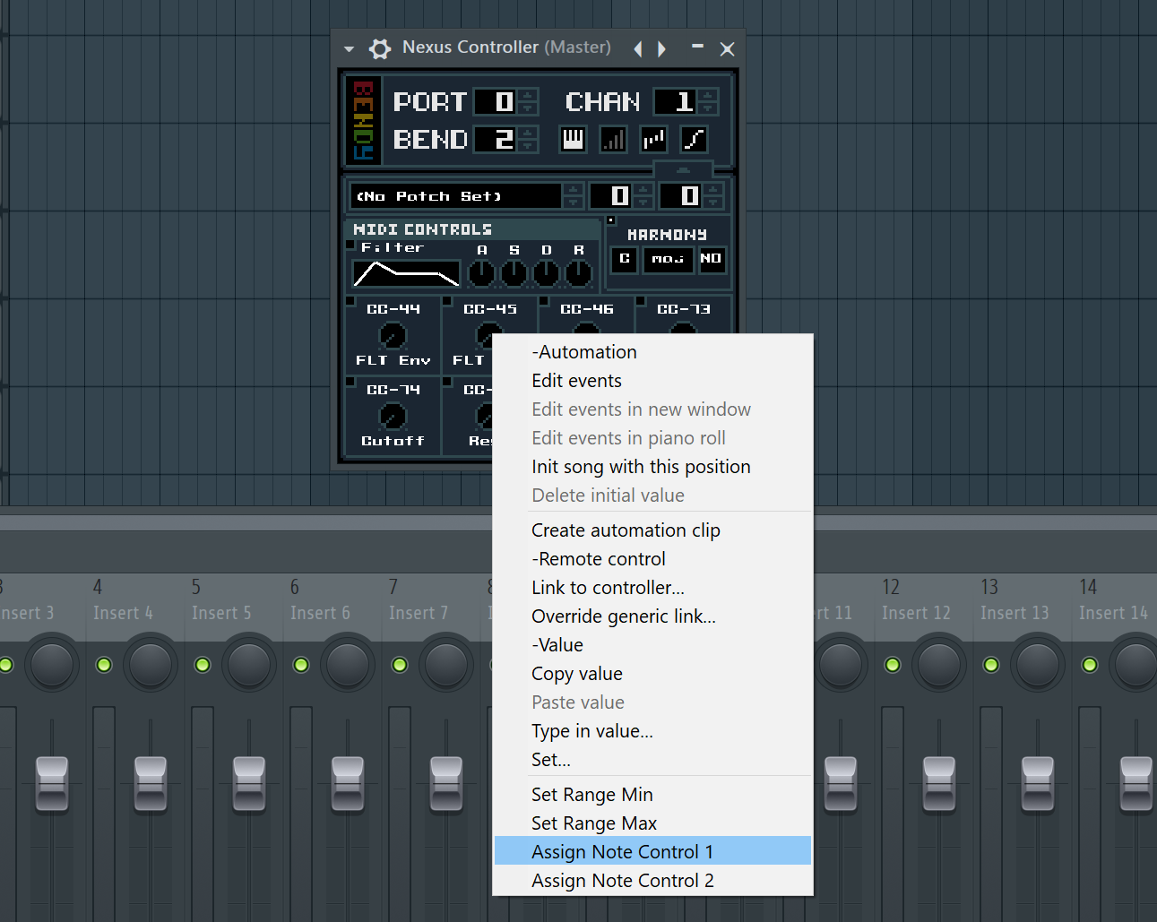

If you right click any control, you can assign it to either Note Control 1 or Note Control 2. Once assigned, you will be able to control that parameter on a per-note basis via the piano roll by selecting it from the Control dropdown:

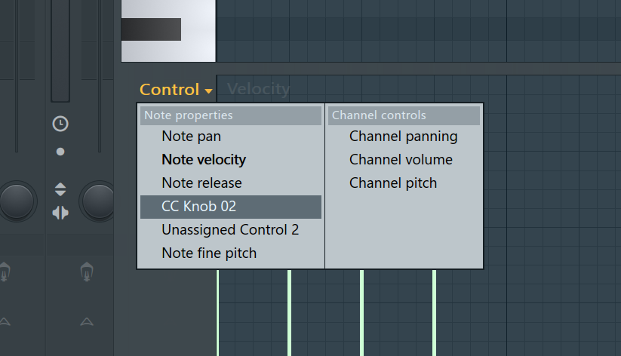

# Note Control Example – Vibrato

Let’s try using note controls to easily apply vibrato to notes using FL Studio’s piano roll slides. Open up BENDY and increase the vibrato SPEED parameter (around 1.4 is nice). Then, right-click the PITCH DEPTH knob:

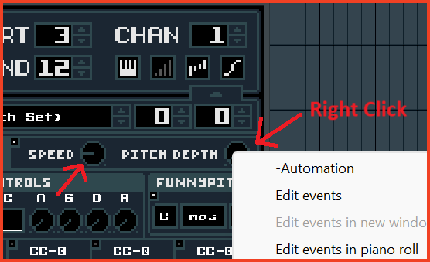

Now open up “Assign Note Control 1” and click “Assign Upper”. What this does is assign’s the top half of FL Studio’s Note Control parameter to control the Pitch Depth knob.

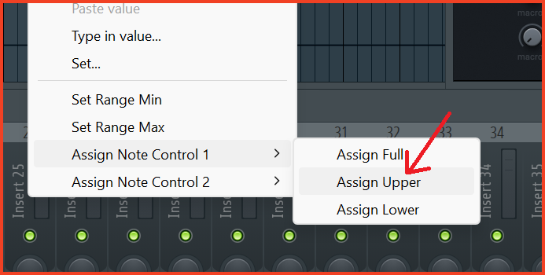

Now open up BENDY in the Piano Roll. In the bottom left, click “Control”, choose “Vibrato Pitch Depth” from the menu. If it says “Unassigned Control 1” you can open and close the piano roll and the name should refresh.

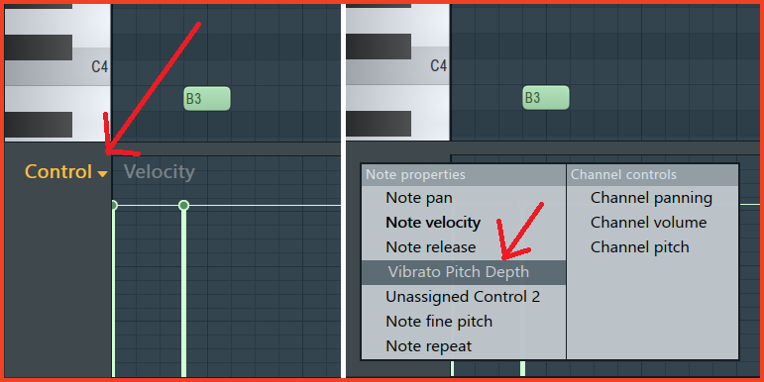

Finally, click in some notes. If you move the note control line over the middle it will apply vibrato to the note! If you want to slide smoothly in and out of vibrato, you can set the control value on a slide note just like you would with a pitch bend.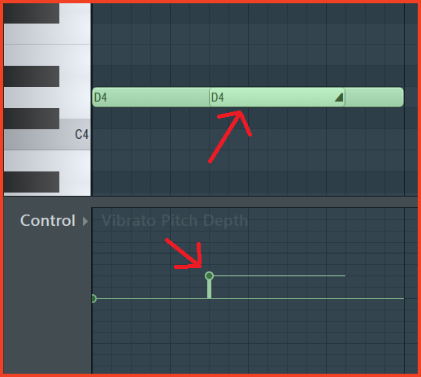

# Parameters

* PORT **–** The MIDI port that BENDY will output Notes/Pitch/Panning messages to.
* CHAN **–** The MIDI channel that BENDY will output Notes/Pitch/Panning messages to (this is usually best left at '1')
* BEND **–** The pitch bend range that your VST plugin is expecting, in semitones. Most plugins default to 2 which allows notes to bend up to one whole note (this plays nicely with pitch bend wheels on MIDI devices). If your pitch bends sound out of tune, try changing this number until the bends are in tune to figure out what your plugin's bend range is.

It's recommended that you figure out how to set a custom bend range in your plugin, and set it to as many full octaves as possible (BEND = 12, 24, etc.) to allow BENDY to take advantage of the maximum amount of bending range.

## Trigger Check Boxes

You can turn these different settings off if they aren't working properly with your plugin/synthesizer. You usually don't need to mess with these, but just in case:

## The Note button

Enables/disables whether or not MIDI notes are sent from the plugin. Disable this if you want to use MIDI OUT or some other tool to send the actual MIDI note data to your instrument.

## The Velocity button

Enables/disables per note velocity sensitivity overriding. Some VSTs/Synths respond correctly to MIDI note velocities, if you're using an instrument that responds to velocity sensitivity, you should leave this off. You probably want it off. It sends messages to adjust the global volume setting of the instrument for each note, which enables primitive velocity sensitivity for instruments that do not have it.

This, however, comes with a big caveat: If you play one note, then another overlapping note with a different velocity, the new velocity will overwrite the old one and make both notes play at the velocity of the last note played. This means you can't do chords/sustained notes with varying velocities per note when this button is enabled.

## The Panning button

Enables/disables per note piano roll panning. Midi doesn't support this out of the box, and BENDY can attempt to add it to any instrument. It has similar caveats to the Velocity button, as the panning is sent as a global MIDI messages that affects all notes on the same channel. This means if you play a Left panned note, then overlap it with a Right panned note, the Left note will instantly switch to the right channel as soon as the Right note plays. This is an unfortunate limitation of the way MIDI works, but you can get some pretty decent effects with this nonetheless.

## The Pitch button

Enables/disables piano roll pitch bending. Disable this if you want to bend the instrument's pitch on your own, but then... Why would you want to do that when you have BENDY? It's up to you, but you probably want to have this on.

## Harmony

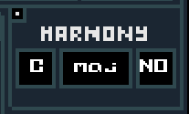

A simple harmonizer, this will sound like garbage unless you set the key correctly or use a full octave shift. Or maybe it will still sound like garbage anyway. The harmonizer needs work and may not be totally accurate. Sorry about that.

# Thank You!

Thanks for using BENDY, I hope you find it useful! This plugin is still in development, so expect to run into some quirks and make sure you **backup your projects** and **save often!** If you run into any issues, if the plugin is crashing all the time or if you have any feature requests please, either send me an email ([superjoebob@hotmail.com](mailto:superjoebob@hotmail.com)) Or, contact me on Twitter (@superjoebob) or Bluesky (@superjoebob.bsky.social).

## Credos

Landon Podbielski – Developer

Carlos "DYN.MIC" Mendonça – Manual Collaborator