**Content of Pre-survey analysis**

Table 1. pre- and post-course survey time distribution

|  |  |  |
| --- | --- | --- |
| Instrument | N | Average time |
| Pre-Course Survey | 372 | 0:06:09 (6 min 9 sec) |
| Post-Course Survey | 71 | 0:10:51 (10 min 51 sec) |

Figure 1 Time distribution in in the pre- & post-Course surveys.

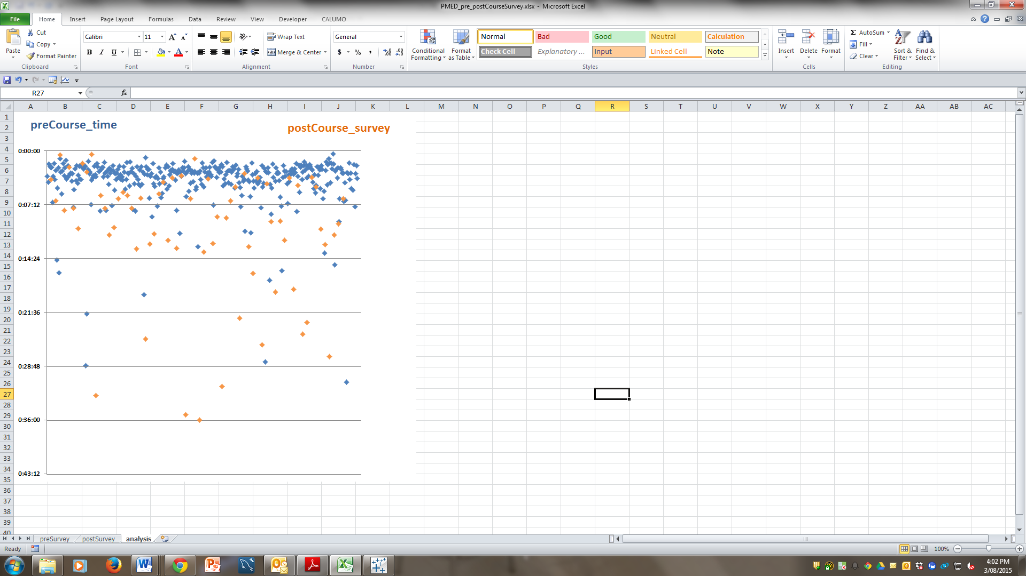

*Please note for post-course survey time distribution the three outliers are excluded for apparently the respondents forgot and left the window open for up to 10 hours.*

Figure 2a Pre-course survey respondents’ geo-locations

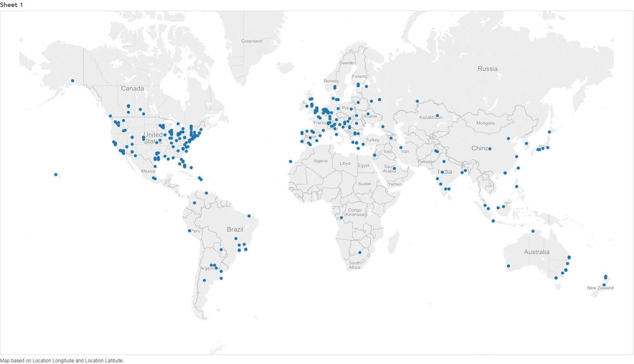

Figure 2b Post-course survey respondents’ geo-locations

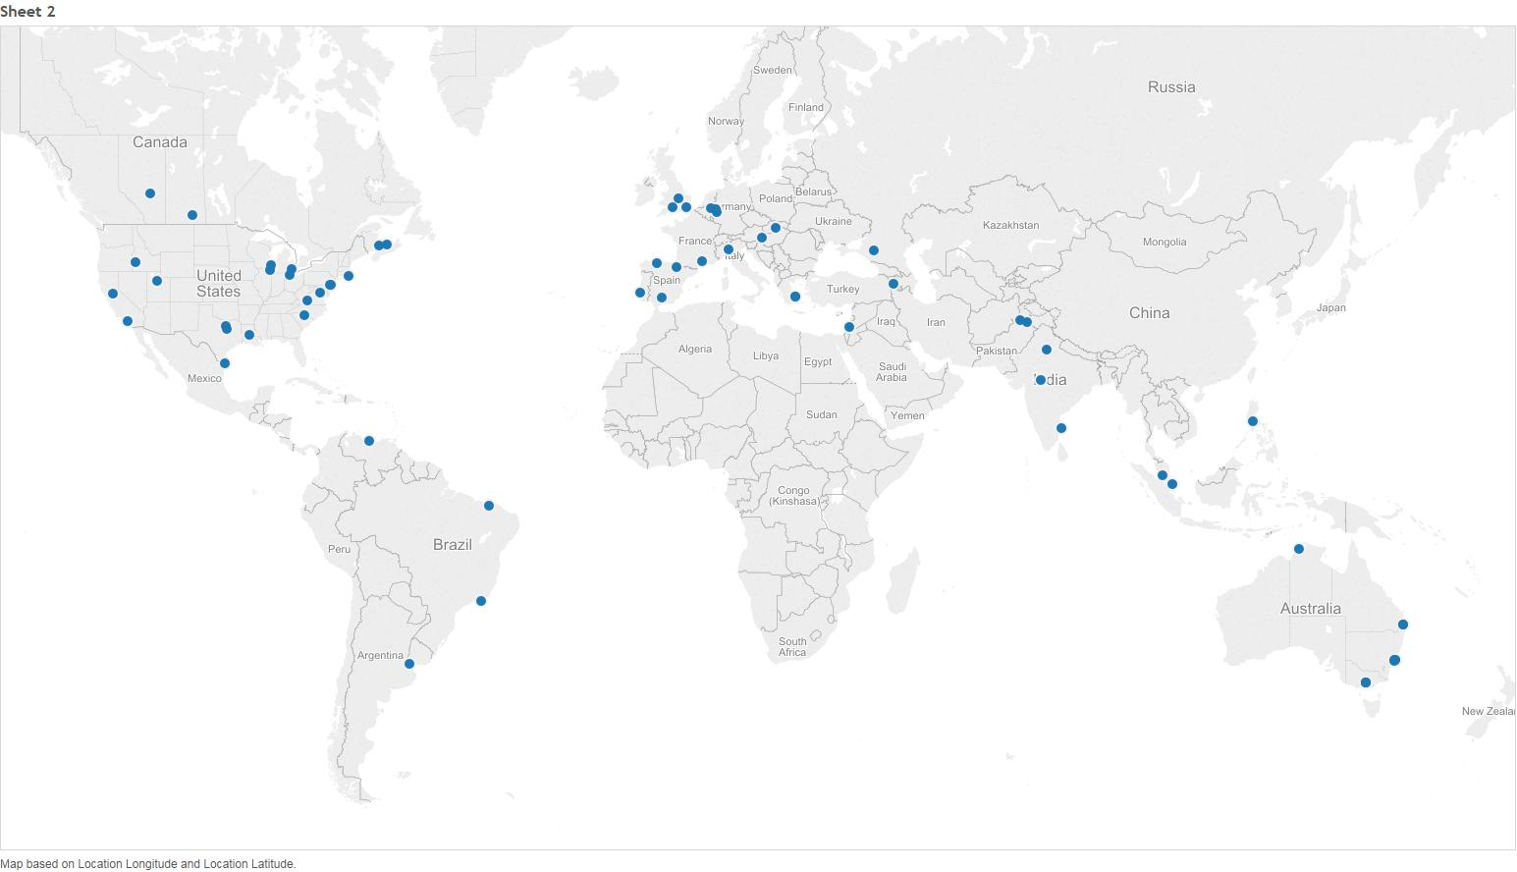

**Pre-Course survey**

**Q7 what are your intentions for the course**

Figure 3

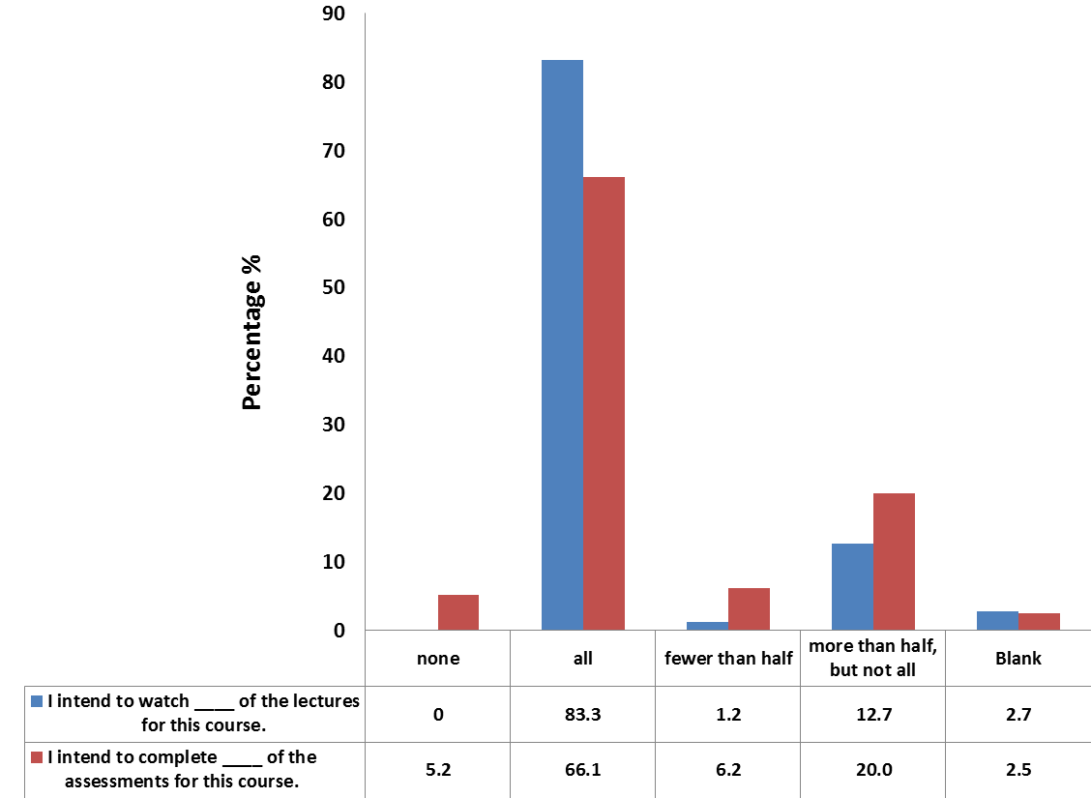

Table 2



**Q8 what is important to you about this course?**

Table 3 Ratings over items (%) with highlights of the highest % per item.



Figure 4 Rating Distribution (%)

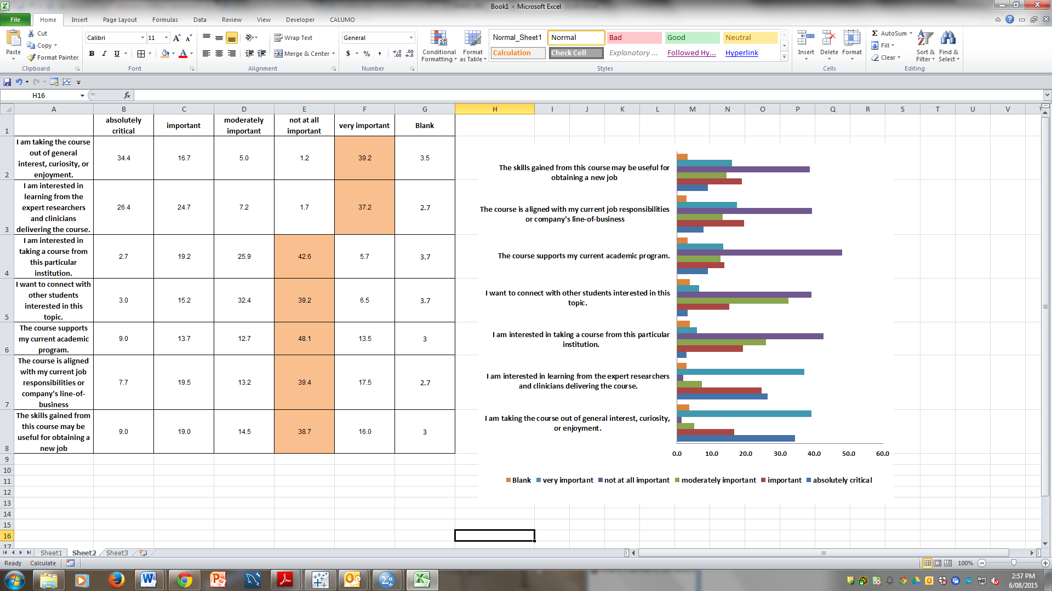

**Q9 Prior to taking this course, how familiar were you with the subject area of this course?**

Figure 5 Percentage distribution

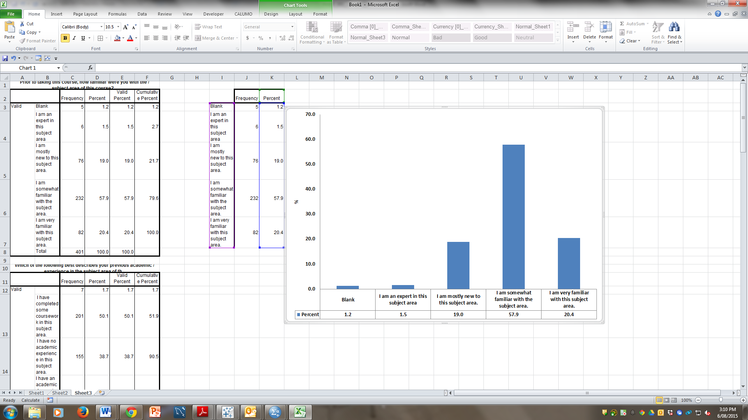

**Q10 & Q11 which of the following best describes your previous academic / work experience in the subject area of this course?**

Table 4 Percentage distribution



**Q12 what is your main reason for taking this course?**

Figure 6 Percentage distribution

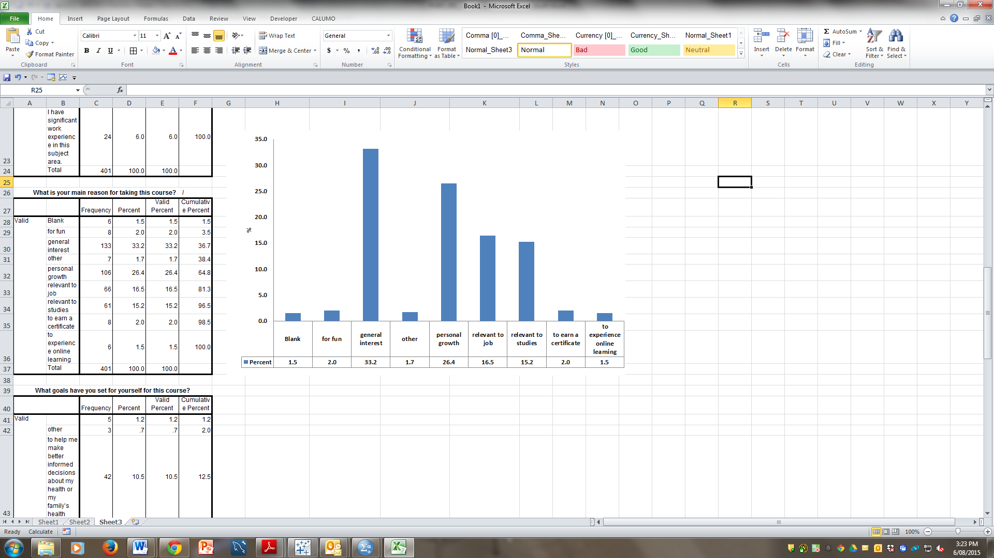

**Q13What goals have you set for yourself for this course?**

Figure 7 percentage distribution

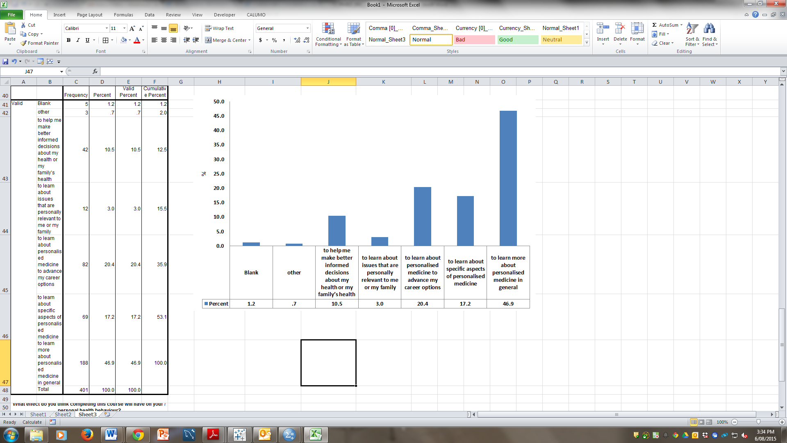

**Q14 What effect do you think completing this course will have on your personal health behaviour?**

Figure 8 percentage distribution

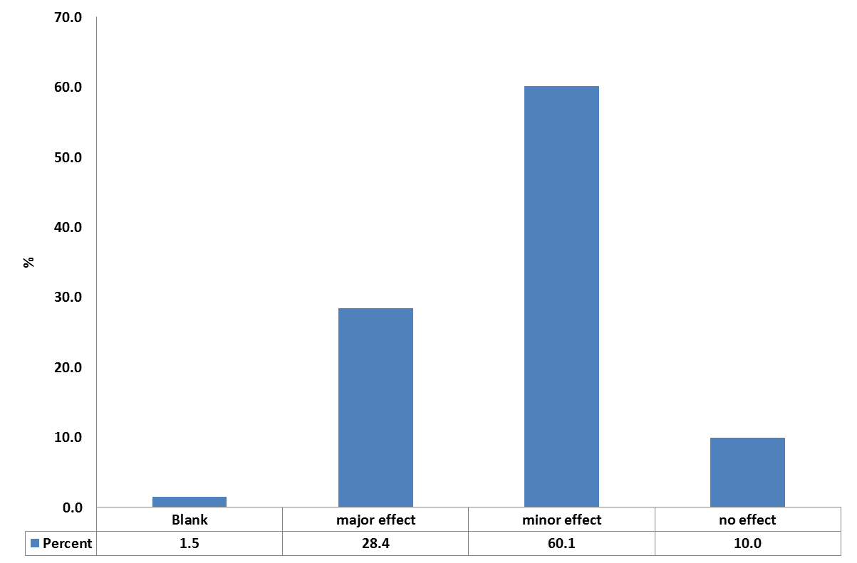

**Q15 How familiar are you with each of the following?**

Table 5a Rating per topic with highlight of the highest ‘pick’, in the order of the percentages (biggest to smallest) in ‘very familiar’



Table 5b Rating per topic with highlight of the highest ‘pick’, in the order of the course week in which the topic was taught.



Note: In general, the orders of the topics in 5a and 5b are almost the same, which indicates respondents consider themselves less familiar with topics to be taught in the later weeks of the course

**Q16 Would you undertake commercial genetic testing?**

Figure 9 percentage distribution

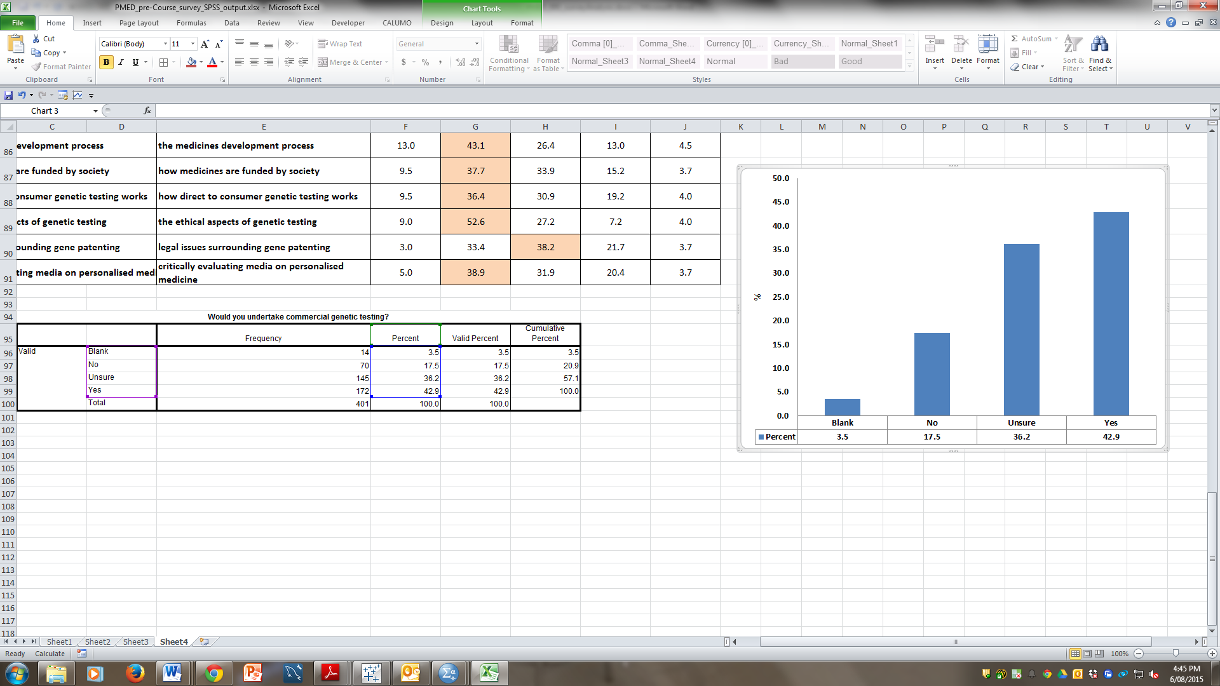

**Post-course Survey**

**Q21 Please indicate below to what extent you agree or disagree with each of the following statements**

Table 6 Rating distributions with highlight of the highest ratings



Figure 10 rating distributions per item

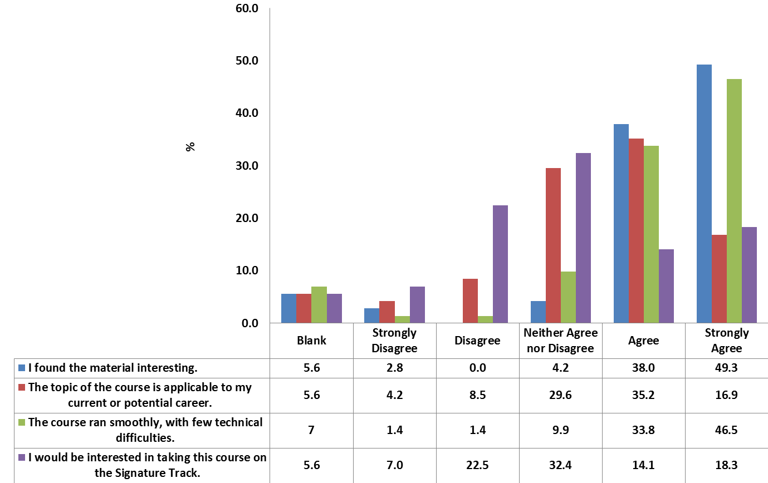

**Q22 & Q23 How would you rate your understanding of the subject matter before & after taking this course?**

Figure 11 Rating distributions per item

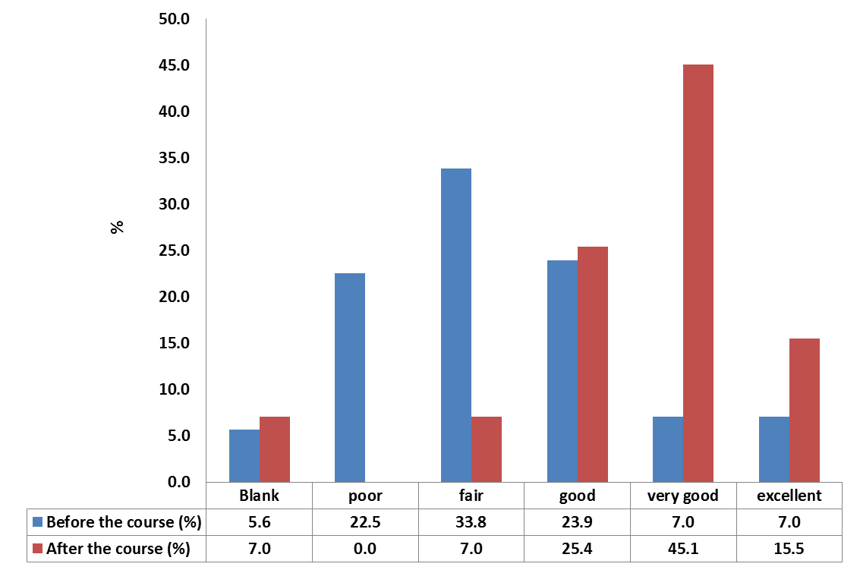

**Q16 & Q33 & Q18**

Table 7 Rating distributions per question



**Q7 Please rate your satisfaction with each of the following**

Table 8 rating distribution with highlight of the highest ratings per item



**Q19 Overall, how do you rate your course experience?**

Figure 12 rating distribution

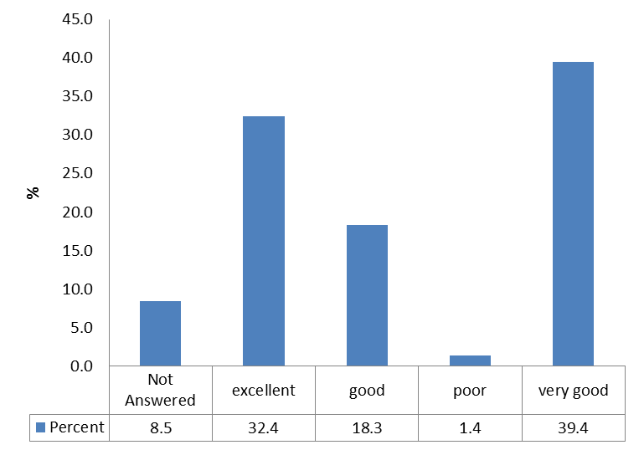

**Q20 please rate the following**

Table 9 rating percentages per item with highlight of the highest ratings



**Q24 how would you assess the impact of the following potential changes to the course?**

Table 10 rating distribution with highest ratings highlighted



**Q25 how many hours per week did you spend on this course?**

Figure 13 Distribution of responses in percentages

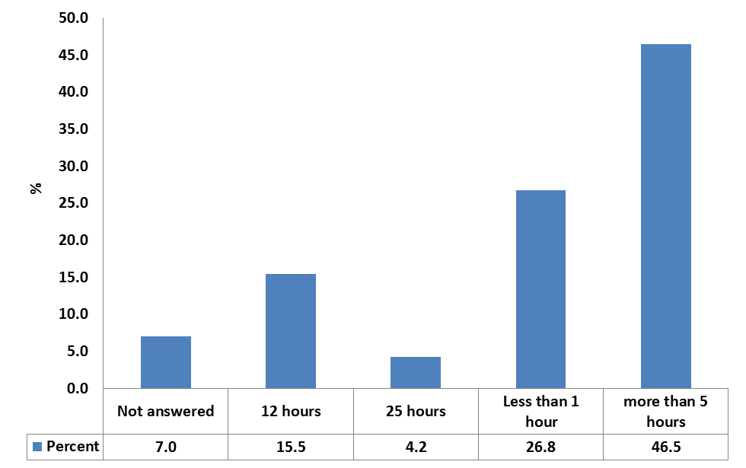

**Q26 how likely would you be to**

Table 11 rating distributions with the highest ratings highlighted per item



**Q15 How familiar are you with each of the following –**

Table 12 rating distributions with the highest percentages highlighted



**Q32 When thinking about yourself, how would you rate the following?**

Table 13 rating distributions with the highest ratings percentages highlighted

