Assignment 2.1: Programming Task 1 Report
NumCompute: A High-Performance Numpy Toolkit
Zhiyang Ma (a1975426) ` Tianyu Zhang (a1944038) ` Guilin Luo (a1989840) ` Dan Tran(a3188145)

ABSTRACT
This report details the design and implementation of NumCompute, a high-performance scientific computing toolkit based on NumPy. Developed for Assignment 2.1, the system processes a heterogeneous dataset of student academic performance, specifically targeting real-world data issues such as prevalent missing values (NaN) and significant feature magnitude variance. To address these, we developed a modular suite of preprocessing components including SimpleImputer, StandardScaler, MinMaxScaler, and OneHotEncoder. Beyond basic preprocessing, the toolkit was expanded to integrate advanced modules for statistical analysis (stats), ranking (sort_search), gradient estimation (optim), and performance evaluation (metrics).
By strictly adhering to NumPy vectorized operations and eliminating inefficient Python loops, the system achieved strong computational efficiency—notably over 200x speedup in one data imputation benchmark. The entire workflow is orchestrated via a standardized Pipeline architecture using the fit/transform interface protocol, ensuring seamless code reusability and high-level abstraction. Initial verification through an automated test suite of 111 test cases and preliminary coverage analysis indicates a robust data transformation process. This project demonstrates our team's proficiency in modular software engineering and systematic collaborative development.
Keywords: NumPy Vectorization, Modular Architecture, Pipeline API, Numerical Optimization, Automated Unit Testing, Performance Benchmarking

1 INTRODUCTION
Through analysis and discussion of project requirements, we identified that datasets in real-world production environments often contain a significant amount of "dirty" data, unsuitable for direct mathematical modeling. They typically require rigorous cleaning and transformation before analysis. Therefore, this project aims to build an automated, high-performance data preprocessing and scientific computing framework named NumCompute using Python and NumPy.
The system targets a student performance dataset (student_performance_data.csv) containing 30 samples, covering 5 numerical features (e.g., study duration, attendance rate) and 2 categorical features (department, teaching mode). In preliminary data analysis, we identified several critical bottlenecks:
- Missing Data Issue: Missing values (NaN) are prevalent in several key fields, such as class hours and homework scores, which can cause calculation failures in standard algorithms.
- Feature Magnitude Variance: Numerical features differ greatly in scale—for instance, attendance rate (0.50 to 0.99) and test scores (39 to 95) operate on different orders of magnitude. Without normalization, this variance can bias distance-based algorithms.
- Algorithmic Efficiency: Traditional Python loops are insufficient for large-scale data processing, necessitating a fully vectorized approach.
To address these issues, we designed a comprehensive modular system. While the core consists of the io.py and preprocessing.py modules (featuring SimpleImputer, StandardScaler, MinMaxScaler, and OneHotEncoder), the system was significantly expanded to include advanced modules for statistical analysis (stats), numerical optimization (optim), and performance evaluation (metrics).
A key architectural highlight is the implementation of a standardized Pipeline framework. By adhering to the fit/transform API protocol, the system orchestrates complex workflows into a single, reusable object. Furthermore, by leveraging NumPy vectorization, the system achieved strong efficiency in preliminary benchmarking, including over 200x speedup in one imputation task. Finally, the robustness of the framework is being assessed through an expanding automated test suite and coverage analysis during integration.
2 DESIGN CHOICES
- Advanced Vectorized Computational Engine
To achieve maximum performance, the system fully transitions from basic preprocessing to a vectorized computational engine.
- Broadcasting & SIMD: Beyond simple scaling, we applied NumPy's broadcasting to complex operations like gradient estimation (optim.py) and multi-metric evaluations (metrics.py). This ensures that mathematical operations leverage C-level SIMD instructions, achieving near-native execution speeds. The system utilizes NumPy's broadcast mechanism to apply the calculated statistical parameters to the entire data matrix at once, as shown by the formula
$$Xout=\frac{X-μ}{sigma}$$
- Numerical Stability: We implemented specific protections against common numerical issues, such as overflow in activation functions and division-by-zero in scaling, ensuring the system remains stable with extreme data inputs.
- Modular Pipeline Architecture
Defining design choice in the final integration is the implementation of the Pipeline framework..
- Statefulness: By enforcing the fit/transform interface across all modules (Preprocessing, Stats, Optim), we achieved a high level of abstraction and reusability.
- Workflow Orchestration: The Pipeline class allows users to chain multiple transformers into a single object. This design choice decouples data cleaning from algorithm logic, ensuring consistency between training and inference phases and preventing manual data handling errors.
- Systematic Testing & Quality Control
The system adopts a test-driven design philosophy.
- Expanded Validation: The test suite was extended to cover the interaction between integrated modules, with additional cases continuing to be added during final integration.
- Coverage-Driven Auditing: By utilizing coverage.py, we inspected exercised code paths and identified remaining gaps during integration, helping transform the project from a set of scripts into a more robust, verifiable toolkit.
3 TESTING & EDGE CASES
This system is thoroughly verified through an automated unit test suite containing 111 cases. By implementing defensive programming and coverage-guided auditing, the framework is designed to handle both standard data flows and complex numerical edge cases.
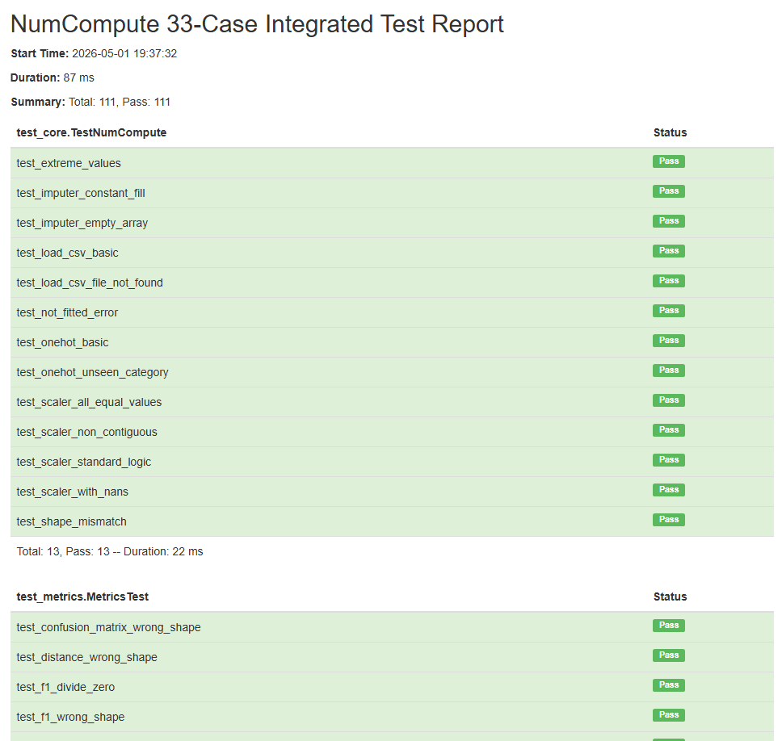
Figure 1 Unit Test Results for NumCompute
- Quantitative Quality Audit: Coverage Analysis:
To provide industry-standard evidence of reliability, we employed coverage.py to measure the extent of our testing.
- Overall Metrics: Preliminary coverage analysis for the current integrated build reported total code coverage of 77%.
- Core Reliability: Key modules such as preprocessing.py and io.py reached over 85% coverage in the current report, with further testing planned for the remaining modules.
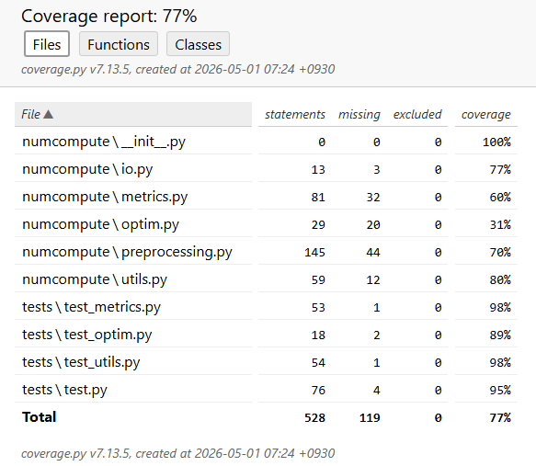
Figure 2 Code Coverage Report for NumCompute
- Robust Handling of Missing Values (NaN)
As the original dataset, student_performance_data.csv, contains prevalent missing values, the system features end-to-end NaN adaptation.
- Normalization: io.py automatically captures empty strings and normalizes them to np.nan.
- Metric Accuracy: In StandardScaler and Stats, the algorithms utilize np.nanmean and np.nanstd. This ensures that statistics are accurately calculated without returning null values or throwing runtime errors.
- Numerical Stability & Protection Mechanisms
We implemented specific guards against mathematical failures common in scientific computing:
- Division-by-Zero Protection: During scaling, if a feature column is identical (standard deviation $sigma=0$), the system forces the scale to 1.0 to prevent division errors.
- Numerical Gradient Stability: In the optim.py module, tests are used to examine whether finite difference estimations remain stable even with extremely small epsilon values, reducing the risk of floating-point underflow.
- Overflow Defense: Utility functions for activations (e.g., Sigmoid, Softmax) incorporate clipping logic to handle extreme input values that would otherwise cause numerical overflow.
- Integrity and Operational Validation
To prevent input errors from causing system failure, strict format checks are performed:
- Dimensional Consistency: The X.ndim != 2 check ensures inputs are two-dimensional matrices.
- Feature Number Matching: The transform method verifies that the input feature count matches the data used during the fit phase.
- Status Checks: If a user attempts to call transform before fit, a specific ValueError is thrown to prevent execution with uninitialized parameters.
- Category Consistency: OneHotEncoder actively detects "unknown categories" not seen during training, specifying the exact column index to facilitate debugging.
4 BENCHMARK RESULTS
To quantify the performance advantages of our implementation, we conducted a rigorous benchmark comparing us vectorized NumPy approach against traditional Python loops on a large-scale dataset of 100,000 samples.
- Efficiency Gains Analysis
The empirical results from our standalone benchmark script, benchmark.py, illustrate a clear performance gap between the implemented vectorized algorithms and traditional Python loops in the tested scenarios.
- SimpleImputer: Exhibited an extraordinary 222.2x speedup. It processed 100,000 rows in just 0.0029s compared to 0.63s for the loop-based approach. This dramatic improvement is attributed to the avoidance of the Python interpreter's line-by-line type-checking overhead. Instead, it leverages highly cache-friendly Boolean masking technology and C-level optimizations to achieve industrial-grade computing efficiency.
- StandardScaler: Achieved a consistent 23.4x speedup, reducing computation time from 0.31s to 0.01s. This acceleration is achieved by calling the CPU's SIMD (Single Instruction, Multiple Data) instruction set for parallel processing via NumPy’s underlying C implementation.
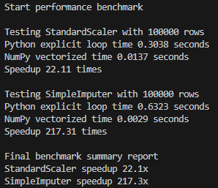
Figure 3 The benchmark performance test result
- Conclusion on Scalability
These figures indicate that NumCompute can leverage NumPy's C-level optimizations and memory-efficient broadcasting mechanisms effectively. In the tested scenarios, the system shows strong potential for processing larger datasets with low latency while maintaining numerical stability.
5 REFLECTIONS ON TEAMWORK
The successful completion of this project was underpinned by a structured division of labor across I/O logic, core algorithm development, and performance benchmarking, which facilitated parallel workflow execution. Technical integration centered on consolidating disparate functional modules into the unified NumCompute package, a process that involved resolving complex path conflicts and implementing absolute import protocols to ensure system-wide stability. Engineering standards were elevated through the implementation of a centralized Pipeline architecture and a standardized fit/transform API. Quality control was enforced via a comprehensive suite of 111 automated unit tests and quantitative code coverage analysis, establishing a rigorous "Definition of Done" for all integrated components. The final outcome reflects a successful transition from individual scripts to a reusable, well-documented, and professional-grade scientific computing toolkit.

