1. How to build full stack node.js express + vue.js
   1. Front end will be created with vue, vuetify and vuex
   2. Back end will be created with Node.js + express + Sequelize for mysql

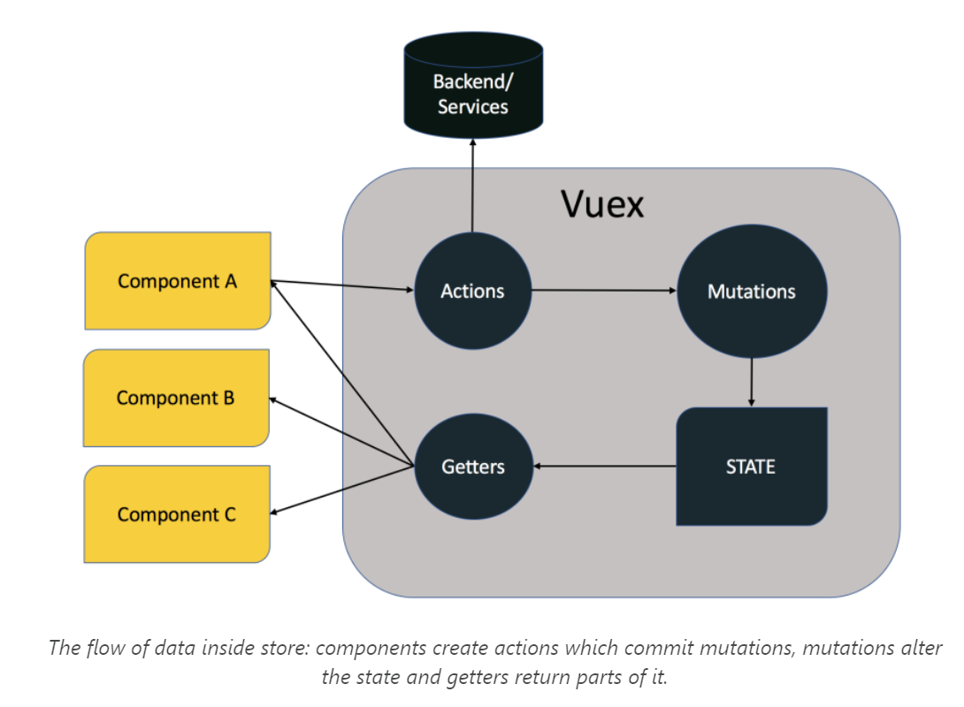 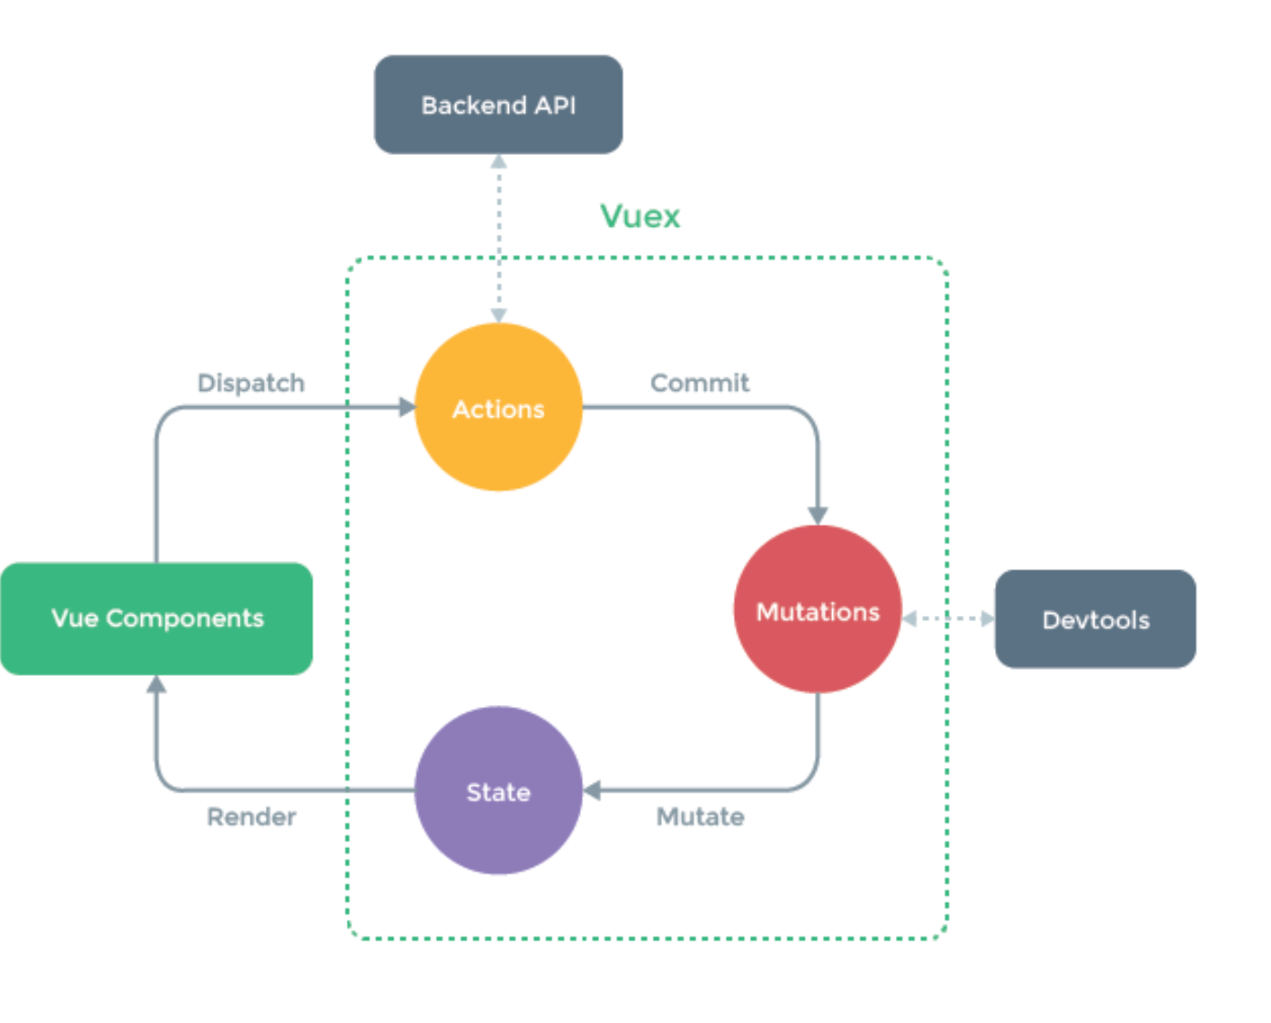

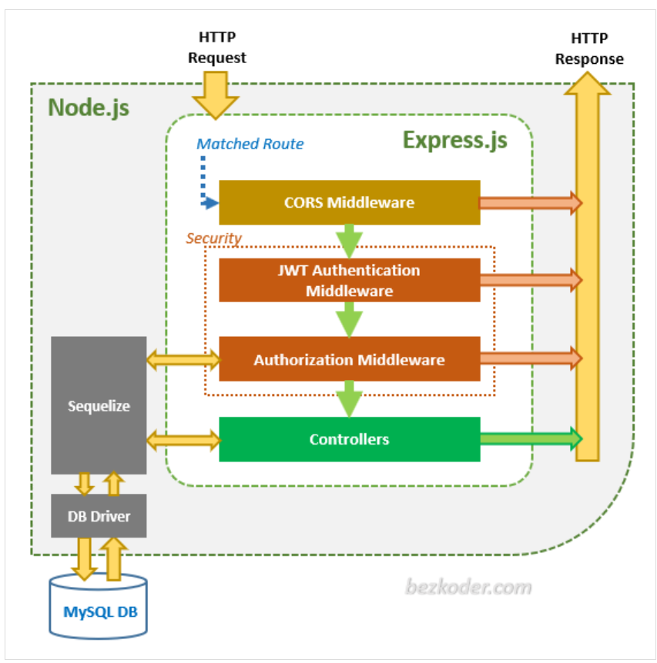

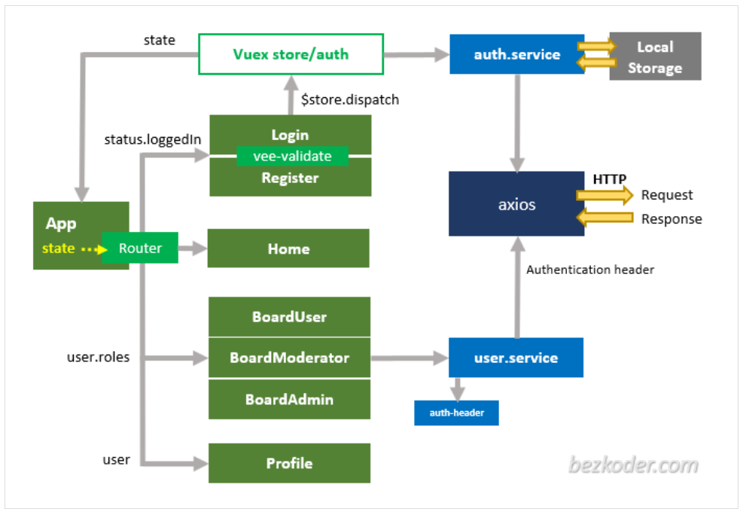

How to set up passport with mysql and express

<https://code.tutsplus.com/tutorials/using-passport-with-sequelize-and-mysql--cms-27537>

explanation about bodyparser

<https://medium.com/@adamzerner/how-bodyparser-works-247897a93b90>

<https://stackoverflow.com/questions/28450400/whats-bodyparser-and-cookieparser>

security improvements: add limiter, user recapcha

speed improvements: add cache (redis)

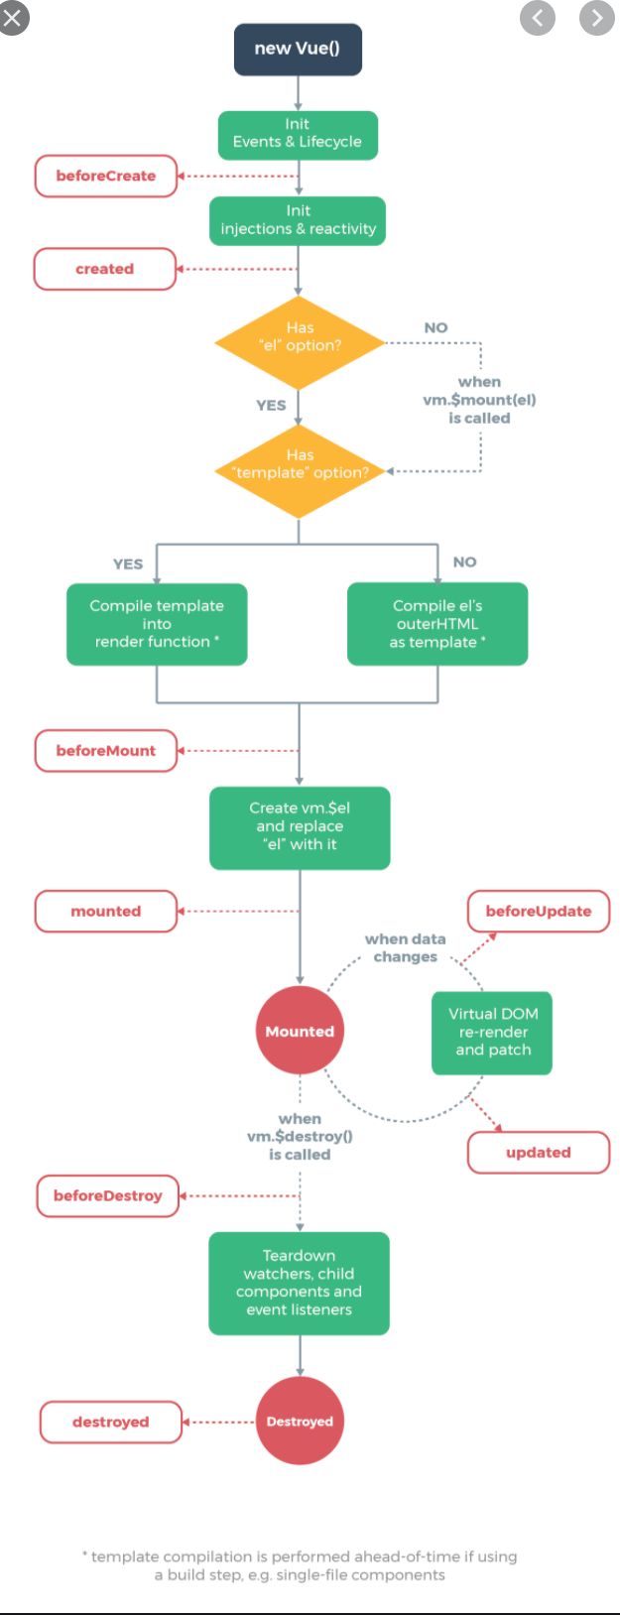

Figure : Vue life cycle

This link will explain vue methods, watchers and computed properties: <https://flaviocopes.com/vue-methods-watchers-computed-properties/>

