TEXCONTROLLER - QUICK MANUAL

After installing software (generally by our support team) you must find some shortcuts at desktop:

- Tex Controller Server
- Milling Spooler Page
- Control Page

FIRST OF ALL START MACHINE

1. START TEX CONTROLLER SERVER

Open this shortcut to launch TEX controller server. This program is used like a bridge between the simple and friendly WEB PAGES and TEX.

You'll see probably some like that...

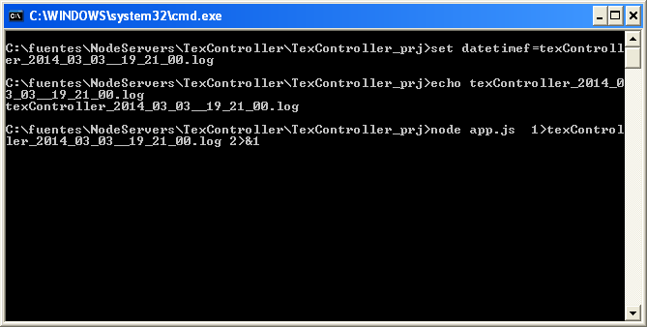

... don't close this window unless you get some kind if communications error with TEX (you'll see at Milling Spooler Page).

All logs messages will be saved at same folder where our support team has installed programs and here we can find important info to understand and solve some problems in the future.

2. OPEN MILLING SPOOLER PAGE

Open this page to start manage millings and see something like that....

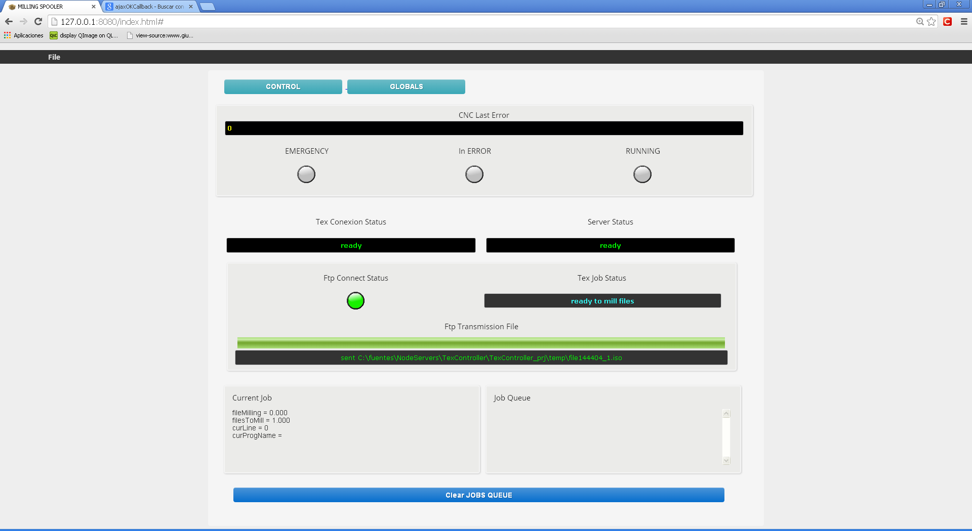

Here you'll find some info about status of TEX and some commands to start milling. Remember that we are showing a simple data only to show you...:


- Open and select from your hard drive file ISO that you want to send TEX to mill.

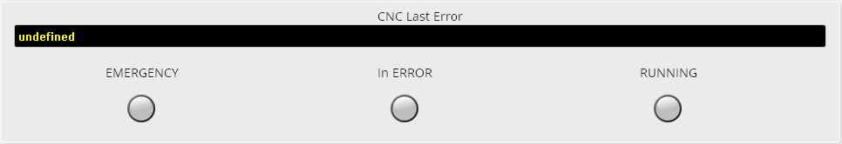
- At CNC Last Error you can see las error message generated by TEX. Also (still not working) some LEDS that show you machine status... In red for emergency and error and in green for running.
- Normally you'll find 0 at CNC Last Error.
- At TEX Connection Status and Server Status you can follow the steps to make and get a stable connection with TEX. Normally if TEX Server loose connection with TEX it try to stablish again the connection.... (also for FTP, necessary to Upload files)

- If all its OK you'll green status.


- Important thing is FTP Connect Status and TEX JOB STATUS.

If you notice that FTP is in red then wait and check Server and TEX Status to see if its trying to reconnect. If system is not be able to RECONNECT FTP and TEX then one solution is SWITCH OFF TEX, CLOSE WEB PAGE AND SERVER and start again.

At TEX JOB STATUS you are going to see this three messages:

- ready to receive files: You can send a new file to MILL
- ready to mill files: You just have sent a file and NOW its ready to start mill... Press button in machine to start to mill (maybe will be green blinking)
- milling files: Machine must be moving and making nice noise... Then you'll see machine is milling the file you have sent before.

Please don't send a new file while machine is milling files.

- Here you'll see the progress of transmission file.


- Or you can see other kind of messages about FTP situation.

BASICALLY THAT'S ALL YOU NEED TO START QUICKLY TO MILL!!!
3. CONTROL PAGE AND GLOBALS

From the milling spooler page you can access to CONTROL PAGE AND GLOBALS PAGE.

The control page lets you make some simple movements (JOGS) of different axis installed at TEX.

- Its very simple and you can move each axis with JOGS.

- You can also change Feedrate of TEX system.


- And also a STOP BUTTON and some info LEDS.

PLEASE TO FORCE STOP DURING MILLING USE MACHINE BUTTON

