MARCOS

Morales Rodrigo

Senior software developer product analyst/owner project & team leader technical leader/consultant

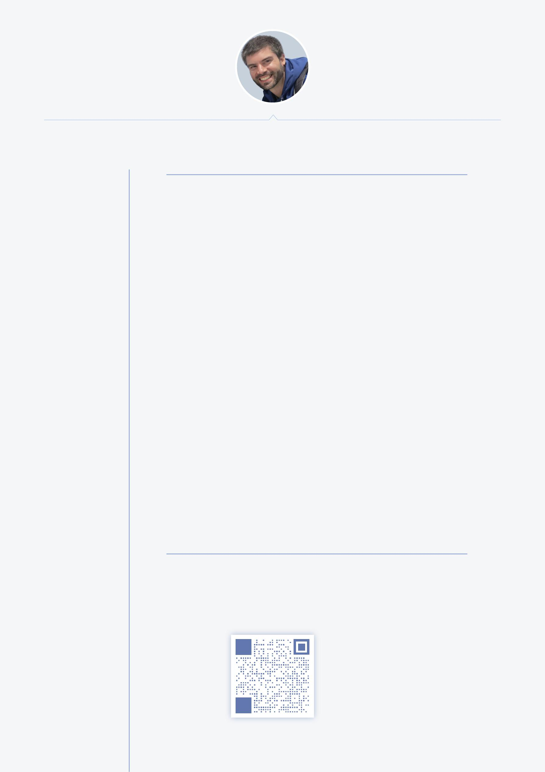

a brief bio... 

contact details 

who am I?

My name is Marcos Morales Rodrigo. I am a senior software developer born in Spain in 1982. I speak Spanish (as it is my mother language), Portuguese (I used to live by the border between Spain and Portugal) and English (I have accredited advanced IELTS - C1/7.5). I have full rights to work freely anywhere in Australia as I am Australian Permanent Resident with no limits and the intention to get my citizenship.

I can describe myself as a highly polivalent IT professional, serios with my work, reliable, motivated, creative, greatly experienced and skilled with superior attention to detail and proficent comunication skills to handle all the stakeholder intercomunications needs.

I have been working in many different industries, companies and bsinesses adapting myself, acquiring new knowledge during the time and always, very soon, disrupting the place and methodologies to push it further with my analytical, creative and fresh point of view.

The IT industry has been my natural environment for many years and that has given me the experience and ability to create, improve and learn always the cutting edge technologies using the most modern methodologies, tools and skills.

I am the kind of worker that always achieve results, aware about the deadlines, in the best way possible whenever it is within a team, leading it or by myself. Obsessed with perfection, scalability and usability of the final product and project I am involved, givin the final user the best service possible.

would you like to contact me?

* marcos@supermarcos.net or supermarcos@gmail.com

 www.supermarcos.net

 (+61) 0406 525 061

 https://au.linkedin.com/in/marcosmoralesrodrigo

page 1 of 5

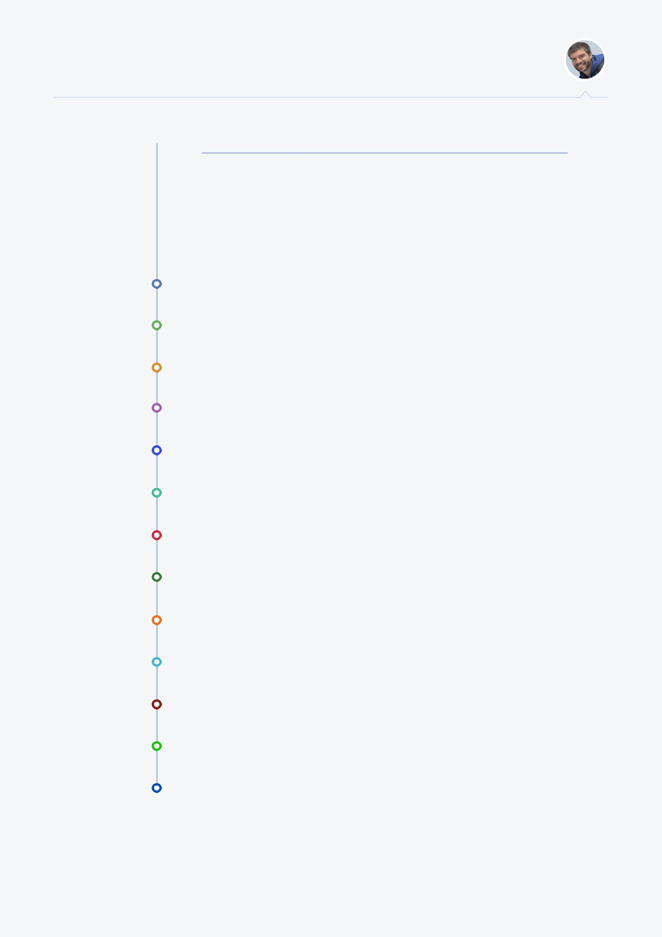MARCOS Morales Rodrigo

education...  what have I (officially) studied?

These are the certifications, degrees and titles I hold. Obviously these are not the only ones I have, but they are the ones that are, somehow, officially accredited.

|  |  |
| --- | --- |
| 2015 | Developer Programmer Superior Diploma |
|  | ANZSCO Code 261312 |
| 2015 | Data Scientist, Data Analysis with R |
|  | Self motivation, Coursera (John Hopkings University) |
| 2012 | UI/UX and FrontEnd Development |
|  | Indra Software Labs |
| 2011 | Android Mobile Development Master Course |
|  | Self motivation, Master D online learning |
| 2010 | Java and J2EE |
|  | Self motivation, Triparty Foundation |
| 2009 | MVC with ASP.net |
|  | GAE Informática, S.A. |
| 2008 | Ms SQL Server Administration and Tunning |
|  | GAE Informática, S.A. |
| 2007 | Payroll and payslip calculation |
|  | Self motivation, Triparty Foundation |
| 2006 | Linux System Administration |
|  | Self motivation, Linux ORG |
| 2005 | 3D Design and Development with 3d Studio Max |
|  | Self motivation, Professional Training and Skills Don Benito |
| 2004 | Bintec Routing Configuration and Administration |
|  | SET ici, S.L. |
| 2003 | SELT@ PBX/IPX VoIP / Asterisc Config and Admin |
|  | SET ici, S.L. |
| 2002 | Superior Professional Degree on IT Systems Administration |
|  | IES Suárez de Figueroa (Zafra, Badajoz, Spain) |

page 2 of 5

skills... 

tools, methods, techniques...

MARCOS Morales Rodrigo

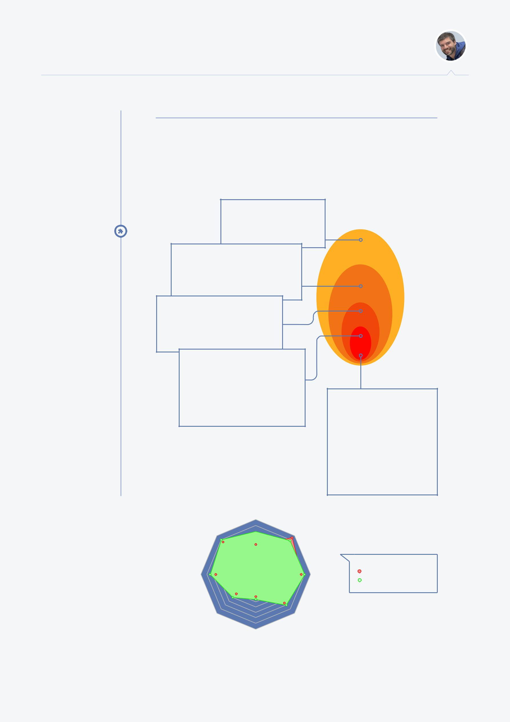

what about my skills?

It's hard to explain and list everything that I've learned and used on my career. There are so many skills, so many different programming languages, methodologies, techniques, platforms, frameworks, services... here are some easy to visualize diagrams to resume them:

Methodologies, project & product

Waterfall / Agile / SCRUM / FDD / TDD...

Project management, team leadership

product design & ownership

technical advisory & quality assurance

Environment & context

strengths 

Monolithic applications for desktops

Web applications and web sites

Mobile development

Server side development and Front end development

FullStack development

Focus

Data analysis, machine learning

Mobile development & touch friendly designs

Client - Server / API first

Design, wireframing, UX analysis and UI design

Source management (git & gitFlow, mercurial, svn...)

Frameworks & SDKs

.NET framework

Android SDK, Cordova, Phonegap, Ionic framework...

jQuery, ExtJS, Angular2+, ReactJs, VueJs, Knockout...

Laravel, Cake, Yii2...

Oauth, Oauth2, Saml

SOAP, Json, WebApp2, Express, WebSockets

NodeJs, npm, pip, Gulp, Grunt, Composer

Bootstrap, MDL...

Programming languages

Javascript / ES5 / ES6 / Typescript

Python

PHP & ASP

HTML / HTML5 / XHTML / XML / YAML

CSS / CSS3 / LESS / SASS / SCSS

Basic / vb6 / Visual Fox / Vb.Net / C#.Net

Java / JSE / J2EE

C/C++

Bash / Shell / Scripting languages

R / Pandas

SQL / T-SQL

mobile

UX & UI  front end

|  |  |  |  |
| --- | --- | --- | --- |
|  |  | legend |  |
| project & product | API design | experience |  |
| relative* knowledge |  |
|  |  |  |
|  |  | why "relative"? |  |
|  |  | well... nobody knows how much they don't know |  |
| data analysis | back end |  |  |
|  | dev ops |  |  |

page 3 of 5

experience... 

me on semver

along time

Road Map

specific new features

general enhancements

very stable version

highest performance

multitasking prod. focused

current

v5.0

massive improvements on reliability and multipurpose use of the platform

v4.0

platform compatibility

new features on backend

revamped frontend

v3.5

better performance enhanced project management new team-focused features

v3.0

higher quality control bumped version management massive platform reengineering

more...

MARCOS Morales Rodrigo

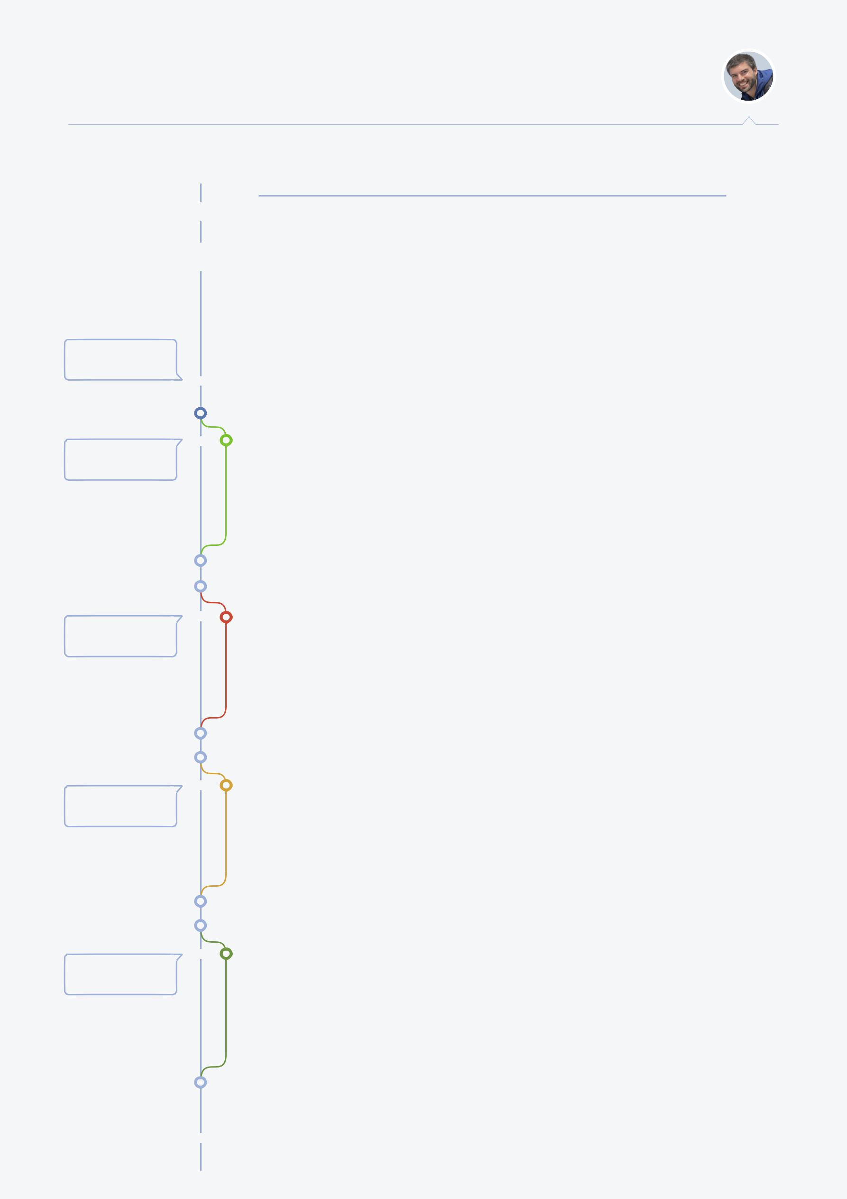

what have I done (so far...)?

My experience is vast and diverse. I've worked for many different industries such food factories implementing automatic lot generation for health tracking for alimentary industry, desktop applications for accounting, taxation and payroll systems, mobile applications for IoT health devices, web applications for CRM and/or solar panel performance monitoring, web design for different companies, UI/UX advisory and implementation, front-end development, back-end development, change advisory, technical leadership, product owner, education systems...

Analyst/Developer for CQUniversity

dec 2017 - current

Hired as experienced Analyst/Developer, my tasks have been so far very diverse from programing and coding to implementation, deployment, dev QA, technical leader, change management and advisory, turning myself in some kind of senior mentor for young workforce and, sometimes, acting as product owner or internal consultant.

Fullstack developer for Brown Paper Bag

jun 2016 - nov 2017

As a fullstack developer, my tasks were analysing, designing and developing from the ground up an education project for schools about Sustainability and Renewable Energies. Most of the front-end was developed by myself and some parts on the back-end. We used Laravel php, C#, Angular 2+, AWS, lambda and serverless, data analysis...

Fullstack developer for APN/ARN

mar 2016 - jun 2016

For the brief few months I worked for APN, I had the oportunity of mostly leading front-end development mentoring a junior front-end developer. I worked also as back-end developer using python when required and briefly as a mobile developer. Unfortunately, the project was closed and APN was bought by NewsCorp.

Software and web developer for Focus Products

Feb 2013 - mar 2016

Leading several modules within the huge CRM/ERP system, I analysed and developed parts as virtual printers, water analysers, reporting and statistics systems, on field scheduling service systems, others tasks performed included data analysing, data migration, remote assistance and end user support. Mainly working with python, knowckout and Google Cloud Platform services.

page 4 of 5

experience... 

v2.5b

multitasking without team

resource management

new reliability implemented

v2.5

new project compatibility enhanced mulstitasking system mentoring and advice features

v2.0

fast response implemented

new platform developed

software focused enhanced

first massive fork

v1.0

stable version released

faster delivery system

new multitasking features

v0.1

customer focused version

hardware cursing mitigation

networking and sysadmin

origin

MARCOS Morales Rodrigo

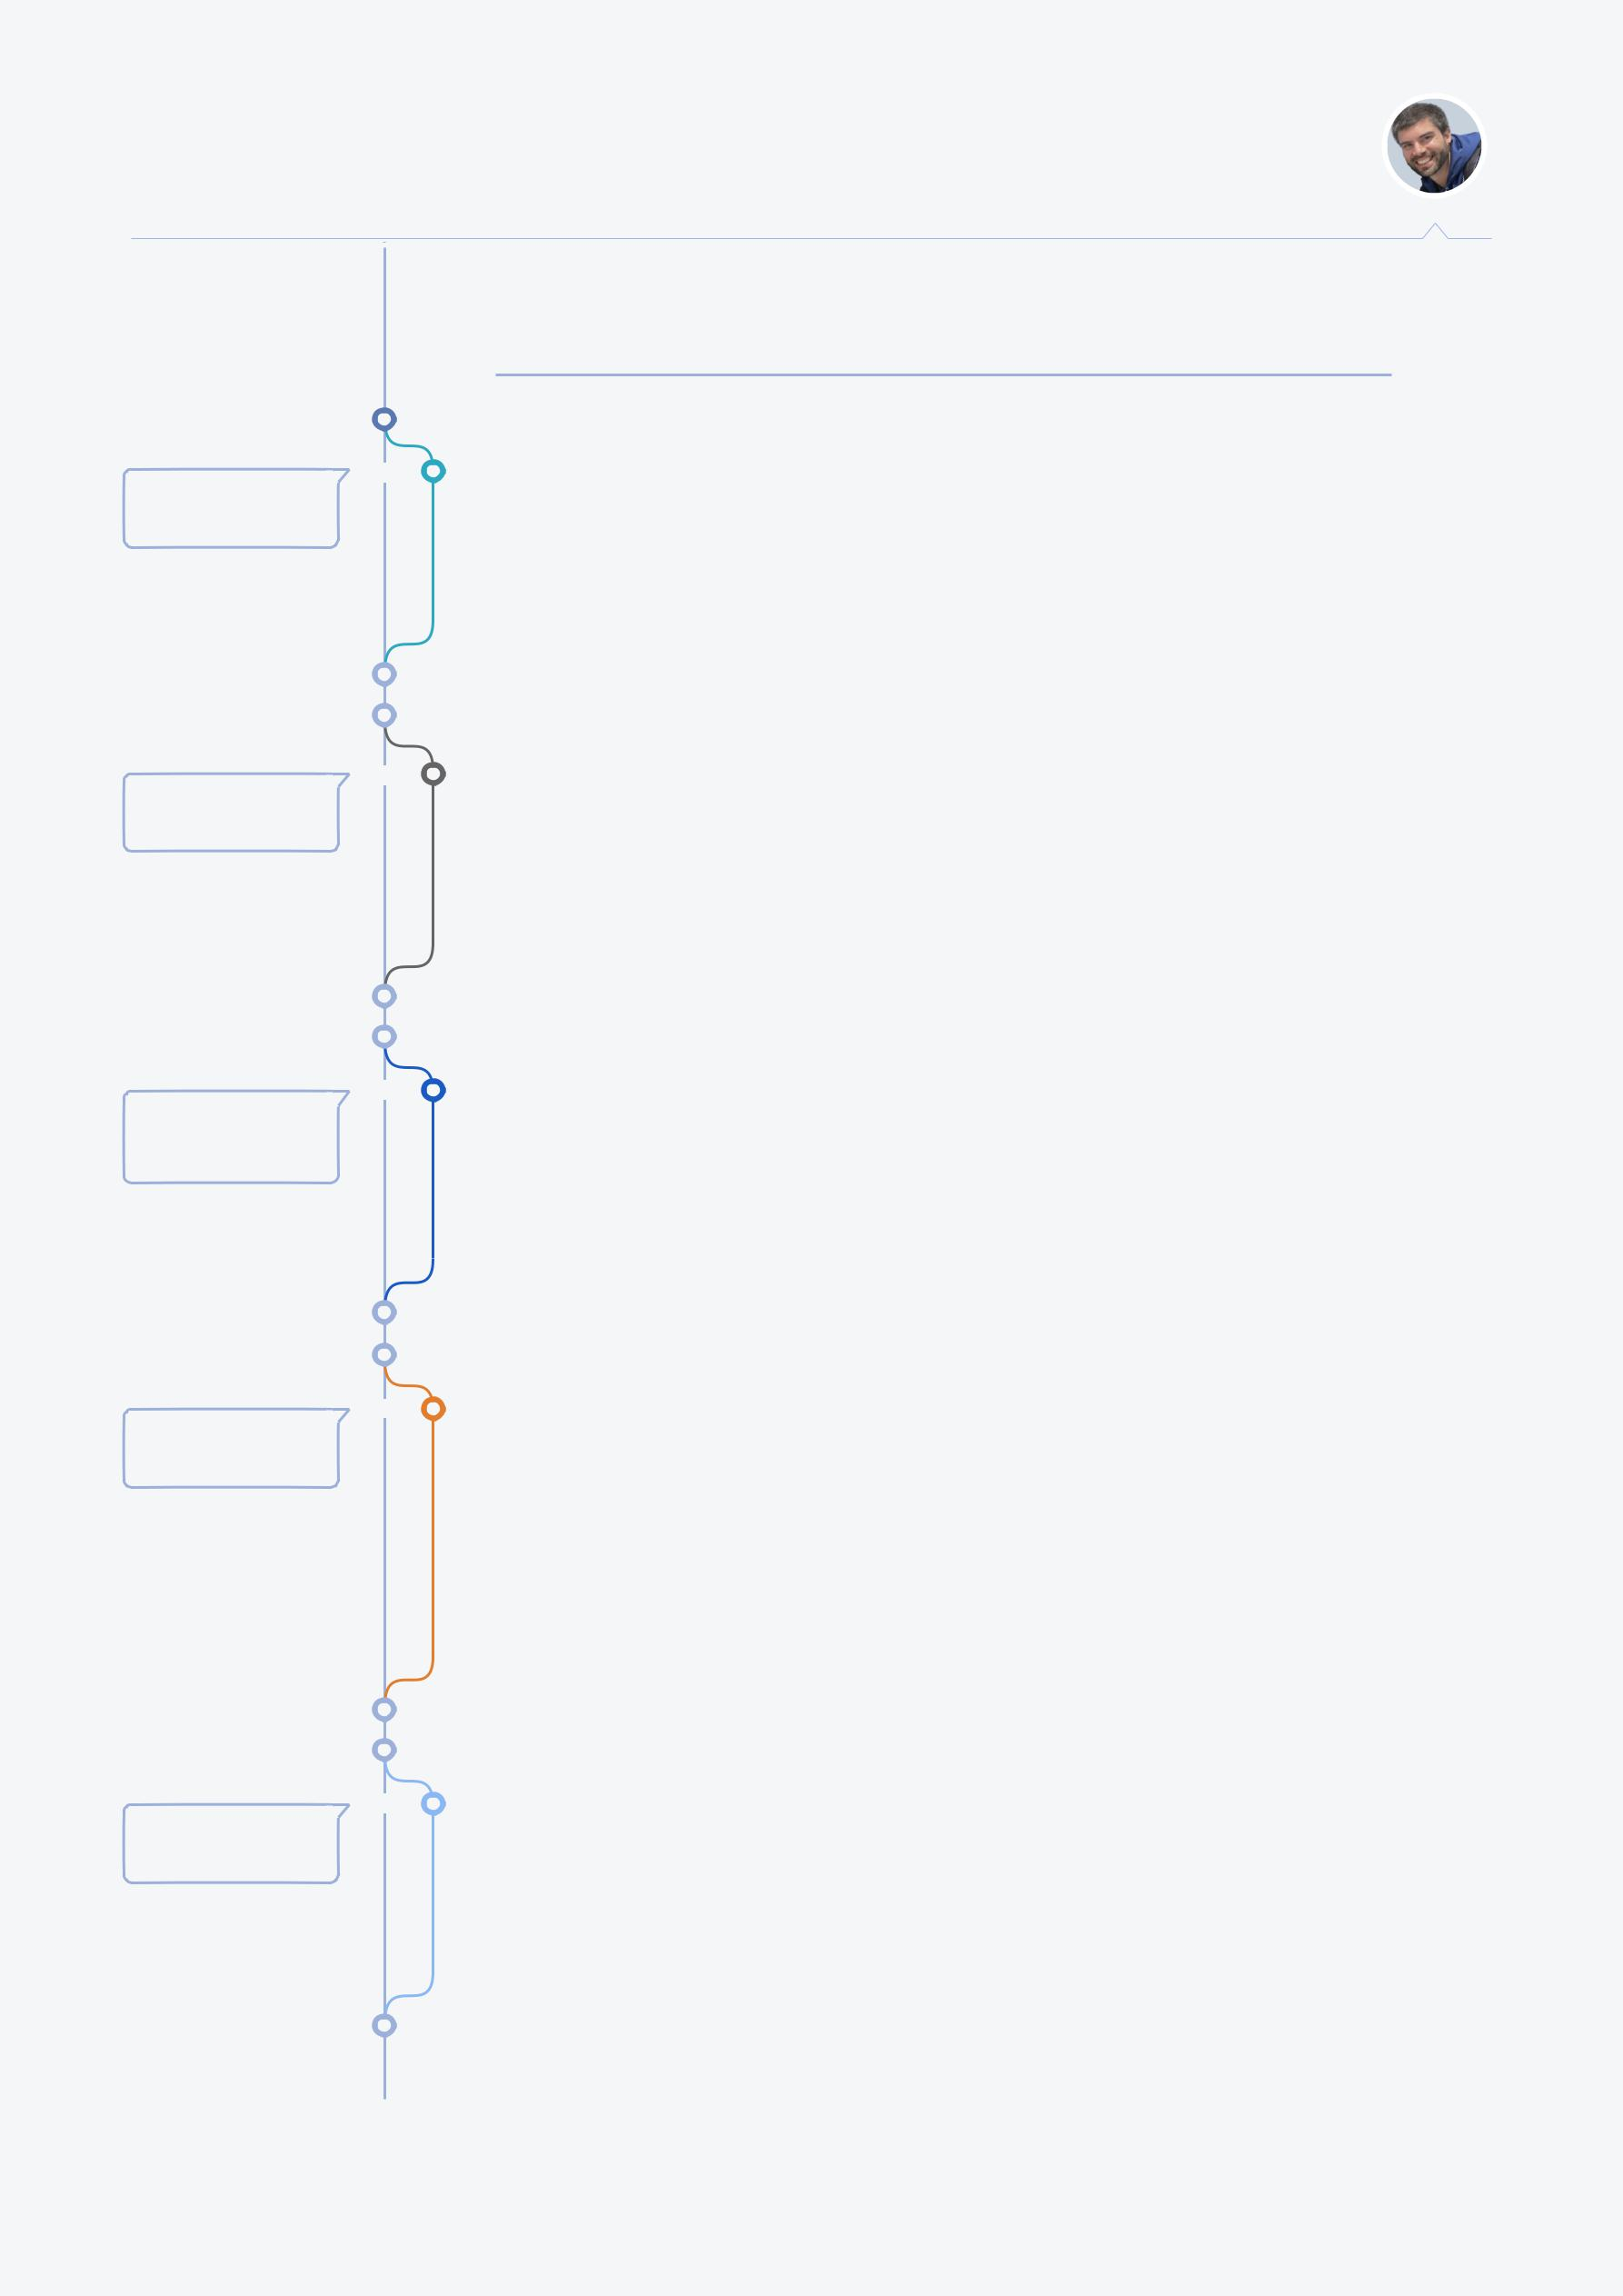

previous experience...

Head Developer for Smooth Symmetry

oct 2012 - feb 2013

Working as a freelancer, most of my jobs were for Smooth Symmetry. I was responsible for design, develop, deployment and maintenance for several web sites, SEO strategies and hosting configuration.

Senior Software Developer for Indra Software Labs

aug 2011 - sep 2012

At the begining I was a Senior Developer, but soon I was moved to the UX/UI core team for the whole factory (400+ employees), in a couple of months I was promoted to help, advice and bring support for architecture design and development for different projects across the company.

Senior Software Developer / Analyst for GAE Informática

may 2006 - aug 2011

Leading the analysis and development of software design for professional services as accounting, taxation, Social Security and payroll/payslips calculation. I also developed many internal systems for version control, package and deployment, support tracking systems by tickets and the implementation of new methodologies within the company.

Technician and Junior Software Developer for SET ici

feb 2003 - may 2006

Field technician, network instalation and administration, server configuration and system administration, customer support and heaps of different small tailored applications for factories (mostly food process), designing trazability systems for lots, bar codes and health requirements. I was also key in the original idea and development of a custom php based ERP/CRM system for Quality Control, Accounting, Warehouse, Field Activity tracking, Project Management...

Hardware, technician, sysadmin for PuntoNET Informatica

jun 2002 - feb 2003

This was my first job. I was in charge of a small hardware shop and my duties mostly consisted in hardware repair and management, technician activities, network design and deployment, system administration, shop maintenance and customer care.

page 5 of 5