
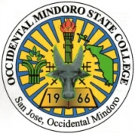
Republic of the Philippines
OCCIDENTAL MINDORO STATE COLLEGE
Rizal St., San Jose, Occidental Mindoro
Website: www.omsc.edu.ph Email address: omsc_9747@yahoo.com
Tele/Fax: (043) 457-0231

Bachelor of Science in Information Technology

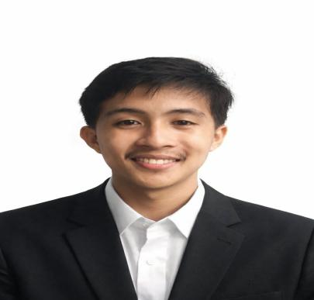
CURRICULUM VITAE

DEEJAY B. CABILES
Purok 2, San Roque, San Jose, Occidental Mindoro, 5100
deejaybautista6@gmail.com
+639127444806

OBJECTIVE: To be able to put in practice and expand my gained knowledge, learnings, and skills. To show initiative in problem solving while performing all given tasks.

EDUCATIONAL BACKGROUND:

Tertiary : Occidental Mindoro State College
Bachelor of Science in Information Technology
2021– 2026

Secondary : San Jose National High School
Senior High School
2019-2021

San Jose National High School
Junior High School
2015-2019

Primary : Cabatuan West Elementary School
2009-2015

SKILLS AND INTERESTS:

- Computer Literacy : Proficient in Microsoft Office ( MS Word, MS PowerPoint, MS Excel)
- Can do a multi-tasking job and have good communication skills.
- Have a professional attitude towards the goal
- Easy to pick up things and pieces of information, and can learn easily

PERSONAL DATA:

Age : 21
Sex : Male
Date of Birth : December 20, 2004
Place of Birth : Magdalena, Cabatuan, Isabela
Civil Status : Single
Height : 5’6 ft
Weight : 53 kg
Religion : Roman Catholic
Mother’s name : Jovita B. Cabiles

CHARACTER REFERENCES:

Name: Philip Gerome D. San Diego
Position: Accounts Services Division Chied
Company: OMECO
Contact No. 0917-615-5980

Name: Marbal D. Quilit
Position: Consumer Accounts Section Head
Company: OMECO
Contact No. 0910-045-1416

Name: James Marlon M. Diestro
Position: Billing Specialist
Company: OMECO
Contact No. 0954-986-3443

I hereby certify that all the above information is true and correct to the best of my knowledge and beliefs.

DEE JAY B. CABILES
Signature over Printed Name

