Supermemo

Collated essential understandings & discussions from DiscordApp

Epistemic note:
Extracts from websites (supermemo, blogs, ...) are quoted and their source appended at the bottom. Unquoted text is essentially the work of DiscordApp chat members. Apply judgment !

Last update: 11. Nov. 2020 07:56 AM
Homepage: https://github.com/supermemo/SupermemoLore
Contact: alexis@incogito.org

Table of Contents
II Subject Index 7
III Using SuperMemo 28
A Introduction 28
A.1 Supermemory is easy if… difficult if... 28
A.2 Roadmap 29
B Knowledge tree 30
B.1 Elements 30
B.1.a Concepts 30
B.1.b Concept group 31
B.1.c Concept vs Categories 31
B.1.d Topic 31
B.1.e Items 32
B.1.f Items vs. Topics vs. Tasks 33
B.2 Branch 34
B.3 Operations 35
B.3.a How to create all future Items/Topics under a specified concept ? 35
B.3.b How to extract text from a Topic, and add it directly under its node ? 35
B.3.c How to add a new Item to a specific sub-Topic? 36
B.3.d Dual KT-pane 39
C Repetitions 40
C.1 Practicing Repetitions 40
C.1.a Grading 40
C.1.b Does the response time at Repetitions influence the next Interval? 40
C.1.c Opening Clozes 40
C.1.d Grading Clozes 40
C.1.e Editing while Reviewing 41
C.1.e.i When should I edit my elements ? 41
C.1.e.ii Should I Dismiss Topics after extracting their Items ? 41
C.1.e.iii Dismiss v.s. Done 42
C.1.f Leeches 42
C.1.f.i Dealing with leeches 42
C.1.f.ii The leech wizard 42
C.1.g Final drill 43
C.1.g.i About its usefulness 43
C.1.g.ii Accessing it 43
C.2 Managing Repetitions 44
C.2.a Sorting criteria 44
C.2.b How to reschedule Items ? 44
C.2.c How to reset Items ? 44
C.2.d How to Spread an imported Topic ? 44
C.2.e Priority queue 46
C.2.e.i Priority 46
C.2.e.ii On its importance: The Priority bias 46
C.2.e.iii Important moments to prioritize 47
C.2.e.iv Automatic Priorities setting in IR 47
C.2.e.v Default Priority option in concepts 48
C.2.f Postpone 48
C.2.f.i Definition & Why is it so important ? 48
C.2.f.ii Auto-postpone 48
C.2.g Dealing with large outstanding queue 49
C.2.h Setting custom Intervals 50
C.2.i How to restrict Repetitions to Items only ? 51
C.2.j Filtering postponed elements 51
C.2.k Customizing rating buttons 51
C.2.l Neural reviews 52
D Spaced Repetition Algorithm 53
D.1 Different algorithms 53
D.2 Retention 53
D.3 Forgetting Index 53
D.3.a Measurement 54
D.3.b Effective retention 54
E Incremental reading 55
E.1 Repetition algorithm (Topics) 55
E.2 Dealing with fully extracted Topics 55
E.3 Article Priority 55
E.4 Background Colors in Internet Explorer are used in Incremental reading 55
E.5 When I try to change the size of Fonts in HTML components nothing happens 55
F Elements & Content 57
F.1 Templates 57
F.1.a Creating Templates 57
F.1.b Applying a default Templates 57
F.1.c Automatic Template selection (text, Picture, ...) 57
F.1.d Editing a Template 58
F.2 Elements 58
F.2.a Switching elements type between Items/Topics 58
F.3 Content format 58
F.3.a Formatting text 58
F.3.b Cloze : Display style 58
F.3.c Cloze : How to remove the colored background of text when you do a Cloze or extract ? 59
F.3.d Images 60
F.3.d.i Picture editing/viewing shorcuts 60
F.3.d.i.α Open in Picture editing software 60
F.3.d.i.β Open in viewer 60
F.3.d.ii Image occlusion : About occlusions on different systems 60
F.3.d.iii Image registry 60
F.3.d.iii.α Searching, Supersets, Subsets 60
F.3.d.iii.β Importing images 60
G Built-in tools 61
G.1 Plan 61
G.2 Tasklist 61
G.3 Visual browser 62
G.4 Statistics 62
G.4.a What is the easiest way of assessing learning performance ? 62
G.4.b Misc 63
G.5 Quick access cheat sheet 63
G.6 Scripting 64
H Shortcuts 65
H.1 By category (TODO: Classify) 65
H.2 Index 67
I Technical 70
I.1 Backing up! 70
I.2 Checking last SM version 70
I.3 Using SM on Linux with Wine 70
IV Knowledge acquisition : Processes, Models, … 72
A Incremental reading 72
A.1 Methodology 72
A.1.a Incremental work 72
A.1.b What is the right amount of changes by Repetition 72
A.1.c Item perfectionism 72
A.1.d How many Clozes should I extract per Topic ? 72
A.1.e When are Topics ripe for extraction (is it worth the cost) ? 74
A.2 IR & Cloze deletions 75
A.2.a Incremental Clozing 75
A.2.b When to split and when to Cloze? 76
A.3 Processing different sources 76
A.3.a PDF 76
A.3.a.i Acquisition methods 76
A.3.a.i.α OCR + Copy paste from PDF 76
ABBYY Finereader 76
Adobe Acrobat Pro 77
A.3.a.i.β Converting to HTML 77
Conversion 77
Issues 77
Solutions ? 77
A.3.a.i.γ Exporting to plain textbook 78
A.3.a.i.δ Buboflash 78
A.3.a.i.ε PDF referencing (“bookmark” method) 79
A.3.a.ii Text cleanup 79
A.3.b Entire books 79
A.3.b.i Using Pending Queue 79
A.3.b.ii Dealing with images 80
A.3.b.iii Other strategies 81
A.3.c Epub, RTF 82
A.3.c.i Epub → docx → HTML Component 82
A.3.c.ii Direct extraction + HTML filtering 83
A.4 Splitting up large body of text 83
B Incremental video 83
C Audio 85
D Workflows 85
D.1 SM as a Post-process 85
D.2 SM as a “storehouse” 86
D.3 SM with IR 86
E Integrating smartphones 87
V Knowledge retention & Management 88
A Formulating knowledge, taking notes 88
A.1 Bloom’s taxonomy 88
A.2 Cornell notes 89
A.2.a Origins 89
A.2.b Cornell notes in SM 89
A.3 Mindmapping 94
A.4 Memory encoding 97
A.5 Mnemonics 98
A.6 Eight learning strategies that foster generative learning 98
A.7 Cloze visual memorization 100
A.8 Q/A Questions 101
A.9 Cloze v.s. Q/A : Which is best ? 101
A.10 Contextualized answer 101
A.11 Other types of cards 102
A.12 Other Sketch / Notes methods 102
A.12.a Smart Wisdom notes 102
A.12.b Links 104
B Building strong synaptic patterns 105
B.1 Techniques for minimizing the complexity of synaptic patterns as a key to keeping E-factors high 105
B.2 Planned redundancy as a way to cross-strengthening synaptic patterns 105
B.3 Approaches that use stored memories 106
B.4 Optional reasoning clues, mnemonic clues, context and examples 106
C Repetitions 108
C.1.a State of mind 108
C.1.a.i Concentration 108
D Topology / Organization (KT, Image registry, etc.) 110
D.1.a Incremental Picture management 110
D.1.b Image registry conventions 110
E Knowledge, Epistemology & SuperMemo 111
E.1 Evaluating the quality of learning progress 111
E.2 What should go into SM ? 111
E.3 Epistemic status of knowledge 112
VI Field-specific discussion 113
A Mathematics 113
A.1 Factoring 113
VII Cognition 114
A Learning 114
A.1 Does SuperMemo improve short-term or long-term Memory ? 114
A.2 Do intelligent students learn faster ? 114
A.3 Procedural & Declarative learning 115
B Memory 115
B.1 Memory can be improved 115
B.2 Aging is not a factoring 116
B.3 Permastore does not exist 116
B.4 Morning is best for learning 116
B.5 Fluency says little of Memory stability 116
B.6 Learning by doing can be expensive 117
B.7 Mnemonic techniques can be expensive 117
B.8 Mind maps are expensive 118
B.9 Mnemonic techniques are not hermetic 118
B.10 Spacing effect does not come from encoding variability 118
C Genius / IQ / Intelligence 119
D Observation about change in cognition/behaviour 119
D.1 Creativity 119
D.2 Insights 119
E Eidetic Memory 119
VIII Misc Topics 121
A Usability “hacks” 121
A.1 Controllers 121
A.1.a Xbox Controller 121
A.1.b Wii remote control 122
A.2 Mouse macros 122
B Emotions & SM 123
B.1 Feedbacks 123
B.2 Visualizing 123
B.3 Self-involvement 123
B.4 Deadlines 123
B.5 Mind – KT sync 124
B.6 Enjoying reviews 124
B.6.a The museum trip 124
B.6.b Gamification 124
B.7 Late on reviews (outstanding Repetitions) 124
C Education & Everyday life 124
C.1 Downtime 124
C.2 State of mind 124
D SM for personal information 125
E SM & Mnemosyne import/export XML format, side-by-side 125
F Supermemo email contacts 126
G Misc links 126
H SuperMemoMemes 126
H.1 The joys & sorrows of Incremental reading 126
IX Supermemo documentation resources 127
A Articles 127
B Videos 127
B.1 Piotr’s Tutorials 127
B.2 Mrozikpl Videos Tutorials 127
B.3 Alessio’s tutorials 127
X 3rd-Party tools 128
A SM Auto Backup 128
B Snapshots (history of your SM collection) 128
C Mind-mapping 129
D Browser extension 129
E Word processor 129
F Smartphones 129
XI Bugs / Quirks 130
XII Placeholder 132

Subject Index

Subject Index
Incremental reading 28
Priority 28
Incremental reading 29
Topics 30
Articles 30
Items 30
Topic 30
Items 30
Topics 30
Items 30
Topics 30
Items 30
Element 30
Element 30
Items 30
Topics 30
Element 30
Element 30
Topic 30
Item 30
Articles 30
Element 30
Topics 31
Element 31
Item 31
Element 31
Item 31
Memory 31
Topic 31
Element 31
Topics 31
Items 31
Incremental reading 31
Topics 31
Memory 31
Reviewing 31
Items 31
Topics 31
Items 31
Repetition 31
Element 31
Topic 31
Topics 31
Items 31
Topic 32
Items 32
Element 32
Items 32
Items 32
Topics 32
Items 32
Cloze 32
Topics 32
Items 32
Item 32
Items 33
Topics 33
Items 33
Topics 33
Articles 33
Memory 33
Intervals 33
Interval 33
Topics 33
Repetition 33
Items 33
Articles 33
Cloze 33
Component 33
Incremental reading 33
Articles 33
Component 33
Incremental reading 33
Articles 33
Item 33
Element 33
Element 33
Item 33
Element 33
Topic 33
Element 33
Element 33
Topic 33
Element 33
Element 33
Element 33
Element 33
Repetition 33
Topics 33
Topics 33
Memory 33
Topics 33
Incremental reading 33
Topic 33
Items 33
Cloze 33
Cloze 33
Priority 33
Topic 33
Topic 33
Element 34
Items 35
Topics 35
Topic 35
Item 35
Topic 35
Topics 35
Component 35
Item 35
Component 35
Item 35
Topic 35
Topic 35
Topic 35
Item 35
Topic 35
Item 35
Topic 35
Incremental reading 35
Topic 35
Topic 35
Item 35
Items 35
Item 36
Topic 36
Topic 36
Topic 36
Topic 36
Item 36
Items 37
Topics 37
Item 37
Items 37
Topics 37
Item 37
Topics 37
Element 38
Element 38
Element 38
Element 38
Element 39
Items 39
Repetition 40
Item 40
Spaced Repetition 40
40
Repetition 40
Repetition 40
Item 40
Interval 40
Interval 40
Memory 40
Clozes 40
Cloze 40
Cloze 40
Cloze 40
Clozes 40
Cloze 40
Interval 40
Memory 41
Incremental reading 41
Incremental reading 41
Items 41
Incremental reading 41
Items 41
Reviewing 41
Items 41
Item 41
Dismiss 41
Topics 41
Items 41
Q&A 41
Q&A 41
Clozed 41
Item 41
Items 41
Cloze 41
Q&A 41
Topic 41
Dismiss 41
Topic 41
Topic 41
Items 41
Interval 41
Interval 41
Interval 41
Item 41
Topic 41
Topic 41
Items 41
Topic 41
Item 41
Item 41
Topic 41
Topic 41
Item 41
Dismiss 42
Topics 42
Items 42
Dismiss 42
Topics 42
Cloze 42
Topic 42
IR 42
Clozes 42
Clozes 42
Topics 42
IR 42
Dismiss 42
Dismiss 42
Topic 42
Dismiss 42
Item 42
Element 42
Item 42
Memory 42
Dismiss 42
Element 43
Element 43
Repetition 43
Interval 43
Interval 43
Items 44
Topics 44
Topics 44
Topics 44
Topics 44
Items 44
Topics 44
Item 44
Topics 44
Items 44
Priority 44
Items 44
Topics 44
Priority 44
Priorities 44
Items 44
Items 44
Items 44
Topic 44
Spread 44
Topic 44
Spread 45
Priority 46
Priority 46
Priority 46
Priority 46
Priority 46
Priority 46
Priority 46
Priority 46
Priority 46
Element 46
Priority 46
Priority 46
Priority 46
Priority 46
Element 46
Priority 46
Priority 46
Priority 46
Priorities 46
Priority 46
Priority 46
Priority 46
Priority 46
Element 47
Item 47
Priority 47
Spread 47
Priorities 47
Clozes 47
Priority 47
Cloze 47
Memory 47
Priority 47
Priorities 47
IR 47
Incremental reading 47
Priorities 47
Priority 47
Topic 47
Priority 47
Priority 47
Priorities 47
Priority 47
Priority 47
Articles 47
Priority 47
Priority 47
Articles 47
Priority 47
Articles 47
Priority 47
Priority 47
Cloze 47
Priorities 47
Priority 47
Priority 47
Cloze 47
Items 47
Spacing 47
Priorities 47
Intervals 47
Cloze 47
Priority 48
Priority 48
Priority 48
Item 48
Priority 48
Element 48
Priority 48
Incremental reading 48
Incremental reading 48
Priority 48
Item 49
Items 49
Reviewing 49
Items 49
Items 49
Interval 49
Items 49
Items 49
Topic 49
Items 49
Repetition 49
Item 49
Interval 49
Interval 50
Interval 50
Intervals 50
Interval 50
Interval 50
Item 50
Item 50
Interval 51
Items 51
Interval 51
Interval 51
Interval 51
Memory 51
Interval 51
Items 51
Items 51
Topics 51
Items 51
Topics 51
Items 51
Topics 51
Items 51
Topics 51
Priority 52
Element 52
Element 52
Element 52
Spaced Repetition 53
53
Topics 53
Items 53
Topics 53
Intervals 53
Interval 53
Interval 53
Items 53
Intervals 53
Intervals 53
Interval 53
Item 53
Topic 53
Topics 53
Repetition 53
Topics 53
Memory 53
Interval 53
Intervals 53
Interval 53
Memory 53
Repetition 53
Repetition 53
Items 53
Element 53
Element 53
Intervals 54
Priority 54
Items 54
Priority 54
Repetition 54
Repetition 54
Interval 54
Repetition 54
Incremental reading 55
Repetition 55
Topics 55
Topics 55
Topic 55
Element 55
Element 55
Dismiss 55
Articles 55
IR 55
Dismiss 55
Items 55
Topic 55
Items 55
Cloze 55
Topic 55
Dismiss 55
Topics 55
Items 55
Dismiss 55
Priority 55
Priorities 55
IR 55
Colors 55
Incremental reading 55
Colors 55
Incremental reading 55
Colors 55
Fonts 55
Item 57
Topic 57
Item 57
Topic 57
Item 57
Items 57
Topic 57
Items 57
Topics 57
Element 57
Element 57
Element 57
Element 57
Element 57
Item 57
Element 57
Element 57
Cloze 57
Item 57
Cloze 57
Picture 57
Item 57
Picture 57
Picture 57
Item 57
Picture 57
Picture 57
Picture 58
Item 58
Topic 58
Items 58
Topics 58
Item 58
Topic 58
Pictures 58
Pictures 58
Component 58
Cloze 58
Cloze 59
Cloze 59
Cloze 59
Clozes 59
Cloze 59
Cloze 59
Cloze 59
Picture 60
Picture 60
Picture 60
Component 60
Picture 60
Component 60
Pictures 60
Priority 61
Topic 62
Topic 62
Topics 62
Topics 62
Topics 62
Dismiss 62
Picture 62
Component 62
Memory 63
Articles 63
Cloze 63
Q&A 63
Items 63
Item 63
Items 63
Topics 63
Element 63
Component 63
Component 64
Pictures 64
Items 64
Element 65
Component 65
Item 65
Element 65
Topic 65
Priority 65
Element 65
Topic 65
Cloze 65
Item 65
Item 65
Element 65
Component 65
Component 65
Component 65
Component 65
Component 65
Topic 65
Component 65
Component 65
Component 65
Component 65
Element 65
Picture 65
Repetition 65
Element 65
Element 65
Element 65
Component 66
Element 66
Element 66
Interval 66
Element 66
Element 66
Topic 66
Element 66
Dismiss 66
Repetition 66
Interval 66
Element 66
Element 66
Repetition 66
Component 69
Component 69
Pictures 69
Element 69
Incremental 69
Memory 69
Incremental 69
Fonts 70
Fonts 70
Incremental reading 71
Incremental 71
Cloze 71
Incremental 71
Intervals 71
Memory 71
Priorities 71
Incremental 71
Repetition 71
Item 71
Item 71
Dismiss 71
Priority 71
Memory 71
Item 71
Item 71
Colors 71
Fonts 71
Pictures 71
Priorities 71
Repetition 71
Spread 71
Priority 71
Colors 71
Styles 71
Incremental 71
Clozes 71
Topic 71
Clozes 71
Cloze 71
Topic 71
Cloze 71
Item 71
Element 71
Component 71
Clozes 71
Items 71
Clozes 71
Item 72
Clozes 72
Anki 72
Clozes 72
Anki 72
Clozes 72
Cloze 72
Cloze 72
Component 72
Cloze 73
Topics 73
Q&A 73
Clozed 73
Item 73
Q&A 73
Reviewing 73
Repetition 73
Q&A 73
Procrastination 73
Reviewing 73
Q&A 73
Cloze 73
Item 73
Items 73
Items 73
Spread 73
Memory 73
Items 73
Item 73
Items 73
Memory 73
Priority 73
Topic 73
Interval 73
IR 73
IR 73
Items 73
Cloze 73
Item 73
Topics 73
Memory 73
Cloze 73
Topics 73
IR 73
Interval 73
Spacing 73
Topics 73
Articles 73
Topics 73
Priority 73
Articles 73
Articles 73
Articles 73
Priority 73
Articles 73
Articles 73
Interval 73
Priority 73
Intervals 74
Articles 74
Spaced Repetition 74
74
Intervals 74
Articles 74
Intervals 74
Incremental reading 74
Spaced Repetition 74
74
Incremental reading 74
Articles 74
Priority 74
Priority 74
Spacing 74
Intervals 74
Intervals 74
Articles 74
Articles 74
Articles 74
Items 74
Articles 74
Cloze 74
Items 74
Incremental reading 74
Articles 74
Articles 74
Articles 74
Priority 74
Cloze 74
Spaced Repetition 74
74
Incremental 74
Repetition 74
IR 74
Cloze 74
Incremental 74
Clozing 74
Clozing 74
Cloze 74
Incremental 74
Memory 74
Cloze 74
Cloze 74
Cloze 74
Picture 75
Memory 75
Topic 75
Cloze 75
Cloze 75
Topic 75
Clozing 75
Item 75
Clozes 75
Cloze 75
Cloze 75
Priorities 75
Cloze 75
Intervals 75
Priorities 75
Priorities 75
Articles 76
Anki 78
IR 78
Interval 78
IR 78
Element 78
Topic 78
Element 78
Cloze 78
IR 78
Topics 78
Priority 78
Element 78
Spread 79
Incremental reading 79
Component 79
Component 80
Pictures 80
Repetition 80
Topic 80
Incremental 80
Element 81
Element 81
IR 81
IR 81
Picture 81
IR 81
Topic 81
Component 81
Component 81
Component 81
Topic 81
Topic 81
Component 82
Incremental reading 82
IR 82
Component 82
Topic 82
Topic 82
Incremental 82
Element 82
Component 83
Element 83
Element 83
Component 83
Element 83
Component 83
Items 83
Topics 83
Item 83
Clozes 83
Component 83
Memory 83
Spread 83
Topics 83
Intervals 83
Items 83
Items 83
Topics 83
Memory 83
Incremental 83
IR 83
Topic 84
Topic 84
Incremental 84
Cloze 84
Incremental reading 85
IR 85
IR 85
Topic 85
Topic 85
Topic 85
Component 85
Topics 85
Topic 85
Articles 85
Articles 85
Topic 85
Topics 85
Topic 85
Picture 85
Topic 87
Topic 87
Clozed 88
Priority 88
Items 88
Priority 88
Priority 88
Topic 89
Memory 89
Clozes 89
Priority 89
Clozes 89
Repetition 90
Priority 90
Cloze 90
Cloze 90
Items 90
Topic 90
Topic 90
Clozes 90
Clozes 90
Topic 90
Cloze 90
Clozed 90
Priority 90
Cloze 91
Topics 91
Items 91
Topic 91
Intervals 91
Item 91
Cloze 91
Memory 91
Topic 91
Element 92
Picture 93
Picture 94
Memory 96
Spaced Repetition 96
96
Repetition 96
Incremental reading 96
Memory 96
Memory 96
Memory 96
Memory 96
Picture 96
Memory 96
Memory 96
Items 96
IR 96
Items 96
Topic 96
Items 96
IR 96
Memory 97
Memory 97
Memory 97
Memory 97
Memory 97
Cloze 99
Cloze 99
Cloze 99
Cloze 99
Item 99
Cloze 99
Cloze 100
Topic 100
Topic 100
Cloze 100
Cloze 100
Clozes 100
Q&A 100
Incremental reading 100
Clozes 100
Clozes 100
Component 100
Picture 100
Component 100
Clozes 100
Element 100
Component 100
Component 101
Cloze 101
Component 101
Items 101
Item 101
Items 101
Styles 101
Picture 103
Memory 104
Items 104
Repetition 104
Repetition 104
Repetition 104
Spacing 104
Memory 104
Repetition 104
Memory 104
Items 104
Repetition 104
Spacing 104
Items 104
Items 104
Items 104
Items 104
Item 104
Repetition 104
Spacing 104
Intervals 105
Memory 105
Items 105
Repetition 105
Item 105
Item 105
Element 105
Item 106
Item 106
Repetition 106
Memory 106
Repetition 107
Items 107
Item 107
Item 107
Item 107
Item 107
Articles 107
Cloze 107
Picture 107
Items 107
Item 107
Items 108
Memory 108
Memory 108
Incremental 109
Picture 109
Picture 109
Pictures 109
Pictures 109
Picture 109
Picture 109
Picture 109
Pictures 109
Picture 109
Picture 109
Picture 109
Picture 109
Picture 109
Items 109
Topics 109
Picture 109
Picture 109
Items 109
Topics 109
Picture 109
Picture 109
Incremental 110
Memory 110
Memory 110
Priority 110
Item 110
Dismiss 110
Picture 110
Dismiss 111
Item 111
Topics 111
Items 111
Cloze 111
Element 111
Topic 111
Dismiss 111
Items 111
Anki 112
Memory 112
Memory 113
Memory 113
Memory 113
Memory 113
Memory 113
Memory 113
Memory 113
Memory 113
Memory 113
Memory 113
Picture 113
Memory 113
Memory 113
Memory 113
Memory 113
Memory 113
Items 113
Memory 114
Memory 114
Memory 114
Repetition 114
Memory 114
Memory 114
Memory 114
Memory 114
Memory 114
Memory 114
Memory 114
Memory 114
Memory 114
Memory 114
Memory 114
Memory 114
Memory 115
Memory 115
Memory 115
Memory 115
Memory 115
Memory 115
Memory 115
Memory 115
Memory 115
Memory 115
Memory 115
Memory 115
Memory 115
Memory 115
Memory 116
Component 116
Memory 116
Memory 116
Memory 116
Spaced Repetition 116
116
Repetition 116
Memory 116
Repetition 116
Interval 116
Item 116
Items 116
Memory 116
Memory 116
Picture 116
Spaced Repetition 116
116
Memory 116
Memory 116
Memory 116
Pictures 117
Picture 117
Pictures 117
Picture 117
Picture 117
Picture 117
Picture 117
Picture 117
Memory 117
Memory 117
Memory 117
Memory 117
Repetition 117
Memory 117
Spacing 117
Spacing 117
Intervals 117
Memory 117
Memory 117
Spacing 117
Memory 118
Articles 118
Spaced Repetition 118
118
Topics 118
Item 118
Memory 118
Topics 118
Memory 119
Topics 120
Items 120
Items 121
Clozes 122
Item 122
Item 122
Cloze 122
Cloze 122
Element 122
Element 122
Item 122
Item 122
Pictures 122
Items 122
Priority 122
Priorities 122
Priority 123
Items 123
Priority 123
Items 123
Items 123
Items 123
Spaced Repetition 123
123
Items 124
Items 124
Incremental reading 125
Articles 126
Intervals 127
Topics 129
Items 129
Clozes 129
Pictures 129
Pictures 129
Component 129
Component 129
Pictures 129
Pictures 129
Topic 129
Component 129
Component 129
Topic 129
Component 129
Incremental 129
Element 129
Component 129
Element 129
Element 129
Component 129
Element 130
Component 130
Articles 131
Clozes 131

Using SuperMemo

Introduction

Supermemory is easy if… difficult if...
“SuperMemo is easy if ...
- you start from a 5 min. face-to-face intro from a friend, or
- you start from reading ABC of SuperMemo and stick to the guidelines (or venture further along this schedule), and
- you stick to the Beginner level for as long as it takes to understand the power of SuperMemo (which should be enough to make you persist with further explorations)
SuperMemo is difficult if ...
- you start from trying to understand it by reading the documentation (e.g. about Incremental reading, Priority queue, etc.)
- you venture to the Professional level and try to understand SuperMemo by just "trying it out"
- you are a software expert who believes that knowing 100 other applications will help you sail with SuperMemo
- you try to use SuperMemo for purposes that it is not suitable for. For example:
  - cramming
  - presentations
  - teaching
  - database
  - knowledge organizer
- you struggle with one of SuperMemo's many weaknesses:
  - non-English keyboards
  - imports from browsers other than Internet Explorer
  - import and export of data to and from other applications
  - departure from standards of time, units, formatting, etc.
- you aren't able to estimate the total amount of time required to extract, transform, and memorize your collection
- you bite off more than you can chew”
“SuperMemo uses a great deal of its own terminology that may be very difficult before it becomes easy and natural. You should always mix reading with practical learning and use. You should do it incrementally (e.g. learn one thing today, learn to do it well, learn to use it correctly, and only then proceed deeper).
If you do it all on your own, keep one thing in mind: SuperMemo is not perfect. The documentation is not perfect. Some frustration is inevitable. It is all WORTHWHILE. No contest!”
Source: http://Supermemopedia.com/wiki/SuperMemo_is_too_difficult!

Roadmap
“The problem of difficult SuperMemo seems similar to a problem of universal schooling. It is possible to push kids from class to class with a set of required reading and basics that need to be mastered. However, most successful kids follow their own passions and expand their knowledge at the edges of the possible. Programming growth of knowledge is difficult and often counter-productive. That's why well-organized self-paced self-directed Incremental reading might be the best tool for mastering SuperMemo and knowledge in general.
The big roadmap is "ABC of SuperMemo". Once you get the gist of that, you can go into a more detailed roadmap "20 steps to mastery". As of that point, things start getting technical and there are many building blocks that everyone needs to assemble on his own depending on his needs and skills.”
Source: http://Supermemopedia.com/wiki/SuperMemo_is_too_difficult!

Knowledge tree
“Knowledge tree: the tree structure in which particular elements of a SuperMemo collection are organized. The knowledge tree is presented in the Contents window. Particular nodes of the tree can hold up to a thousand children each, but for performance reasons it is recommended not to keep more than a hundred children elements in a single node. Some authors use the term knowledge hierarchy to refer to the knowledge tree.
See also:
- Building the knowledge tree
- Contents window
- Tree structure at Wikipedia”

Source: http://help.supermemo.org/wiki/Glossary#Knowledge_tree

Elements
“Single page of information stored in SuperMemo (e.g. an article, a question-answer pair, etc.). All elements kept together are called a collection.
Elements may have the form of:
- Topics (Articles, extracts, summaries, etc.),
- Items (testing material),
- concepts (general ideas used in semantic learning),
- tasks (elements representing to-do jobs).
A Topic presents a larger part of the learning material, e.g. an article about the greenhouse effect. Items provide specific testing questions, e.g. How thick is the cerebral cortex? In the simplest case, Topics have the form of a page of text while Items are formulated as questions and answers (see: Topics vs. Items). Every Element is represented in the Contents window as a single leaf of the knowledge tree. The content of individual elements is displayed in the Element window. Read more: Items, Topics, concepts, and tasks”

Source: http://help.supermemo.org/wiki/Glossary#Element

Concepts
“Concept: Element associated with an idea. Multiple elements can form links to a concept. Links indicate that elements are associated with the idea represented by the concept. For example, if you learn about infections, you can define a concept flu virus. You can link this concept with many elements related to flu. Each time you want to learn about flu, you might begin from the concept flu virus. Concepts can also form concept groups, which are sets of elements located in the same portion of the knowledge tree. For example, you may create a concept called chemistry to group all your knowledge in the area of chemistry. See also: Concepts”
Source: http://help.supermemo.org/wiki/Glossary#Concept

Its a way to "tag" the Topic/Item before you create it basically.
Concepts in SM are like tags. For example, whenever I add an article about algebra, I link it to the concept named algebra. Then I can quickly open all the Articles about algebra in the browser and Review them (either traditionally of with the "neural Review" tool).
A single Element in the browser can be linked to more than once concept.
You can also make a link between two concepts. For example, my concept "Algebra" is linked to the concept "Mathematics". Whenever I "go neural" on "Mathematics", SM while also include Topics about algebra. Also, if I "go neural" on "Algebra", SM can also jump to "Mathematics", and maybe to "Arithmetic".
“Concepts are conveniently organized in a concept registry. You can always check which concepts have been defined and which elements they link too. However, if you do not want to pollute your concept registry with lesser tags, you can always insert keyword markers in the text of elements (e.g. $Election to mark all material related to the US Election 2016, etc.). You can then put all elements marked with a given tag in the browser with Ctrl+F. Naturally, in-text tagging does not "spell check" your tags as it is the case with concepts. You cannot misspell a concept and, as a result, you cannot miss an Element tagged with that concept.”
Source: http://Supermemopedia.com/wiki/Tags_instead_of_tree_structures_for_organizing_knowledge
Another thing I realized that if we linked each Item with a concept, the links registry would become pretty useless, because if each Element is connected to a concept it would just list each Item in your collection. So this makes me think that concepts and concept links are to be used sparsely too. Yet more support for this: "requiring an active act on adding to concept usership increases the quality of registry member user lists by eliminating less relevant links" from: http://super-Memory.com/help/new.htm#Concepts So it seems that concepts have the purpose of spreading activation across different yet related domains in the tree, mainly for facilitating creativity through the neural Review function, and not to be used as a tag system.

Concept group
“Set of elements added to the knowledge tree at a branch related to a given concept. For example, you can add all elements related to gravity to a concept group named Physics. Each time you add elements, they land in a specific location in the knowledge tree. That location is determined by the hook of the default concept group. Concept groups supersede categories known from earlier SuperMemos. The main difference between concept groups and categories is that the former are associated with concepts that play multiple roles in SuperMemo (starting with SuperMemo 17)”
Source: http://help.supermemo.org/wiki/Glossary#Concept_group

Concept vs Categories
http://Supermemopedia.com/wiki/Categories_vs_Concepts
http://Supermemopedia.com/wiki/SuperMemo_messed_up_my_Contents_structure

You can delete concepts safely, they dont delete your elements. BUT, delete it by Concepts registry.

Topic
“Element that presents a synthetic overview of knowledge (e.g. an article to read). Knowledge stored in Topics is gradually converted into Items (e.g. in the process of Incremental reading). Optimally, Topics introduce you to the learned knowledge by providing a synthetic overview. You later keep the knowledge in your Memory by only Reviewing Items. In a well-structured collection, Topics will always be parents to Items derived from their contents. Each time a student loses the sense of context during Repetition, he or she can press Ctrl+Up to view the parent of the current Element. This way a quick Review of the synthetic material in the Topic is possible. See also: Topics vs Items”
Source: http://help.supermemo.org/wiki/Glossary#Topic

Items
“Simple Element, which often has a form of a question and an answer. Items ensure long-term recall of information. Items take part in active learning, which is opposed to passive Review or reading (done with the help of Topics). Items are often created by means of Cloze deletion. See also: Topics vs Items”

Source: http://help.supermemo.org/wiki/Glossary#Item

Items vs. Topics vs. Tasks
Properties | Items | Topics | Tasks
Length | Must be as short and simple as possible | May contain lengthy texts and rich graphics, but can also be made of short extracts or single sentences | May be either short (e.g. task description, URL, etc.) or long (e.g. reading list Articles)
Repetitions | Repeated as many times as it takes to keep them in Memory (usually just 7-12 times per lifetime) | Presented in always increasing Intervals (unless you explicitly choose your own Interval). Once fully processed, they are usually deleted | May never enter the Review process. If they are subject to Review, they behave in the same way as Topics
Purpose | Make sure you do not forget what you have learnt. This is done by regular rehearsal (Repetition) | Introduction to new knowledge. They provide the source of reading material for generating new Items | Used to define to-do tasks, e.g. Articles to read, jobs to do, e-mail to respond to, etc.
Created | Usually by Add new (Alt+A) or by Reading : Remember Cloze (Alt+Z) on the Component menu in Incremental reading | Usually by pasting Articles from the clipboard with Ctrl+N or by Reading : Remember extract (Alt+X) on the Component menu in Incremental reading. There are many other methods (e.g. Ctrl+Shift+W to import Articles from Wikipedia, etc.) | Usually by Add a new task (Alt+F1)
Setting the type | Check Type : Item on the Element menu or Element type : Item in the Element parameters dialog box (Ctrl+Shift+P) | Check Type : Topic on the Element menu or Element type : Topic in the Element parameters dialog box (Ctrl+Shift+P) | Check Type : Task on the Element menu or Element type : Task in the Element parameters dialog box (Ctrl+Shift+P)
Repetition cycle | First question components are presented. Answer components are presented only after choosing Show answer | Topics are just presented as they are (even if some components are checked as Answer) | Rarely do tasks take part in Repetitions. If they do, they are just presented "as is" (like Topics)
Processing | They are intended for active recall of information from Memory | They are intended for passive Review, reading or generating smaller Topics taking part in Incremental reading | They await processing in a tasklist
Form | Stimulus-response (most often: question and answer) | Article (or its fragment) | Depends on the purpose (e.g. URL, e-mail, article, name, job description, etc.)
Location in the knowledge tree | Usually as children of the parent Topic (if any), or added as children of the current append hook of the current category | Usually as parents of Items generated with Cloze deletion. By default added to the currently selected category | Within the category on which the tasklist is built
How they enter the learning process | Usually enter the learning process at the moment of being added to the collection (e.g. with Add new or Remember Cloze) | Usually enter the learning process at the moment of being imported (e.g. with Ctrl+N) or extracted (Remember extract) | May not take part in the Review process at all. Introduced into Review by tasklist Priority sequence with Remember (and usually converted to a Topic at the same time)
Source: https://www.supermemo.com/help/Topic.htm

Branch
in the Contents window, an Element in the knowledge tree with all its descendants (incl. its children). All elements in a branch can be processed with subset operations. For example, if you would like to Review your physics material before an exam, you could select the Physics branch in the Contents window, and click Learn (Ctrl+L) at the bottom of the window. You can add new branches with Add and Insert (Ins) in the Contents window. A branch that is built automatically by adding elements to a concept is called a concept group. All concepts are associated with their own branches/groups.
See also:
- Building the knowledge tree
- Contents window
- Tree structure at Wikipedia

Source: http://help.supermemo.org/wiki/Glossary#Branch

Operations

How to create all future Items/Topics under a specified concept ?
Set concept group:


The yellow bulb > choose the concept > accept
This is the window of "current one concept group". From now on, new elements will be created in a hook of the concept.

How to extract text from a Topic, and add it directly under its node ?
If you want an Item to be extracted from a Topic and end up directly under it (I assume you refer to Topics with "note". The elements with the T symbols in the knowledge tree.), then select the part you want to end up in the answer Component of the Item, and press Alt+Z. The rest of the contents will be present in the question Component of the Item. If you want to make another Topic from this Topic, then you press Alt+X.
Let me show an example. Here's a Topic where I've selected a part of the text:
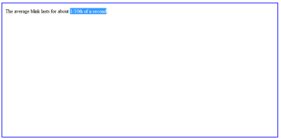

If you select the text like this, and press Alt+Z, you will create an Item directly under the Topic (note). You can confirm this by opening the knowledge tree and checking. Or you can press Alt+Left arrow to take you directly to your newly created Item. Here's how it will look (though the text will look differently in yours since you probably have HTML components instead of text components):
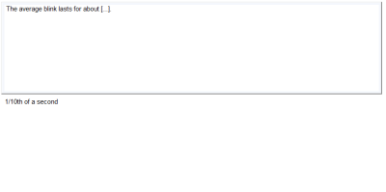

If you have longer texts in your Topic, then, as per the Incremental reading learning method, you'd want to make Topic (note) extracts (select text and press Alt+X) by dividing the entire text into smaller and smaller parts until you end up with a "unit", as the Topic/note example I used, that's appropriate for an Item, and then create Items from it. Here's an example for how the knowledge tree might look after processing some of the text on the Wikipedia article on oxen:

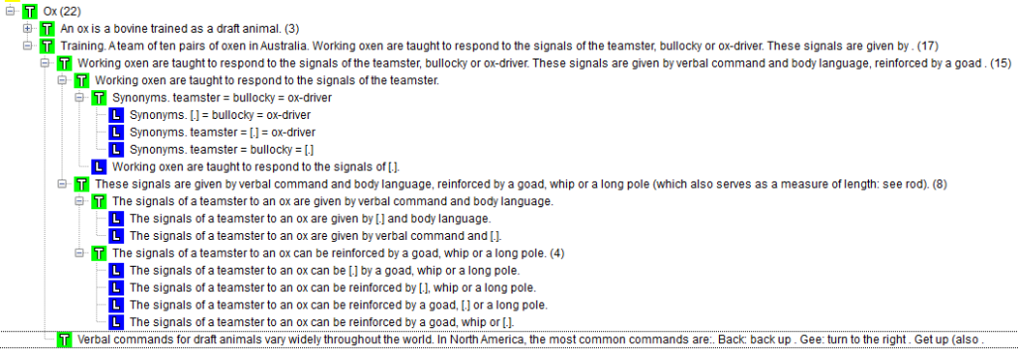

How to add a new Item to a specific sub-Topic?
With categories (and it seems the same with concepts) there are two different attachment points -- the root of the concept and the hook. The root is the topmost place in the KT where it resides while the hook can be anywhere. With categories I would create a "folder" Topic with the same name, assign that as the root of the category, then change the hook as needed on any node within that Topic. Did it all the time and it worked great.

So for example in SM16 I had a category called "Computer Science" that was rooted at the Topic "folder" node of the same name in this image:
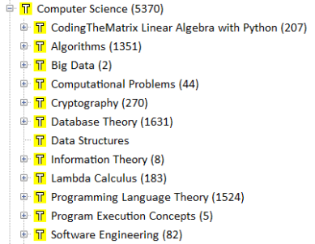

But I would move the hook for that anywhere within that hierarchy.
But it is still rooted at the top.

I would set the hook to cryptography then press Alt+A and it would add a new Item under cryptography automatically
The root wouldn't change unless I selected that option (they are right next to each other)
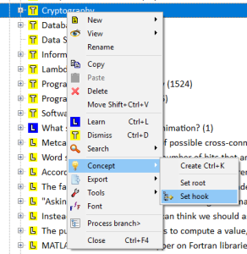

The hook is simply the location where new Items/Topics are added for the selected concept.

You change the current concept using the dropdown in the main window. So if I was working in Math and wanted to add a CS Item I would switch concepts to CS, pull up the KT window, find the cryptography node, then set the hook on it. That would set the hook for the CS concept so all future Items/Topics added /while the CS concept is active/ would be added under that node.

To keep the same example, I just changed the hook for my CS concept to the "Cryptography" node
the popup looks like this:
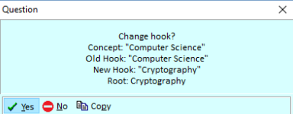

Hmm that's odd -- it changed the hook AND the root on mine
I just went into the concept registry and it shows this:
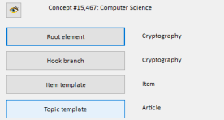

I manually changed it to the correct root. THIS is what I was talking about earlier.

Not sure what happened with it changing BOTH hook and root -- maybe @mrozikpl has some insight since concepts are still new to me. Categories didn't behave that way before.
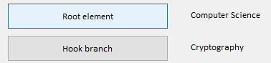
Now pressing Alt+A adds a new Item under the Cryptography node as expected
(it also did when both root and hook were the same node, but I still don't know why changing the hook changed the root as well -- maybe it's because I changed the hook to something outside of the concept? I haven't migrated my Topics under the concepts in the KT yet, not sure if I'm supposed to or not)

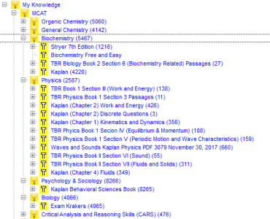
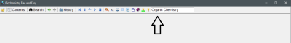
Any Alt+A I press adds to organic chemistry as well.

That concept above the arrow is only set by you. It doesn't mean "this Element belongs to this concept" but rather it means: "any new Element will go into this concept's hook".

If you choose a new section in the contents tree, the concept for adding new elements doesn't change.
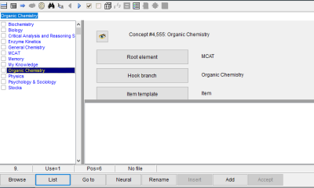
Is that right?
If you create a new Concept, SM will change the default concept group to your newly created concept, but not when selecting nodes.
I think you'll want to set the Root Element to Organic Chemistry as well, I don't see an use for setting the root Element above the concept's root.
But, if you, say, were studying Chang's Chemistry (book), and thus adding many elements in sequence to that sub-node within Organic Chemistry, you would temporarily set the Hook branch to Chang's Chemistry (and make sure to set the default concept group to Organic Chemistry first)
so any new elements would be in the Organic Chemistry concept group, but actually added to its Chang's Chemistry sub-node.
Uses for concepts:
- Linking concepts for neural Review
- Setting different learning parameters per concept group
- Setting different auto-applicable templates for each Element type (so you don't have to apply templates manually as often)(edited)
- Hook branch
Source: http://help.supermemo.org/wiki/Concepts

Dual KT-pane
I've gotten accustomed to using double pane whenever reorganizing my KT.
You can open 2 copies of SM containing 2 separate collections and copy and paste Items between the KTs. One at a time, unfortunately, but it is doable.

Repetitions

Practicing Repetitions
Repetition: act in which a given Item is rehearsed by going through the following stages:
- show the question (or the stimulus)
- respond to the question (or react to the stimulus)
- compare the response with the correct answer and grade yourself (or be graded by the program for your reaction to the stimulus)
Note that all Repetitions take place on a date selected by SuperMemo by using the Spaced Repetition algorithm (see: SuperMemo Algorithm).

Source: http://help.supermemo.org/wiki/Glossary#Repetition

Grading
Apart from pass and fail, grades don't have any affect on the next Repetition date scheduled for an Item. Major distinction comes from 5,4,3 vs 2,1. The only thing that gets altered minorly is the Interval length.

Does the response time at Repetitions influence the next Interval?
NO.
Source: http://super-Memory.com/help/faq/learn.htm#Responsetime

Opening Clozes

Q: I had the same issue with the trailing space and got into a bit of an argument with someone (one of the support team?) on Supermemopedia about it a long time back. They advocated using the keyboard like Piotr does in the videos and claimed it is faster but I disagree. MS Office shows it can be done to select the word without the trailing space and there is empirical usability evidence that shows using the mouse in conjunction with the keyboard (e.g. double-click word with right hand mouse and left hand executes Cloze instantly) yields great results. Otherwise we would have stopped using mice decades ago. :\

A: yes. Ctrl+. and Ctrl+/ are very helpful. In my case I read short extracts (usually ready for Cloze) with Ctrl+Right. Then I press Ctrl+Shift+Right / Ctrl+Shift+Left and select the Cloze (when not using the mouse)

Grading Clozes
Q: If you guys answer a Cloze with a synonym rather than that specific answer do you grade it as "fail", "good", or "great"?
A:
- Rather good. From what I remember in algo SM 17 the difference is only between Fail/Pass. I find the same Interval SM is computed whenever you grade 5,4,3.
- I mark "fails" when I have a blank in Memory. "pass" for synonyms or closely related terms. "good" for answers that take about 1-3 seconds "great" for immediate correct answers.
“In the old days, when you had to type the whole text yourself, you might try to do it perfectly at first attempt. Different formulations would only take the cost of processing of information in your brain. With solid fluency, that cost would be negligible.
In Incremental reading, the formulation is handed to your from electronic sources. This is what makes for the blitz learning speed of Incremental reading. […]
These Items probably gets a pass via pattern recognition in which the eye picks up some salient strings and generates the right semantics even if the grammar is bad, formulation illogical, MIP violated, etc.
Those fast pattern recognition answers are dangerous in that they may not ensure the recall in all life contexts. However, Incremental reading covers that up with redundancy. If you encounter the same information while reading in a different context and it still seems novel, you will cover it with two Items from different angles. This boosts usability without slowing you down.”
Source: http://Supermemopedia.com/wiki/You_do_not_stick_to_your_own_20_rules!

Editing while Reviewing

When should I edit my elements ?
“A good rule of the thumb is "one edit per one Review". This helps you prevent edititis, i.e. editing your Items to perfection at infinitum while being pretty slow in overall learning. “

“Most of all, if an Item works, and works instantly, there is no need to improve it, unless (1) it takes more time to Review that it would take to edit, or (2) you suspect you might fail in the future. “

Source: http://Supermemopedia.com/wiki/You_do_not_stick_to_your_own_20_rules!

Should I Dismiss Topics after extracting their Items ?
Q: So I created a lot of extract (by Alt+X), then those extract will have the same Review schedule as my Q&A? Do you guys delete the extracts? Wouldn't having both the extract and its corresponding Q&A or Clozed Item redundant?

A: I think once you have created Items (Cloze deletions/"Q&A") for a particular Topic extract, you can safely Dismiss the original Topic that they came from.
Even if you don't, though, passive Review of a Topic isn't likely to interfere much with your performance on its related Items--even when the two occur on the same day, although same-day Review should occur rarely, especially after a first Interval or two, since their Interval sequences will be different and since SM introduces significant randomization around the "ideal" Interval for an Item/Topic.
If a Topic and one of its Items happens to occur in your Repetitions for the same given day, and if you feel the passive Review of the Topic affected your recall of the related Item, then you can grade the Item as you think you would have performed had you not seen the Topic.
(If you think you would have failed without the Topic Review, then grade the Item "fail." I find that I usually have a good sense of how I would have performed without the passive reminder.)
But, again, I personally Dismiss Topics once I've created Items for them.

Q: Do you Ctrl+D to Dismiss these Topics because you already have a Cloze deletion on them?Would this Topic be called part of the IR process?

A: If you feel the existing Clozes sufficiently cover it, I would, yes. I would then return to it only if one of the existing Clozes were to become a leech.

See also: Dealing with fully extracted Topics (IR)

Dismiss v.s. Done
Dismiss removes the Topic from the queue but keeps all the content in the node in the KT, while Done removes it from the queue and deletes all its content. So you can Dismiss if you want to keep the original info around. I only recently started using Done and only for those things I know I've finished processing.

Leeches
Particularly difficult Item that causes problems in learning. The definition of a leech is specified by means of the Element filter dialog box used in View : Other : Leeches (Shift+F3) from the main menu. A semi-leech is an Item that is not a leech but will become one once it is forgotten. See: Leeches
Source: http://help.supermemo.org/wiki/Glossary#Leech

Dealing with leeches
If a leech comes up, I first apply one of the 20 rules at a time and see how it works. If I used most of the 20 rules, the only remedy is a mnemonic technique and some redundancy (helps stabilize additional synaptic patterns): try to peg them to a specific location you know VERY WELL. The method of Loci technique is almost infallible if you use it correctly). If it doesn't work postpone to reset your Memory trace. And even if this doesn't work, delete/Dismiss.

The leech wizard
Q: Now that I know the answer, how do I stop this wizard popping up all the time?
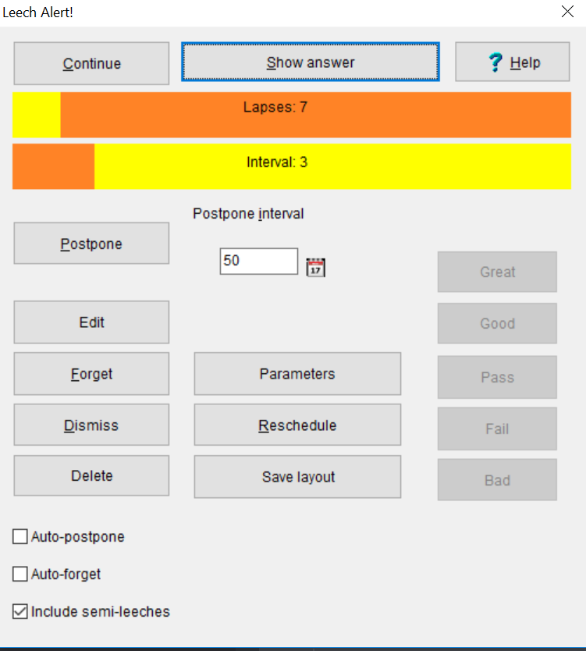

A: If you don't look to further reschedule or reformulate the Element just answer correctly a few more times. The number of lapses will still be saved in the Element's Repetition history but the Interval will widen enough not to be considered a leech anymore.
“It is the combination of certain number of lapses + Interval that trigger the Wizard.
Press Shift+F3 or View : Other : Leeches to see the criteria.”

Source: http://help.supermemo.org/wiki/Leeches
You can also disable leech management globally.

Final drill

About its usefulness
As your knowledge tree grows, you will rarely go to the end of your learning process.
Alt+O > Learning > Skipp final drill

Accessing it
I hit ESC from the main window and was prompted for final drill

Managing Repetitions

Sorting criteria
You can change the order of Items and Topics generally in "Learn : Sorting : Sorting criteria" (Ctrl+V>O). In this window you can set how you want your elements to be sequenced as you learn generally. The higher you set the "proportion of Topics", the more Topics are prioritized, and the lower the setting the less Topics and more Items.

I like to have my Topics shown first with just a small amount of Item Repetitions. When I finish my Topics, I can focus solely on Items later. So I set it pretty high, as you can see. Regarding the two other sliders, since I want to focus on my highest-Priority material, I also set the prioritized Items/Topics more to prioritized than randomized, but not completely, because I still want to see some material that's not as prioritized-which, due to overload, I otherwise wouldn't see without processing the entire overload. With a small amount of randomization, I can see some unprioritized elements despite the overload. This interplays with the Priority queue though, so unless you've made out proper Priorities for your elements, I wouldn't mess with this.
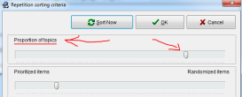

How to reschedule Items ?
Ctrl+M, or view these Items in Browser. Set to xx day
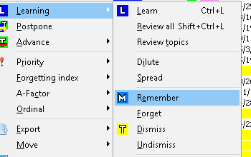

How to reset Items ?
  - One by one
    - Choose forget then remember in Browser
    - Or Ctrl+M
  - Multiple
    - Click the parent Topic, Process Branch > Learning > Forget. Then Remember

How to Spread an imported Topic ?
1) Open the branch with your elements. (breed). i.e. select the Mother:
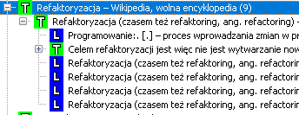

Or if you have not a mother just select Shift+Up / Shift+Down, and click Ctrl+Space
You will see sth like that:
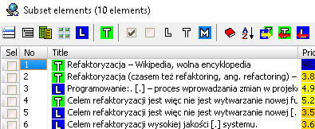

2) Now, right-click the mouse over the "Browser":
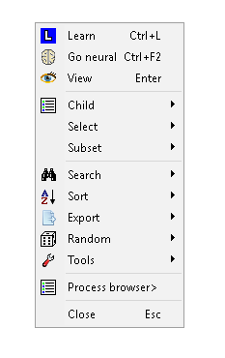

3) Process Browser > Learning > Spread:
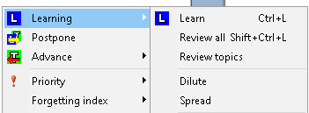

4) Press YES

5) Select desired Number of elements per day, and Rescheduling period > OK
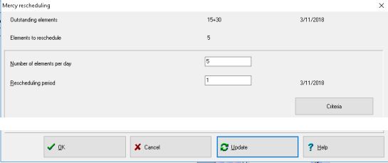

Priority queue
Queue of elements ordered by their Priority. Use Priority queue to always start from learning the material that is most important for you. Do not despair if you do not finish learning for a day. With Priority queue, you know you did your best and only lower Priority material was left behind. Remember to use Auto-sort and Auto-postpone to make the most of the Priority queue. See: Priority queue
Source: http://help.supermemo.org/wiki/Glossary#Priority_queue

Priority
Number that reflects the importance of an Element in SuperMemo. Most important elements have the Priority 0%, while the least important elements have the Priority 100%. Priority can be changed with Priority : Modify (Alt+P) on the Element menu. For more, see: Priority queue
Source: http://help.supermemo.org/wiki/Glossary#Priority

On its importance: The Priority bias
“False sense that all learning subjects are very important and equally important. Only months of prioritization training can help overcome this bias/sensation. A good user of SuperMemo will avail of the full spectrum of Priorities from 0% to 100%, and will apply them naturally and instinctively.”
Source: http://help.supermemo.org/wiki/Glossary#Priority_bias

There are some bias related to your Repetitions, such as tunnel vision and Priority bias (thinking that everything is important). That's why sorting criteria is helpful.
At first it's difficult to prioritize bc. It's a feeling that you approve forgetting.
I would recommend to practice prioritizing bc. your learning process will be better sorted (from high Priority to low), and more important, you start with high-Priority when your brain is the most freshed.
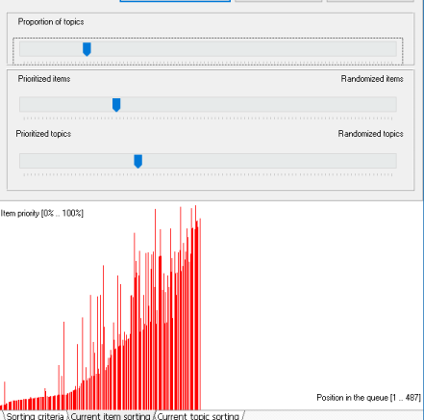

Important moments to prioritize
The most important moments to prioritize elements/Element sets:
- At Item failure (e.g. by lowering Priority)
- At finish reading the article (e.g. by using Spread : Priorities)
- At new Clozes (e.g. you could set high Priority for new Cloze to hatch in your Memory at least once)
Source: http://help.supermemo.org/wiki/Priority_queue#Prioritization_rulebook

Automatic Priorities setting in IR
In Incremental reading, extract Priorities depend on a number of factors. Primarily, they are derived from the Priority of the parenting Topic. The higher the Priority of the parent, the higher the Priority of the extract. However, for very high Priorities, extract's Priority is likely to be lower than that of the parent, while for low Priority Articles, extract's Priority may be much higher than that of the article. This is because high Priority Articles are supposed to be read slowly line by line and generate many extracts, while low Priority Articles are only skimmed or speed-read while fishing for extracts. Length of the extract also affects its Priority, with short extracts receiving a higher Priority. This is because long extracts are usually created for the sake of later reading, while shorter extracts are more likely to contain meaningful information that is only a step away from generating Cloze deletions. Finally, a tiny degree of randomization is added in generating extract Priorities in order to prevent clustering of extracts coming from the same article while making Repetitions sorted by Priority.
Priority of Cloze deletions is similar to that of the parenting extract. To prevent the clustering of Items derived from the same extract, as well as to avoid Spacing effect and interference, Priorities and the first Intervals of Cloze deletions are dispersed randomly around the presumed optimum value.
Source: https://www.supermemo.com/help/new2006.htm#Automatic%20priority%20setting%20in%20incremental%20reading [Appear to be working as described]

Default Priority option in concepts
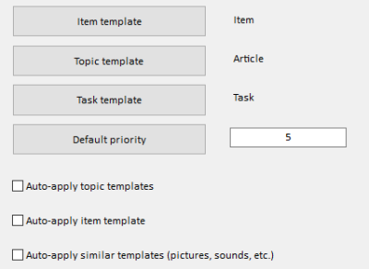

Priority is a range from 0..100 in percentage --
Setting the value is choosing where in the Priority queue all created elements go, so a setting of 0 = always the #1 Item, setting of 50 = 50% into the queue, 100 = all the way at the end of the queue etc

Priority is attached to each Element so the elements inherit the default setting at creation time but after that Priority can shift.
It mixes it up a little so that you don't just always do 0s

Postpone

Definition & Why is it so important ?
Learn : Postpone can be used to move outstanding material Review to a later time whenever you cannot cope with your daily load of Repetitions. [… With the advent of] Incremental reading [.. it serves] an anti-overload option: Postpone blurs the concept of the must-do outstanding material that had levied a heavy toll on the ranks of SuperMemo users. [...] To fully understand the importance of Postpone, you need to master the concept of Incremental reading first.
Source: http://help.supermemo.org/wiki/Postpone

Auto-postpone
Option available with Learn : Postpone : Auto-postpone (from the main menu) that makes sure that excess Repetitions are automatically postponed before the learning begins. Auto-postpone uses user-defined criteria in choosing elements that should be postponed. Most importantly, high Priority material is protected from being postponed. Auto-postpone affects only the material that has been left outstanding from previous days. It does not postpone Repetitions scheduled for the current day until the next day of learning.
Source: http://help.supermemo.org/wiki/Glossary#Auto-postpone
Auto-postpone affects only outstanding elements scheduled on preceding days. For example, on Dec 1, 2009, Repetitions from all days up to Nov 30, 2009 will be subject to default Postpone. Only Repetitions scheduled on Dec 1, 2009 (and in the future) will not be affected.
Source: https://www.supermemo.com/help/postpone.htm

If you haven't already, you might want to check out the "auto-postpone" function, which would ease up on the daily load.

Dealing with large outstanding queue

Q: So am I understanding correctly that if I use postpone I can reduce that near-3000 Item outstanding queue to just today's workload + 50 ? (or whatever I set the # to)

A: I would advise using postpone only on at least semi leeches.
Otherwise, all that postpone does is create the illusion of clearing your outstanding queue.

The only Items you should care about Reviewing on any given day are those in immediate threat of being forgotten (falling below 90% retrievability). That includes only the outstanding Items scheduled for today and very recent days.
Everything else you can just treat as forgotten and Review them at your leisure. No sense in postponing them as that will just obscure how long they been forgotten.

Q: How to filter the outstanding queue in the browser to show only those < 90% ?

A: Filter based on Review date. Do the Items that are scheduled for today and very recent days. Tackle the others in whenever and however you want; they are essentially forgotten.
That's what I do at least, and it's working well for me I think

Q: How would you define "very recent" in that case? I'm looking at the filter and the default Interval is 0..60. It also checks only memorized Items by default, not pending.
Virtually all the Items I've put in for the past 3 months are in the one Topic I'm focused on anyway.
0..30 memorized gives 1,411 elements
0..5 memorized gives 253
But I'm not seeing the connection between # days and forgetting index going below 90%
I do see however that it is showing the Items that would be presented for reps during that timespan, which is fine.

A: Yeah, I just sort by schedule date, not by retrievability. That is, I sort by Next rep ascending (default order). I worry about today's reps first. Yesterday's less so. The day before yesterday's even less than yesterday's. Etc.
Whatever is scheduled for today ("next Repetition" date) you can assume are most on the verge of forgetting.
It's impossible to identify whether an Item is forgotten without attempting to recall it. "Forgottenness" can only be expressed in terms of a probability. And most of us treat anything with less than 90% probability as being "forgotten"

Q: Just to clarify, are you talking about setting Interval 0..1 in the filter dialog, or setting the next rep field in the filter dialog to today?

This is what I had that got me 108 starting from Oct 2:
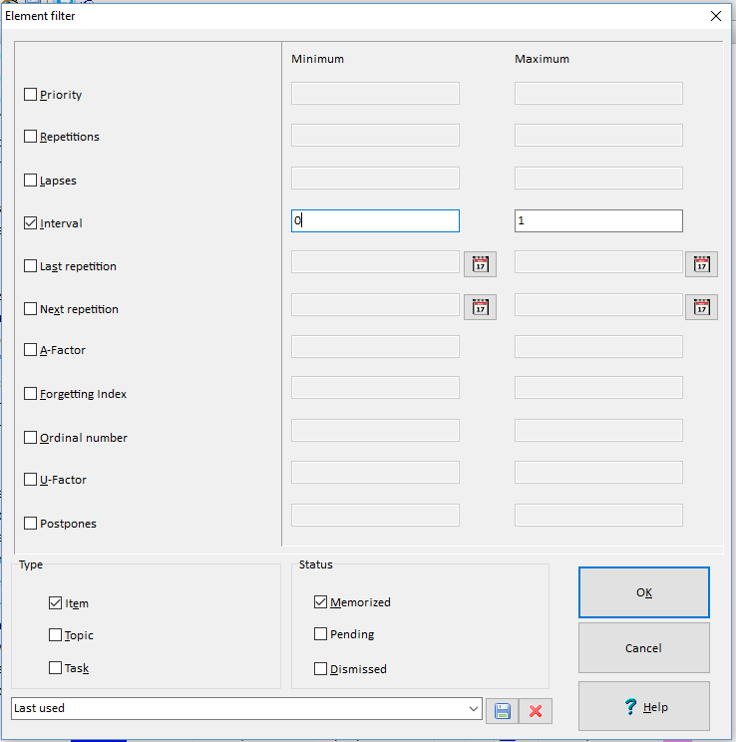

I just changed to filter on next Interval of today and it now lines up w/ workload of 88:
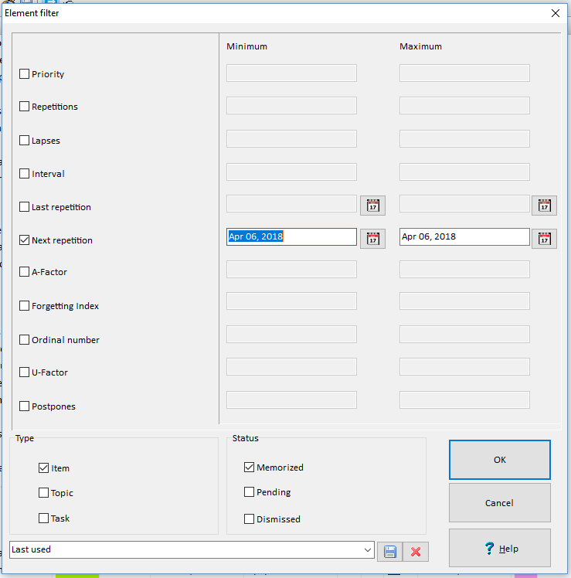

A: Don't use Interval, use next rep (as in last screenshot)

This process essentially gives you a filtered subset of the outstanding queue. Run Learn on it, and then when done that means you've processed today's reps and can ignore all the rest of the outstanding queue.
I also run randomize on the filtered list before learn.

Setting custom Intervals
Q: I have one right now that is set to 14 days, because earlier today I chose to use the minimum possible Interval.
Will it:
- Use the minimum possible calculated Interval now on EVERY future rep for that Item,
- Or, only the first rep of that Item?
I want minimum Interval for these Items but only until I pass my test, then I want to relax the Interval.

A: "In SuperMemo 17, cutting the Interval from 3 years to 3 months will work only for that one Interval. In the next Review, SuperMemo 17 will always compute the status of Memory and will likely propose a long Interval again (e.g. 4 years)."

How to restrict Repetitions to Items only ?
Q: How do you change sorting criteria? I absolutely want to separate Items and Topics to do Items first. Currently they are mixed in so I end up skipping Topics every day just because I only have time to do my Items at that moment so the Topics are wasted.

A: In Browser leave only Items and go Ctrl+L

Filtering postponed elements
If you abuse Ctrl+J you can catch them by filtering by postpones on Topics:
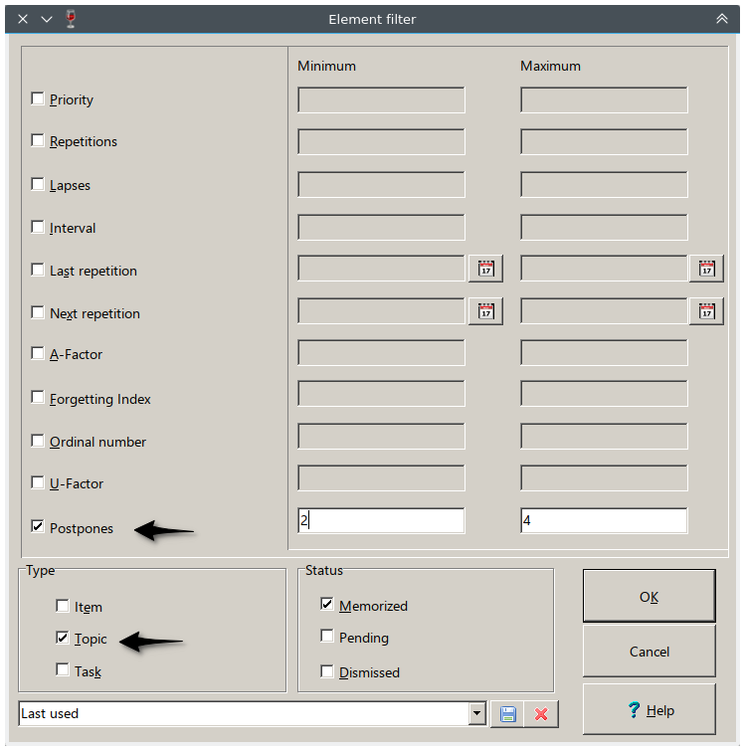
I ran the filter with 1..4 since I don't have elements with 2 postpones.

Customizing rating buttons
I found this small tweak much more intuitive.

You can change it in Tools -> Options -> Language tab -> Localization Table button
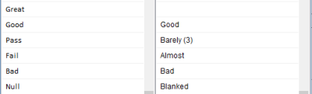
I don't see a Null/Blanked button in the rating so I just rate a complete blank as "Bad"

“Very personalized” sample:
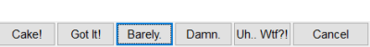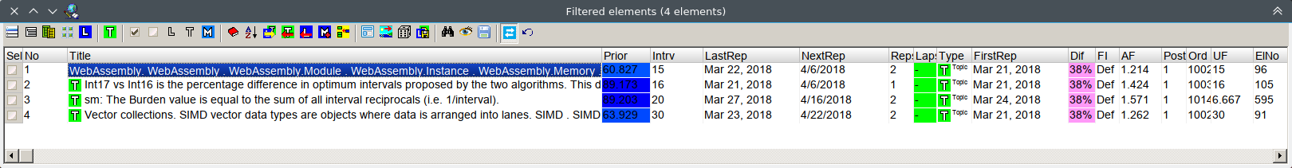

Neural reviews
Neural mode uses concepts links and the knowledge tree to create outstanding reviews.
“Even though concept groups are used in spreading activation in neural creativity the links formed by parent-child-sibling relationships are taken as only carrying minor Priority (in comparison to concept-concept, concept-Element and Element-Element links set by the user)”

Spaced Repetition Algorithm

Different algorithms
“Topics and Items are presented for Review in the learning process in a different way:
- Topics are presented in always increasing Intervals. Each new Interval equals the old Interval multiplied by a constant called A-Factor
- Items are presented in Intervals that depend on grades you score in the process of learning. Those Intervals are determined by the SuperMemo algorithm. If you grade your answer Pass (3) or more, the Interval will increase. Otherwise it will drop back to a few days (i.e. the Item will be considered forgotten)”
Source: https://www.supermemo.com/help/Topic.htm

Q: Do you know what algo the Topics use for Repetition?

A: Algo for Topics is:
- Fully under your control
  - It's not for "optimum Memory",
  - But "optimum for processing knowledge" i.e.
    - reading,
    - extracting,
    - etc.
- Increasing (to dilute the learning process)
  - Look for term A-Factor
    - If e.g. A-Factor is 2 Review Interval will double.
    - The higher the A-Factor the faster the increase Intervals.
- Shortcuts
  - Ctrl+J or Ctrl+Shift+R : Set Interval whatever you want.

Retention
“Proportion of knowledge retained in Memory at any given time. Retention is greater than 100% minus the forgetting index. The forgetting index refers to the probability of forgetting at the moment of a Repetition while retention refers to the average recall probability between the last and the next Repetition. For an exact formula linking the forgetting index and the retention see: Theoretical aspects of SuperMemo. Retention equals 100% minus the forgetting index only when measured on Items repeated on a single day (e.g. as displayed in Tools : Calendar)”

Source: http://help.supermemo.org/wiki/Glossary#Retention

Forgetting Index
“Proportion of elements that are not remembered at Repetitions (usually expressed as percentage). The forgetting index can be programmed to fall between 3% and 20%. This way, the speed vs. retention trade-off in learning can be controlled by the student. You can set the default forgetting index with Tools : Options : Learning : Forgetting index (default) and individual Element forgetting indices with Forgetting index in the Element parameters dialog box. To understand the difference between the requested, measured, default, individual, expected and the estimated forgetting index, see: Forgetting index”

Source: http://help.supermemo.org/wiki/Glossary#Forgetting_index

Measurement
“Forgetting index as it is actually measured at Repetitions. It is displayed in the statistics window as Measured FI. Measured forgetting index is usually higher than the requested forgetting index, esp. if the forgetting index is less than 5%. This comes from the fact that SuperMemo imposes some limitations on the length of Intervals in order to prevent excessively frequent Repetitions. Secondly, if you delay Repetitions, skip Repetitions on a given day, or use Postpone, you step away from the optimum learning process and inevitably increase the measured forgetting index. Finally, in an overloaded learning process, the measured forgetting index of low-Priority Items is higher by design (see: Tools : Statistics : Analysis : Graphs : Forgetting Index vs. Priority). You can restart the measurements of the forgetting index with Tools : Statistics : Reset parameters : Forgetting index record

Source: https://www.supermemo.com/help/fi.htm#measured_forgetting_index

Effective retention
If you set your forgetting index to 10%, you will remember 90% of the material at Repetitions. This does not imply that your knowledge retention will be 90% only. Your average retention will be nearly 95%! This comes from the fact that 90% refers to the retention at Repetitions, while the initial retention right after the Repetition is theoretically 100%. During the inter-Repetition Interval, retention is decreasing from 100% to 90%. On average you roughly remember 95% of the material. The exact formula linking the forgetting index with the retention is as follows (source):
retention = -(forgetting index)/ln(1-(forgetting index))
Forgetting index | Retention
3% | 98.49%
5% | 97.47%
10% | 94.91%
15% | 92.29%
20% | 89.62%
The reason that the retention is not equal to 1-0.5*(forgetting index) is that forgetting is approximately exponential in nature. Immediately after the Repetition, forgetting proceeds at the highest rate.
Source: https://www.supermemo.com/help/fi.htm#Retention_is_higher_than_100.25_minus_the_forgetting_index.21

Incremental reading

Repetition algorithm (Topics)
See: Different algorithms

Dealing with fully extracted Topics
Once you've completely finished a Topic and don't feel like storing the contents, do the "Learning : done" command on the Element menu.
“Once you complete reading the entire article and have extracted all the interesting fragments, press Ctrl+Shift+Enter (or Learning : Done on the Element menu). This will Dismiss the article, i.e. remove it from the Review process, and delete the contents of the processed article (without deleting the extracted material). Done will delete a childless article (i.e. an article that did not provide interesting extract or whose extracts have been processed and moved to various Categories). Using Done will greatly reduce the size your collection and eliminate "dead hits" when searching through your collection.”
Source: https://www.supermemo.com/help/read.htm#Skill_2:_Reading_Articles
Look up woz's WW2 IR video (https://www.YouTube.com/watch?v=XRuLV2_A3Ts) he posted on YouTube last month. It shows how he uses Done to Dismiss and delete simultaneously while preserving the node in the KT. Also shows how he reformulates Items.
That's interesting. It deletes the contents? Frequently I return to a Topic to extract more Items, such as when I discover I left something out, that an existing Cloze deletion is too broad (i.e. , does not adequately meet the Minimum Information Principle), or when some piece of the original Topic that once seemed insignificant now seems quite so. I see the benefits of removing them--as you mentioned, dead search hits and large collection size--but maybe keep the risk in mind
See also: Should I Dismiss Topics after extracting their Items ?
See also: Dismiss v.s. Done

Article Priority
See: Automatic Priorities setting in IR

Background Colors in Internet Explorer are used in Incremental reading
“Instead of font color, background Colors are used in HTML-based Incremental reading to preserve the original font used in the document. However, for this to work you must uncheck this option in your Internet Explorer: Tools : Internet Options : Accessibility : Formatting : Ignore Colors specified on Web pages”

Source: https://www.supermemo.com/help/faq/read.htm#139-8844

When I try to change the size of Fonts in HTML components nothing happens
“This will happen if your Internet Explorer is set to ignore font size. This can be set in Internet Explorer (not in SuperMemo) at Tools : Internet Options : General : Accessibility : Ignore font sizes (specified on webpages)”

Source: https://www.supermemo.com/help/faq/HTML.htm#126-9536

Elements & Content

Templates

Creating Templates
You will want to clearly mark your templates as either being an Item Template or a Topic Template. I put "Item - xxx" or "Topic - xxx" prefixes in mine.
Only apply Item templates to Items and Topic Items to Topics.
To create/edit a Template safely, create a new Element and detach it from its assigned Template: Element menu : Template : detach Template. You can double check in the Element parameters: Ctrl+Shift+P, in which it should say "none" for the Template. Then you can edit the Template and not worry about other elements becoming affected.

Applying a default Templates
The Template that will automatically be assigned to an Element depends on the current concept selected. In this case, you have selected "Root: All My Knowledge" (you see this in the Element window). If you click the lightbulb symbol right to the left of it, you'll bring up the concept registry. Here you can change the Template that'll be automatically assigned to elements upon creation, by clicking where I underlined, and picking a new Template from the window (Template registry) that pops up.
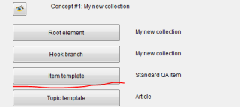

This will not change the templates for the elements already assigned to the concept, but only to the elements you create after changing the assigned Template.
And yeah, you might want to create and save the desired Template first, so you can pick it out from the list at all! Then you create a random Item and go for: Element menu : Template : detach Template", create the desired Template and then go "Element menu : Template : save as Template". Then you have created and saved,a new Template that you can assign to the concept since it's in the Template registry.

If you change an article's concept group, and after that, you make Cloze deletions, they will take the Template you set as the Item Template for that concept group

They are 3-state checkboxes. The middle state (dimmed checked appearance) means you will get a prompt to auto-apply a Template (e.g. when making a Cloze deletion), while the fully checked state means you will get no prompts

Automatic Template selection (text, Picture, ...)
If you want an Item Template with a Picture to be assigned automatically, then create a new Template and name it after the standard one, but with "Picture" after. For me, this assigns the standard Item Template and the Picture "variant" appropriately. I remember reading in the documentation that putting "Picture" after the name makes it functionally different. This seems to be exclusive to "Picture" and maybe some other expression. For "sound", "import file", etc. I have to assign this Template manually.

Editing a Template
WARNING: DO NOT EDIT ANY Template IN THE Template REGISTRY! I did that before and hosed everything up. I think the SM tech support had to fix my collection manually. If you need to change a Template create a new Item/Topic, apply the Template, make the change, then save as the original Template name. (it sucks that the app allows you to edit in the registry but either the docs or Supermemopedia emphatically warns against it)

Elements

Switching elements type between Items/Topics
You can switch an Item to a Topic and vice versa using Ctrl+Shift+P and also change the Template from there, but I've gotten odd warnings/errors occasionally if I change both at once.

Content format

Formatting text
For text formatting I’ve always opted for Ctrl+Shift+F12 (I think) which just gets rid of all formatting and makes it look like a plain text document. The more I use SuperMemo the less I care about stuff I would usually care about; formatting, font, heck, the feeling of holding a book even, because I’m more looking for valuable ideas rather than progress though something for the sake of doing it. I’m not trying to knock anyone (it’s cool if you want to use a certain font or format), but when it comes to most reading that doesn’t have diagrams or important Pictures in it, I’ve found it easier to just strip as much away as possible. I do use Pictures A LOT though.
I've also used Ctrl+Shift+F12 almost every time I paste something in, then bold what I want to emphasize etc. I set my default font to Calibri maybe 14 or 16 pt can't recall, plenty large enough to read without being overwhelming. With F6 now that might change a bit though, especially since I just found out Ctrl+Shift+1 converts only the selected content to plain text. So now I can surgically reformat instead of nuking everything.
Try to split this book, or better yet, extract some text. Now, to filter HTML :
- Use F6,
- Or try to select text and Ctrl+Shift+1,
- Or Ctrl+Shift+F12 for entire text Component.

Cloze : Display style
Is the red the default colour? Do you find it rather hard to read because it is so dark and not enough contrast with the text?

You can change your Stylesheet if you wish :
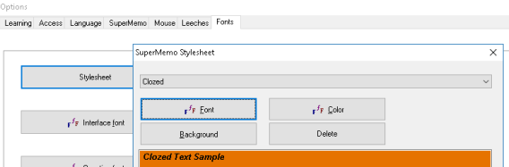

I modified my Stylesheet a long time ago to change the default text font to 16pt Calibri. Much easier on my tired eyes.
Especially since I was in the habit of taking all pasted in text and hitting Ctrl+Shift+F12 to convert to plain text then bolding/line breaking/etc as I wanted.

Cloze : How to remove the colored background of text when you do a Cloze or extract ?
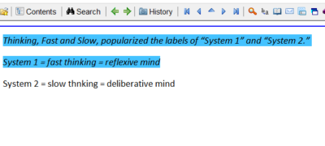
Q: I want to nuke the blue
A: That is not advised, the colored text reminds you that an extract on thay piece of information was created. It is also unnecessary, SM will clean it up for you when you do the next Cloze anyway

Example:
I just made three Clozes from this, first "test" then "test 123" then "test 123 456" -- in the last two there was already some orange highlight from the previous Cloze
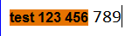
first Cloze
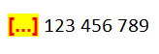
second
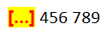
second Cloze's answer -- notice the orange is automatically cleaned up
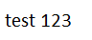
etc

If you still want to do it: Ctrl+Shift+F6 > Ctrl+F > Extract > Delete it

Images

Picture editing/viewing shorcuts

Open in Picture editing software
Shift+Click on Picture Component: it will open in Paint.

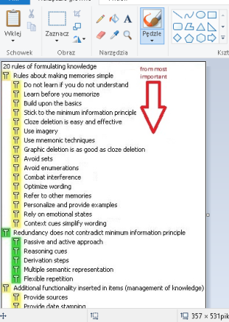

Open in viewer
Ctrl+Click on the Picture Component: open in default image viewer.

Image occlusion : About occlusions on different systems
I was advised (IIRC) that SM expects every system it is on to have the same resolution, therefore once I create an occlusion at a certain resolution on one system all future reps (presumably for the rest of my life?) must be at the same resolution…
Because of that I quit using SM occlusions and just manually create separate images in Paint.NET if I need that.

Image registry

Searching, Supersets, Subsets

Importing images
To mass import Pictures, access the image registry and then click Add:
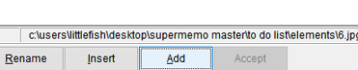

Built-in tools

Plan
http://supermemo.guru/wiki/Planning_a_perfect_productive_day_without_stress
http://help.supermemo.org/wiki/Plan#Creating_a_new_schedule

Tasklist
Basically a task list is a list of things, and each thing has its own “profile”, I guess? The two most important criteria in the “profile” of each task is “value” and “time”.
To figure out “value” one suggestion on the SuperMemo site is to ask yourself “if I could pay someone money to do this thing, how much would I be willing to pay them?”. To figure out “time” you are supposed to calculate based on “1 = 1 hour,” and break it down to whatever value it needs to be, but I’m lazy so I treat it as 1 = 1 minute.
As an example let's say I want to change my GMail password every six months or so for security purposes. I would create a new task that says "Change Google password". Because I know it would suck having my mail account hacked, I know that even though it is boring, it is really valuable.
So I would say I would be willing to spend $50 a year to have someone do this thing for me, so I mark "50" in the value field. In order to do this, I would need to open up "1 Password," my password manager thing, get my old password, generate a new password and make sure this password is changed on my iPhone, iPad, computer and SM laptop, it might take 10 minutes collectively to do this, so in the "time" field I mark 10. SM divides the value (50) by time (10) and uses this to calculate "Priority" which is 10.
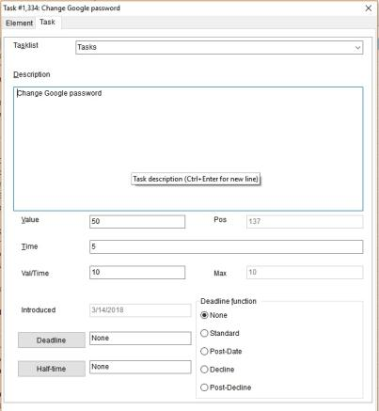

Task Lists have been more useful for me at helping me figure out the value of the things I want to do. Often times whatever is new is what feels the most important, but it's not always that way.

YES, the deadline function has changed the game
The other thing I have REALLY grown to like about task lists is that each task is it's own "Topic" also. So I can easily write down "captain's logs" about whatever thing it is, especially if it's something that's repeating.

So I set the task to a deadline for six months from now, and six months from now it appears on my list. But if for some reason BEFORE that I see the need to change my password, I can go back into the task list and find the task and leave a note about it in the "log"
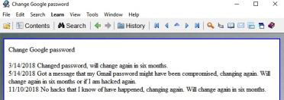

For important repeating tasks in my life, I just create a task, try my best to give it the proper value and time estimate, and SM arranges it so that the most important thing is first. I start there and work my way down, dismissing tasks that no longer are relevant or delaying the ones that are recurring to the appropriate time. If it's recurring I write a note down and then send the deadline to whatever point in the future.
They pop up just like any Topic would, but most of the time I just pass over them without much thought. It's just nice to know that everything that's important to me is "in circulation" and I've also gotten a little kick out of writing myself notes for the future. Like that skit in the office where Jim sends Dwight messages from the future.
Guess it's not totally the same, but it's like sending yourself e-mails that you get on a specific day. It's like rescheduling Topics, but it's not the "do something right now" immediacy that Topics are. With Topics you need to take action right then and there (read, extract, Dismiss), but tasks are more flexible because they CAN be.
- I have multiple collections that I use solely for the tasklist it contains (Books/movies/media I want to consume),
- And I have one master tasklist that I look at and complete every day.

Visual browser
Visual browser is rather for photo album or for templates where you have a big "Picture Component"

Statistics

What is the easiest way of assessing learning performance ?
On the assumption you do not cheat on your grades, you can use the following in Tools : Statistics : Statistics:
- Size of your knowledge: Memorized
- Speed of learning: Memorized/Day
- Quality of learning: Retention
See the exact explanation in help files. All those parameters can be misleading if not interpreted correctly.
Source: http://Supermemopedia.com/wiki/What_is_the_best_way_of_assessing_your_performance_in_learning_on_SuperMemo%3F

Misc
- In the Workload window, when we see i+t of say 12 + 3, that is 12 things to push into long term Memory via Repetitions, and 3 Articles to process into knowledge via Cloze or Q&A
- Better view of repeating Items per day
  - > Shift+Alt+A > Use > Workdone > Item Repetitions.
- To see your MFI and Retention on particular subject (branch): Ctrl+Shift+B
- You can use “Repetitions”, to know how many Items Topics you have done today.
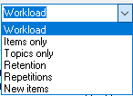

Quick access cheat sheet
We can set a default Element e.g. in my case root of the knowledge tree (ALL)
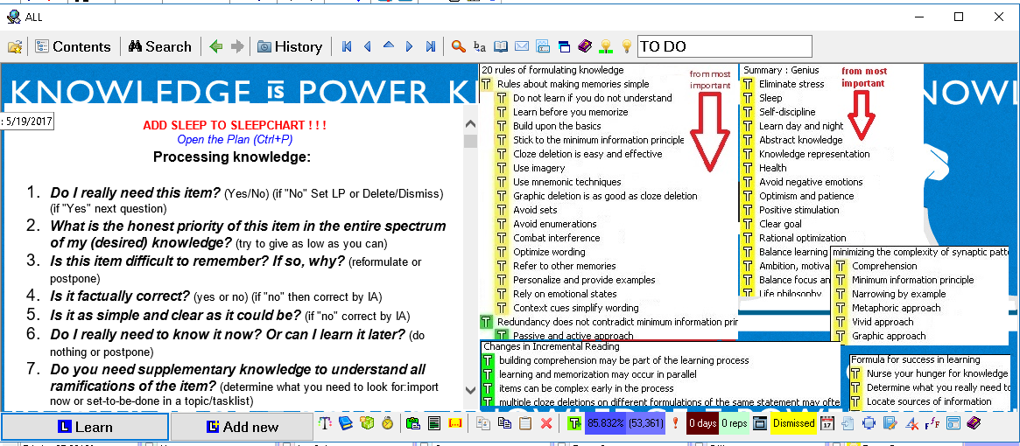
when we click ESC this should show up (in my example) and e.g. when you are processing knowledge and you want to have some quick information stored in your collection, you press ESC.

To do this, Alt+O > Access > select this.
NOW, create HTML Component by Alt+E > C > H
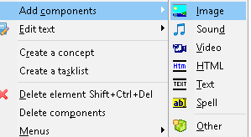


For instance, in that root you can create HTML Component (Alt+E>C>H), and store some information and Pictures also

In my case there are question about "processing knowledge"
so, whenever I feel I need to some information I just click ESC and Alt+Left to back to my Items
and that's how it looks like when I click (windows + Up)

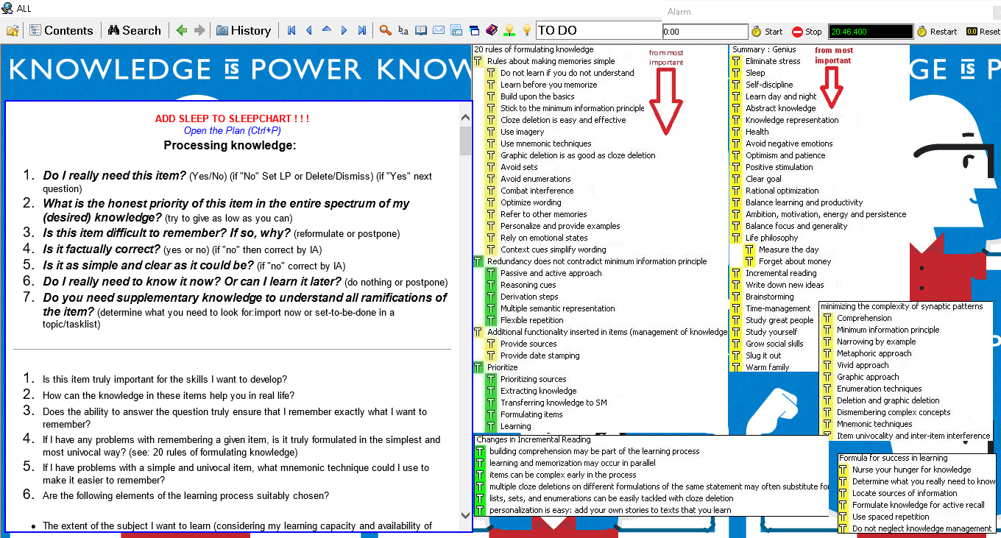

Scripting
http://help.supermemo.org/wiki/Scripts

Shortcuts

By category (TODO: Classify)
- Content / Element
  - F3: Search in text in Current Element
  - F6: Filter HTML code
  - F9: Open file associated with selected Component, in default app
  - F12: Open Sleep Chart
  - ESC: Presentation mode
  - Alt+A: Create new empty Q/A Item
  - Alt+D: Duplicate current Element
  - Alt+M: Open Template registry/Apply Template
  - Alt+N: Create new empty Topic
  - Alt+O: Open Option dialog
  - Alt+P: Open Priority dialog
  - Alt+Q: Create Reference
  - Alt+R: Rename an Image in the Image Registry
  - Alt+T: Edit Title of Element, or use selected text as Title
  - Alt+U: Translate selected text
  - Alt+X: Extract content to a new Topic
  - Alt+Y: Replace selected text with its Phonetic transcription
  - Alt+Z: Create a new Cloze Item from selection into a child Item
  - Alt+F1: Create new Task
  - Alt+F10: Open Element menu
  - Alt+F12: Open Component menu
  - Alt+\: Delete text before the cursor
  - Alt+.: Delete text after the cursor, excluding references
  - Alt+Home: Navigate to Collection Root (parent of all knowledge)
  - Alt+End: Navigate to Last Element of Collection
  - Alt+Left: Back (Navigation)
  - Alt+Right: Forward (Navigation)
  - Alt+PgUp: Navigate to Previous Element of Content window
  - Alt+PgDown: Navigate to Next Element of Content window
  - Alt+Shift+H: Insert Horizontal line
  - Alt+Shift+T: Tile components
  - Alt+Shift+X: Create with Priority, a new Cloze Item from selection into a child Item
  - Alt+Click: [On Component] (De)select Component
  - Alt+(Click+Click): [Away from Component] Select all components
  - Shift+F4: Import mail from default mail client (provided it supports EML format)
  - Ctrl+D: Delete selected Component.
  - Ctrl+E: Cycle between Presentation, Editing, Drag&Size modes
  - Ctrl+Q: Import a File into current Component, and insert it in ad hoc Registry
  - Ctrl+N: Create new Topic from Clipboard
  - Ctrl+P: Open Plan
  - Ctrl+R: Search & Replace text in Current Element
  - Ctrl+T: [After selecting a Component] Change focus between Component (TAB appears to have unexpected behavior sometimes)
  - Ctrl+W: Open the Workload Calendar
  - Ctrl+F3: Search the web (with Selected Text)
  - Ctrl+F5: Apply default layout
  - Ctrl+F8: Add images into registry
  - Ctrl+F9: Edit file associated with selected Component, in default app
  - Ctrl+Enter: Open Commander
  - Ctrl+Up: Navigate to Parent of currently displayed Element
  - Ctrl+Alt+N: (Equivalent to Alt+N in older Supermemos)
  - Ctrl+Alt+F10: Show/Hide SM background window
  - Ctrl+Alt+F11: (Un)dock the Toolbar
  - Ctrl+Alt+F12: Cycle between Levels (Beginner, Basic, Middle, Professional)
  - Ctrl+Shift+A: Import from the Web
  - Ctrl+Shift+F: Open Font Registry
  - Ctrl+Shift+H: Repetition history for displayed Element
  - Ctrl+Shift+I: Ignore selected text by marking it with the ignore font
  - Ctrl+Shift+K: Open Link Registry
  - Ctrl+Shift+M: Apply a Template
  - Ctrl+Shift+O: Open Component Order Editor
  - Ctrl+Shift+P: Open Element Properties dialog. Warning: read this
  - Ctrl+Shift+Q: Change image fitting mode (Commander > Fit Picture > choose the fit)
  - Ctrl+Shift+R: Execute Repetition now
  - Ctrl+Shift+S: Swap Q/A
  - Ctrl+Shift+T: Transfer a copy of current Element in another Collection
  - Ctrl+Shift+V: Move displayed Element under Content Window’s selected Element
  - Ctrl+Shift+W: Import from Wikipedia, applies Wiki-specific filters
  - Ctrl+Shift+Y: Import from YouTube, applies YT-specific filters
  - Ctrl+Shift+1: Strip HTML from selected text. This does not make the text format-less
  - Ctrl+Shift+F2: Overwrite source Template with currently applied Template
  - Ctrl+Shift+F5: Save current Layout as Default Layout
  - Ctrl+Shift+F6: View or edit Source file of richly formatted texts (HTML or RTF)
  - Ctrl+Shift+F12: Convert HTML to Plain Text, for entire Component
  - Ctrl+Shift+Enter: Done!
  - Ctrl+Shift+Del: Delete currently displayed Element, *and all its children*
- Knowledge Tree
  - Alt+Shift+Enter: Collapses KT branch, or try Ctrl+Down
  - Ctrl+J: (After selecting an Element) Element’s Interval settings
  - Ctrl+Space: Open browser with selected Element’s branch
  - Ctrl+Shift+P: Show Element properties
  - Ctrl+Shift+B: Displays statistics for a specific Topic
  - Ctrl+Shift+Space: TODO
- Repetitions
  - Alt+C: Show Element in Knowledge Tree
  - Alt+G: Cancel
  - Alt+Shift+M: Mercy
  - Ctrl+D: Dismiss
  - Ctrl+M: Remember
  - Ctrl+R: Forget
  - Ctrl+J: Reschedule a Repetition (Interval dialog)
  - Ctrl+Up: View parent Element (useful to find context)
  - Ctrl+F7: Set a read point (“bookmark”)
  - Ctrl+Alt+L: In browser, execute Learn
  - Ctrl+Shift+F11: In browser, Randomize material
  - Ctrl+Shift+D: Add element to drill
  - Ctrl+Shift+J: Reschedule Later Today
  - Ctrl+Shift+P: Open Element properties
  - Ctrl+Shift+R: Execute Repetition
- General
  - ESC: Quick-access Cheat Sheet
  - Alt+F5: Docks SM
  - Shift+F3: Show Leeches window
  - Ctrl+N: Add a new article
  - Ctrl+V>O: Sorting criterias
  - Ctrl+Shift+H: Show Repetition history
- Windows / Popups
  - Alt+S>Alt+I: Open Image Registry

Index
Shortcut Index
Alt+. 65
Alt+(Click+Click) 65
Alt+\ 65
Alt+A 33, 36pp., 65
Alt+C 66
Alt+Click 65
Alt+D 65, 83
Alt+E 63p.
Alt+End 65
Alt+F1 33, 65
Alt+F10 65
Alt+F12 65
Alt+F5 66
Alt+G 66
Alt+Home 65
Alt+Left 35, 64p.
Alt+M 65
Alt+N 65
Alt+O 43, 63, 65
Alt+P 46, 65
Alt+PgDown 65
Alt+PgUp 65
Alt+Q 65
Alt+R 65
Alt+Right 65
Alt+S>Alt+I 66
Alt+Shift+Enter 66
Alt+Shift+H 82
Alt+Shift+M 66
Alt+Shift+T 65
Alt+Shift+X 65
Alt+T 65
Alt+U 65
Alt+X 33, 35, 41, 65, 83, 129
Alt+Y 65
Alt+Z 33, 35, 65
Ctrl+. 40
Ctrl+/ 40, 78
Ctrl+Alt+F10 65
Ctrl+Alt+F11 65
Ctrl+Alt+F12 66
Ctrl+Alt+L 66
Ctrl+Alt+N 65
Ctrl+Click 60
Ctrl+D 42, 65p.
Ctrl+E 65
Ctrl+Enter 65, 129
Ctrl+F 31, 59
Ctrl+F5 65
Ctrl+F7 66
Ctrl+F8 65, 92, 129
Ctrl+F9 65
Ctrl+J 51, 53, 66
Ctrl+L 34, 51
Ctrl+M 44, 66
Ctrl+N 33, 65p.
Ctrl+Q 65
Ctrl+R 65p.
Ctrl+Right 40
Ctrl+Shift+1 58, 66, 82, 129
Ctrl+Shift+A 66
Ctrl+Shift+B 63, 66
Ctrl+Shift+Del 66
Ctrl+Shift+Enter 55, 66, 132
Ctrl+Shift+F 66
Ctrl+Shift+F11 66, 132
Ctrl+Shift+F12 58p., 66, 82
Ctrl+Shift+F2 66
Ctrl+Shift+F5 66
Ctrl+Shift+F6 59, 66
Ctrl+Shift+H 66
Ctrl+Shift+I 66
Ctrl+Shift+J 66
Ctrl+Shift+K 66
Ctrl+Shift+L 90, 132
Ctrl+Shift+Left 40
Ctrl+Shift+M 66
Ctrl+Shift+O 66
Ctrl+Shift+P 33, 57p., 66
Ctrl+Shift+Q 66
Ctrl+Shift+R 53, 66
Ctrl+Shift+Right 40
Ctrl+Shift+S 66
Ctrl+Shift+T 66
Ctrl+Shift+V 66
Ctrl+Shift+W 33, 66, 131
Ctrl+Shift+Y 66
Ctrl+Space 45, 66, 132
Ctrl+T 65
Ctrl+Up 31, 65p.
Ctrl+V 44, 66
Ctrl+W 65
Ctrl+Win+C 124
ESC 43, 63pp.
F3 42p., 65p.
F6 58, 65, 76, 82
F9 65
Shift+Alt+A 63
Shift+Click 60
Shift+Down 45
Shift+F3 42p., 66
Shift+F4 65
Shift+Up 45

Technical

Backing up!
IMPORTANT: Set up a backup strategy! See 3rd-Party tools
Supermemo, while an amazing software, is prone to all sorts of bugs and woes: random collection corruption, crashes, information loss, …
It is vital that you set up multiple backing up strategies, ideally:
- Snapshots: periodic restore points of your work, e.g. every 15/30 minutes. This will allow you to keep an history of your work through time, and to revert to one of them should something happen.
- Backups: archives of your work at various point in time (weekly, monthly, yearly, …). They should be kept on separate media than your work station, and ideally off-site (Dropbox, Google Drive).

Checking last SM version
http://www.supermemo.org/install/17_70efdf2ec9b086079795c442636b55fb/sm17.ver

Using SM on Linux with Wine
Limitations because of the reduced Win32 API functionality and because of IE. First, IE: There are issues with dealing with multimedia and external content (anything that requires Internet Explorer).
You need to equip your wine prefix (akin to installation) with Internet Explorer. But Wine only emulates IE so well. Best version you can get is IE8. As for reduced Win32 support, while winetricks configures notepad.exe to be the default HTML editor, it errors out saying that it can't find the Component's HTML file (it's not directly possible to edit the HTML source of a Component from within SuperMemo).
Text, HTML, Pictures, Binary files, Plan, even MAPI email (to email an Element from within SM) work well. I forgot about Incremental video, but I'm exploring an alternate way to aggregate videos incrementally and import notes from them into SM Also, any functionality that SM says requires "Windows Vista or higher" will likely not work.
Your windows is assumed to be Windows XP Requirements for each version of SM. https://www.supermemo.com/english/which.htm and http://super-Memory.com/help/minreq.htm
Installation steps with winetricks:
$ mkdir -p $HOME/wineprefixes/sm17
$ WINEARCH=win32 WINEPREFIX=$HOME/wineprefixes/sm17 winetricks ie8 # optionally also: allfonts
$ WINEARCH=win32 WINEPREFIX=$HOME/wineprefixes/sm17 wine sm17inst.exe
It will add a handy SuperMemo.lnk shortcut in ~/Desktop
To be clear: Web import (or anything that involves SM querying for the contents of an internet explorer window) won't work. Incremental video won't work
If you use arch AUR, install ttf-ms-Fonts (or equivalent package for your distro) and forget about the huge allfonts winetricks download suggestion. SuperMemo sees all Linux Fonts and can use them as well

Knowledge acquisition : Processes, Models, …

Incremental reading

Methodology

Incremental work
Your work on extracting fragments, producing Cloze deletions and editing them should also be Incremental. In each Review, do only as much work on the learning material as is necessary! Extracting and editing in Intervals adds additional benefit to learning and is more time-efficient. Each time you rethink structure and formulation, you hone the representation and "connectivity" of a given piece of knowledge in your Memory. In addition, your Priorities change as you proceed with learning. At times, you will over-invest your time in a piece of knowledge that quickly becomes irrelevant or out-dated. The Incremental approach will reduce the impact of over-investment. Incrementalism should then be used not only while reading, but also in the follow-up processing and formulation of knowledge.
Source: https://www.supermemo.com/help/read.htm

What is the right amount of changes by Repetition
Woz isn't against making a bunch of changes each time you encounter an Item. His rule is about taking at least one action per encounter.
He rather wants to show us changes that can be done through Review in short timeframe. It's rather logical that you want to minimize "endless improvements" to Item that you can in the end delete/Dismiss/low Priority. Time-saving + Memory improvement by editing/simplifying. But for urgent situation (e.g. exam) I would rather formulate/simplify at once. Also, two extremes: Futile Review vs Item perfectionism.

Item perfectionism
“Another facet of the same problem is taking too many actions on a single piece of information. It is highly inefficient to work on Colors, Fonts, Pictures, Priorities, etc. during a single Repetition. All those actions can be Spread over time. Naturally, setting the right Priority is one of the most important steps. Perhaps a piece of information is not important enough to ever squeeze through your crowded learning. If so, you will save tons of time on not doing Colors and Styles.”
Source: http://help.supermemo.org/wiki/Incremental_learning

How many Clozes should I extract per Topic ?
There's no sin in making many Clozes. Each Cloze from the same Topic will be a new question asking only one thing. A bad thing would be to have two Cloze deletions [...] [...] in the same Item (Element with answer Component).
I frequently use overlapping Clozes. It can be a powerful tool for getting more reps in to cement some knowledge in. Also against advice I do have a few Items with two Clozes. But those are special cases where I need to remember them together and/or seeing one would immediately make me think of the other. So it feels like a cheat to leave it in, and in those cases I probably wouldn't encounter just one of the two terms in real life anyway so I need to recall the pair in context. I do however include plenty of context in the Item. But I'm not 100% sold on continuing to do it that way and so far have kept it to only a handful.
I don't have any examples offhand but in a few cases there are terms that can appear even in different sentences but are conceptually related in a given domain. So closely related that thinking of one immediately brings to mind the other. Which is great except in the real world you won't encounter a problem where you randomly come across one and need to think of the other. Instead you will encounter a problem that requires you to understand how those two things relate to the problem, can solve it, etc. Things like that. So in that sense they are in the same category and perhaps I could have invented some term to chunk them and that would be better. I actually do that grouping and chunking in many cases now, and don't use dual Clozes anymore, so maybe I was partly being lazy and holding over some Anki habits also. (since you can do multiple Clozes in Anki)
I have multiple Clozes in cases where one Cloze is a clue to the other.
I've noticed that remembering modifiers (in Psychology and Sociology in my case) is much more susceptible to forgetting than hard-line facts.
Q: Can either of you provide a concrete example of what you mean? That would be much appreciated.
A:
Can either of you provide a concrete [...] of what you mean? That would be much appreciated
Can either of you provide a [...] of what you mean? That would be much appreciated
Can either of you provide a concrete example of what you [...]? That would be much appreciated
Can either of you provide a concrete example of [...]? That would be much appreciated
Can either of you provide a [...]? That would be much appreciated
A: Or in other cases I'll do something like:
[...] Molecular theory explains microscopic behavior of gases
Kinetic [...] Theory explains microscopic behavior of gases
Kinetic molecular [...] Explains microscopic behavior of gases
Then once I'm comfortable with the entire phrase I'll Cloze all of it and delete the three Component parts
A:
An equation is transformed when [either/both] side(s) of an equation is/are multiplied by a variable
An equation is transformed when both [...] of an equation are multiplied by a variable
An equation is transformed when both sides of a/an [...] are multiplied by a variable
An equation is transformed when both sides of an equation are [...]ed by a variable
An equation is transformed when both sides of an equation are multiplied by a/an […]
An equation is transformed when [...] of an equation are multiplied by a variable
An equation is transformed when [...] are multiplied by a variable
An equation is transformed when both sides of an equation are […]
An equation is transformed when [...]
A: It's important to point out that every subphrase has enough significance to be worth memorizing as a unit.
You wouldn't want to go overboard and start demanding of yourself that you memorize all facts verbatim in exactly the manner they were expressed by a particular author.
In other words, the wording of each Cloze phrase isn't just incidental, Kinetic molecular theory is a thing unto itself : a collocation

When are Topics ripe for extraction (is it worth the cost) ?
Q: I believe the purpose of extracts is to turn them into Q&A/Clozed Item. But it's not easy to determine how to formulate a Q&A out of the extract the first time Reviewing the extract. I tend to just hit Next Repetition. Probably it takes 3 reviews before turning it into a Q&A, and in some way maybe it's a form of Procrastination. How do you guys draw the line between "Reviewing long enough to determine its worthiness for a Q&A/Cloze" and potentially just procrastinating?
A: When in doubt about the value of creating an Item, create one. The vast majority of Items have a negligible cost. Most Items require just a minute or two--Spread out over a lifetime--to retain in your Memory until you die!
The only Items we really need to stress about are those that refuse to stick--and you can make the decision of how to handle those after they become leeches.
(A typical leech that you end up deleting will have only cost you a few minutes investment of time.)
It isn't the size of your collection that will ever overwhelm you. It's the speed at which you learn. Pace yourself, and your collection can easily grow above 100,000.

Q: It seems that a general rule is to follow the SM algo for Item reps because those Items are the ones we chose to commit to Memory, but have much more flexibility (through Priority manipulation or manual Topic Interval changes) when doing IR. But once we get IR down to the level of individual Items (Cloze or Q/A) we should mentally switch and let the SM algo take over for that Item. Does that sound right to you ?

A: The value of Topics for Memory is nearly zero, it materializes when you Cloze. Topics are for processing knowledge. IR is a reading technique. This was explained as metaphory "the meat grinder" (from Supermemopedia, source at the bottom):

“Interval Spacing for Topics is unimportant
Articles and extracts are handled in the same way. We call them Topics. They are organized into a Priority queue with most important Articles at the top of the queue. During learning, you get as many Articles as you can read. It can be 1 on a bad day, or 100 if you are in a mood for heavy reading. If you do not have time to read, Articles get moved to future dates. Low Priority Articles may get moved further, but this matters little for you. You always have more Articles than you can read, and you always read as much as you have time. You can manually set an Interval, e.g. if you do not want to read an article until you understand another one. You can also advance a set of article (which also increases their Priority slightly).
With this clarification, you may notice that your question has been answered with these words: Intervals do increase in unprocessed Articles to dilute the process. It was also mentioned that the degree of increase is secondary and matters more for technical and performance reasons.
Spaced Repetition is not use to determined Intervals for Articles, however, they are spaced in time and the Intervals are increasing. Incremental reading is like a meat grinder for web knowledge. You put knowledge meat into the grinder, and you pour stable memories into your brain. Spaced Repetition is like a glue that keep knowledge in your head. Incremental reading is more about the grinding process. All Articles you put into the grinder, get split into smaller portions. All portions have their Priority. All portions compete mostly on their Priority. Spacing and Intervals are secondary. Intervals do increase in unprocessed Articles to dilute the process. This only helps to keep the queue for the day shorter. There is a degree of random reshuffling to make sure you do not hurt yourself by always classifying new Articles as the most important Articles in the world. There is a degree of reshuffling between Items and Articles to make sure you do not forget what you learn. Each time you see important information, you only need to point to the most important keyword and with one click, the rest is automatic. All Cloze deletions are treated like all other Items in the learning process.
Here is then the summary of the Incremental reading algorithm:
- put Articles in the grinder
- keep reading
- keep telling SuperMemo which Articles are most important
- keep telling SuperMemo which knowledge you want to remember
Articles compete with each other on Priority. Knowledge from Cloze deletions is mastered with the help of Spaced Repetition. All the remaining details you are likely to master slowly with weeks and months of learning. Each time your are not sure how to proceed, or each time you feel a drop in efficiency, search Supermemopedia and you will sure find suggestions how to resolve your dilemmas.”
Source: http://Supermemopedia.com/wiki/ABC_of_Incremental_reading_for_any_user_of_spaced_Repetition

IR & Cloze deletions

Incremental Clozing
Clozing keywords incrementally works best.

Converting text to Cloze deletions should be Incremental. Each conversion act works on your Memory. Doing it all at once is thus wasteful.
Moreover, only when a piece of texts comes up for Review again, you can assess well which of its portions need to be reinforced.

Then you want to reinforce just one keyword because it is hard to say how far this keyword will affect the recall of other keywords, and there are always side effect: a Cloze can make you forget side information, or forget entirely unrelated information, or more often, help you remember things that you do not Cloze (at that particular stage of learning, at least).

You will delete your texts incrementally as well. This may take a year or two. When you see the text that says things that are obvious, you know it is mature for deleting. All its knowledge has been sufficiently consolidated in the form of Cloze deletions.
All individual recall acts and re-thinking acts contribute to the ultimate Picture of the processed text in your Memory.

Imagine like this, Topic is unprocessed information (MOTHER) you choose some keywords and Cloze(is that really a verb?:), then the Cloze are children of the Topic.
whenever rep comes up, you can incrementally or at once, delete the rest of context.
Because the act of Clozing is a rep.
*Note about the one Item one action. For those that are trying to exactly emulate Piotr's process, if you watch his newest video you can see that he doesn't really take that approach himself. He seems to make extracts, immediately process the extracts with Clozes, etc. and then immediately delete them.

When to split and when to Cloze?
The timing of extract and Cloze will depends on needs and Priorities. There are no fixed rules. There are two extremes that depend on importance and urgency:

- Do Cloze deletions on things you must remember now and tomorrow, or things that are too important to miss later on
- Read in bigger chunks, use longer Intervals, and set lower Priorities on texts that are less essential or less urgent

In between the two extremes you have a whole spectrum of choices and options that you need to test for yourself. No strategy can beat your own custom strategy. For this you need some experience though. Even the size of your collection will determine how you act (e.g. the length of the outstanding queue will often determine your perception of Priorities and speed)

Processing different sources

PDF

Acquisition methods

OCR + Copy paste from PDF

ABBYY Finereader
It seem to have exceptional reviews:
- https://www.dealarious.com/blog/abbyy-finereader-pro-Review/
- https://www.quora.com/Whats-the-best-OCR-software-for-Mac-Is-anything-better-than-ABBYY-FineReader
- http://uk.pcmag.com/abbyy-finereader-14-professional/35567/Review/abbyy-finereader
After comparing Adobe Pro and ABBYY Finereader OCR capabilities with a complex statistics book with lots of formula from png scans, my experience is that Finereader is clearly superior:
The lay OCR generated better text overlay for regular text (French & English sentences), but rather mediocre for Math formulas (as expected, and so does Adobe).
Where it really shines, is that you can train the text recognition algorithm by manually fixing typos, through a rather well-made interface that prompts you with "low confidence" sections. It made a noticeable improvement in both regular text, and formulas (simple ones that is, not fractions, integrals or else).

Adobe Acrobat Pro
Seem to be the best solution, at least in my case. Not only is its OCR functions amazingly quick its extremely accurate and maintains the formatting of the text without all of the clutter and script of HTML tags

Converting to HTML

Conversion
Project homepage: https://github.com/coolwanglu/pdf2htmlEX
Windows binaries: http://soft.rubypdf.com/software/pdf2htmlex-windows-version
Warning about Windows: the windows version is notorious for bugs and crashes and couldn't handle large amounts of files that I fed through it unlike in Ubuntu (April 2018).
Run with: pdf2htmlEX.exe --printing 0 --optimize-text 0 --embed-font 0 --embed-image 0 --embed-javascript 0 --dest-dir to-directory --decompose-ligature 1 --fallback 0 --space-threshold 0.125 --heps 1 --veps 1 --fit-width 1024 --hdpi 150 --vdpi 150 --split-pages 1 --bg-format png input.PDF

Issues
Everything circles back to the issue that no matter how perfect the conversion is to HTML upon import to SM everything gets messed up.
Texts turn into table boxes, formatting gets messed up, and when you filter with F6 the whole thing goes completely to shit. The text is no longer continuous and refined to textboxes, can't really extract things etc.
Every line turns into a DIV. There is no concept of flowing text (no concept of paragraphs). I see that it may be the chief reason why you can't select text across lines !
Everything is layout-oriented, like PDF. This is what I saw on buboflash. Haven't yet tried the tool locally.
SM handles most single-column semantic markup pretty well in my experience. (The kind of markup that Wikipedia uses, or your reasonably popular blog or CMS engine would output. Headings are H1....H6, flowing text in <P> paragraphs, etc.) I haven't "stressed" it with table-rich HTML.
Most scientific PDF Articles that I import are fine. My textbook PDFs are where the difficulties arise.
Take a look at that geneve demo (https://coolwanglu.github.io/pdf2htmlEX/demo/geneve.HTML) with the chrome inspector -- all the CSS is already embedded directly in the page! So there is no external CSS, which means the issue is 100% with how SM handles it. Likely a ton of the custom layout is handled by the very complex scripts embedded in the HTML and SM isn't having any of that. So it looks like a simple no-go.

Solutions ?
PdfReflow:
- https://sourceforge.net/projects/pdfreflow/
- https://sourceforge.net/p/pdfreflow/discussion/1142245/thread/ceb0ded5/
PdfMasher:
- https://github.com/hsoft/pdfmasher
- https://www.YouTube.com/watch?v=zNWut5M-sIA

Exporting to plain textbook
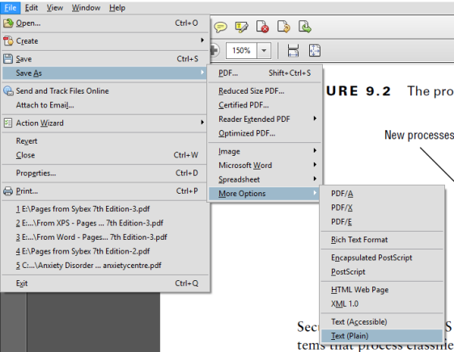

I do recommend chopping up the PDF into chapters, sections, etc first though

Also just noticed this going back over the original text in Notepad++ -- at least in this PDF there seems to be a standard marker for inline (bold) section headings. In this case 3 spaces after the heading. So I can probably do a mass replace on that to make it a bit nicer too.
Each PDF may be different so it could pay to scan through the text to look for patterns and compare
Example from the PDF:

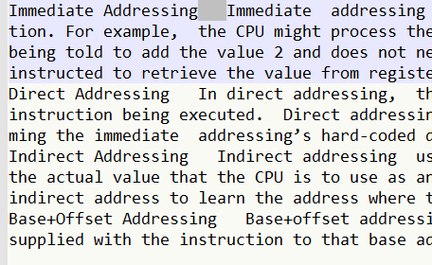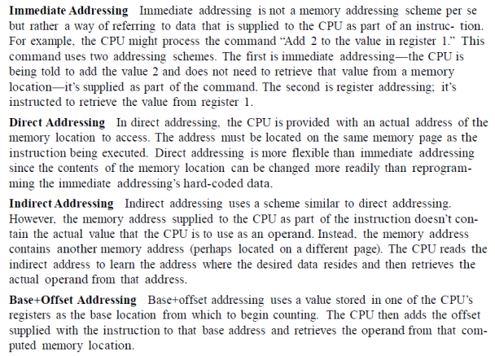

So basically the workflow would be:
(1) Acrobat Pro save as plain text (not "accessible" plain text) and then
(2) Preprocess (Regexp) in text editor of choice as desired, then
(3) Paste that into SM.

Buboflash
See: https://buboflash.eu - Official website
See: https://www.YouTube.com/channel/UCDv7pMAKXZOBX1Ny6gpHd0w - Official YT Channel
See: https://www.YouTube.com/watch?v=me1T6PS-_LI – “From PDF to Anki (or SM) flashcards”

PDF referencing (“bookmark” method)
Do IR but just hold a pointer to the text in SM and then read and extract the PDF on the Interval that IR prompts you to.
I could create an Element/Topic/whatever pointing to that other PDF I downloaded and that enters the queue, then when it comes up in the queue again I click the link, open the PDF and read a bit, extract stuff as desired, then make a note of where I left off in the original Element and continue. Extraction would simply be pressing Alt-D to dupe and then do a Cloze or whatever on the extracted text, insert a snipped image from the PDF etc

Text cleanup
Something that may help you with your PDF cleanup. This is a simple autohotkey script that binds Ctrl+/ to the following key sequence: press home, press backspace, then press space.
I'm going to try doing IR on my next chapter, and when I pasted it into Word I started doing that to clean up the line endings. Basically to make the paragraphs wrap and space out properly. AHK to the rescue. Now Ctrl+/ once per line instead of fiddling with three keystrokes per line.
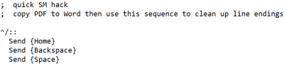

So the sequence is that I start at the bottom of the doc and press Ctrl-/ then up arrow then Ctrl-/ then up arrow then … Quick mod makes it even better:
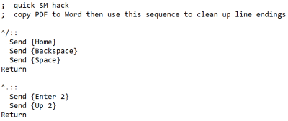

Entire books

Using Pending Queue
https://www.YouTube.com/watch?v=xqdhskJuhCo
By using the Pending queue as I've shown the individual Topics are processed in book order. Once they enter the Priority queue along with other memorized elements they are subject to some randomization (esp. if Auto-sorting is enabled), but by then you would have scanned the material in sequential order at least once. When to process the next book section is embedded in the decision of going back to Outstanding material or carrying on with the next Element in the Pending queue.
Often I'd come back after a meal to "treat myself with new material" since my mind was not focused enough for the demand of answering to active-recall questions (and importing text is more like busy-work). You can mark this "mental switch" by doing Learn : Stages : 2. New material and then back to Learn : Stages : 1. Outstanding material when the time is right
If you have elements in the Pending queue sorted by position in the knowledge tree, elements from two books will not be interleaved. If you need to interleave them while maintaining the order, I guess you have to pick elements from Book1 and intersperse their ordinals (by spreading them on top of the ordinals range of Book2) [UNTESTED]. But I am not sure how to tell SM to proceed with the Pending queue by ordinal number instead of position in the knowledge tree.
About using the Pending queue to interleave elements from two books while keeping the sequential order of each (for example: Book 1 chapter 1 -> Book 1 chapter 2 -> Book 2 chapter 1 -> Book 1 chapter 3). It's indeed possible to do so using the pending queue browser. Just Spread the ordinals of Book1 on top of the ordinals of the elements of the other book. SM smartly avoids ordinal collissions. After that, sort by ordinal and Right click : Tools : Save pending. I had missed this option before (D'oh!)

Dealing with images
- “Instead of Localize, you should better use Import. Localized images do not "propagate" (i.e. get to illustrate or derivative texts). They just sit interwoven with HTML
- if one images replaces another, it can be caused by data corruption, or deleting images directly from the registry, rather than image components (the empty spaced are later filled out with new images)
- Localize is subject to changes to Internet Explorer, while Import makes you only dependent on SuperMemo
[…] Keeping images in image components is safest and best for Incremental reading. Most importantly, images can propagate to all children elements and never need to be duplicated”
Source: http://Supermemopedia.com/wiki/Localized_images_propagate_in_unwanted_places

This workflow might seem rather annoying, but I follow this practice because SM becomes slow when I paste too many images inline. Because the text will be extracted and split, it doesn't make sense to me to put an image besides a text that is not related to the image, so I see the logic behind the image Component approach. What I do when importing a book is leave a placeholder for any and all figures:
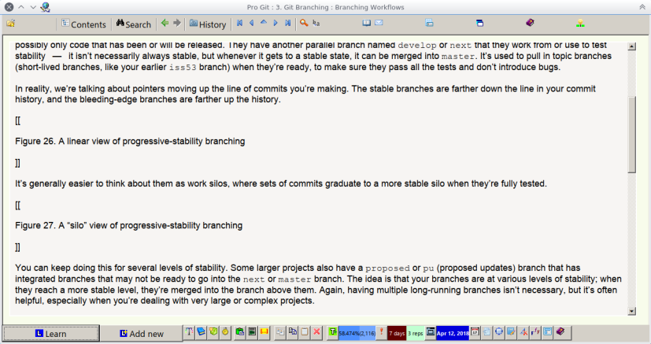
Then I process the text incrementally, and only when I've identified the precise extract a figure is applicable, I import the image into SM's registry and insert the image Component
So here, I delayed the insertion of Pictures until it was time to process the "Switching Branches" section of the book. In this extract I inserted 3 image components (figs. 14, 15, 16 of the book), in this extract exclusively. Since they are image components with images from the registry, any further extracts will have them propagated, not duplicated.
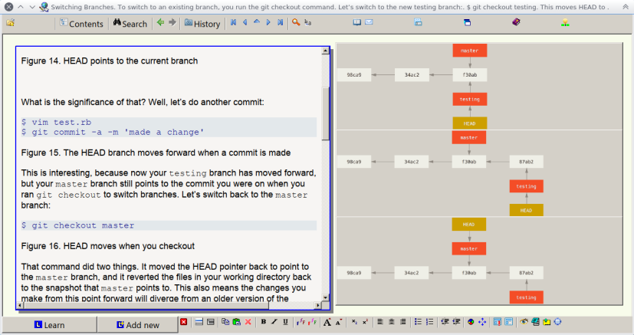
Q: If I understand correctly, when you are prompted with a Repetition of one such Topic, you go back to the book, at the given page to check/import the placeholders images ?
A: Yes. I'll have them already in a folder (14_foo.png, 15_bar.png) though, and yes to the other question.

Other strategies
- http://Supermemopedia.com/wiki/Incremental_Reading:_sequence_of_reading
- You can have one chapter-per-Element of the book (say, to avoid hogging SM with a really large Element), all added to the pending queue (forgotten instead of memorized), with chapters sorted by position in the knowledge tree, so when executing stage 2 of Learn (learn new material) they will be gradually introduced to the learning process in book order
- Even better just put the table of contents and paste the content as the elements are being introduced in the learning process
- http://Supermemopedia.com/wiki/How_to_learn_elements_in_a_specific_sequence%3F
- https://imgur.com/iruZL8H
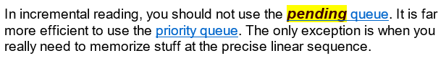

The trouble with IR of whole books for me is that IR takes time, and often I need basic understanding of the big Picture sooner than mastery of any amount of detail. You don't need IR to get the gist of a big Topic, and once you have the gist, you realize 90% of what you would have thought were important details worth memorizing are in fact not worth memorizing.

Epub, RTF

EPub is basically an extended form of XHTML: https://www.w3.org/AudioVideo/ebook/
You can take ePub files and rename them zip files and grab the text files chapter by chapter

Epub → docx → HTML Component
RTF is supported but personally i don't know how it's supposed to work
Source: http://help.supermemo.org/wiki/Using_text_components

I just tried converting the epub to docx and it worked ok. Kept the diagrams.
I've successfully placed word content into SM many times without much issue. Pasted directly into HTML Component.
When exporting to Word, it lets you add a line after each paragraph so the text is not all bunched up.
I just tried Export from Word to single web page, and it creates a HHTML format.

To paste into an HTML Component, do I just click Insert to create the Topic, double click the Topic, and literally just paste over whatever you have from word into the box

After epub > Word, changing font size and style, find and replace any oddities, copy and paste into SM, I get this...
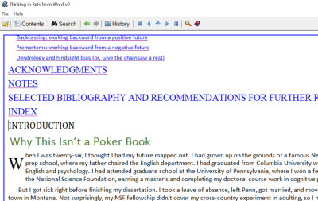
It's looking good!

Direct extraction + HTML filtering
Try to split this book, or better yet, extract some text.
Now, to filter HTML:
- Use F6
- OR try to select text and Ctrl+Shift+1
- OR Ctrl+Shift+F12 for entire text Component.

Splitting up large body of text
Q: I got my nicely formatted ebook into SM . It has about 300 pages or so. For Incremental reading, do you now split it up into lots of little sections, like Woz did on his IR video recently? Does SM then feed back these sections to you in order, or in random order? I am wondering if it is random, I might not then understand sections as they may depend on knowledge gotten from earlier parts of the book.
A: It won't do it intuitively. You either have to enter split lines Alt+Shift+H where you want the document to be cut up or enter manually coded headers and then parse the HTML text by Ctrl+Shift+1 (Component menu : Reading : Split : Split article)
I LOVE the split function. I enter HTML as im editing the PDF file so once I copy and paste it over to SM its ready to split.

Q: Do you segement by volume of text, by Topic or a combo? e.g. do you limit a Topic to say 3 pages on a PDF? Or a whole chapter?

A: If it's a whole book definitely by chapter, then by sub-sections in the chapter, and sub-sub sections. Then if something comes up that’s past a point you've come to yet learn reschedule it for a few days later.

Incremental video

I love the concept, yet, it has many quirks...
- Glitches when resizing the Element window (video pauses or refreshes),
- Requires too many steps to get rid of the video Component from an Alt+X extract once you don't need it anymore,
- Buggy interface
- Possibility of losing all of the videos next time YouTube changes its API (as happened last year or so, lots of complaints on Supermemopedia)
- It wouldn't make the video extract render as a new Element until i navigated away from the Element in the Component's tree
- Whatever I name the extract is propagated only in the Element's title, but no reflection of it on the HTML Component or reference

Idea: I considered just using Items (or I guess Topics now) that include a timestamped link to the YouTube video instead of the embedded video with javascript buttons like SM currently uses. No real reason why you can't just open the link in a browser, watch what you want, Alt+D to create a new child Item as needed to write down the notes you want to make as you watch the video and write the start/stop timestamps into it. Now it isn't dependent on any external API.

So far my use cases all end up with Clozes from annotations from the video extracts that will go in the "knowledge" collection. The bundled video templates are not well designed for this flow (have to delete the video Component manually)
I've also taken screen shots from videos and placed them in components just like you have. It's an extremely powerful way to trigger a Memory.

I do see an use case to keep the video sequences for procedural learning, and for using the fragments as questions or answers. i can't reconcile with the fact that Repetitions of video fragments will Spread over time and not be active recalls by staying as Topics
Incrementally viewing a video over increasing Intervals would lose context unless you captured a ton of it in Items.
I have a one hour video lecture I "incrementally" watched using my previous described method. I watched half of it, made several Items from it, then haven't watched it again in maybe two years. I remember the content well enough that I could start over near the halfway part and be able to follow along.
But couldn't do that with a technical or math video. Complex Topics require you to "load" the concepts into working Memory to understand all the interconnects and build on them. Have to use a lot of extracts I would think.

See: http://Supermemopedia.com/wiki/Autoplay._Videos_from_YouTube
Incremental video is a good supplementary for IR. Kurzgesagt is fantastic channel!
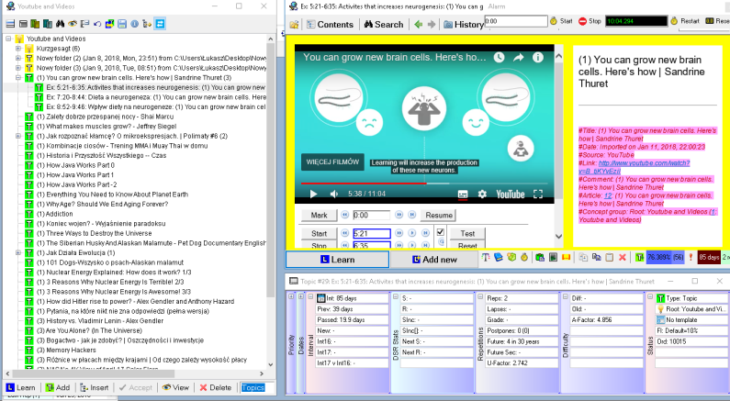

Audio
I just tend to import the entire thing to Voice Dream and listen to it that way, it just ends up being a 6 hour long text file

Workflows

SM as a Post-process
Typically after I decide what subject I want to learn, I concentrate just on understanding the material. Piotr emphasizes this point a lot. It is generally pointless to memorize material you don't yet understand.
Sometimes, though not always, this means I will study the entire textbook in a traditional manner without the use of SuperMemo at all.
That's not a rule, for sure, though. Sometimes it means I will just read the chapter before turning to SuperMemo.
But I rarely read a sentence, then add it to SuperMemo, read another sentence, add it to SuperMemo, etc. I need to get a sense of what the important concepts are. What is that I even care to learn?
I guess in some sense, I AM "incrementally reading," just not with the aid of SuperMemo. (Piotr would probably groan if he heard that this is what I'm doing.)
At a certain point, I have a basic framework in my mind of the material, and feel confident in what exactly I want to enter into SuperMemo. I then just type it in manually: I'll create a category, create a Topic (perhaps a chapter title), and type in manually several sentences related to that Topic.
Only after I have a basic understanding of the subject do I feel competent to decide what is SuperMemo-worthy

Source: http://supermemo.guru/wiki/20_rules_of_knowledge_formulation#New_rules:_Incremental_reading
- Building comprehension may be part of the learning process, and creating Cloze deletion of poorly understood phrases is acceptable
- Learning and memorization may occur in parallel

SM as a “storehouse”
Over the last few years I've been thinking of SuperMemo more as a storehouse of useful and cool ideas and less of a lens that I view everything through. If I learn a neat interesting fact I can often put it into SuperMemo straightaway (If I am at my computer) or send it to my dropbox from my notes app. If it I'm not using SuperMemo, such as listening to a podcast while walking, I will listen to something, pause it, and think about that idea until I can see a basic model of it and explain it in simple terms or metaphors. Once I can get to that point, I write that conclusion down in as simple language as possible and send that to dropbox and later it gets put into SuperMemo. Incremental reading has become less "highlight from the book" and more "stop when I find a good idea somewhere, make sure it has substance, then write it down."

SM with IR
I’ll add the PDF to IR (using one of aforementioned methods). Then before processing it, reading it, or anything, I create a SQ3R Template alongside the Mother Topic Article. I’ll create a mind map in there and a Survey/Questions/Main Point components. Then the next time it comes around I’ll start going through the text and creating bullet points from the text itself rather than typing them up as my own notes. Then eventually I shift them over to the Cornell Template, create cues and summaries. Then ill add up all the summaries from the sub-Topic sand add them to the mother Topic so anytime that page comes around its the ultimate "quick" sheet for Review.

I'll import a PDF, not intending to process it immediately, but eventually come back across to it in the future (~1-3 days from now). I'll split the mother PDF along the artificial split lines that I made at certain sub-sections (or sections that aren't reliant upon each other). However, as soon as i'm done importing the PDF ill create a mind map that's VERY broad that captures the chapter title in the center and just the sub-chapters/sections branching from the main title. Then I create another Component that is a Roman Numeral outline of those Topics along with questions that i'm hoping to answer once im done going through the text. *These are all added to the Main mother Topic Template. Then i'll eventually come around to those other sub Articles and ill process them using the Cornell method. Then when im completey done with all of them I take the "summary" of all of my sub-Articles and paste them together into a MEGA-summary and add that to that mother Topic. Considering all of the sub Topics have been processed and the huge mother PDF is just blue and pointless Ill eventually just delete it so that the mother Topic is just a mind map/SQ3R questions/ and a Mega summary.

Again helps with the Big Picture thing A TON.
I don't like the idea of dismissing info like Piotr suggests, If I did work on adding something into my Knowledge base I want it to work for me and do something.
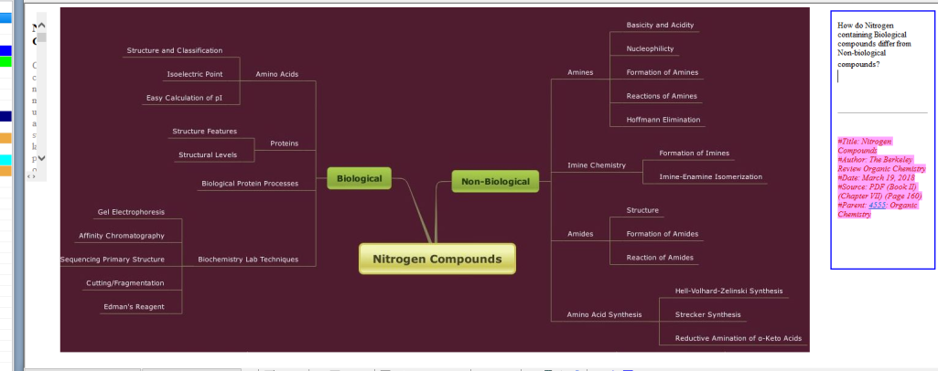

Integrating smartphones
Using workflow on iOS https://workflow.is/ –
I now have an "Add to Supermemo" dropbox folder and two new workflows: upload photo to that folder (pick photo and use share button) and one to automatically upload last photo taken to that folder. I made that to let me snap pics from a book I'm reading while sitting in a doctor's office. Works well so thanks for the idea!
I just took three photos of three pages, tapped on the screen a few times and they are all in the Dropbox folder now waiting for processing when I get home. Cool!

An addition to my workflow when dealing with external books/etc that has really paid off. Using the Workflow app on the iPhone (there are probably similar for Android if you use that) you can set up action sequences with variables/etc that can be initiated directly or from a share button. So take a photo of a page or scan a few pages in (I use the Scannable app to auto-sense and scan pages automatically to PDF) and then trigger the workflow to have it upload the image or PDF to a predefined folder in Dropbox, e.g. /Add to Supermemo/ and they are waiting for you when you get back to your computer to process them in. For text notes I use a custom action sequence in the Drafts app that appends the current note to a text file in the same folder and then deletes the note off the phone.
It's a pretty slick way to facilitate info capture similar to the GTD idea of a universal inbox for capture

Knowledge retention & Management

Formulating knowledge, taking notes

Bloom’s taxonomy
I use this reference sheet a lot to guide my process of formulating questions and its one of the leading theories in education psychology. Gives you a lot of insight and cues to use on developing the different levels of knowledge in regard to a certain Topic.
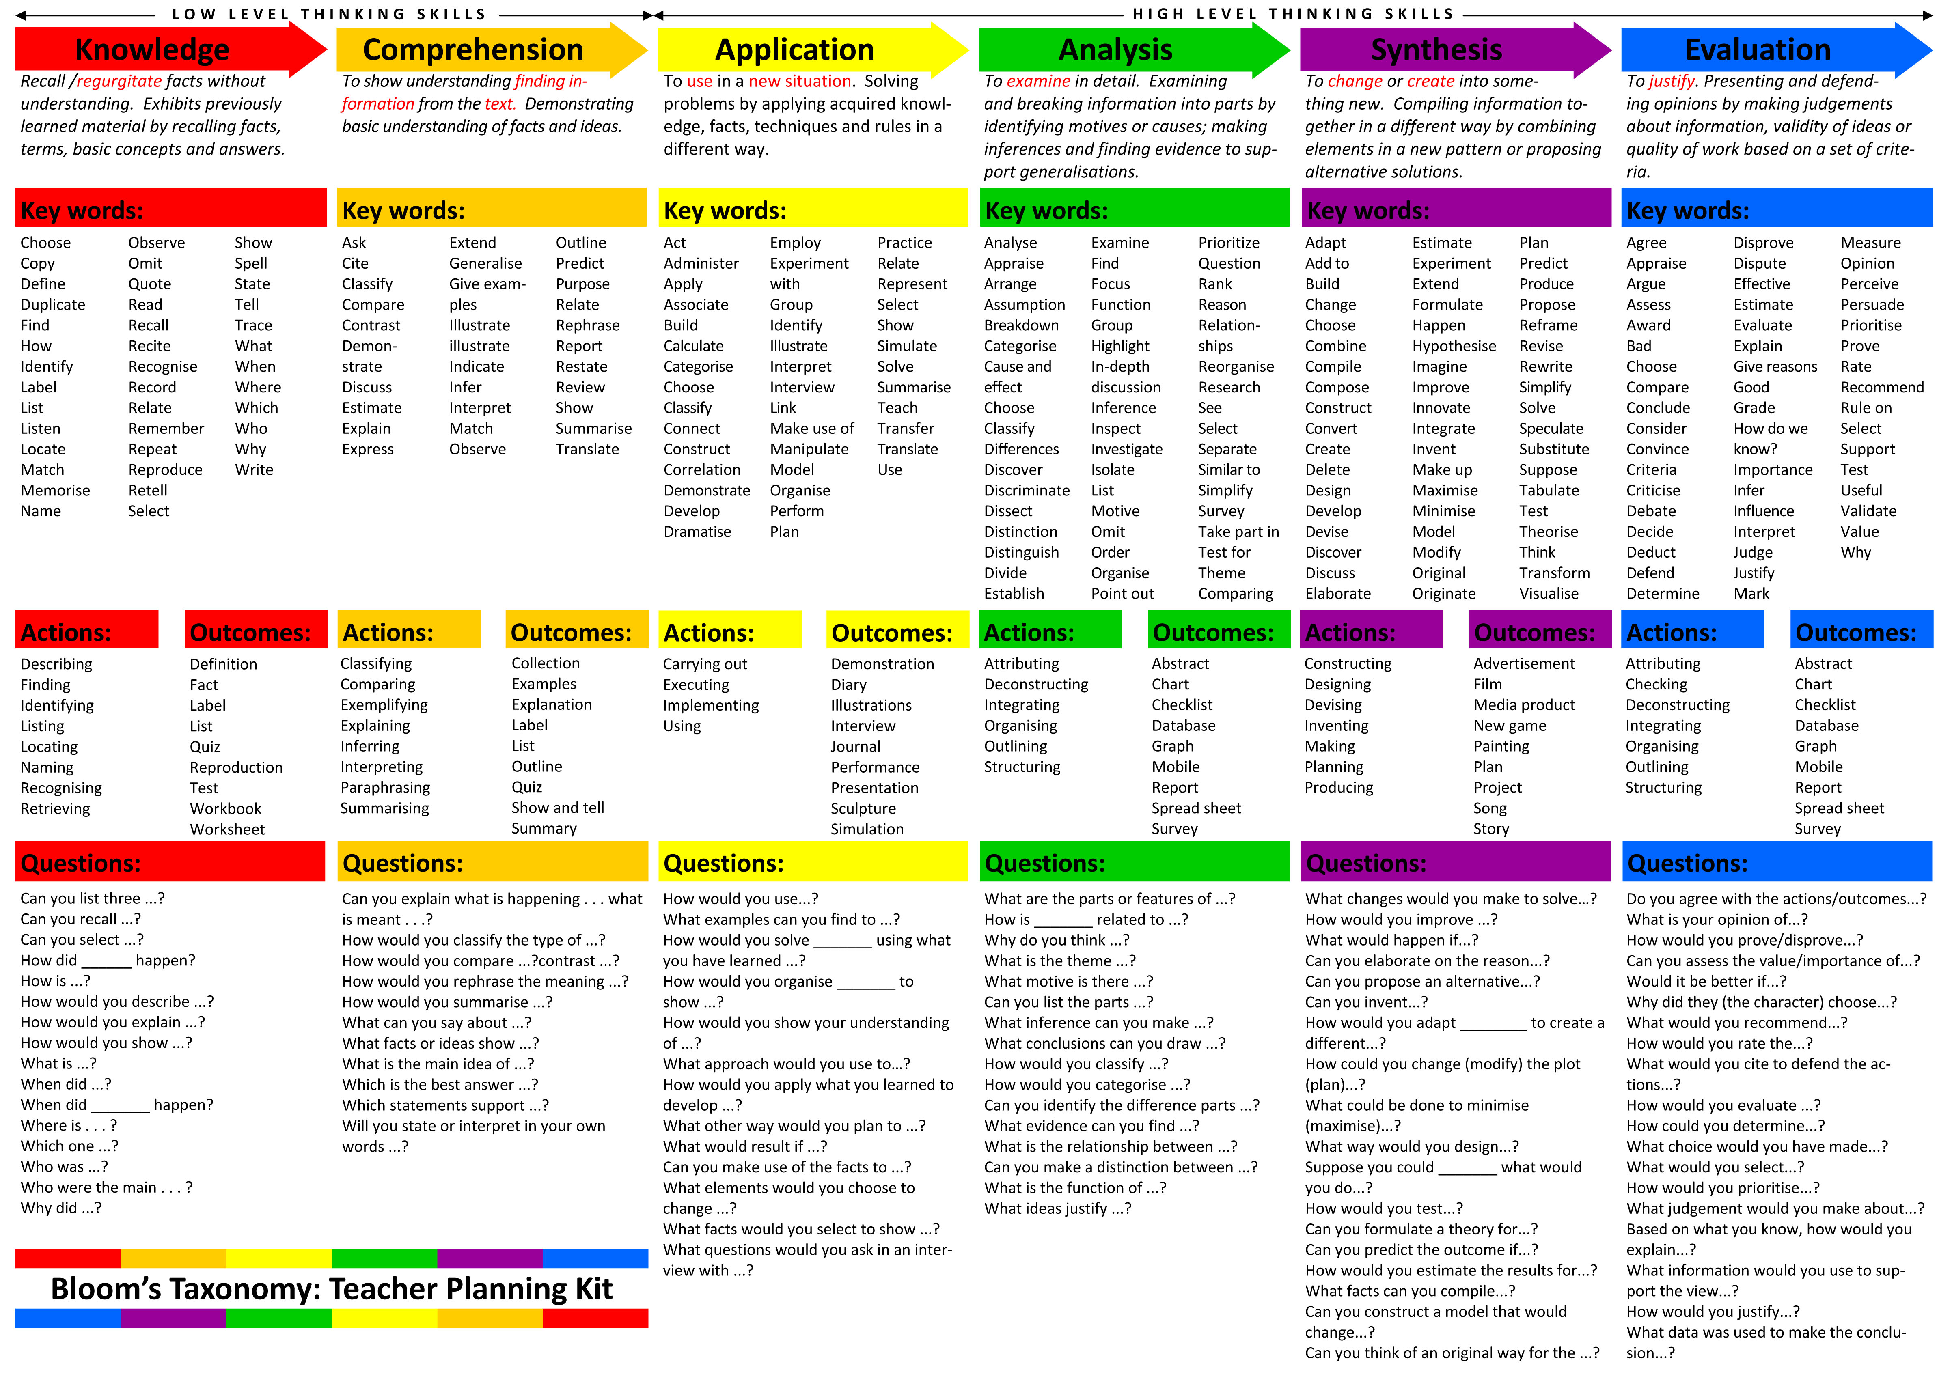

Interesting that "why" is on both ends of the spectrum. There was an SRS blog post I read somewhere years ago that said "why?" questions seem to work best and I have found that is generally true for me as well, so its good to see that asking the "why?" question differently can put you at different ends on the scale.

I'm assuming because why answers can usually never be answered by a simple dictation. It requires deeper level processing that forces you to explain a situation or mechanisms involved in the answer.

The issue with Bloom's (newly revised) is that it focuses more on acquiring skills associated with a Topic/idea/principle rather than content itself. Like I mentioned it should be used as an enrichment supplement, not a direct model for your acquisition of knowledge. Considering that Benjamin Bloom's work is one of the most highly cited in the field of Educational Psychology also bids it more credibility.
I do not use it at all in terms of structuring my own knowledge process. I literally use it as a Template to formulate new types of Q/A pairs when I can no longer think of new and creative ones.

Cornell notes

Origins
The Cornell Notes system (also Cornell note-taking system, Cornell method, or Cornell way) is a note-taking system devised in the 1940s by Walter Pauk, an education professor at Cornell University. Pauk advocated its use in his best-selling book How to Study in College.

The Cornell method provides a systematic format for condensing and organizing notes. The student divides the paper into two columns: the note-taking column (usually on the right) is twice the size of the questions/key word column (on the left).

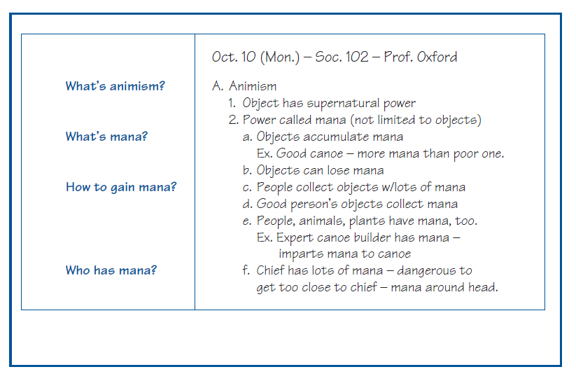

Cornell notes in SM
When using the Cornell Template I organize all similar ideas into one of the single boxes so when I extract it all the ideas that are related to that idea are extracted together.

Benefits:
- If you come across a cue question that you cant perfectly recall, you can then go to the relevant information that you have Clozed and increase their Priority.
- It simply allows you to see:
  - 1) What information is most relevant in a large body of information (a chapter let's say)

Sometimes when you're reading a large article or chapter regarding some information, there are bookend ideas that the author includes just to be thorough, but they are non-essential in understanding the main argument or points being driven. Those Items are the ones that can be assigned low Priority. . On the other end, there are sometimes single paragraphs or statements that really encapsulate the idea of the section and those points can be given a much higher Priority.

  - 2) Which information in that large body of text you are weak at comprehending in relation to the others.
Upon Review, the Cornell style Template comes up again as a Topic and you have the opportunity to Review the cue questions. Naturally, some information just sticks better and others are a bit more elusive to your Memory. The ones that you remember, great let them be. The ones that seem a bit fuzzy you can go to the Clozes associated with them and increase their Priority so you're hitting them more frequently.

Usage:
Mine looks a bit like that as I progress through the article. Keep in mind I have already processed this so the PDF portion of the article has been removed.
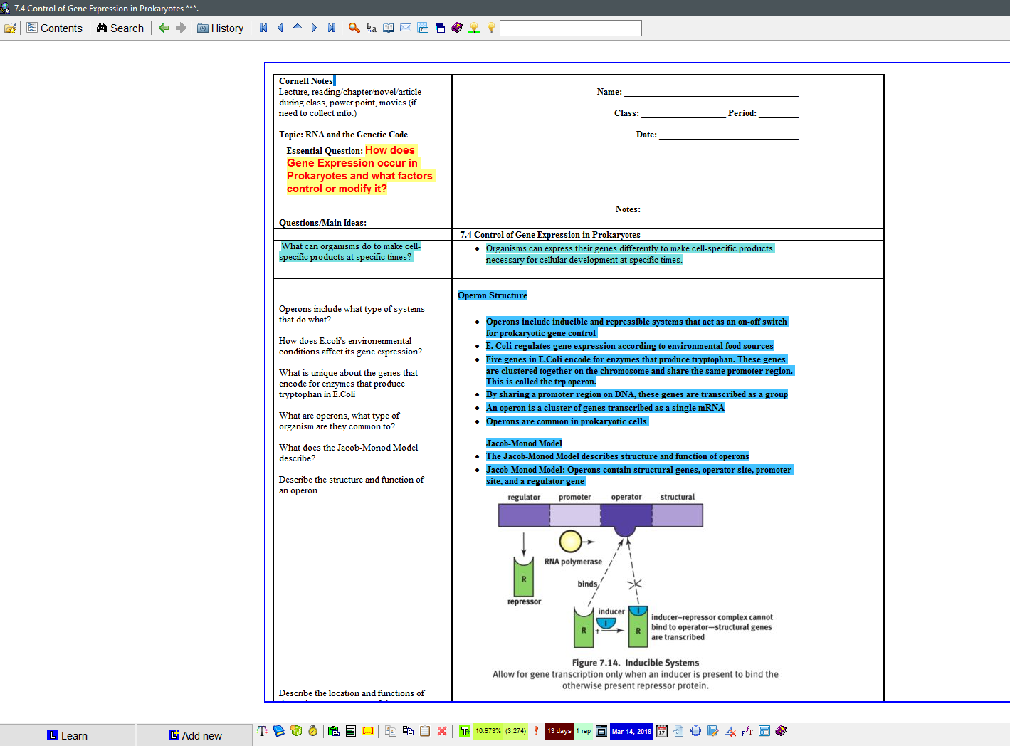

Then the Operon extract looks like this
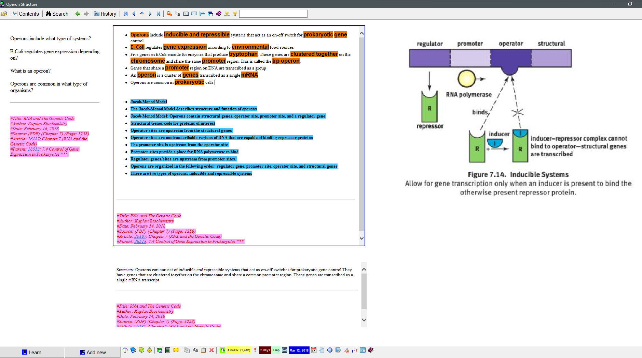
And the Clozes are just simple normal one sentence bits.

Then I've formatted it in a way that when it shows up in my Repetition cycle it shows up like this allowing for an opportunity for active recall again

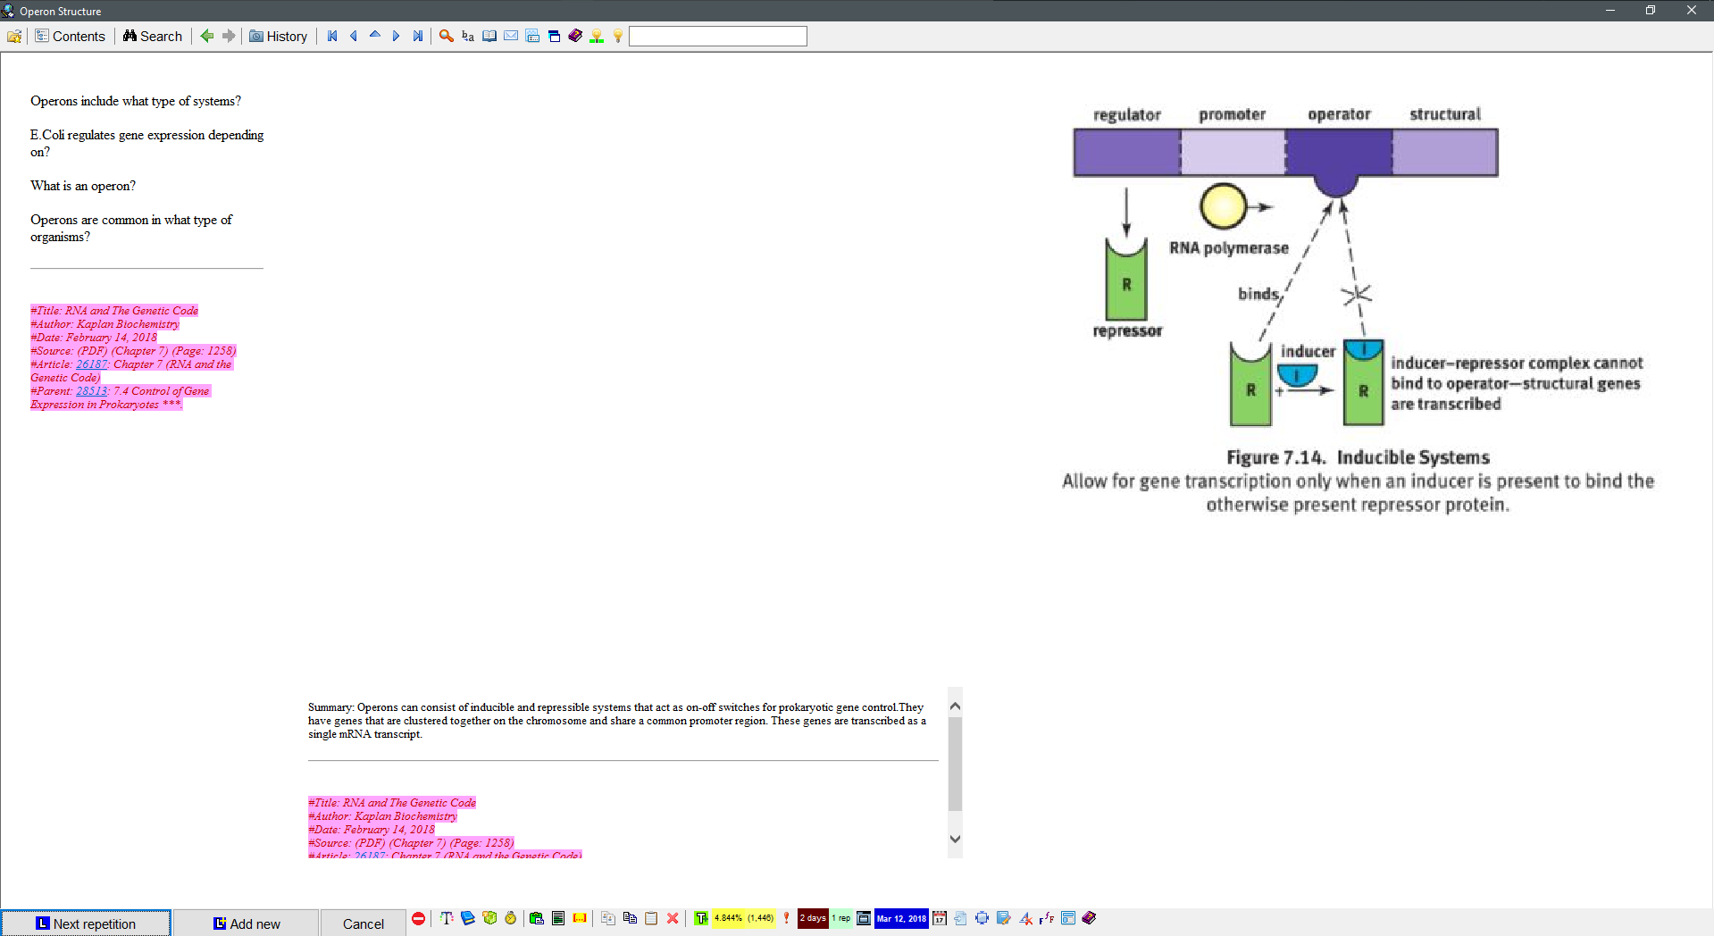
As I press enter the main bullet points will reappear.

I'm still modifying my technique, trying to gain the balance between speed and comprehension. What I've been noticing (or have known through manually doing this technique as well) is that the serious comprehension gains in the Cornell method come from formulating the questions and rewriting the summaries and then reinforcing the stuff I don't understand using the Priority percentage. Im not really too picky about rephrasing every single sentence that I'm going to Cloze. So my processing goes a bit like this: 1) I'll quickly go through the pasted PDF and start separating out chunks of the chapter into bullet points (literally just pressing Ctrl+Shift+L) that capture different ideas. 2) Once I've done that then ill go through those bullet points and break it down further with more bullet points (That single paragraph can now be let's say 7 bullet points). 3) Then I'll copy and paste those clusters of ideas over to the actual Cornell Template. 4) Once that's done ill generate generalized questions and create a summary of the contents in that Cornell sheet. I won't directly Cloze from that sheet because It usually holds a chapter and if I were to do that I would have 100+ Items per Topic. 5) Instead I'll then extract clusters of bullet points that encapsulate a whole idea and then extract them as a sub-Topic. This causes the clusters of bullets it to become detached from the Cornell sheet; 6) This is where I start creating the Clozes and editing the text if need be. 7) Once i've created the Clozes ill apply another type of "Cornell" Template that has 3 HTML components for the notes/cues/and summary portions. 8) I'll again go and create more specific questions this time and rewrite a smaller summary more specific to this sub-section.

I turn textbook text into Cornell style notes, then I create a "cue" column of questions that relate to ideas in the notes portion of the Template. Every time the mother Topic comes around, the notes portion of the Template is blocked and i'll try to answer the questions. Depending on the info ill either Cloze the information in the notes section immediately or leave it be until I feel as though I'm losing recall ability on that information . If the information is already Clozed i'll go to those questions and increase their Priority.

Say this is how it pops up in my rep cycle
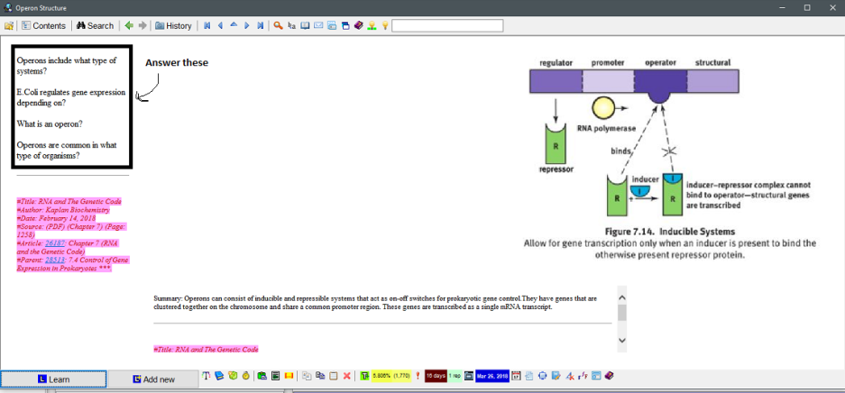

I answer those questions then I hit enter and it looks like this.
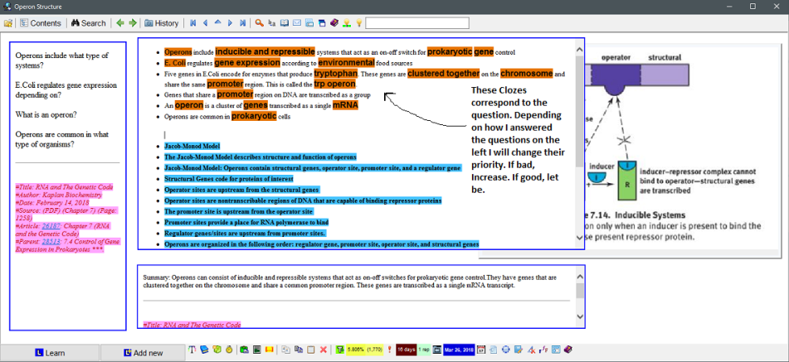

Also keep in mind I have already "processed" the notes part. Many times I won't even begin to Cloze them until I notice that my answers to the questions on the left are really lacking.

The only reason I would say this is sub optimal is because Topics are scheduled differently than Items. Your Topic Intervals will be artificially low.
On the other hand however, It's better than the one Item one action rule cause these ideas are stored semantically as a chunk allowing for a broader retention of all related information. If I were to keep all of them as single extracts taking single Cloze's every time not only will comprehension whimper but my rate of encoding will also significantly drop.
I actually won't do this for other information that is easier, less dense (news article for example). However, in my experience when one idea can be interconnected to 10 different yet similar ideas, having the information memorized as a front load in working Memory leads to higher accuracy (solely in my case, of course). Everyone should experiment with their own methods and do whatever yields the best results!

This is a sub-Topic of a larger mother Cornell note
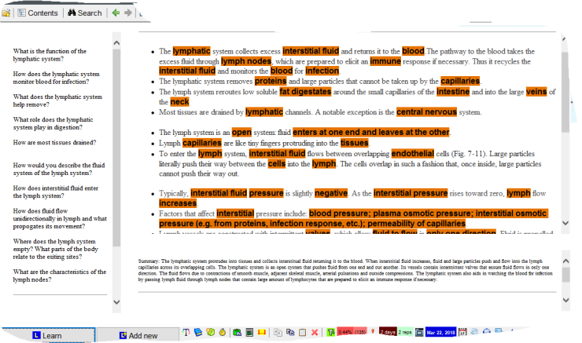

Mother one's look more like this
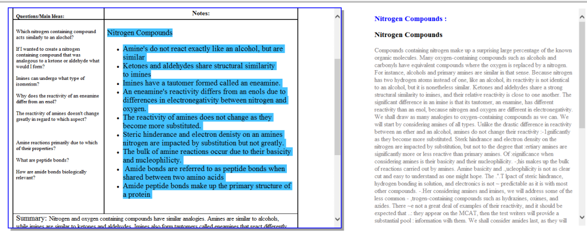

I scan my textbook use Adobe's OCR to add it into SM and I run the side by side Template as im reading to process the text. Once, its processed I delete the textbook stuff and just leave the note Template be.

Q: how do you handle images in your Cornell Template? Do you just paste them into one or more image components and rearrange the elements? If so do you detach the Element from the Template before doing so?
A: Yeah well I have "two" formats technically. The first one is the MSWord Template next to the whole PDF. While I'm doing that I just paste the image into the notes part of the Cornell Template since im going to split or extract different parts of the article later. I'll also Ctrl+F8 and internalize them so they don't get lost.
Once I split them I'll generally opt for my other Cornell Template which consists of the three HTML components: Cues, Summary, and Notes. In this one ill enter image components and fit them accordingly

Initial run through:
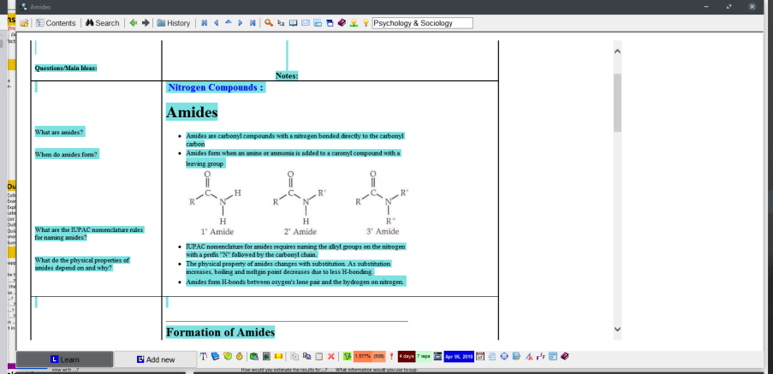

When split:
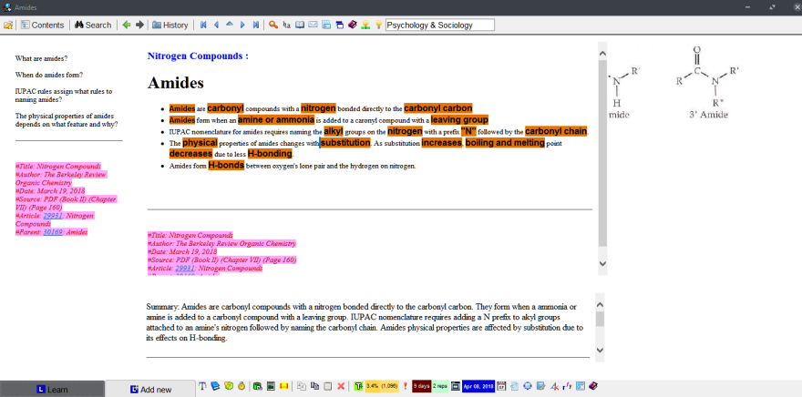

Q: Also, how do you make those tables, or lines, in the HTML components? I can only get it to work by copy-pasting from word processing software external to Supermemo.
A: Those are pasted in from a word Template. You can find the Template online in Google images.

Mindmapping

Learning & Repeating

I've gone back and forth between
- Reading PDF -> extracting to SM,
- And alternately reading PDF -> update mindmap -> when mindmap is complete extract from mindmap to SM

So far the second approach seems better and has the advantage that I end up with an all-in-one big Picture capture that I can refer back to anytime

Using XMind I can edit it anytime, so for example I have to study multiple sources (books, audio lectures, video, sites, etc) and can update the mindmap as needed then pop into SM and add the new knowledge for long-term SR retention

Between big Picture capture and then reduction into SM these have been a godsend making the studying process much easier.

Mindomo but is an awesome mind mapping site that automatically creates note style outlines for you based off of your mind map.

I like the concept map idea because the point is to create propositions w/ linking verbs/adjectives/etc instead of just mindmaps.
But CMapTools doesn't seem to impose a structure so it gets chaotic fast. Or maybe it can and I just haven't messed with it enough to find that option yet.
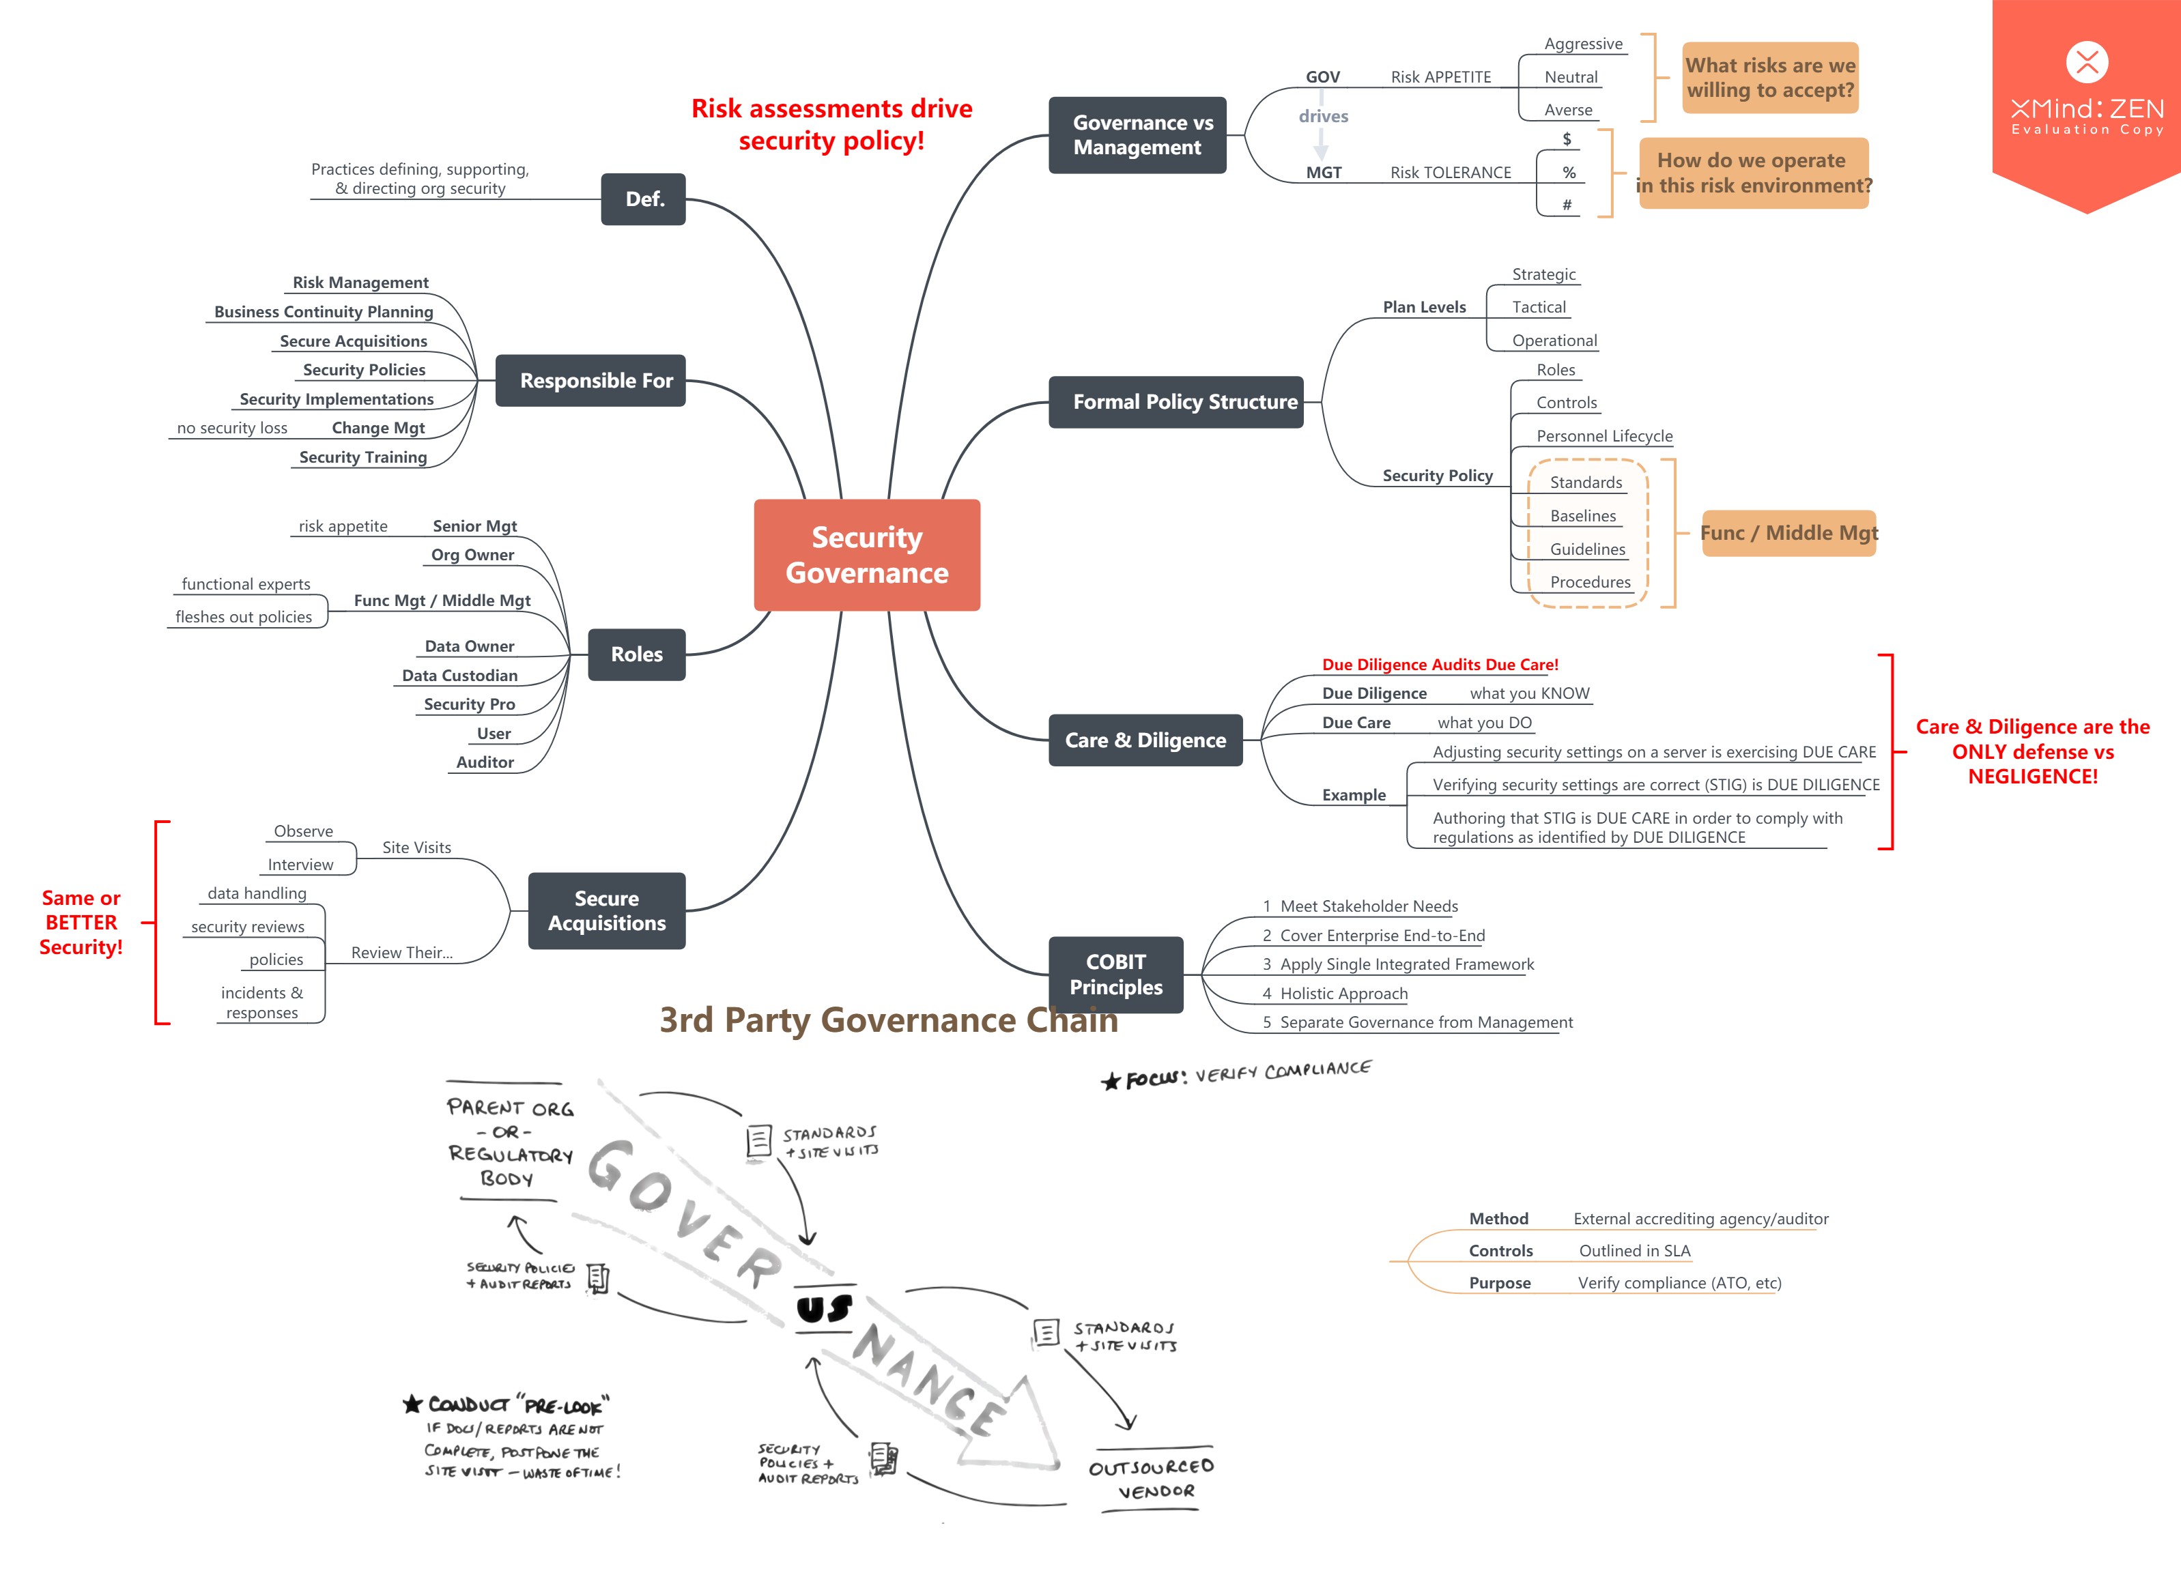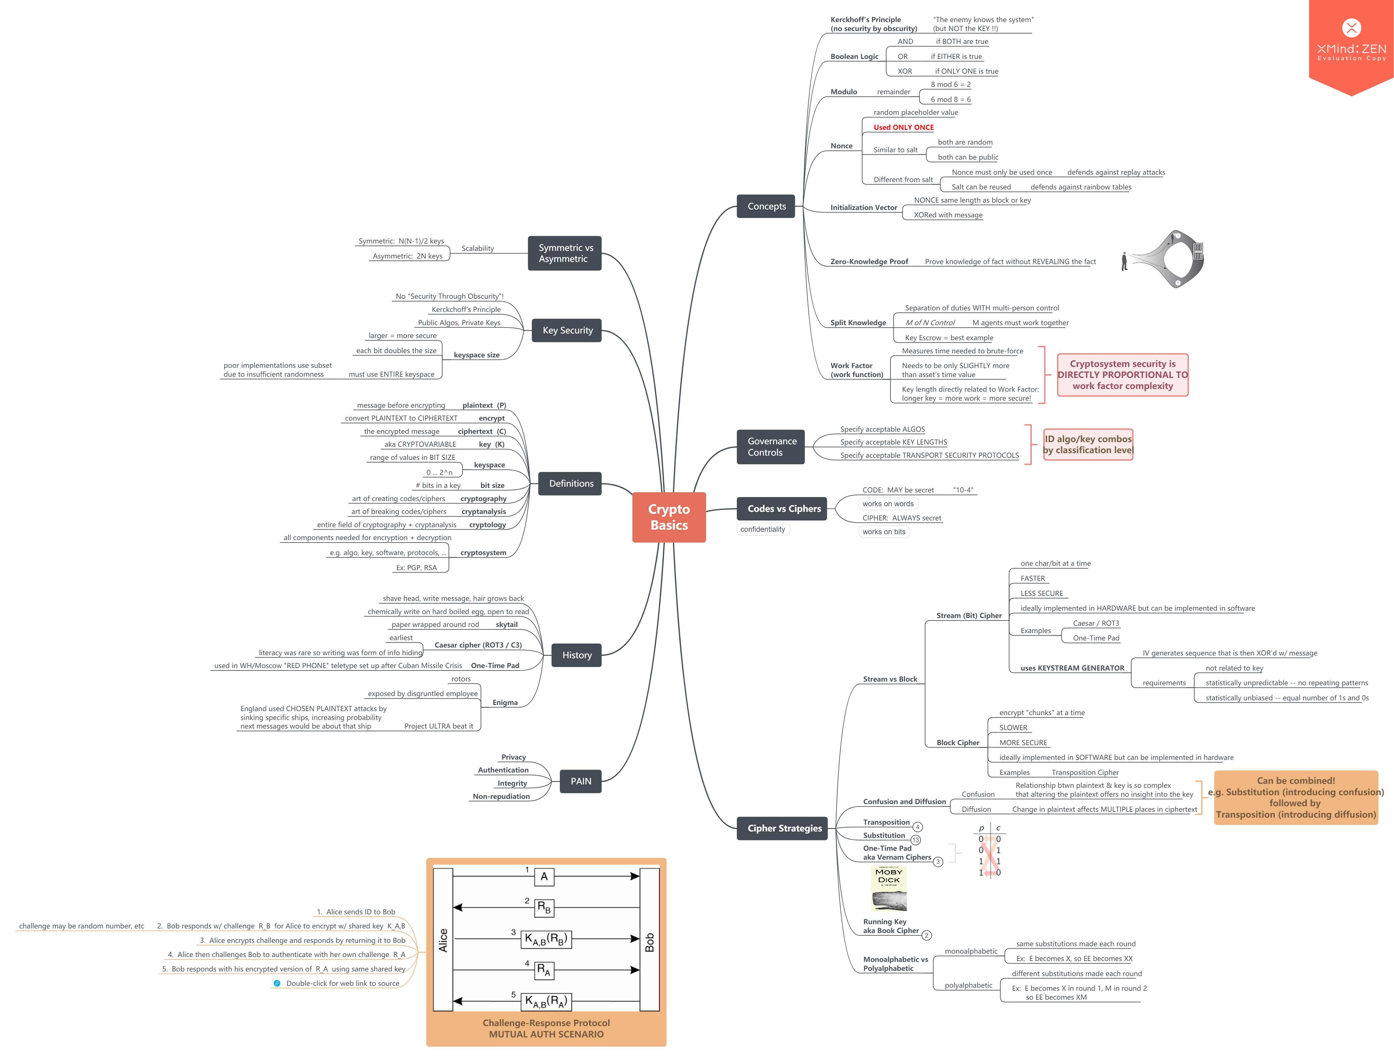

Memory encoding
Mnemonic techniques is one of the technique of minimizing the complexity of synaptic pattern. I don't have any (medical) background about it. But from what I have read minimizing the complexity of synaptic pattern is the most important principle of effective knowledge representation in systems based on active recall in Spaced Repetition.

Repetition cannot be equated with learning per se. That's why there is no ready-made collection :), that's why Incremental reading is recommended by Piotr.

Mnemonics is all about the encoding and retrieval processes of Memory. The weakest form of encoding a Memory is Maintenance Rehearsal (Which are just simple Repetitions of some material). SuperMemo doesn't just necessarily use this as it takes advantage of the testing effect as well. Mnemonics on the other hand, specifically the Memory palace, chunking, or the peg-system utilize Elaborative and Semantic encoding which research has indicated FAR FAR outweigh any other forms. In addition, when you use hard locations as in the Memory palace location- it serves as an easy hook to retrieve memories as our brains are better with visual-spatial components rather than "abstract ideas". It would be much more difficult for someone who's completely clueless about biological sciences that amino acids are precursors to proteins located in the cell, rather then telling them to imagine a Picture of a prison cell in your living room with a HUGE chunk of steak placed in it. Your point about memories fading are valid, as that's the case for ANY Memory, don't use a synaptic pathway in your brain and it will be pruned to increase the efficiency of your brain. If you stopped using SuperMemo today and came back a year later, your Memory for many of those Items will be totally shot. The Cornell notes don't take long to create the process just takes longer cause you are actually encoding during the IR process as opposed to just extracting them and having them eventually get encoded through the testing effect. I've shown an example of how I progress through the materials above.

I did find that a mnemonic that is conceptually related to the Items being memorized seems to cement the overall concepts even more and make retrieval a lot easier.
(or rather conceptually related to the Topic, not necessarily the Items in the list themselves)

Mnemonics are a must if you are dealing with large volumes of knowledge regardless of the type of information.
Again what it comes down to is encoding which basically translates into how fast can you turn the stimulus you are dealing with into a construct that can be stored in the brain

I still will continue to use traditional run and gun IR, but if information is dense i'm leaning toward the Cornell way.

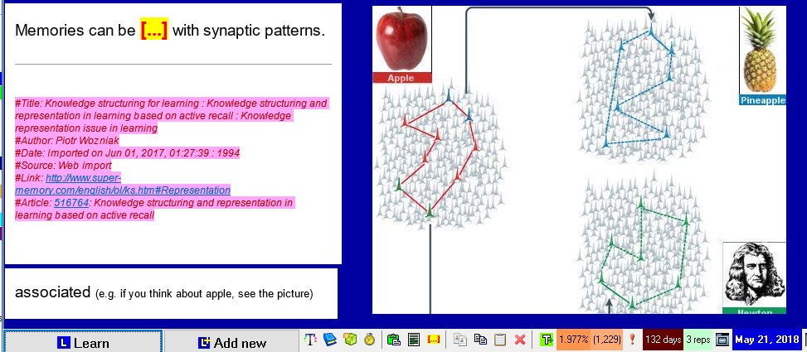

capitalizing on previously stored memories is a rule to minimize the complexity of synaptic pattern.


Mnemonics
Sequences are pretty easy for me. I created a Dominic System of Person-Action-Object years ago
that I use to drop sequences in Memory palaces.
As long as the location is associated with the information in any way I know what it's referring to
University became a joke because in classes where all I had to do is memorize information, I could memorize chapters of books with really high accuracy in just a few days.
Any of the books by Dominic O'Brien, Art of Memory by Frances Yates, Moonwalking with Einstein by Joshua Foer
The thing about Mnemonics is that it's constantly being advanced mostly by Memory athletes and they discuss techniques, and methods mostly through the internet so searching the names of previous Memory athletes or current competitors on google will take you far.

Any of the books by Dominic O'Brien, Art of Memory by Frances Yates, Moonwalking with Einstein by Joshua Foer

Eight learning strategies that foster generative learning
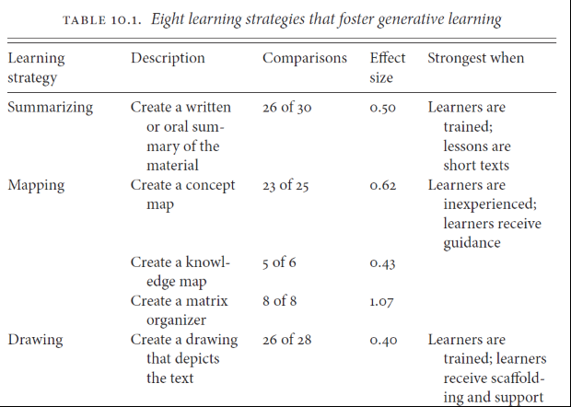
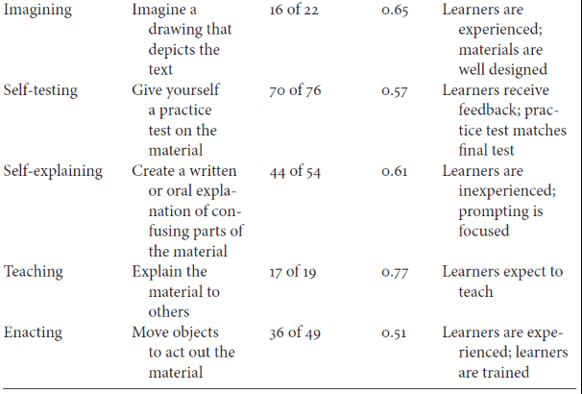
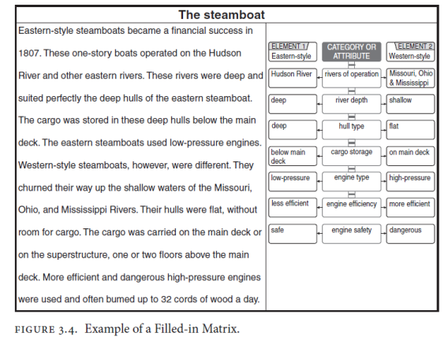
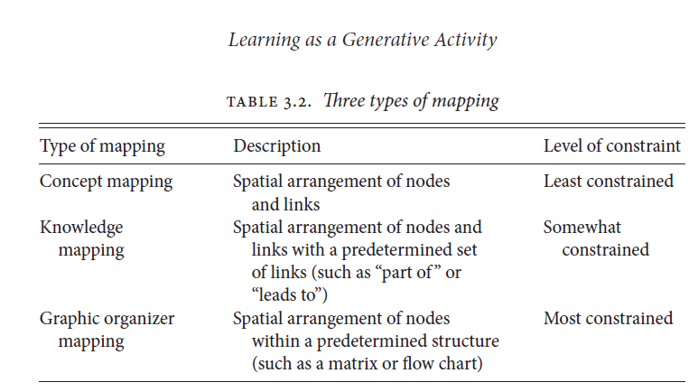
To me, Self explaining and Teaching are pretty similar. But I think teaching is superior because the mindset of ElI5 really helps get rid of the terminology and nail down the concepts and ideas. IIRC, enacting is not really useful or worth the trouble. The experiments were done on elementary to high school students, giving them actual molecular structure models and let them play with it to understand chemistry better
actual drawing draws the attention away from comprehension; students tend to focus on the drawing itself. Imagining is suitable for imagining how blood flows through the heart or mainly biology.
All the experiments were done mainly on academic settings; not sure its application for us

Cloze visual memorization
Do you guys notice that many times, you can answer a Cloze immediately as you glance at it? I'm wondering if that comes from being conditioned by the phrasing before, or quickly processing the rest of the information through your periphery vision. Kinda scares me as it could be a false perception of knowledge.
I remembering reading about a programming guy talking on a board about SM that he could OWN his Cloze deletions and then someone asked him a question about information that was extensively in his SM KT, but in a different context and he couldn't answer the question.

Basically a priming effect -- you memorize a particular path and can nail the Cloze almost immediately from the context but have difficulty in other contexts
Solutions
- I started to add multiple cards to "attack" a particular Item from multiple angles, to build up different paths to it.
- That might come down to asking various types of questions, perhaps from across that blooms taxonomy image you uploaded
- That's why I ended up using that whole Bloom Taxonomy chart and try to always include Q/A variations even if I have Cloze versions of them.
  - I was reading about the thermodynamics of certain biosynthesis pathways and wrote questions like If you wanted to make the most efficient solar panel what biomolecule from __ pathway should you use
  - the weirder the better i.e. the more creative the better ---> more creativity

Q/A Questions
I often elaborate on an answer in the answer field. The answer is the first sentence, the second is just a random thought I had while writing it. Notice it is asking how the situation can arise which requires more than a one or two words answer. Some of my answers are much longer than that and include explanations from a text or lecture etc. I grade myself on the answer not the elaboration. I do have some that ask why as an extra question but as you mentioned those technically violate the minimum info principle so I'm starting to reformulate them into two cards, one for the answer and one for the reason why.
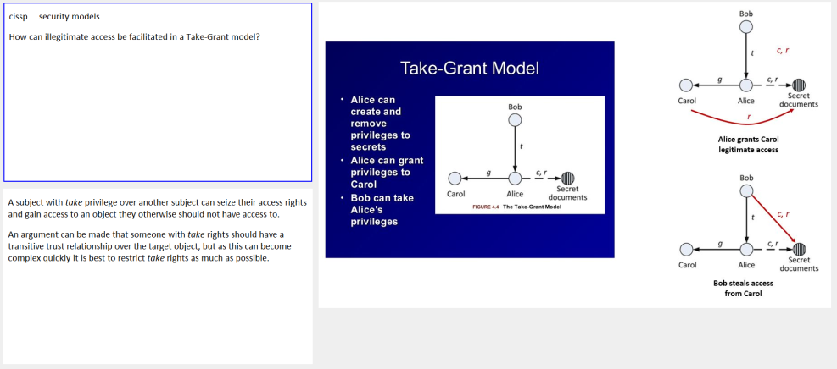

Cloze v.s. Q/A : Which is best ?
Probably there is no universal rule. Everyone can choose his/her own proportion and it may change from Topic to Topic. Q&As require skills. If you formulate them wrongly, you will have problems with recall. Cloze deletions also require (different) skills and it is easy to mass-produce lots of garbage. Cloze deletions can also provide clues that make remembering "too easy". Probably a few different SHORT Clozes from different context on the same question are best for beginners (esp. that they are much faster to generate).
Interestingly, those who started with old SuperMemo (e.g. sm7) seem to stick with Q&A. But those who started with Incremental reading, do only Clozes. Both groups will probably swear by their method.
Source: http://Supermemopedia.com/wiki/Which_is_better:_Clozes_or_Q%26A%3F

Contextualized answer
1) Adding an HTML Component to the right side (similar to the Article Picture Template). That Component holds all 3 paragraphs of your question with no Clozes
2) Extract each paragraph into their own separate Element
3) Right click the HTML Component on the right and untick Display at : On question (so it's shown when I browse or answer the question, for reinforcement of the context)

Illustration:

1) Inserted HTML Component, made 3 extracts
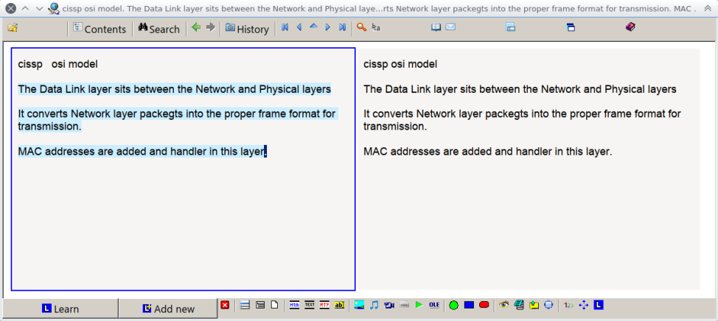

2) Cloze on the 1st extract. "Context" Component not shown when executing the rep until after the answer (excuse typos)
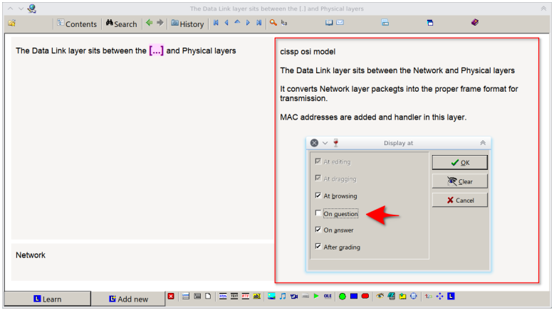

Other types of cards
- I create some "explain this concept as if at a whiteboard" Items
- Explain the difference between [concept X] and [concept Y]
- I stick to one image per Item, largely because I use a strict set of templates when I create Q/A Items directly. I have 2 image answer templates (one for a small image, one for a large image) and the same 2 for questions, as well as one image Q/A with an image question and image answer.

Other Sketch / Notes methods

Smart Wisdom notes
One of the most unique note taking Styles I've ever come across.
publicly available info on it is limited as the author seems to want to restrict it to in-house classes in the UK
When I came across it about five years back he was promising a DVD for sale the following year but I don't think he ever produced it.
There used to be more available but I can't find it now
The notes use a specific Template with specific icons. Very structured style.
Here's what they look like:

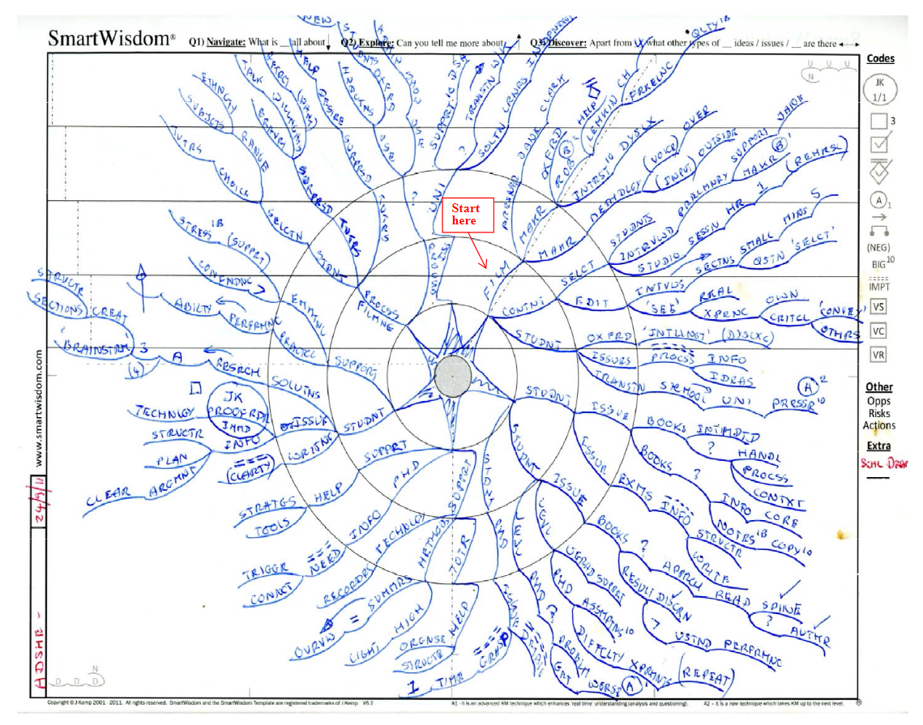

I used these for some coursework I had to do about five years back and they worked very very well for capturing a highly compressed version of the core material.

http://www.drewhajduk.co.uk/index.php/smart-wisdom-note-taking-made-easy/
https://cdn.discordapp.com/attachments/421645841003053057/422950705813520394/Smart-Wisdom_reduced_size.PDF

Impressions: the PDF doesn't answer how information is first encoded. blog post does. reason for that style of information delivery from the author seems to be to make presenting it his business.
Here's a clip showing someone using it for like two seconds from a distance https://www.YouTube.com/watch?v=LTv5I2OjsAA&feature=youtu.be&t=189
It looks like there are a few brief glimpses shown in these marketing videos https://www.YouTube.com/user/TheSmartwisdom
http://citeseerx.ist.psu.edu/viewdoc/download?doi=10.1.1.388.1632&rep=rep1&type=PDF Briefly skimmed that research article and noticed just some primary things that should be considered. Seems like Johnathan Kemp is listed as an author yet no indicator of conflict of interest, I wonder if they really just arbitrarily picked that method or there's some relationship involved. The study conducted the SmartWisdom way but did not compare it to the other listed forms of note-taking. Cornell may be linear in format but it is fundamentally different from classical traditional linear-note taking that they presented and should not be categorized as such. I would like to see how they all competed vs one another. Sample size is extremely limited. Would like to see a larger size ideally. I'm definitely going to take a further look into this though as it definitely has sparked my interest.
Q: It seems very convoluted though. Where would you say it's effectiveness arises in extracting/processing information?
A: Similar to mindmap, forces up-front processing to distill down to critical core terms, captures big-Picture in compressed fashion ; it is far less convoluted in action actually. It also apparently works very very well for dyslexics, possibly due to the compression and its unique word compression method : words are all-caps, no vowels except within first three letters.

Links
- http://davidseah.com/node/the-fast-book-outliner/
- http://www.schrockguide.net/sketchnoting.HTML
- https://www.YouTube.com/watch?v=4ItcHag3agE&list=PLdKI62dB717xntLBme1dcjSumZWwsmTw7&index=7
- https://www.YouTube.com/watch?v=FrNqSLPaZLc
- Anyone interested in rapid learning should look up Scott Young's MIT Challenge video series on YouTube: https://www.YouTube.com/watch?v=E7jWLtdnlfM&list=PLevjQIg-kYubWBFB8NN8EYvYjmJhjEzVA&index=33

Building strong synaptic patterns

Techniques for minimizing the complexity of synaptic patterns as a key to keeping E-factors high
“The most important principle of effective knowledge representation [...] is minimization of the complexity of synaptic patterns involved in storing Memory engrams (Wozniak, 1990). This principle translates to keeping the content of question-answer Items simple, specific, graphic, consistent, comprehensible and univocal. The main purpose of such an approach is to make sure that the spatiotemporal pattern of firing during the learning task is the same in each successive Repetition. In other words, there should be minimum change to the synaptic pattern in the course of Repetition as a result of pattern extraction. [...] optimum Repetition Spacing is based on [... uniform and stable] Memory engrams [...], and consequently [...] atomic entities. If the neuronal firing was to change its course over a number of Repetition, a subset of synapses in the relevant synaptic pattern would not receive sufficient enhancement resulting in partial loss of the learned information.”
“Variable synaptic stimulation at Repetitions reduces the effectiveness of Memory consolidation.”
Source: https://www.supermemo.com/english/ol/ks.htm#Complexity

Planned redundancy as a way to cross-strengthening synaptic patterns
“In this subchapter I will discuss techniques that, in a sense, go against the approach based on minimum complexity of synaptic patterns. Namely, I will show the importance of redundancy of knowledge representation in effective recall of information. The paradoxical contradiction between the previous and the presented approach can quickly be resolved if we notice that the redundancy is not understood here as adding extra components to otherwise minimally intricate synaptic patterns. The function of redundancy is here exclusively to promote the establishment of additional synaptic patterns serving as emergency access routes to the remembered knowledge. Redundant Items will by no means duplicate their content in the database, at least not in the syntactic terms. This, first of all, would go against the principles of the Repetition Spacing algorithm, which assumes the uniqueness of Items as one of its fundamental premises. However, the same semantic contents might be expressed using different means for the sake of providing the pattern-matching neural network of the brain with an opportunity to derive the semantic common denominator (as, for instance, in Items that use multiple narrowing by example). The derivation of the common denominator will naturally proceed through the mechanism of pattern extraction. The redundancy will generally comprise the following elements:
- using both active and passive recall
- providing accessory reasoning derivation steps
- providing optional reasoning context
- providing multiple representation for semantically homologous Items
The main function of redundancy is not to make Items easy to remember, but to make sure that forgetting an Item does not affect the entire associative structure of the knowledge graph. Forgetting, as it should be stressed here, makes an inherent part of Repetition Spacing algorithms, and cannot be by any means eliminated. The ideal model of 100% retention is for biological reasons unfeasible. Redundancy is supposed to minimize the possible effects of forgetting on the performance of the learned skill.”
“It's recommended that all symbols should be explained in parentheses as explanatory note. (e.g. when you start losing the meaning during longer Intervals)”
For more detail, read:
Source: http://www.super-Memory.com/english/ol/ks.htm#Redundancy

Approaches that use stored memories
- Metaphoric (uses declarative memories) : https://www.supermemo.com/english/ol/ks.htm#Metaphoric%20approach
- Vivid (uses emotion) (derogatory terminology, humorous statements, reference to esthetics, taste, basic instincts, sex) : https://www.supermemo.com/english/ol/ks.htm#Vivid%20approach
- Graphic (uses visual processing capability of the human brain.) : https://www.supermemo.com/english/ol/ks.htm#Graphic%20approach
- Mnemonic (uses artificially redundant graphic images to represent unique and non-sensical information) : https://www.supermemo.com/english/ol/ks.htm#Mnemonics

Optional reasoning clues, mnemonic clues, context and examples
“The fact that Items should comply with the minimum information principle does not mean that they cannot be in any way redundant in itself. It is only important to make sure that the compulsory content that is subject to the Repetition does not contain redundant elements. Apart from that, the Item itself may contain a great deal of accessory material that might be useful in learning. This can include context clues and explanations, reasoning clues, mnemonic clues, illustrative examples, or even hypertext links, etc. Each time it must only be clearly specified that the redundant contents is not compulsory and in any way needed for scoring the passing grade.
It is well known that the total utility derived by the consumer from a number of goods is not the arithmetic sum of the particular utilities. This property derives from the fact that products may enhance or suppress each other’s utility. This fact can be comprised in an Item formulated as follows:
Q: Why isn’t the total utility function a sum of utilities of particular products?
A: because products may mutually enhance or suppress their utility
As I tried to show in the preceding section, a simple derivation step might enhance the student’s deductive ability with reference to the above piece of knowledge. This could be accomplished by a simple question like "Is the utility function a sum of utilities of particular products?". However, it appears to be useful to provide some redundancy to the answer Element (which in this case is simply "no"):
Q: Is the total utility function a sum of utilities of particular products?
A: no (because products may mutually enhance or suppress their utility)
Seemingly, this Item became a sister copy of the one mentioned earlier. However, the compulsory semantic connection to be recalled in order to score a passing grade is different in these two cases. Again one Item refers to the procedure, the other to feasibility. The explanatory part placed in parentheses is by no means needed to pass the Repetition and serves exclusively as a Memory strengthener, reasoning clue and reference note. The student may opt not to read the explanation at Repetitions at all. However, if her or she notices that his or her response became automatic rather than semantic, the reasoning clue may serve to restore the right context and ground for the answer.”
Source: https://www.supermemo.com/english/ol/ks.htm#Clues

Repetitions

State of mind

Concentration
In the pursuit of more and more knowledge, you may develop a tendency to give careless answers and hastily jump from question to question in order to reduce the Repetition time. There are no dangers related to fast Repetitions on condition that the speed is achieved by simplicity of Items rather than by negligence in providing answers. It is often possible to automatically answer a question without understanding its important implications. Instead of being semantic, i.e., based on the meaning, the Repetitions become syntactic or literal, based on the automatic rendition of the Item's wording. Not only is the thus acquired knowledge of little value, but what is worse, you may become disillusioned with SuperMemo because of inadequate learning progress. To prevent such an outcome, you must constantly control the learning process by asking the following questions:
- Is this Item truly important for the skills I want to develop?
- Does the ability to answer the question truly ensure that I remember exactly what I want to remember?
- If I have any problems with remembering a given Item, is it truly formulated in the simplest and most univocal way? (see: 20 rules of formulating knowledge)
- If I have problems with a simple and univocal Item, what mnemonic technique could I use to make it easier to remember?
- Are the following elements of the learning process suitably chosen?
  - The extent of the subject I want to learn (considering my learning capacity and availability of time)
  - The degree to which I want to get into details
  - The level of knowledge retention I want to reach (see: Forgetting index)
  - The amount of time a day I can afford to spend on SuperMemo
Source: https://www.supermemo.com/Articles/decalog.htm#concentration

I have absolutely experienced this, especially with a lot of Cloze sentences I copied in from a PDF textbook or typed in manually while studying a course a couple years ago. Without the big Picture tying the concepts together it becomes a bunch of isolated facts. ("concept" here used in the generic sense, not the SM category sense) That's why I end up often preferring to type in my own Q/A cards to "attack" a concept from multiple angles, i.e. one to define a term/concept/idea, another to explain it as if at a whiteboard, another to differentiate that term/concept from one or more other similar terms/concepts, etc. I also tend to add notes in answer fields for other related Items, e.g. at the end I may say something like "this is an example of [term/concept] in action as it [does something]" where the brackets denote some text that is specific to that term/idea/concept.

A creative wandering state of mind is welcome in the process of reading. However, while making Item Repetitions, the whole world of students consciousness must be focused on only two entities: the stimulus (question), and the response (answer). The brain will do the rest by creating or reinforcing the association between the two. The less noise arrives at this binary world, the better the association. Even the relevant information, e.g. illustrations in an article, must be chosen carefully to make sure it does not provide additional cues that might lead to a false sense of remembering. All hint-carrying references, examples, illustrations, etc. must be removed from Items.
Source: http://super-Memory.com/help/faq/Memory.htm#89416-4130

Topology / Organization (KT, Image registry, etc.)

Incremental Picture management
One thing I've found useful over the years is I tend to only have one Picture per flashcard (Unless multiple Pictures are needed OR it's a language flashcard; I have different Pictures that signal different languages). The Picture that I choose needs to "represent" the core idea of what that flashcard is about.
For example, I have a flashcard about how Eskimos/Inuit people refer to polar bears ("Those that go down to the sea"). The flashcard could either have a Picture of an Eskimo/Inuit person OR a polar bear, but since I think it contributes more to my knowledge of polar bears than it does of the Eskimo/Inuit people, I use a polar bear Picture.
I have about 10,000 Pictures in SuperMemo, and every day I try to organize them just a little bit so that each Picture represents a concept and that concept is stored in a somewhat organized way in my knowledge tree. When I have a concept for whatever Picture I have, I put an asterisk on the end of the Picture name in the Picture registry (For example, my polar bear Picture is titled "A Polar bear*"; the "A" is for animal). When I see the asterisk I know that I have a concept for that thing so I can quickly assign it to the correct concept as I make the flashcard. I also figured out how you can see all of the Items/Topics that you have that feature whatever Picture in it, and then I assign all of them to a particular concept which moves them to that area in the knowledge tree. Keeping an organized knowledge tree isn't my biggest goal in life, but every day I try to add one new concept to SuperMemo that has a Picture associated with it and move all of those Items/Topics to that area. When making new flashcards I will know if I have a concept for something if the Picture I choose has an asterisk on it. If it does, I assign it to that concept. If not, it just sits there until I eventually get to that concept in my daily concept creation.
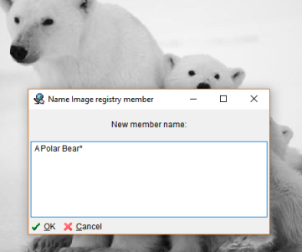
Flashcard in question as well as the name of the Picture in the image registry

Image registry conventions
I use a rough convention, basically "[category] keyword keyword" in images:

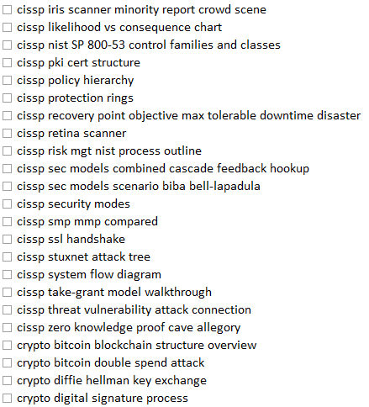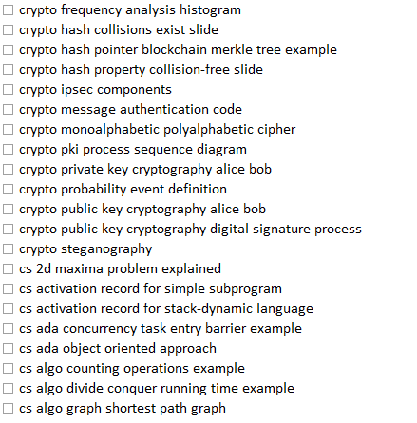

[category] basically corresponds to a category/concept
only issue is that when I reuse the image in a different context/category/concept then it's kind of odd to have it show up where it "doesn't belong" -- but that's such a minor issue that it doesn't concern me.

I also use PRS for people, so "PRS Malcom X" or "PRS Stephen Hawking" for the registry.

Knowledge, Epistemology & SuperMemo

Evaluating the quality of learning progress
For an Incremental reader, the ultimate test on his or her learning progress is the applicability of the acquired knowledge in real life. The context of the learned association should ideally be filtered out at learning, Review and retrieval states. All that should ever matter is how the formed association contributes to the complete fabric of knowledge of the individual.
Source: http://super-Memory.com/help/faq/Memory.htm#89416-4130

What should go into SM ?
A: The eternal problem with something like SuperMemo, is deciding what adds the most value and sticking with it.

- Only after I have a basic understanding of the subject do I feel competent to decide what is SuperMemo-worthy
- According to Piotr, you just enter whatever you want and give it a Priority.

A: I think that is a common problem. To me the benefit of SM as a learning environment is that you can reformulate/delete at will. I will often come across a Q/A Item I put in over a year ago and I question if it is worth remembering now. If it is worth keeping but difficult to remember I'll reformulate it. If it is no longer worth remembering I'll Dismiss it. Quite a few times those were things I needed to know for a test in school but don't need to know all the gory details for the rest of my life -- high points / wavetop big Picture concept understanding is better in some cases and in those cases I freely Dismiss the Item as no longer relevant. (but kept around just in case I want to refer to it for some reason later)
Since you are only dealing with Topics/Items you have just recently created you may want to consider adding context when you make the extract. Also you may be dealing with what I dealt with early on…
I would literally extract every section or paragraph and try to find sentences to extract/Cloze.
Because why not memorize everything?
But that's where the human Element comes in -- you have to exercise positive control over what you choose to learn and apply that mental filter before you extract: Is this material really worth remembering? That is something only you can answer for yourself. If the answer is yes then you may need to add context tags, include surrounding sentences/paragraphs, etc. Or just put in a note "I made this card because __" which I've also done.
Afterwards when I get hit with something 18 months later I wonder do I really need to know the relatively unimportant difference between these two old dudes' theories from 100 years ago when I don't work in that field?

A: Contrary, for me I think I've just become a Topic hoarder.
I won't Dismiss them thinking, "I bet there's still some different ways I can ask this question in the future"

Epistemic status of knowledge
Q: Do any of you guys consider the epistemic status (Relating to knowledge or to the degree of its validation) of the knowledge you add to SM? Any thoughts on this?
That is: your confidence in the truth of what is asserted in the Items.
But really at the point when you decide to add the knowledge to the collection at all.

A: To me it seems like Woz himself searches to manage it based on consistency with the rest of his knowledge, mainly through spotting contradictions and dealing with them ad hoc, establishing an ever-expanding self-corrective and integrated body of knowledge as he proceeds with learning (Don't quote me on it though as it's just an impression I got from reading some of the documentation.) An issue I'm thinking of here is how this might only work effectively if your collection is huge and covers a lot of ground, because if it not, then you might just not ever come across any of these contradictions, which would undermine the self-corrective aspect.

Field-specific discussion

Mathematics

Factoring
When I used Anki for my calc prep stuff I spent a lot of time doing occlusions on factoring pattern recognition.
I found a table that had a bunch of common patterns and made tons of occlusions for each side of each one and drilled them into Memory

Cognition
See: http://supermemo.guru/wiki/Myths_of_Memory_and_learning

Learning

Does SuperMemo improve short-term or long-term Memory ?
SuperMemo builds up long-term Memory but helps you increase your mnemonic skills that will result in the impression that your short-term Memory works better.
You can also look at this like that: SuperMemo loads knowledge to short-term Memory and this is transferred to long-term Memory. The effect on long-term Memory is stable but the speed of putting things into short-term Memory may increase due to training. Short-term Memory improvement comes slowly with training, but long-term Memory build-up comes immediately upon employing SuperMemo!
https://www.supermemo.com/help/faq/supermemo.htm#STM_or_LTM

Do intelligent students learn faster ?
“The article presented below seems to indicate that your IQ does not really matter much in learning with SuperMemo! [...]
- The conclusions for you, the user of SuperMemo:
- Never say: "I am too stupid to learn it". If you cannot understand something, you probably miss some facts needed to complete the Picture or perhaps the book you are studying is just badly written. Do not blame yourself! If you really try and you cannot, it probably is not your fault
- Never say: "I have too bad Memory to really learn it". The experience of thousands of students of SuperMemo is that on average we differ very little as far as basic Memory properties are concerned! Some students can really better structure the material to learn and thus learn really fast but with SuperMemo ... you will be forced to develop better mnemonic techniques (ways to structure the material in your Memory). Otherwise the intractable material will make your Repetitions a living hell. With time, you will see that your speed of learning does not differ much from the speed of other students.
- What really counts most in learning is motivation! If you really want to learn something, the only true limitation is time and the availability of a well-written (or well-structured) learning material. With SuperMemo, your Memory no longer is a factor!”
Source: http://super-Memory.com/english/iq.htm

“It is a common sense reasoning that good students learn faster than bad students; the fact that should be reflected by the parameters of the learning process. A natural intuition is that good students should exhibit low forgetting index, quick response time, high grades, etc.
My observation is, however, that in learning based on self-assessment, the opposite correlation appears to be true. Successful students apparently learned slower and appeared to forget Items much more frequently than the unsuccessful students!
The interpretation of this paradoxical finding is that good students are by far more critical in the judgment of their own progress. It has been for long postulated in my earlier publications that there is very little difference between individuals as far as the mechanisms of Memory are concerned. It is the way humans process information that sets them apart from each other. Consequently, little difference could be observed among the students in the ability to remember. However, those who appeared to be self-indulgent and lenient in self-assessment, usually showed much lower levels of knowledge retention in absolute terms (i.e. as judged by the supervisor).”
Source: http://super-Memory.com/english/ol/analysis30.htm#_Toc324565997

Procedural & Declarative learning
Procedural learning is used to acquiring a skill such as riding a bike or typing the keyboard. In procedural learning, we do not tell the brain exactly how it should perform. The brain provides "the answer" on its own by trial and error, while we only "approve or disapprove" of its performance. In declarative learning, as in memorizing a textbook, we tell the brain exactly what to learn, and expect it to encode information in Memory. Procedural learning, by definition, is highly repetitive (you repeat the same moves again and again, only with a slightly improved precision). With declarative learning, we want to minimize the Repetition. For those reasons we need to discuss the two types of learning separately.
https://www.supermemo.com/help/faq/Memory.htm “There is a physical limitation on how much we can learn per day”

Memory

Memory can be improved
Myth: We cannot improve Memory by training. Infinite Memory is a popular optimist's myth. A pessimist's myth is that we cannot improve our Memory via training. Even William James in his genius book The Principles of Psychology (1890) wrote with certainty that Memory does not change unless for the worse (e.g. as a result of disease).
Fact: If considered at a very low synaptic level, Memory is indeed quite resilient to improvement. Not only does it seem to change little in the course of life. It is also very similar in its action across the human population. At the very basic level, synapses of a low-IQ individual are as trainable as that of a genius. They are also not much different from those of a mollusk Aplysia or a fly Drosophila. However, there is more to Memory and learning than just a single synapse. The main difference between poor students and geniuses is in their skill to represent knowledge for learning. A genius quickly dismembers information and forms simple models that make life easy. Simple models of reality help understand it, process it, and remember it. What William James failed to mention is that a week-long course in mnemonic techniques dramatically increases learning skills for many people. Their molecular or synaptic Memory may not improve. What improves is their skill to handle knowledge. Consequently, they can remember more and for longer. Learning is a self-accelerating and self-amplifying process. As such it often leads to miraculous results.
Source: http://supermemo.guru/wiki/Myths_of_Memory_and_learning#Memory_can_be_improved

Aging is not a factoring
Myth: Memory gets much worse as we age. Aging universally affects all organs. 50% of 80-year-olds show symptoms of Alzheimer's disease. Hence the overwhelming belief that Memory unavoidably gets rusty at an older age.
Fact: It is true that Memory tends to decline slowly with aging on average. It is true that the risk of Alzheimer's increases with age. However, a well-trained Memory is quite resilient and shows comparatively fewer functional signs of aging than the joints, the heart, the vascular system, etc. Moreover, training increases the scope of your knowledge, and paradoxically, your mental abilities may actually increase well into a very advanced age. Here is some detail
Source: http://supermemo.guru/wiki/Myths_of_Memory_and_learning#Aging_is_not_a_factor

Permastore does not exist
Myth: It is possible to produce everlasting memories. Even reputable researchers use the term permastore (e.g. Prof. Harry Bahrick). It is a widely-held belief that it is possible to learn things well enough to protect them permanently from forgetting.
Fact: It is possible to learn things well enough to make it nearly impossible to forget them in lifetime. Every long-term Memory, depending on its stability, has an expected lifetime. Forgetting curves plotted by SuperMemo never seem to drop to zero. There are always memories that resist forgetting (e.g. by Review in real life). When the Memory stability is very high, the expected lifetime of a Memory may be longer than our own lease on life. However, if we happened to get extra 200 years to live, no Memory built in present life would remain safe without Review.
Source: http://supermemo.guru/wiki/Myths_of_Memory_and_learning#Permastore_does_not_exist

Morning is best for learning
Myth: Learn new things before sleep. Because of the research showing the importance of sleep in learning, there is a widespread myth claiming that the best time for learning is right before sleep. This is supposed to ensure that newly learned knowledge gets quickly consolidated overnight.
Fact: The opposite is true. The best time for learning in a healthy individual is early morning. Many students suffer from DSPS, and simply cannot learn in the morning. They are too drowsy. Their mind seems most clear in the quiet of the late night. They may indeed get better results by learning in the night, but they should rather try to resolve their sleep problem, e.g. with free running sleep (see: Curing DSPS and insomnia). Late learning may reduce Memory interference, i.e. obliteration of the learned material by the new knowledge acquired during the day. However, a far more important factor is the neurohormonal state of the brain in the learning process. In that sense, the brain is best suited for learning in the morning. It shows highest alertness and the best control of the balance between attention and creativity. The gains in knowledge structure and the speed of processing greatly outweigh all minor advantages of late-night learning
Source: http://supermemo.guru/wiki/Myths_of_Memory_and_learning#Morning_is_best_for_learning

Fluency says little of Memory stability
Myth: High fluency reflects high Memory strength. Our daily observations seem to indicate that if we recall things easily, if we show high fluency, we are likely to remember things for long.
Fact: Fluency is not related to Memory strength! The two-Component model of long-term Memory shows that fluency is related to the Memory variable called retrievability, while the length of the period in which we can retain memories is related to another variable called stability. These two variables are independent. This means that we cannot derive Memory stability from the current fluency (retrievability). The misconception comes from the fact that in traditional learning, i.e. learning that is not based on Spaced Repetition, we tend to remember only memories that are relatively easy to remember. Those memories will usually show high fluency (retrievability). They will also last for long for reasons of importance, Repetition, emotional attachment, etc. No wonder that we tend to believe that high fluency is correlated with Memory strength. Users of SuperMemo can testify that despite excellent fluency that follows a Repetition, the actual length of the Interval in which we recall an Item will rather depend on the history of previous Repetitions, i.e. we remember better those Items that have been reviews many times, at the right time
Source: http://supermemo.guru/wiki/Myths_of_Memory_and_learning#Fluency_says_little_of_Memory_stability

Learning by doing can be expensive
Myth: Learning by doing is the best. Everyone must have experienced the value of learning by doing. This form of learning often leads to memories that last for years. No wonder, some educators believe that learning by doing should monopolize educational practice.
Fact: Learning by doing is very effective in terms of the quality of produced memories, but it is also very expensive in expenditure of time, material, organization, etc. The experience of a dead frog's leg coming to life upon touching a wire may stay with one for life (perhaps as murderous nightmares resulting from the guilt of killing). However, a single Picture or mpeg of the same experiment can be downloaded from the net in seconds and retained for life with Spaced Repetition at the cost of 60-100 seconds. This is incomparably cheaper than hunting for frogs in a pond. When you learn to program your VCR, you do not try all functions listed in the manual as this could take a lifetime. You skim the highlights and practice only those clicks that are useful for you. We should practice learning by doing only then when it pays. Naturally, in the area of procedural learning (e.g. swimming, touch typing, playing instruments, etc.), learning by doing is the right way to go. That comes from the definition of procedural learning
Source: http://supermemo.guru/wiki/Myths_of_Memory_and_learning#Learning_by_doing_can_be_expensive

Mnemonic techniques can be expensive
Myth: You should always use mnemonic techniques. Some enthusiasts of mnemonic techniques claim that you should use them in all situations and for all sorts of knowledge. They claim that learning without mnemonic techniques is always less effective.
Fact: Mnemonic techniques also carry some costs. Sometimes it is easier to commit things to Memory straight away. The pair of words teacher=instruisto in Esperanto is mnemonic on its own (assuming you know the rules of Esperanto grammar, basic roots and suffixes). Using mnemonic techniques may be an overkill in some circumstances. The rule of thumb is: evoke mnemonic techniques only when you detect a problem with remembering. For example, you will nearly always want to use a peg-system to memorize longer numbers (e.g. a PIN). Best of all, mnemonic tricks should be a part of your automatically and subconsciously employed learning arsenal. You will develop it over time with massive learning.
Source: http://supermemo.guru/wiki/Myths_of_Memory_and_learning#Mnemonic_techniques_can_be_expensive

Mind maps are expensive
Myth: Mind maps are always better than Pictures. A Picture is worth a thousand words. It is true that we remember Pictures far better than words. It is true that mind maps are one of the best pictorial representations of knowledge. Some mnemonists claim that all we learn should be presented in the form of a Picture or even a mind map.
Fact: It all depends on the material we learn. One of the greatest advantages of text is its compactness and ease at which we can produce it. To memorize your grandma's birthday, you do not really need her Picture. A simple verbal mnemonic will be fast to type and should suffice. In word-pair learning, 80% of your material may be textual and still be as good or even better than pictorials. If you ask about the date of the Battle of Trafalgar, you do not need a Picture of Horatio Nelson even though a Picture is usually very helpful. If you add a Picture of the actual battle, you will increase the quality and extent of memorized information, but you will need to invest extra minutes into finding the appropriate illustration. Sometimes a simple text formula is all you need.
Source: http://supermemo.guru/wiki/Myths_of_Memory_and_learning#Mind_maps_are_expensive

Mnemonic techniques are not hermetic
Myth: Mnemonics is a panacea to poor Memory. Some Memory programs focus 100% on mnemonic techniques. They claim that once you represent knowledge in an appropriate way, it can be memorized in a nearly-permanent way.
Fact: Mnemonic techniques dramatically improve Memory retention. However, they still do not produce everlasting memories. Repetition is still needed, even though it can be less frequent. If you compare your learning tools to a car, mnemonics is like a tire. You can go on without it, but it makes for a smoother ride
Source: http://supermemo.guru/wiki/Myths_of_Memory_and_learning#Mnemonic_techniques_are_not_hermetic

Spacing effect does not come from encoding variability
Myth: Encoding variability theory of Spacing effect. Many researchers used to believe that presenting material in longer Intervals is effective because of varying contexts in which the same information is presented.
Fact: Methodical research indicates that the opposite is true. If you repeat your learning material in the exactly same context, your recall will be easier. Naturally, knowledge acquired in one context may be difficult to recover in another context. For this reason, your learning should focus on producing very precise Memory trace that will be universally recoverable in varying contexts. For example, if you want to learn the word informavore, you should not ask How can I call John? He eats knowledge for breakfast. This definition is too context-dependent. Even if it is easy to remember, it may later appear useless. Better ask: How do I call a person who devours information?. Now, even if you always ask the same question in the same context, you are likely to correctly use the word informavore when in need. Encoding variability improves learning via generalization. This improves recall by the resulting increase in coherence. See: Knowledge darwinism
Source: http://supermemo.guru/wiki/Myths_of_Memory_and_learning#Spacing_effect_does_not_come_from_encoding_variability

Genius / IQ / Intelligence
http://super-Memory.com/Articles/genius.htm#What%20is%20intelligence
- Purpose of education is to improve our problem solving abilty.
- We can improve problem solving ability by training (i.e. learning)
- We need more abstract knowledge rather than just plain facts. (collection of rules vs collection of facts)
- Good environemnent is great for such training and developing genius,
- For genius breaktrough speed is less important (see: darwin)
- Knowledge is substance you convert to ideas
- Develop good representation (20 rules) and use (Spaced Repetition) ...etc.

I started thinking about that several years ago after reading about the issue of praising kids for their intelligence instead of their efforts. Bottom line is that praising kids for their intelligence actually handicaps them because it reinforces that if they overcome an obstacle or fail to overcome an obstacle it is due to something out of their control (genetic intelligence) rather than their efforts. So they lose their sense of agency. Tons of "gifted" kids/adults feel depressed and coasting through life because they were told all the time "you're so smart!" instead of "wow you really tackled that problem and wouldn't give up!" which would better teach them resilience. Similar to only praising girls for looks instead of actions.

Observation about change in cognition/behaviour

Creativity
I've noticed over the years since I chose to pursue education again that a lot of what he says about knowledge and creativity ring true. I'm sure others have noticed that you may have some insight about an issue or a different way of looking at a problem and have someone make a comment about your IQ etc. Actually I'm convinced that someone of average IQ could use this system and achieve similar insights leading people to think they have become "smarter" when the fact is they have just trained their brain to remember and correlate a lot of information. I think there was a discussion a while back about how SM may have an effect of raising your intelligence precisely because it magnifies your ability to draw connections, think abstractly, and spot patterns more quickly. Those happen to be common measurements of "intelligence" so it is interesting to see if SM has effects in terms of IQ scores and the like. (I'm imagining someone using SM to drill on techniques for solving IQ puzzles and raising their score -- but are they "smarter" if they just "studied for the test"?)

Insights
Learning something new and suddenly make a connection to one or two other Topics you learned via SM and use them as analogies.
When I encounter that kind of insight I always try to encode it into a new Item to memorize and annotate the related ideas when they come up again

Eidetic Memory
Q: Have you ever met someone who seemed like a walking encyclopedia? At the very least, we can see them on Jeopardy every day. They can recall precise terms, names, and dates relating to Topics of broad scope. I know one guy like this who insists he has just always been able to remember trivia easily. He even complains that his problem is that he ONLY remembers trivia easily. "The less useful it is, the more likely I am to remember it," he says. Is this guy lying? Are these people genetic mutants? Or are they all secretly using something like SuperMemo?

And "easily" seems like such a bold claim. Easily? Without SuperMemo, I myself would find the challenge utterly impossible. And even WITH SuperMemo, I wouldn't call it "easy." (It's a hell of a lot of work!)

A: The two explanations that come to mind are 1. They Review that information somehow, maybe even mentally and 2. They have learned to “encode” information really well so that it doesn’t deteriorate as quickly in the mind.

I like the idea of “thinking in a memorable way” (Review/encoding technique), you’re basically always on the lookout for little chunks of knowledge that can improve your life. One thing I have in SuperMemo that I always go back to is something along the lines of “the best learners are the most proactive summarizers.” This ideal genius in my mind isn’t sentimental about ideas or wording. If an idea is new and novel, he/she “tears it out” of the book/show/movie/etc. And represents it in his/her own mind
Basically focused curiosity mixed with a Pokémon-esque desire to “represent them all,” meaning having as many possible broad frameworks “caught” in their mind.
It’s all super abstract, but that’s what I’ve wanted to become I guess. Not the “know it all” guy but I want my mind to easily “slot” new information in and relate it to stuff I already know with minimal work. SuperMemo ensures that whatever we store gets preserved, but how you “pack” the info can greatly affect things also.
Which also gets into “substance over flashy packaging,” or not being duped into thinking an idea is super awesome because it was said on a stage of written in a book, and the idea really isn’t that useful or unique or interesting.
Just like the nerd always has his phone out looking for a Pokemon on the street, you’re always on the lookout for different ways of thinking.
Be deliberate about making mental associations as you go about your life rather than just depending on the associations occurring naturally and unconsciously.
When studying Memory techniques a long time ago, I remember reading that the first technique is just to think about it in the first place. 99% of the time when we forget where we placed our keys, it's because, when we place them down, we aren't thinking about where we place them.
One technique I read about for remembering where you placed your keys was imagining wherever you placed your keys, that area exploding into a million pieces. The grains of wood, the carpet around the area, EVERYTHING all exploding like that one scene in Inception.
It’s not much effort to imagine an explosion wherever you sit your keys, so it’s basically a free action.

Misc Topics

Usability “hacks”

Controllers
Once you get into the zone, you can really tear through your reps with a controller. I think not being able to easily click on other things makes it easier to not get distracted

Xbox Controller
I can cast my computer monitor to my TV and sit on my couch and do my reps. A bit more lax than sitting upright on the computer pounding away at the keyboard.
Also move through the Items a lot faster I'm noticing as there's less hand movement required.
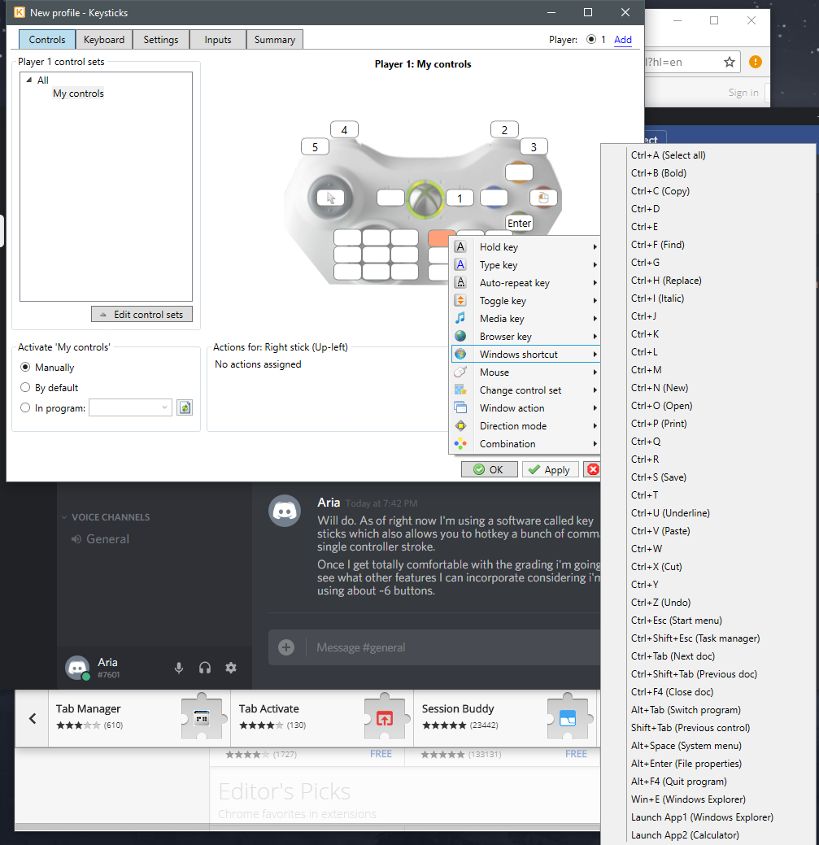

Sample mapping:
Left Bumper (5)
Left Trigger (4)
Right Bumper (3)
Right Trigger (2)
Triple Line (1)
Left Stick – Mouse
A Button – Enter
B Button - Right Click

I'm using a software called key sticks which also allows you to hotkey a bunch of commands to a single controller stroke.
Once I get totally comfortable with the grading i'm going to see what other features I can incorporate considering i'm only using about ~6 buttons.

Wii remote control
Shortly after the Wii first came out I was thinking "this would ROCK if I could do SuperMemo with it," and slowly as bluetooth support and different programs emerged for it, I started writing scripts for my Wii remote to act as my SuperMemo controller. A button = 4, directional pad = up, down, left, right, B = enter key, etc.
I have used the SAME Wii remote every day for at least 8 years, pressing the B and A buttons probably MILLIONS of times and it still works as good as day 1
I've found that when I'm using the Wii remote I get through Items MUCH faster than when I'm using mouse and keyboard

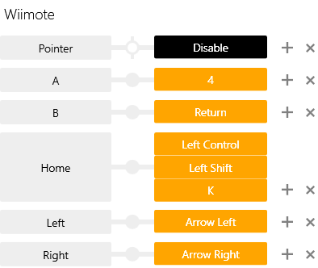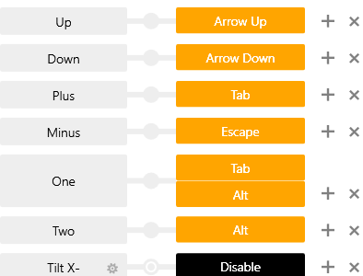

Mouse macros
I use a gaming mouse and I macro Template changing, converting text, increasing and decreasing text size to the different buttons
Two buttons on the left are for changing text size



Wow, I purchased one of those MMO mouses and can say that it is totally worth it. Between using my xbox controller for my Repetitions and the mouse for creating Clozes my time has already dropped from 29 sec/Item to 22/Item. Curious to see how much further it goes in the long run.

The Repetitions are on the Xbox controller so they're going by super fast. In regard to the Cloze's I made a bunch of shortcuts to the 12 different buttons like Cloze, previous Element, next Element, delete before cursor, delete after cursor. Everything is almost done with the mouse now so I never have to take my hand off of it making movements that much more minimal and increasing efficiency.

Emotions & SM

Feedbacks
I also have the "text dialogue end" sound from Ocarina of Time play when I get an Item correct.
I have a little library of bloops and bleeps that I cycle through, I like good sounds when I get an Item right.
I want my brain to associate it with as many positive things as possible
Good sounds, Pictures that are fun to look at, etc.
The final thing I could see happening is there being an RPG that is integrated on top of SuperMemo so that by playing the game, you solve flashcards and get in-game rewards based on your performance.
We've become addicted to way LESS productive things simply because our brain gets addicted to it.

Visualizing
The only thing I do to make it interesting/fun is try to imagine that I'm on a quiz game show or that I'm having a conversation with someone.
I'll read the Items aloud like I'm talking to someone

Self-involvement
I try to mutter the answer to myself. If don't know it, I didn't say it, so I can't mark it as "good".
Even though I see the answer, agree "yeah, that's the answer" even if I got it wrong. It forces me to stay honest.

Deadlines
One reason I avoid the Priority feature is that I find deadlines highly motivating. If I set Priorities and allow myself to just Review as much as I'm in the mood for, I won't do half as many.
Instead, I use a combination of postpone (on individual leeches on subjects of low Priority at the time) and the filter feature to prepare a set of outstanding Items that I feel like focusing on next(edited)
In other words, everything is Priority 0. But before I start my reps, I will use the filters to select among the outstanding Items based on my taste at the moment
Maybe I will filter on outstanding + easy, for example
Then, as I'm actually doing my Repetitions, I will select "postpone" or "reschedule" on individual Items that I just don't care about at that moment

Mind – KT sync
SuperMemo is all about programming myself, so I think of it as an extension of my mind and my identity. Just like someone on /r/malefashionadvice cares about how their clothes go together, I want my Items to look slick and cool. Like you just said, it's a lot easier to do that stuff incrementally like pruning a bonsai tree, but I have an idea in my mind of how each flashcard will look in its final form, and I'm always trying to inch closer and closer towards that ideal

Enjoying reviews

The museum trip
I've always loved going to the museum and I've tried to make SuperMemo more like a trip to the museum by making the presentation happy to look at. It takes a few extra minutes but when I'm making flashcards I'm often watching something casual and light (I like to watch old downloaded episodes of Conan or Colbert) so I don't mind a few extra seconds to make them look cool.

Gamification
It's my version of WoW. It's like telling a crack addict they need to do crack for just two extra minutes more a day. Why not an extra week?
Once the benefits were obvious, it wasn't hard to keep up with it.

Late on reviews (outstanding Repetitions)
"The infamous Outstanding parameter becomes a form of religion. If it does not get down to 0+0, users feel like a failure. This attitude towards Review has percolated to other applications that rely on Spaced Repetition. Many have the aura of homework built into their design, incl. fake rewards to motivate learning." http://supermemo.guru/index.php?title=Hating_SuperMemo&diff=8517&oldid=8512

Education & Everyday life

Downtime
I love using an app on my phone called “Voice Dream.” It reads anything you put into it from ePub books, your Instapaper or Pocked feed, etc. When I am by myself I usually keep earbuds with me and pop them in to listen to either something on Voice Dream or podcasts, whichever I’m feeling at the moment. Sometimes it’s good to totally unplug and let your brain go into “screensaver mode” so you can mentally chip away at things like one would chip away the HP of an RPG boss.

State of mind
You read a bumper sticker or someone says something that strikes you as a neat line of reasoning so you grab your notebook or phone and write it down.
Also probably has something to do with the “flow state” of getting in the right mindset on command and directing the processing power of your brain to capturing new ideas. Have our RAM as free as possible to process new ideas verses being anxious about stuff and letting the world throw popups or install malware into your brain so you’re constantly thinking about whatever Facebook/phone notifications/etc. Are telling you.
Uninstall brain bloatware and only have one window open at a time.
I’ve found the less I check my phone compulsively for no reason and the less I use social media it’s easier to feel like I’m in control. I love using my phone to look up info about stuff, but when I’m out and about I try to ONLY use it for googling, writing stuff down for SuperMemo or putting stuff on a to do list.
I want my brain’s screensaver to not be “hey, you have 10 seconds? Check Facebook!”
I found setting my phone to greyscale made a HUGE difference in how much compulsive checking I do. It is a boring functional device now moreso than a shiny toy. I don't know about androids but on the iphone you can set it so triple-pressing the home button will switch between greyscale and color. Also Win10 fall update has a greyscale mode toggle as well, Ctrl+Win+C. Only catch with Windows is it operates deeper in the stack than at the pixel display level -- screenshots taken in greyscale mode will be permanently greyscale!

SM for personal information
On the subject of adding personal Items to SM, I have a few containing specific info on friends I'm not in regular contact with. Year of birth, spouse/kids names, important bits of info etc. Makes catching up after several months much easier. I think it can help with the "personal network" for professional development as well, i.e. add in Items for that great doctor who answered all your questions or the mechanic who went the extra mile etc. So when you need one of those services or someone needs a recommendation you have it right in your mind. But I haven't gone that far just yet.

SM & Mnemosyne import/export XML format, side-by-side
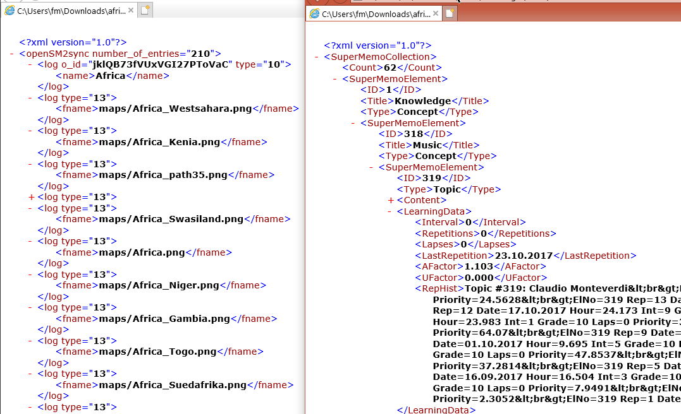

Supermemo email contacts
Piotr Woźniak: woz2018@supermemo.org

Misc links
- Sketchnoting
  - http://davidseah.com/node/the-fast-book-outliner/ (Physical book outlining method)
  - http://www.schrockguide.net/sketchnoting.HTML (Structured visual note taking)
  - https://www.YouTube.com/watch?v=4ItcHag3agE&list=PLdKI62dB717xntLBme1dcjSumZWwsmTw7&index=7 (Sketchnoting tutorials, breaks everything down simply and low-threat)
  - https://www.YouTube.com/watch?v=FrNqSLPaZLc (Feynman rapid learning technique)
  - https://www.YouTube.com/watch?v=E7jWLtdnlfM&list=PLevjQIg-kYubWBFB8NN8EYvYjmJhjEzVA&index=33 (“MIT challenge” guy techniques)
- https://www.reddit.com/r/juststart/ (if anyone in the future wants to understand how internet marketers think just go camp out on this sub for a while, it's all about how to set up an online marketing / niche / hub site and shovel out products for sale / affiliate links / drive traffic etc)
- http://tinyhabits.com/
- https://learn-anything.xyz/ “Search Interactive Maps to learn anything”
- http://joyousandswift.org/epistemic-status/

SuperMemoMemes

The joys & sorrows of Incremental reading


Supermemo documentation resources

Articles
- https://www.supermemo.com/help/faq/other.htm “Questions of special interest”
  - https://www.supermemo.com/help/faq/other.htm#30037-6778 “Q: Your support files are disorganized, confusing and repetitive”
- http://help.supermemo.org/wiki/Glossary
- http://Supermemopedia.com/index.php?limit=500&tagfilter=&title=Special%3AContributions&contribs=user&target=SuperMemoHelp&namespace=&topOnly=1&year=2018&month=-1 “Woz contributions to Supermemopedia”

Videos

Piotr’s Tutorials
https://www.YouTube.com/channel/UCqmYtieCc3liSTYxLwk_MLw

Mrozikpl Videos Tutorials
https://www.YouTube.com/watch?v=QosglgYT_Mw

Alessio’s tutorials
https://www.YouTube.com/watch?v=xqdhskJuhCo “Importing a book into SuperMemo’s pending queue”

3rd-Party tools

SM Auto Backup
- Dropbox backup script
  - https://github.com/davecan/SafeSuperMemo

Snapshots (history of your SM collection)
I've setup snapshots and linked them with the Shadow copies feature on Windows. With this setup, your files are versioned at specified Intervals, and at a very low cost. Snapshots are basically just diffs between each successive version, instead of actual copies, and so is much more efficient space-wise.
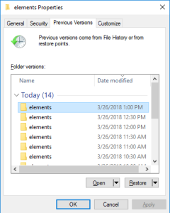
I've set up two snapshots tasks for now : a) Every 1/2 hours for 24 hours, b) Every day for 3 months
I'm personally using a server with ZFS setup (FreeNAS http://www.freenas.org/) so that I have redundant on-site backups, but I believe Windows offers similar features with its built-in Shadow copies system, for simpler setups.
*redundant: even if one or two hard drives were to fail before I can replace them, my data are still safe. This is called RAIDZ2

Keep in mind that this does not excuse from not having off-site backups. Better safe than sorry, I'd personally rather pay 50$ per year (+/- one overpriced cup of coffee per month) and have almost certainty that my precious data accumulated and hardly built over the years are safe, rather than cry when I lose all my efforts over a perhaps unlikely, but still possible accident.

Using snapshots also has a few other direct and indirect advantages over copies:
- Your data is saved WHILE using supermemo. No need to close and synchronize your content,
- As a consequence of it, if something happens while you are editing your collection, you can always revert back to a very close version,
- You can take virtually any amount of snapshots you want, since two diffs of 15 minutes cost almost the same as one of 30 minutes ; meaning that you can reach very fine levels of granularity on your snapshots, and have very accurate versioning.

Mind-mapping
  - XMind
    - http://www.xmind.net/
    - https://en.wikipedia.org/wiki/XMind
  - Mindomo “Mind mapping site that automatically creates note style outlines for you based off of your mind map”
    - https://www.mindomo.com/
    - https://en.wikipedia.org/wiki/Mindomo

Browser extension
  - Mercury Reader. It's great for converting a webpage into something easily readable with one click, and lets you control some of the parameters (font style/size, light/dark theme)
    - https://mercury.postlight.com/reader/

Word processor
  - CintaNotes Provides a way to store and retrieve text collected from other documents or websites. Since version 3.0 CintaNotes supports attaching files and images to notes.
    - https://en.wikipedia.org/wiki/CintaNotes
  - Kami PDF / Doc App : It higlights what you copied, and leave you a readpoint.
    - https://www.kamihq.com/
  - Scrivener (/ˈskrɪvənər/) is a word-processing program and outliner designed for authors.[4] Scrivener provides a management system for documents, notes and metadata. This allows the user to organize notes, concepts, research and whole documents for easy access and reference (documents including rich text, images, PDF, audio, video, web pages, etc.)
    - https://en.wikipedia.org/wiki/Scrivener_(software)

Smartphones
- IOS
  - Workflow “Powerful automation made simple”. Workflows combine a bunch of steps across apps into a single tap. Collect workflows like these to save time and effort every day.
    - https://workflow.is/

Bugs / Quirks
- Freezing
  - Usually when running a search honestly, and occasionally when navigating between Topics/Items. Only recourse was to kill the process and restart. Hoping it doesn't corrupt the collection. Another reason why I made my backup script. Can't be too paranoid w/ SM. :\
- Templates
  - Editing: WARNING: DO NOT EDIT ANY Template IN THE Template REGISTRY! I did that before and hosed everything up. I think the SM tech support had to fix my collection manually. (See: Editing a Template for workaround)
- Images
  - Smth strange happened. My pics are all over the place. This is destroying all my visual Clozes.
    - Solution:
      - Click the Pictures so they're highlighted hit Ctrl+Enter and type fit all Pictures
      - Sometimes an option box comes up that asks you to adjust the Template across as elements, always make sure you click to keep the changes local
  - Images will not paste into an HTML Component at all
  - Images will go missing from the Component at some later date
  - Pictures get swapped with other Pictures
    - Solution:
      - I've had both so I started using only image components for images. Images have to be internalized or they get all sorts of messed up.
      - I’ll still copy and paste them into the HTML space for time but once I’m done getting in all the info into the Topic I’ll do a quick Ctrl+F8 and insert them all as image components. I like to add the images into the HTML while im reading and then at the end use that function to pick and choose the ones I want to turn into an image Component.
        - Ctrl+F8 is only when the image is pasted into the HTML. Don't need to do it for images that are part of an image Component. SM site says it downloads images so I assume it makes them local refs. Doesn't seem to do anything when I test it in a Topic with a wiki article in it.
        - So when the HTML content from a page is pasted into the HTML Component the img tags are still pointing to the images on the server, but Ctrl+F8 downloads the images and places them in the image registry and updates the references to point to the local cached images instead. Then those aren't at risk of being lost and later you pick some and convert them into image components
- Content
  - Ctrl+Shift+1 key combo seems to work on and off. It is likely related to the HTML structure
- Video
  - A playing video playback is not interrupted when it is deleted, forcing user to restart SM
- Incremental Video
  - Glitches when resizing the Element window (video pauses or refreshes),
  - Requires too many steps to get rid of the video Component from an Alt+X extract once you don't need it anymore,
  - Buggy interface
  - Possibility of losing all of the videos next time YouTube changes its API (as happened last year or so, lots of complaints on Supermemopedia)
  - It wouldn't make the video extract render as a new Element until i navigated away from the Element in the Component's tree
  - Whatever I name the extract is propagated only in the Element's title, but no reflection of it on the HTML Component or reference

Placeholder

- Using SuperMemo
  - Layouts
    - Browser messing up display
  - Content
    - Turning Topics into Items
      - Mark a component as answer
        - Manually by right clicking
        - Applying an Item template (or one with an Answer-marked component)
    - Cloze
      - Opening Cloze
  - Shortcuts
    - Composite shortcuts
    - AHK
      - Set Hook
      - Compress picture
      - Format content
      - Overlapping Cloze-like
    - Templates
      - Shortcut prefixed to Template name
    - Keypirhina
      - FileCatalog
    - Chrome
      - Omnibox
        - Wiki search (wiki)
        - Google Image (i)
        - Thesaurus (t)
  - Technical
    - Linux
      - VM + Remote Desktop (Remmina)
- Getting started
  - Tree classification
  - References
    - http://help.supermemo.org/wiki/References
    - http://Supermemopedia.com/wiki/How_to_propagate_references_after_an_Articles_has_already_been_processed_(extracts_or_Clozes)
  - “TO DO” Concept group
  - Layouts
    - http://help.supermemo.org/wiki/Glossary:Layout
  - Use Shortcuts
  - Learnbar
  - Processes
    - Importing knowledge
      - Chrome
        - Tabs Outliner
        - Highlight
        - Open in IE
      - Import (Ctrl+Shift+W)
      - Search
        - Omnibox
          - “wiki” > Wikipedia
          - “sup” > Supermemopedia
          - “gu” > Supermemo.guru
    - Incremental Reading
      - https://hooktube.com/watch?v=XRuLV2_A3Ts
        - Import Article
        - Extract / Split
        - Done (Ctrl+Shift+Enter)
        - If wants to Study new content now
          - View in browser (Ctrl+Space)
          - Randomize (Ctrl+Shift+F11)
          - Add to outstanding queue 
          - Learn (Ctrl+Shift+L)
      - IR & Repetitions
        - Reviewing a Topic
          - 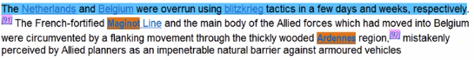
          - Extract, Cloze, Delete, Done, Reschedule as necessary
          - Next repetition
        - Reviewing an Item
          - Answer & Grade Item
          - Edit if necessary

