import numpy as np
import matplotlib.pyplot as plt

x = [4, 5, 10, 4, 3, 11, 14 , 6, 10, 12]
y = [21, 19, 24, 17, 16, 25, 24, 22, 21, 21]

plt.scatter(x, y) plt.show()
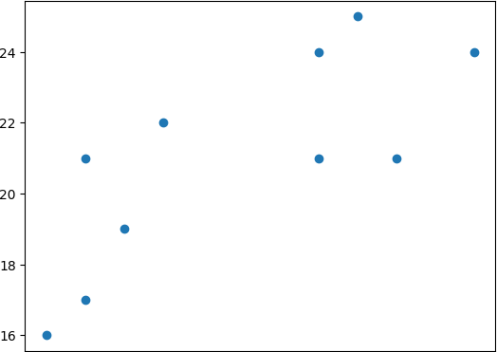

import numpy as np
import matplotlib.pyplot as plt
from sklearn.cluster import AgglomerativeClustering

x = [4, 5, 10, 4, 3, 11, 14 , 6, 10, 12]
y = [21, 19, 24, 17, 16, 25, 24, 22, 21, 21]

data = list(zip(x, y))

hierarchical_cluster = AgglomerativeClustering(n_clusters=2, affinity='euclidean', linkage='ward') labels = hierarchical_cluster.fit_predict(data)

plt.scatter(x, y, c=labels) plt.show()

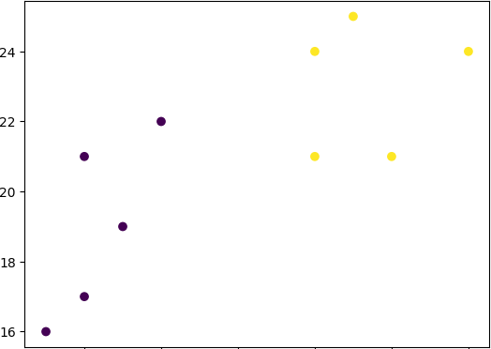/usr/local/lib/python3.10/dist-packages/sklearn/cluster/_agglomerat warnings.warn(

import numpy as np
import matplotlib.pyplot as plt
from scipy.cluster.hierarchy import dendrogram, linkage

x = [18, 22, 25, 27, 42, 43]
y = [18, 22, 25, 27, 42, 43]

data = list(zip(x, y))

linkage_data = linkage(data, method='ward', metric='euclidean')

# Extract x-axis labels as the elements from the data list x_labels = [str(point) for point in data]

dendrogram(linkage_data, labels=x_labels) plt.show()

