Supplementary Materials for

**Disentangling climate change & land use change effects on river flows: a probabilistic approach**

**Nicholas Wraya, Duncan Bowiea, Ian Pattisonb Athanasios Angeloudisa, Lindsay Beeversa,**

**aThe University of Edinburgh, bHeriot-Watt University**

# Table of Research Results

Table SM1 – A tabulation of conclusions reached by various authors concerning the relative contributions of CC and LU to streamflow and other attributes

|  |  |  |  |
| --- | --- | --- | --- |
| **Author** | **Methods** | **Region Studied** | **Conclusions** |
| Dong et al., 2015 | SCS-CN | Sub-Tropical China | For Large Basins LUS>CCS and for Small Basins CCS>LUS |
| Li et al., 2021 | Hydrus-1D  Wavelets | Loes Plateau, China | CCS affects evapotranspiration LUS affects deep drainage |
| Wang and Hejazi, 2011 | Decomposition  Budyko | Contiguous US | CCS has more effect on streamflow than LUS |
| Yin et al., 2017 | SWAT | Heihe River, NW China | LUS increased streamflow by 7.12%, CCS increased streamflow by 14.08% |
| Ahn and Merwade, 2014 | Linear Regression, Simulation, Annual balance, Budyko | Four US States | LUS > CCS |
| Zhang et al., 2018 | MK, Wavelets, DMC | Wuhua River China | LUS 85.8% of run-off reduction |
| Li et al., 2009 | Time Series Analysis | Loess Plateau, China | For decrease in run-off LUS 9.6% CCS 95.8%  For decrease in SWC LUS 18.8% CCS 77.1%  For increase in ET LUS 8.0% CCS 103.0% |
| Jiang and Wang, 2016 | Hydrologic Sensitivity | Liao River, NE China | On streamflow variability LUS >56.8% CCS <43.4% |
| Zhang et al., 2016 | Time Trends | Heihe River, NW China | On baseflow variation LUS 24 to 92% CCS 8% to 76% |
| Zhou et al., 2018 | Linear Regression, MK | Dongjiang River, S China | Run-off change down/mid/upstream LUS 13%/13%/77% but overall LUS 42% CCS 58% |
| Qin et al., 2020 | Trend Analysis | Rivers and Lakes across China | Mean run-off change in Chinese basins LUS 46.5% CC 53.5% but LUS gradually increasing its share |
| Kazemi et al., 2019 | MK, Budyko, HBV | Harvey Catchment, Western Australia | Streamflow reduction 1971-2015 LUS 45% CCS 55% |
| Bao et al., 2019 | MK, Budyko, Fu | Middle Yellow River, China | Streamflow reduction 1956-1979 CCS 75.8%  Streamflow reduction 2001-2016 LUS 75.5% |
| Liu et al., 2020 | Budyko, MK, Choudhury-Yang | Lancang-Mekong River, Tibet/S China | Run-off changes LUS 40.45% CCS 13.91% |
| Li et al., 2021 | Budyko, Climate Elasticity | Tarim River, East Turkestan, China | Influence on Baseflow LUS -65% CCS + 34% |
| Andaryani et al., 2021 | MK, ECH, Budyko, SWAT | NW Iran | Reduction in river flow LUS 16.4% CCS 83.6% |
| Tomer and Schilling, 2009 |  | US Mid West | CCS>LUS |
| Jin et al., 2021 | MK, DMC, Slope Ratios, GLM | Beijing Region, China | 1961-1977 CCS 20.0% to increase in run-off, 1977-2017 LUS 120% to decrease in run-off |
| Gao et al., 2016 | Budyko | Loess plateau, China | LUS>60% in effects |
| Jiang et al., 2015 | Budyko | Weihe River, China | CCS>LUS |
| Li et al., 2007 | MK | Wuding River China | Streamflow reduction: LUS 87% CCS 13% |
| Zhang et al., 2021 | MK, DMC, SWAT | Qingshui River, China | Discharge increases CCS 38.59% LUS 5.17% |
| Khan et al., 2021 | Fisher Information, CUMSUM, Budyko, MK | Illinois, US | Three Catchments:  1)CCS 28.34% LUS 71.66%  2)CCS 18.54% LUS 81.46%  3)CCS 25.96% LUS 74.04% |
| Dariane and Pouryafar, 2021 | MK, Pettitt, Ordered Clustering Analysis | Zarrinehrood River, Iran | Reduction in Streamflow CCS 79% LUS 21% |
| Zolfagharpour et al., 2022 | SWAT, Degree of Hydraulic Alteration | Zayandeh-Rud River central Iran. | Reservoir Impoundment 74.8%, CC 27.3% |
| Liang et al., 2020 | Double Mass | Minjiang River, China | LU proportions to runoff variation 109.0% for 1970–1995, 78.5% for 1996–2012 and 94.1% for 1970–2012 |

# Terms for Land Use

Authors refer to “*land use*”, and “*land cover change*” (both López et al., 2006 and Carlón Allende et al., 2009), *“land use change*” (Agarwal et al. 2016; Dong et al., 2015; Li et al., 2021), “*land use variance*” (Dong et al., 2015), “*anthropogenic land cover change*” (Li et al., 2020), “*land use, land use change and forestry*” (IPCC, 2000), “*human land disturbances*” (Wang and Hejazi, 2011), both “*human-induced changes*” and “*direct anthropogenic modifications*” specified as damming, irrigation and urbanisation by Wang and Hejazi, (2011), “*human activities*” (Ma et al., 2008) or some variant thereof, often without providing exact definitions of their terminology

# The Lindean Sub-Catchment

An example of the determination of the LCAP:

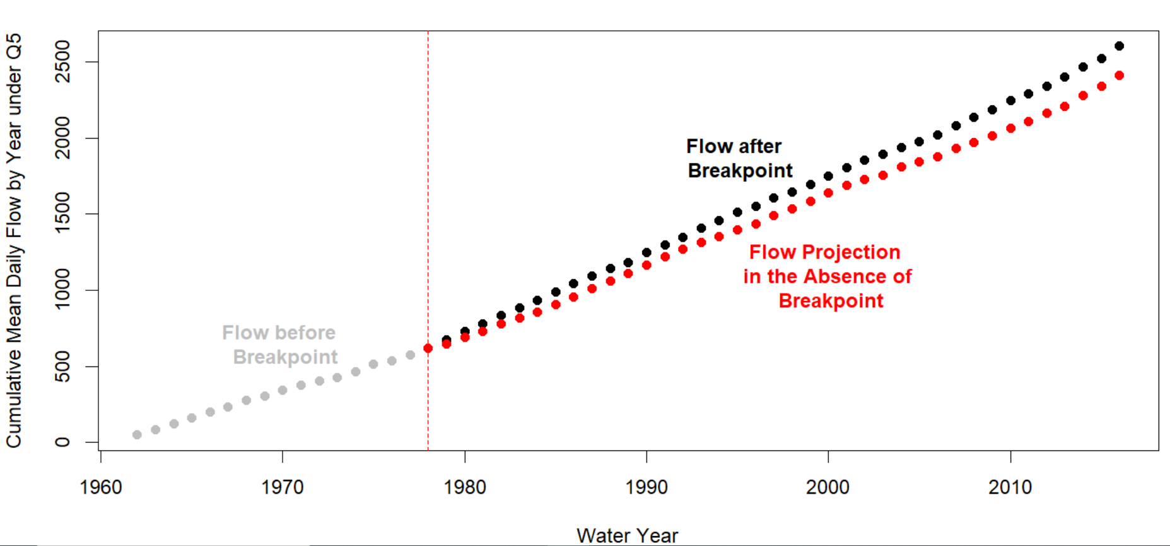

Figure SM1 Yearly Flow for Lindean under Q5 with Precipitation under P5 and Temperature under P5 and Breakpoint Year 1978

The difference between the actual data (black dots) and the projection forward from the breakpoint (red dots) shown in Figure SM1, is used to calculate the respective LCAP for that combination of second-stage metrics (see Section 3).

# References

These references are not cited in the presented paper

Carlón Allende, T., Mendoza, M.E., López Granados, E.M., Morales Manilla, L.M., 2009. Hydrogeographical Regionalisation: An Approach for Evaluating the Effects of Land Cover Change in Watersheds. A Case Study in the Cuitzeo Lake Watershed, Central Mexico. Water Resources Management 23, 2587–2603. https://doi.org/10.1007/s11269-008-9398-6

Yin, Z., Feng, Q., Yang, L., Wen, X., Si, J., Zou, S., 2017. Long Term Quantification of Climate and Land Cover Change Impacts on Streamflow in an Alpine River Catchment, Northwestern China. Sustainability 9. https://doi.org/10.3390/su9071278