**Subject: PRF192- PFC**

**Workshop 05**

**Objectives: Use functions in the library math.h for getting an integer at random and stdio.h for formatting output**

**Grading: 4 problem, marks: 2, 2, 3, 3**

**Problem 1. Dice Throws ( 2 marks)**

You are required to develop a program that will throw two dice until the top faces of the two dice total to a specified number.

The output from your program looks something like:

|  |
| --- |
| Dice Thrower  ============  Total sought : 11  Result of throw 1 : 1 + 3  Result of throw 2 : 4 + 4  Result of throw 3 : 6 + 2  Result of throw 4 : 5 + 6  You got your total in 4 throws! |

Algorithm should be as the following

/* Get a random integer between min and max randomly */

**int intRandom(int min, int max)**

{ /* Refer to the lecture to get algorithm for this task */

}

**main()**

Variable : int total, x,y, count

do

{ Accept total;

}

while (total<2 || total >12);

count =1;

do

{ x= intRandom(2,6);

y= intRandom(2,6);

Print out (“Result of throw %d “ %d + %d\n”, count, x, y)

count++;

}

while (x+y != total);

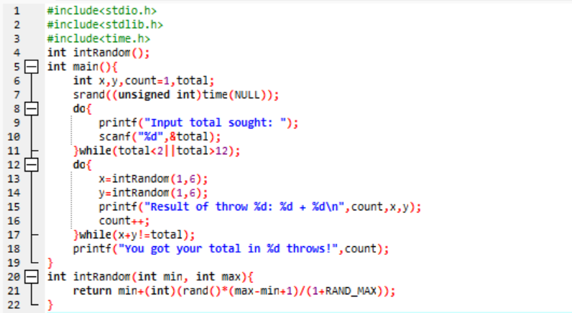

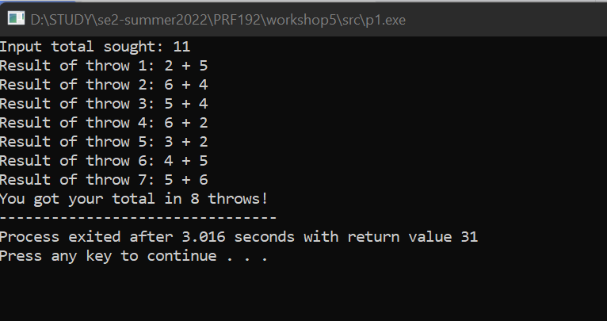

**Problem 2. Ball Lottery ( 2 marks)**

A basket contains ten balls.

Balls are numbered from 1 to 10.

User gets a pair of balls and he/she hopes that sum of numbers is equal to a known expected total.

This problem is the same with the previous problem but the total is between 2 to 20.

The output from your program looks something like:

|  |
| --- |
| Ball Lottery  ============  Total sought : 11  Result of picks 1 and 2 : 1 + 3  Result of picks 3 and 4 : 4 + 5  Result of picks 5 and 6 : 6 + 3  Result of picks 7 and 8 : 5 + 6  You got your total in 8 picks!  The algorithm for this program is similar to those in the previous problem |

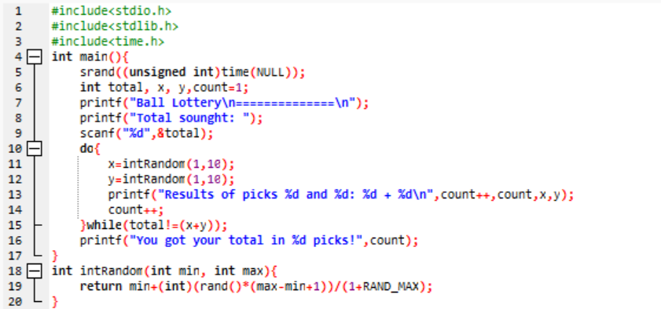

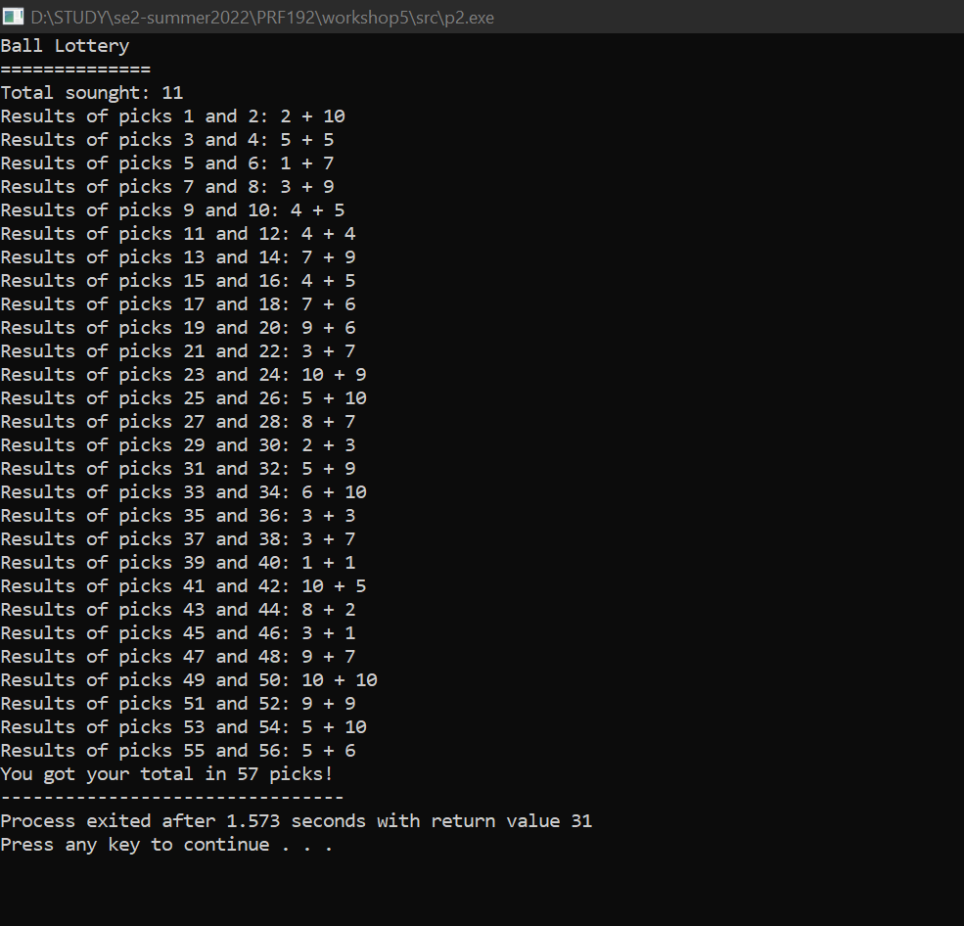

**Problem 3. Program using menu ( 3 marks)**

Write a C program using the following simple menu:

1- Processing date data

2- Character data

3- Quit

Choose an operation:

* When user chooses 1: User will enter values of date, month, year then the program will announce whether this date is valid or not.
* -When user chooses 2: User will enter two characters, then the program will print out ASCII codes of characters between them using descending order. Examples: Input: ca

Output:

c: 99, 63h

b: 98, 62h

a: 97, 61h

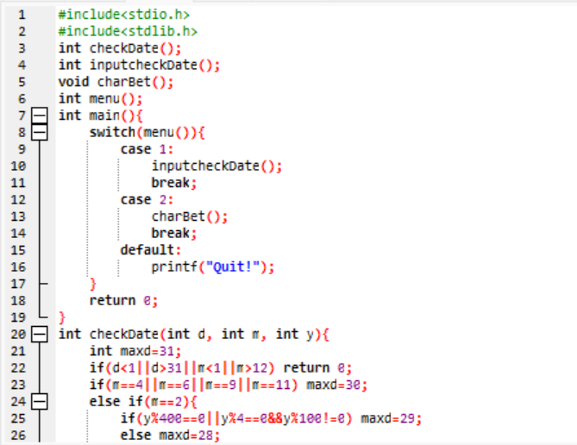

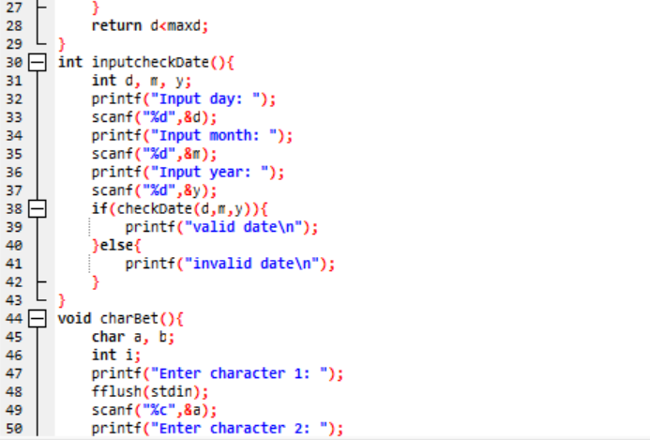

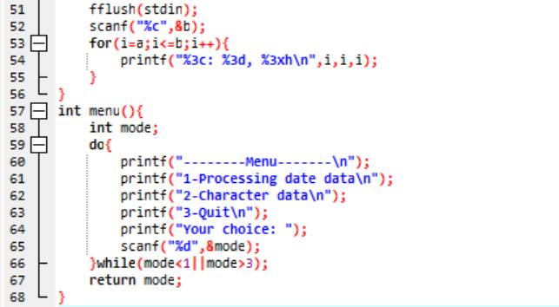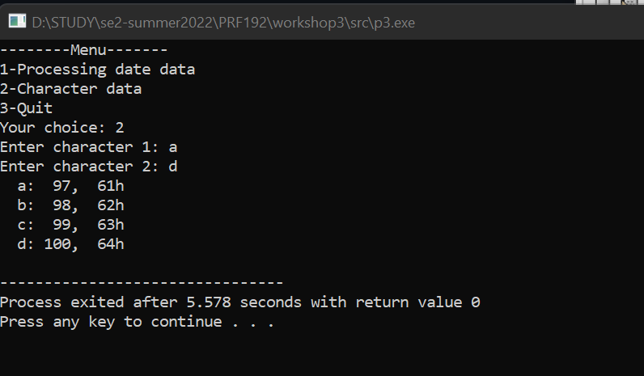

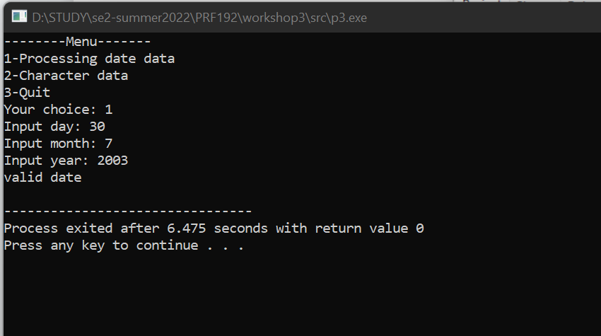

**Problem 4. Program using menu ( 3 marks)**

Write a C program using the following simple menu:

1- Quadratic equation ( phương trình bậc 2)

2- Bank deposit problem

3- Quit

Choose an operation:

* When user chooses 1: User will enter values describing a quadratic equation then the program will print out its solution if it exists.
* When user chooses 2: User will enter his/her deposit ( a positive number), yearly rate ( a positive number but less than or equal to 0.1), number of years ( positive integer), then the program will print out his/her amount after this duration.

***Validations***

* Deposit, d >0
* Yearly rate, r: > 0.0 to <1.0
* Number of year, n>0
* Amount at the n(th) year: P = d(1+r)n , Use the function **pow(x,y)** in Math.h for xy

