Cairo University  
Faculty of Computers and Information



**CS251**

**Software Engineering I**

**Game-based Educational Platform** Software Design

Abdelaziz Mahmoud CS_3

Abdallah Abdelazim CS_2

Mohammed Amged CS_3

Fatma Elsayed CS_3

December, 2016

Contents

Instructions [To be removed] 3

Team 3

Document Purpose and Audience 3

System Models 3

I. Class diagrams 3

Important Algorithm 5

II. Sequence diagrams 5

Class - Sequence Usage Table 7

Ownership Report 8

Policy Regarding Plagiarism: 8

References 8

Authors 8

# Team

|  |  |  |  |
| --- | --- | --- | --- |
| **ID** | **Name** | **Email** | **Mobile** |
| 20140169 | Abdelaziz Mahmoud Abdelaziz | zizomody2511@gmail.com | 01063930937 |
| 20140219 | Mohamed Amged Hamed | popop9933@yahoo.com | 01006093286 |
| 20140203 | Fatma Elsayed | Elsayedfatoma@yahoo.com | 01205867520 |
| 20140170 | Abdallah Abdelazim Abdallah | Abdallah.abdelazim@hotmail.com | 01110095611 |

# Document Purpose and Audience

**What is this document?**

* **This document is a Software Design Specification for an educational website where a teacher can log in and create a game in a field and the student will be also able to log in and play and learn from this games**

**The targeted audience**

* **The client**
* **The Project manager**
* **The Developers**

# System Models

## Class diagrams (5 photos)

1. **All Packages**

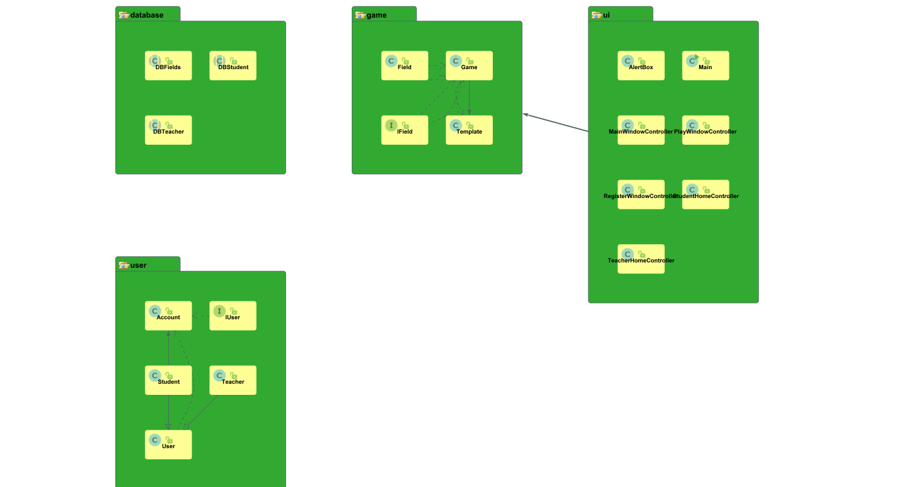

1. **database Package classes**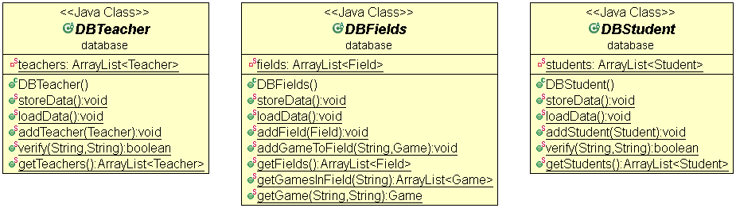
2. **user Package classes**

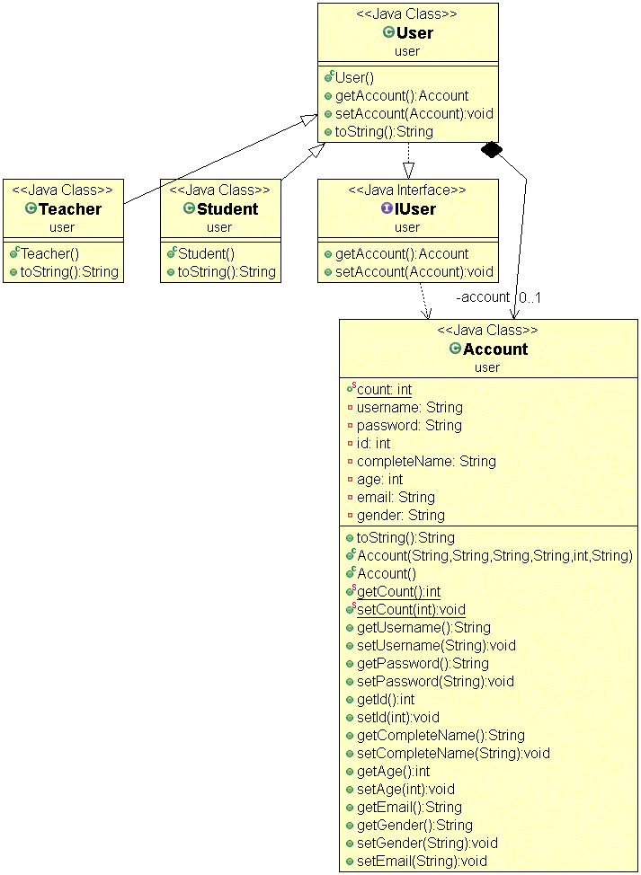

1. **ui Package classes**

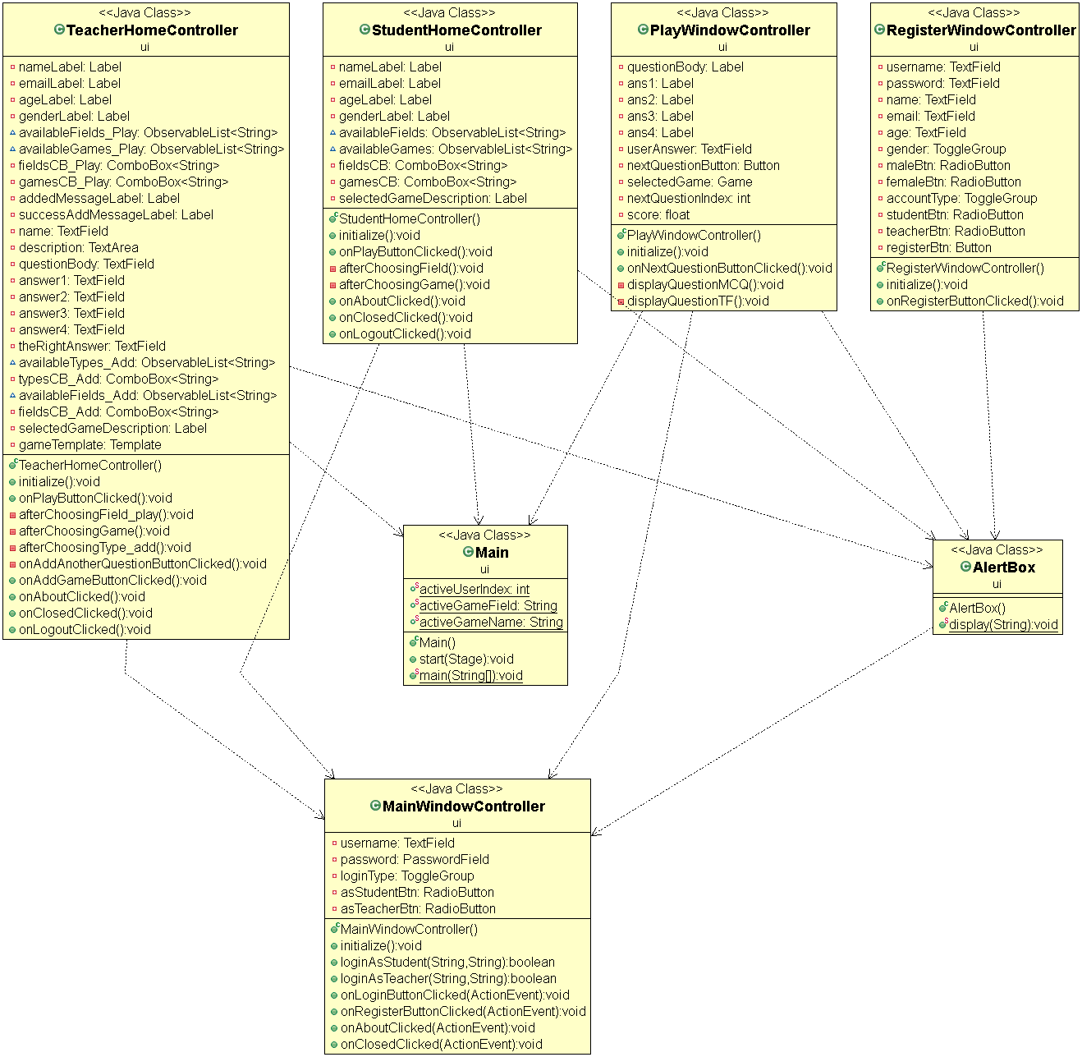

1. **game package classes**

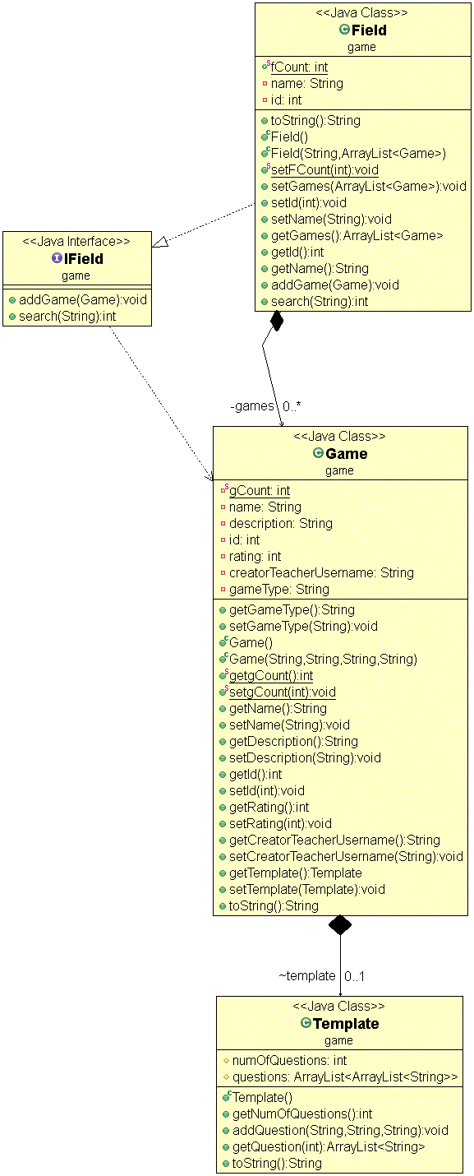

**F – system**

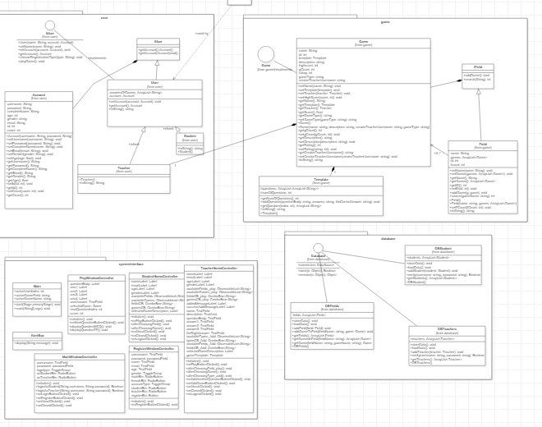

| **Class ID** | **Class Name** | **Description & Responsibility** |
| --- | --- | --- |
| 1 | Profile | this class has  1.the games that the user played  2.the fields that he is interested in |
| 2 | Account | This class has all the information about the user like the age, gender,….including his profile |
| 3 | IUser | This class is the entire interface to the user with it he can use the website |
| 4 | User | This class represents the function that the user can do like play a game, open profile |
| 5 | Student | This class represents what a student user can do |
| 6 | Teacher | This class represents what a teacher user can do |
| 7 | field | This class is about the field it has its name what games within that field and so on |
| 8 | game | This class is about the game it has its name  The teacher who made it and so on |
| 9 | database | Responsible for storing data |
| 10 | Games database | Where all the games are stored |
| 11 | Fields database | Where all the fields are stored |
| 12 | Teachers database | Where all the teachers are stored |
| 13 | Students database | Where all the students are stored |
| 14 | Registration Page | The GUI page to choose a username & password and add other information about himself in order to create an account |
| 15 | website Interface | Work as a GUI Interface for the user to interact with the system and choose either play, register or add game. |
| 16 | Template | To can teacher to add game by send tools to him |

## II. Sequence diagrams

1. Register an Account

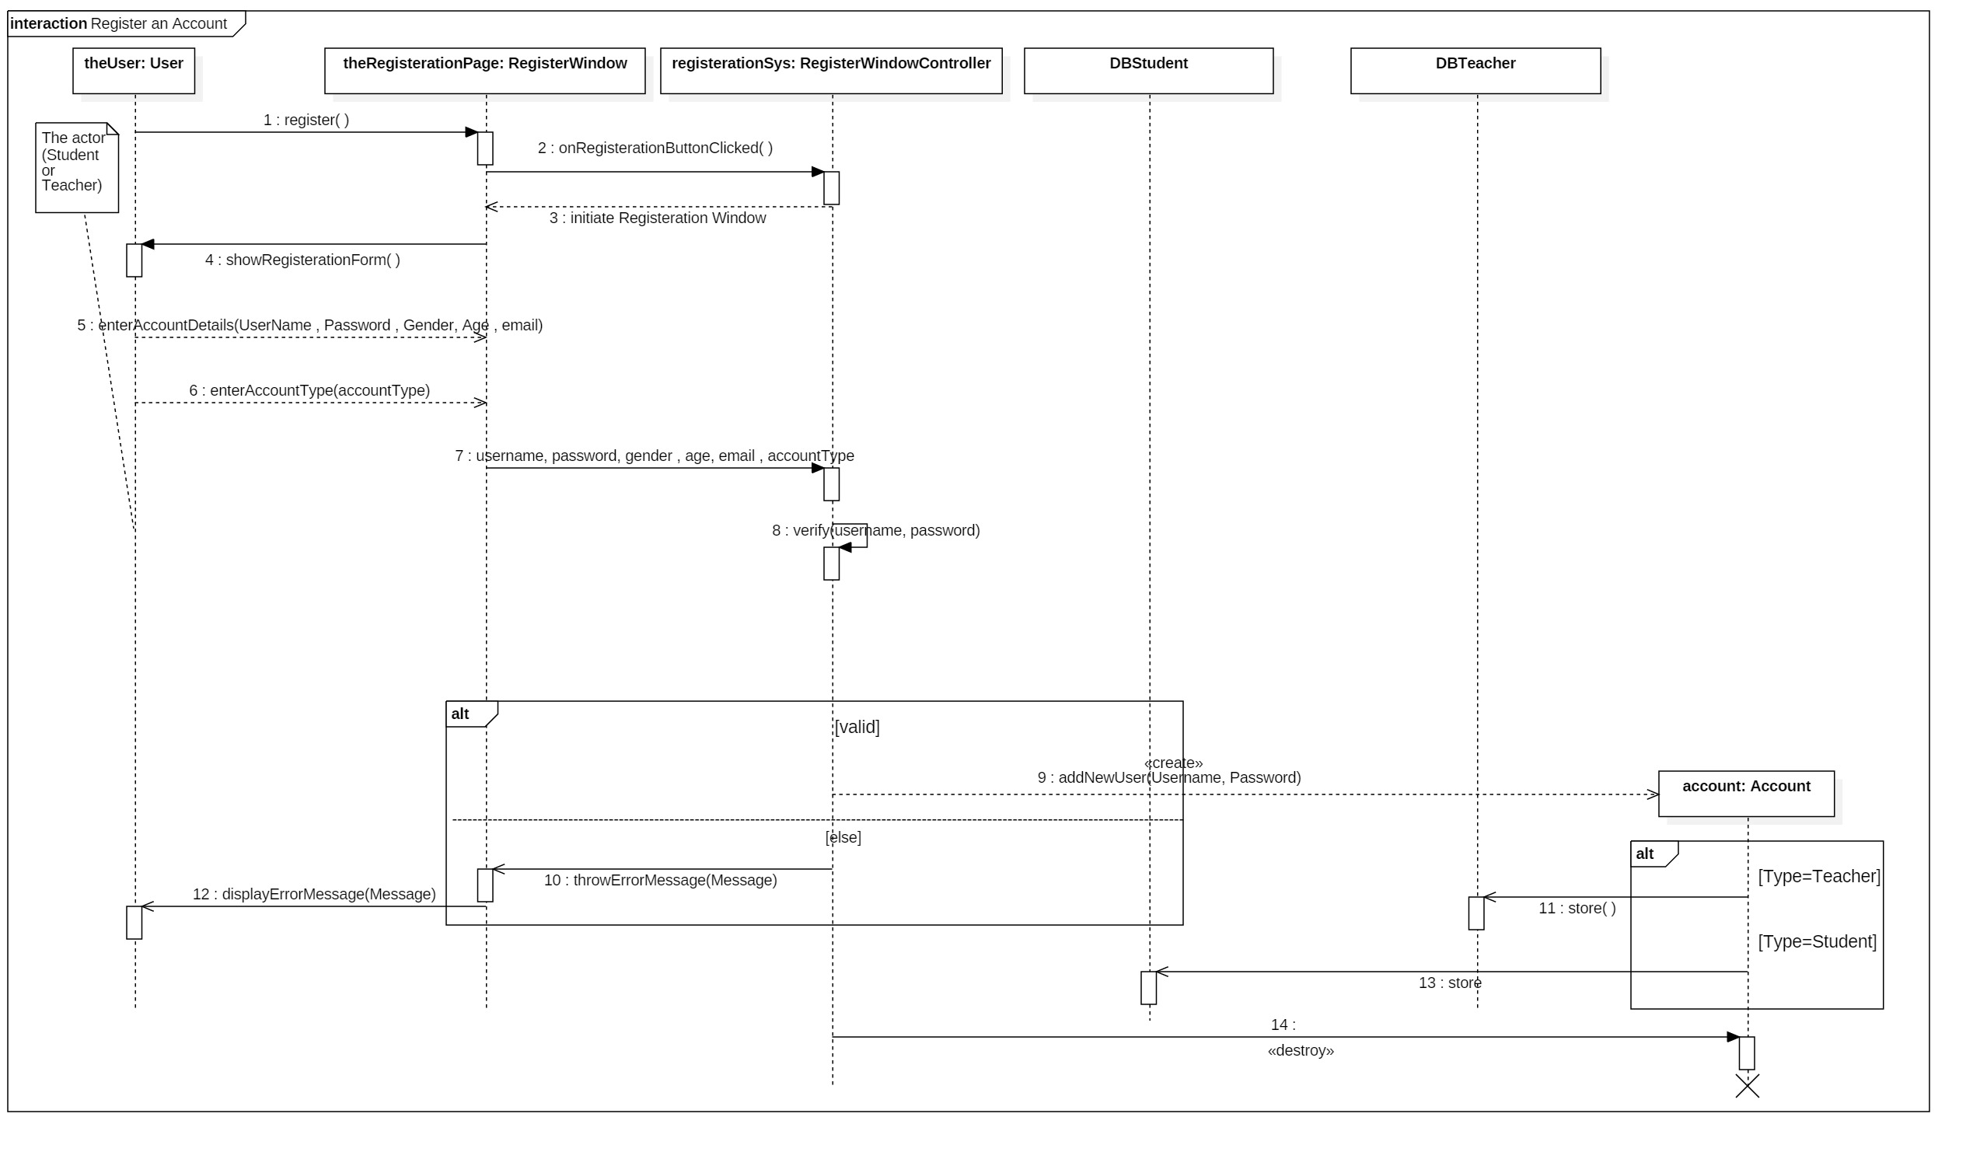

1. Add a game

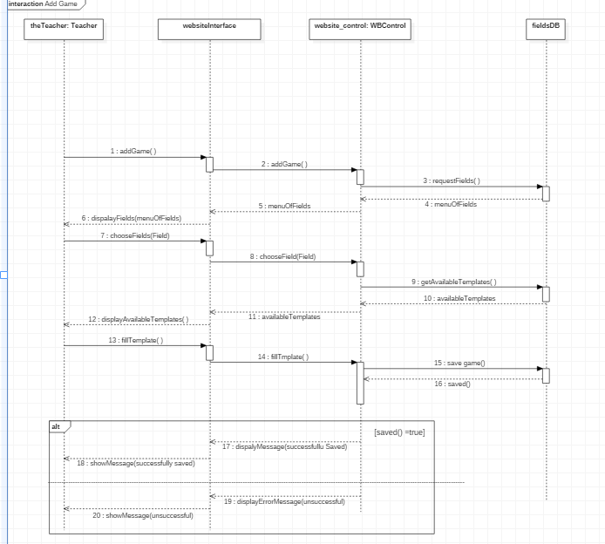

1. Play a game

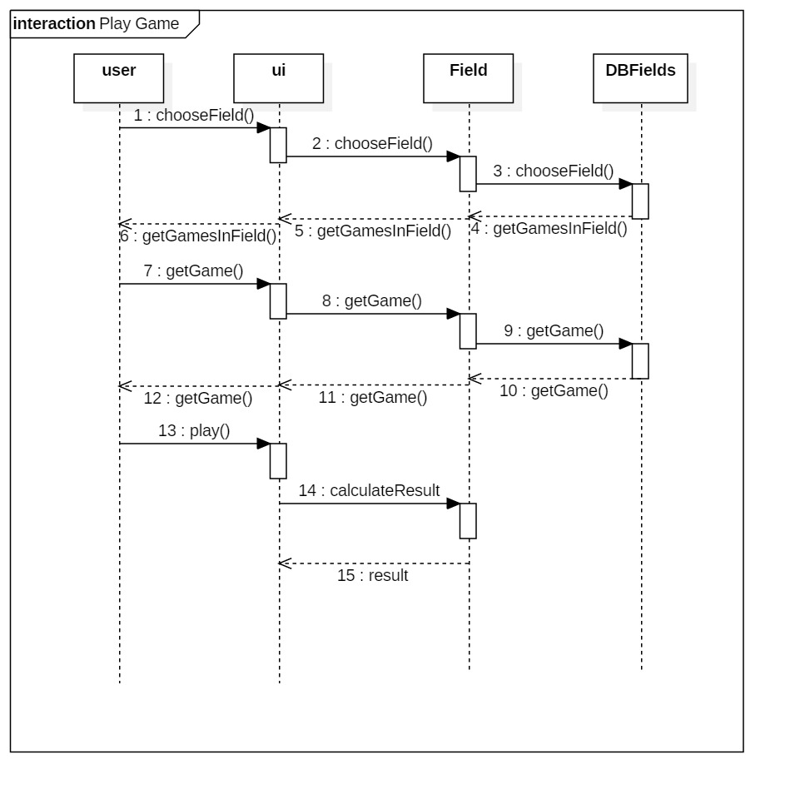

### Class - Sequence Usage Table

| **Class Name** | **Sequence Diagrams** | **Overall used methods** |
| --- | --- | --- |
| Profile | Add game and add game | Add game ,get game |
| Account | Register | Set name ,set password |
| User | Register , add game and play game | Set account ,play game |
| Student | Register , add game and play game | Register |
| Teacher | Register , add game and play game | Add game |
| field | add game and play game | Choose filed |
| game | add game and play game | Choose game |
| database | Register | store |
| Games database | Add game and play game | store |
| Fields database | Add game and play game | store |
| Teachers database | Register | store |
| Students database | Register | store |
| Registration Page | Register | Register |
| website Interface | Register ,add game and play game | Register ,add game and play game, choose game ,choose filed |

# Ownership Report

|  |  |
| --- | --- |
| **Item** | **Owners** |
| Register Sequence Diagram | *Abdallah Abdelazim* |
| Add Game Sequence Diagram | *Mohammed Amgad/Abdelaziz Mahmoud* |
| Play Game Sequence Diagram | Fatma Elsayed/Abdelaziz Mahmoud |

# GitHub Repository:

<https://github.com/Abdallah-Abdelazim/Game-based-Educational-Platform>