Category | Command | Comment (what it does)
Shell / system | echo $SHELL | Show your current default shell
 | cat /etc/shells | List shells installed on your system
 | history | Show command history
 | clear | Clear the terminal screen
 | uname -a | Show detailed OS/kernel/arch info
 | shutdown -h now | Shut down immediately
 | shutdown -r | Reboot
Help | man <cmd> | Open the manual page for a command
 | <cmd> --help | Quick help/usage for a command
 | info <cmd> | GNU “info” documentation (if available)
 | whatis <cmd> | One-line description of a command
SSH (remote) | ssh -Y <user>@access.cims.nyu.edu | SSH into remote host (with X11 forwarding)
 | ~. | Disconnect/terminate an SSH session
Navigate | pwd | Print current directory
 | cd .. | Go to parent directory
 | cd ~ | Go to home directory
 | cd / | Go to filesystem root
 | cd /abs/path | Go to an absolute path
 | cd ./rel/path | Go to a relative path
List | ls | List files/directories
 | ls -l | Long listing (perms/owner/size/time)
 | ls -a | Include hidden files (. prefix)
 | ls -la | Long listing + hidden files
View files | cat <file> | Print full file contents
 | less <file> | Page through a file
 | head [-n N] <file> | Show first lines (default 10)
 | tail [-n N] <file> | Show last lines (default 10)
 | tail -n +N <file> | Show from line N to end
 | nl <file> | Show file with line numbers
 | stat <file> | Show detailed file metadata
Create | mkdir <dir> | Create a directory
 | mkdir -p a/b/c | Create nested directories (no error if existing)
 | touch <file> | Create empty file or update timestamp
 | echo -e "a\nb\nc" | Print with escaped newlines (\n)
Copy / move / delete | cp a b | Copy file a to b
 | cp -r dir dir_copy | Copy a directory recursively
 | mv old new | Rename/move a file or directory
 | rm <file> | Delete a file
 | rm -r <dir> | Delete a directory recursively
Find | find . -name "*.txt" | Find files by name under current dir
 | find . -type f | Find regular files
 | find . -type d | Find directories
Search text (grep) | grep "PAT" file | Print lines matching pattern
 | grep -i "pat" file | Case-insensitive search
 | grep -c "PAT" file | Count matching lines
 | grep -n "PAT" file | Show line numbers for matches
 | grep -v "PAT" file | Show lines not matching
 | grep -r "PAT" dir/ | Recursive search in a directory
 | grep -w "PAT" file | Match whole word only
Redirection / pipes | cmd > out.txt | Redirect output to file (overwrite)
 | cmd >> out.txt | Redirect output to file (append)
 | cmd < in.txt | Use file as input to command
 | a | b | Pipe output of a into b
Count (wc) | wc file | Show lines/words/bytes
 | wc -l file | Lines only
 | wc -w file | Words only
 | wc -c file | Bytes only
Sort / uniq | sort file | Sort lines (lexicographic)
 | sort -r file | Reverse sort
 | sort -n file | Numeric sort
 | sort -b file | Ignore leading blanks
 | sort file | uniq | Remove adjacent duplicates (sort first)
 | sort file | uniq -c | Count occurrences
 | sort file | uniq -d | Show only repeated lines
 | sort file | uniq -u | Show only unique lines
Cut (fields/chars) | cut -d, -f3 file | Extract field 3 using , delimiter
 | cut -c1-3 file | Extract characters 1–3
 | cut -b1-4 file | Extract bytes 1–4
Paste (columns) | paste f1 f2 | Merge files column-wise
 | paste -d, f1 f2 | Merge with delimiter ,
 | paste -s f1 f2 | Paste serially (each file into one line)
 | paste -sd, file | Join all lines into one line (delimiter ,)
 | ls | paste - - - | Format output into 3 columns
Transform (tr) | ... | tr 'e' 'a's | Replace characters (e→a)
 | ... | tr 'a-z' 'A-Z' | Lowercase → uppercase
 | ... | tr -s 'x' | Squeeze repeated x into one x
 | ... | tr -d 'x' | Delete x characters
 | ... | tr -d '[:space:]' | Delete whitespace
 | ... | tr -d '[:digit:]' | Delete digits
 | ... | tr -cd '[:digit:]' | Keep digits only (delete everything else)
Category | Command | Comment (what it does)
Navigate | cd <DirName> | Change into directory <DirName>
Delete dirs | rmdir <FolderName> | Remove empty directory (safer than rm -r)
List | ls -p | Add / after directory names (visual cue)
List | ls -lh | Long listing + human-readable sizes (KB/MB/GB)
List | ls -lhS | ls -lh but sorted by size
Editor (vim) | vim <FileName> | Open/edit a file in Vim
Editor (vim) | i | Enter insert mode (start typing)
Editor (vim) | :w | Save file (keep editor open)
Editor (vim) | :q | Quit without saving
Editor (vim) | :wq | Save and quit
uniq | uniq <file> | Print unique values (works best when duplicates are adjacent—often after sort)
uniq | uniq -c <file> | Unique values + frequencies
uniq | uniq -d <file> | Only duplicated lines
uniq | uniq -u <file> | Only lines that appear once
Category | Command | Comment
Pipes (example) | cat files.txt | wc -l | Count lines via a pipe (explicit example used)
Cut (delimiter :) | cut -d: -f1 <file> | Extract field 1 using : delimiter
 | cut -d: -f1,3 <file> | Extract fields 1 and 3
 | cut -d: -f-3 <file> | Extract fields 1 through 3
 | cut -d: -f1-3 <file> | Another way to extract fields 1–3
Paste | paste -sd,- <file> | Join all lines into one line using delimiters , then -
Transform (tr) | echo "java" | tr '[ja]' '[eb]' | Map sets of chars (j→e, a→b)
Here’s the L03 content in the same “Category / Command / Comment” table format (one command per row).
Category | Command | Comment (what it does)
sed (setup) | echo -e "apple\nbanana\napple\nbacon\ncat\ndog\napple pie\na b c\n123\nb\nx y z" > sample.txt | Create sample file for sed examples
sed (setup) | cat sample.txt | Display sample file
sed | sed 's/apple/orange/' sample.txt | Replace first apple with orange per line
sed | sed 's/apple/orange/g' sample.txt | Replace all apple with orange per line
sed | sed '2s/apple/orange/' sample.txt | Replace only on line 2
sed | sed 's/^/hi/' sample.txt | Add hi to the start of each line
sed | sed 's/$/hi/' sample.txt | Add hi to the end of each line
sed | sed '3d' sample.txt | Delete line 3
sed | sed '1,2d' sample.txt | Delete lines 1–2
sed | sed '$d' sample.txt | Delete last line
awk (setup) | echo -e "10 20\n30 40\n50 60" > sample.txt | Create space-delimited sample file
awk (setup) | cat sample.txt | Display sample file
awk | awk '{print $0}' sample.txt | Print entire line
awk | awk '{print $1}' sample.txt | Print first field
awk | awk '{print $2}' sample.txt | Print second field
awk | awk '{print $1 "," $2}' sample.txt | Print fields 1 and 2 with a separator
awk | awk '{print $NF}' sample.txt | Print last field (NF = number of fields)
awk | awk '{print $1 + $2}' sample.txt | Print sum of fields 1 and 2
awk | awk '{print $1 * $2}' sample.txt | Print product of fields 1 and 2
awk | awk '{if($1>20) print $0}' sample.txt | Print line only if field1 > 20
awk | awk '{for(i=1;i<=NF;i++) print $i}' sample.txt | Loop through all fields and print each
awk (setup) | echo -e "10,20\n30,40\n50,60" > sample.txt | Create comma-delimited sample file
awk (setup) | cat sample.txt | Display comma-delimited file
awk | awk -F "," '{print $1}' sample.txt | Print field1 using , delimiter
awk | awk -F "," '{print $2}' sample.txt | Print field2 using , delimiter
Permissions | ls -l | Show permissions in long listing
Permissions | chmod 775 names.txt | Set permissions (rwx/rwx/r-x)
Permissions | ls -l names.txt | Verify updated permissions
Permissions | ls -l sample.txt | View current permissions
Permissions | chmod +x sample.txt | Add executable bit
Permissions | ls -l sample.txt | Verify executable bit set
Paths | which python | Show path to python
Paths | which bash | Show path to bash
Scripts | echo -e "#!/bin/bash\necho Hello World" > run.sh | Create a bash script
Scripts | chmod +x run.sh | Make script executable
Scripts | ./run.sh | Run the script
Script arguments | $0 | Script name
Script arguments | $1, $2, $3 ... | Positional arguments
Script arguments | $# | Number of arguments
Script arguments | $@ | All arguments (separate words)
Script arguments (examples) | echo "Script name: $0" | Print script name
Script arguments (examples) | echo "First arg: $1, Second arg: $2" | Print first two args
Script arguments (examples) | echo "Total args: $#" | Print argument count
Arithmetic | x=$((a + b)) | Arithmetic with $(( ))
Arithmetic | y=\expr $a + $b`` | Arithmetic with expr
Arithmetic | (( x += 5 )) | Increment x by 5
Arithmetic | if (( x < 20 )); then echo "x is less than 20"; fi | Numeric condition (arithmetic context)
String tests | if [[ $x == "james" ]]; then echo "Hi James"; fi | String equality test
String tests | if [[ $x != "hasan" ]]; then echo "Not Hasan"; fi | String inequality test
Command substitution | x=$(cat data.txt) | Capture command output into variable
Command substitution | for i in $(cat file.txt); do echo $i; done | Loop over words from command output
Conditionals | if [ $x -eq 9 ]; then ... elif [ $x -lt 5 ]; then ... else ... fi | If/elif/else with [ ] numeric tests
Loops | for var in $@; do echo $var; done | Loop over all args
Loops | while read line; do echo "Line: $line"; done < sample.txt | Read a file line-by-line
Compare (integer) | -eq -ne -gt -ge -lt -le | Integer comparisons for [ ]
Compare (boolean) | -o -a | OR / AND for [ ]
Compare (string) | = == != -z -n | String compare + empty/nonempty tests
File tests | -e -d -f -r -s -w -x -u -g | File existence/type/permission tests
File test (example) | FILE="sample.txt"; if [ -e "$FILE" ]; then cat "$FILE"; else ls; fi | If file exists: cat; else: ls
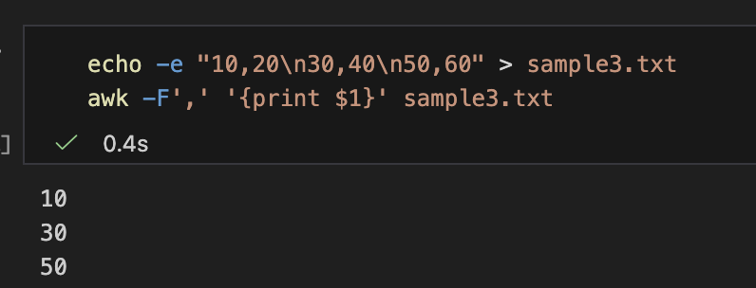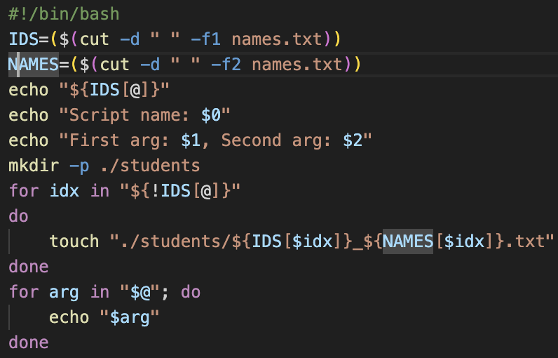
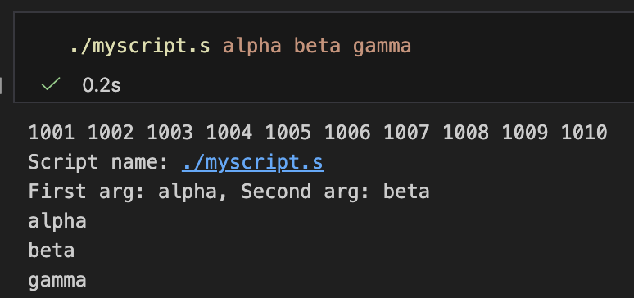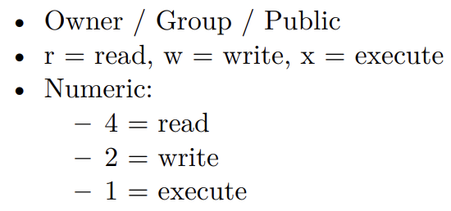\

In Python, the following data types are immutable (cannot be changed after creation):
- int (integer)
- float (floating point)
- bool (boolean)
- str (string)
- tuple
- frozenset
- bytes

In Python, the following data types are mutable (can be changed after creation):
- list
- dict (dictionary)
- set
- bytearray
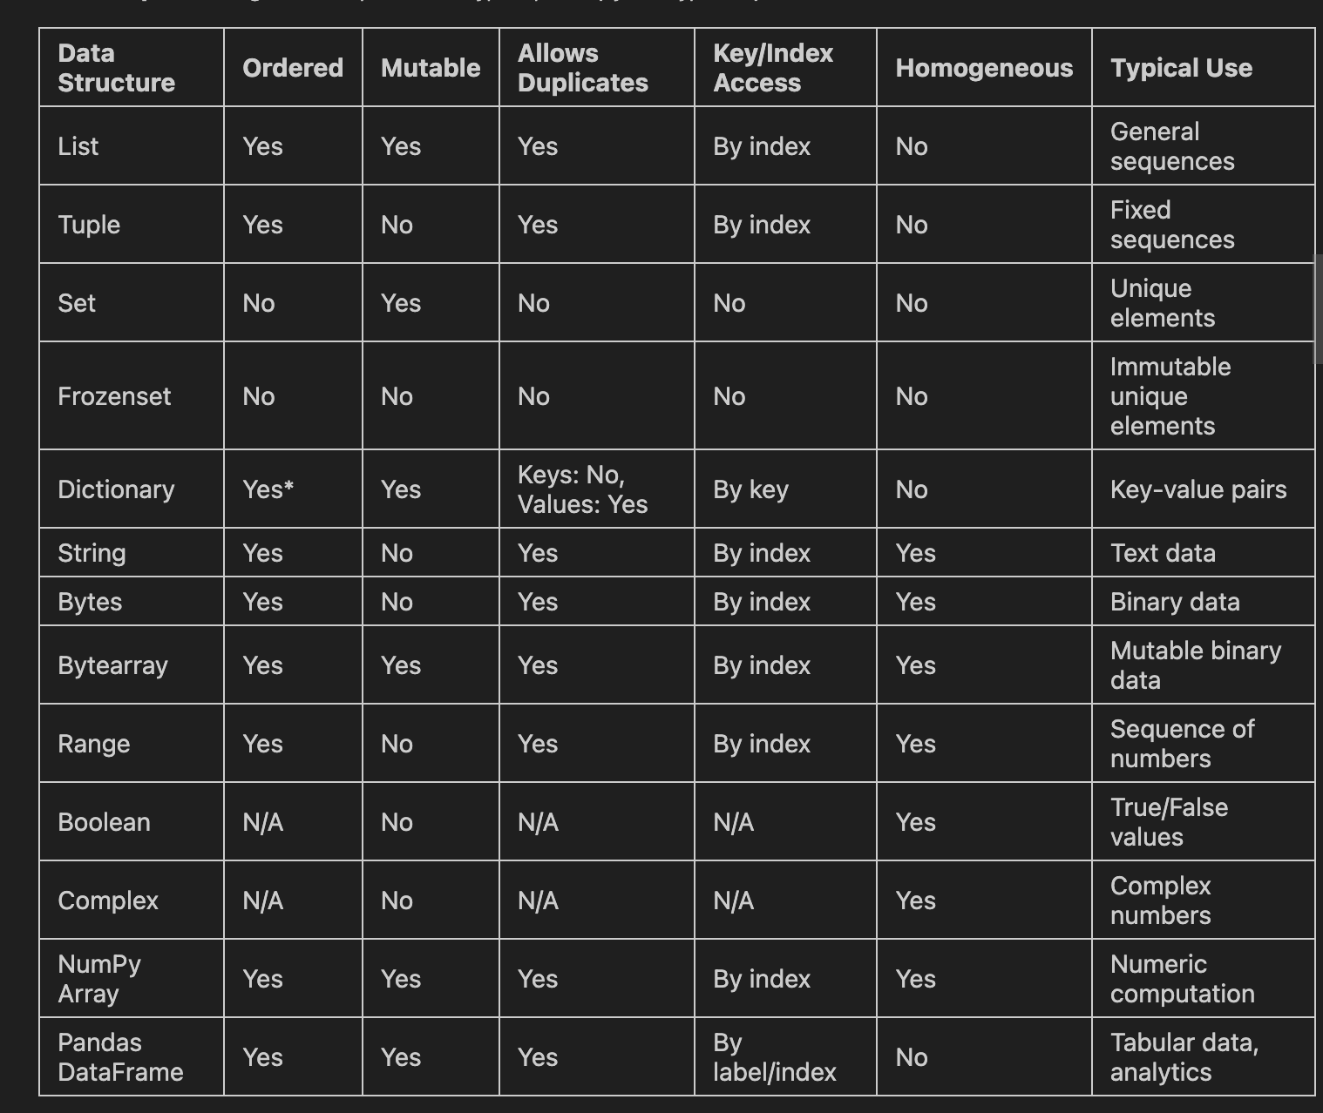
Symbol | Meaning in sed | Example | Result
^ | Start of a line | sed '/^#/d' file | Deletes all lines starting with a # (comments).
$ (Address) | Last line of the file | sed '$p' file | Prints only the very last line of the file.
$ (Regex) | End of a line | sed 's/!$/./' file | Replaces an exclamation point at the end of a line with a period.
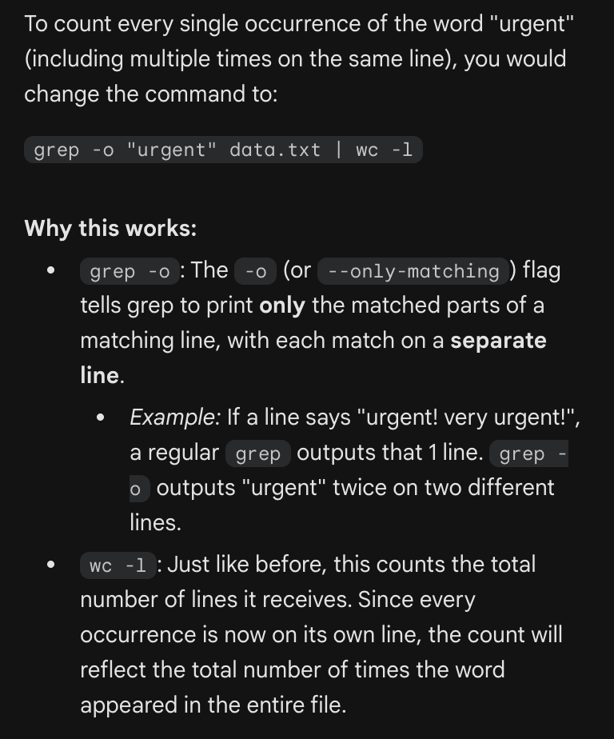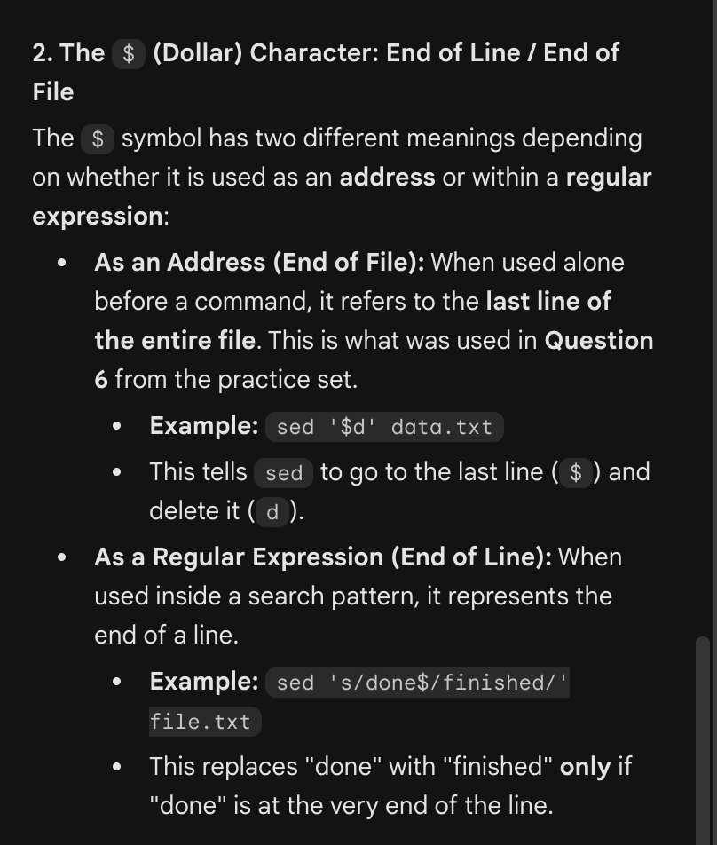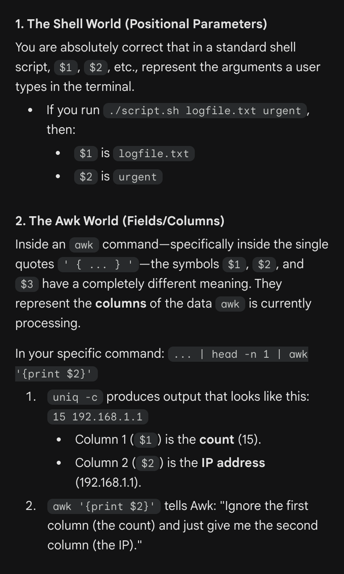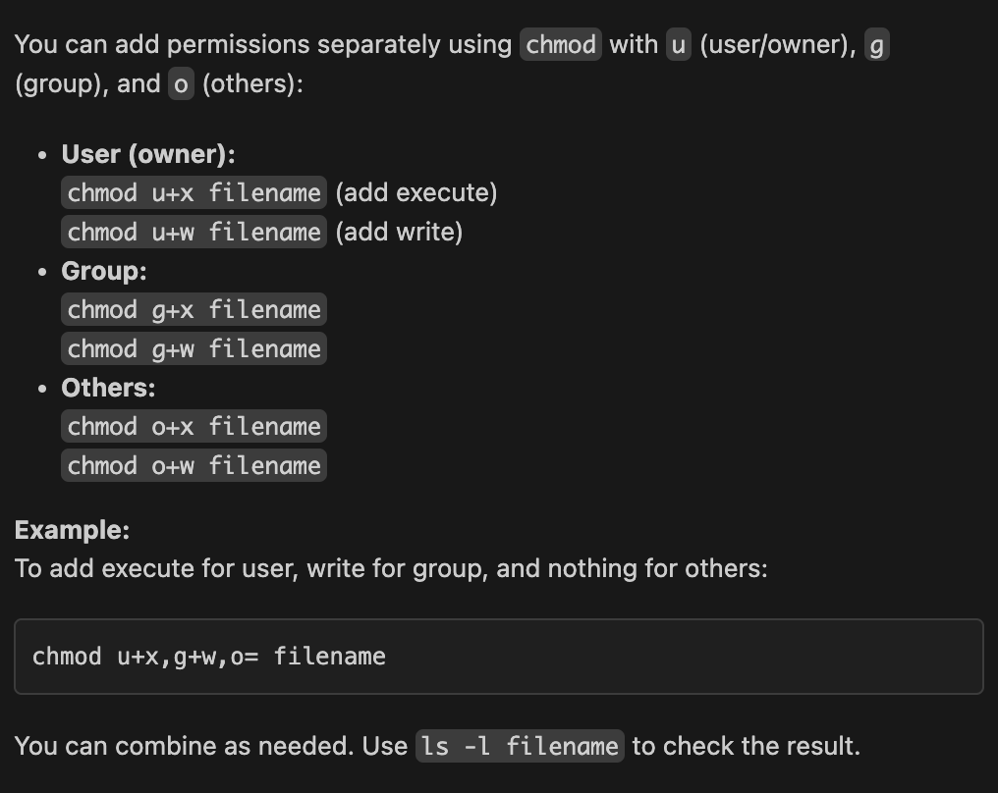
Data Type | Can be a Key? | Can be a Value?
String | Yes | Yes
Integer/Float | Yes | Yes
List | No | Yes
Tuple | Yes (if elements are hashable) | Yes
Dictionary | No | Yes
Set | No | Yes

