COMP3230 Principle of Operating System

Assignment 01 (Due date: 2016/10/13)

UID : 3035124881

Name : Cheng Wei ( BEng (CE) )

Task 3:

1. Given the following piece of code: How many copies of variable c are there at the end of the program ? What are their values ?

Main(int argc, char \*\* argv)

{

int c = 5;

int child = fork();

if( child != 0 )

{

child = fork();

c += 10;

if( child )

c += 5;

}

}

Ans: There are 3 copies of variables at the end of the program with three different kinds of values. There are 5, 10, 15 respectively. 

1. Show the curves of the given program malloc.c. Discuss and explain the patterns of the curves.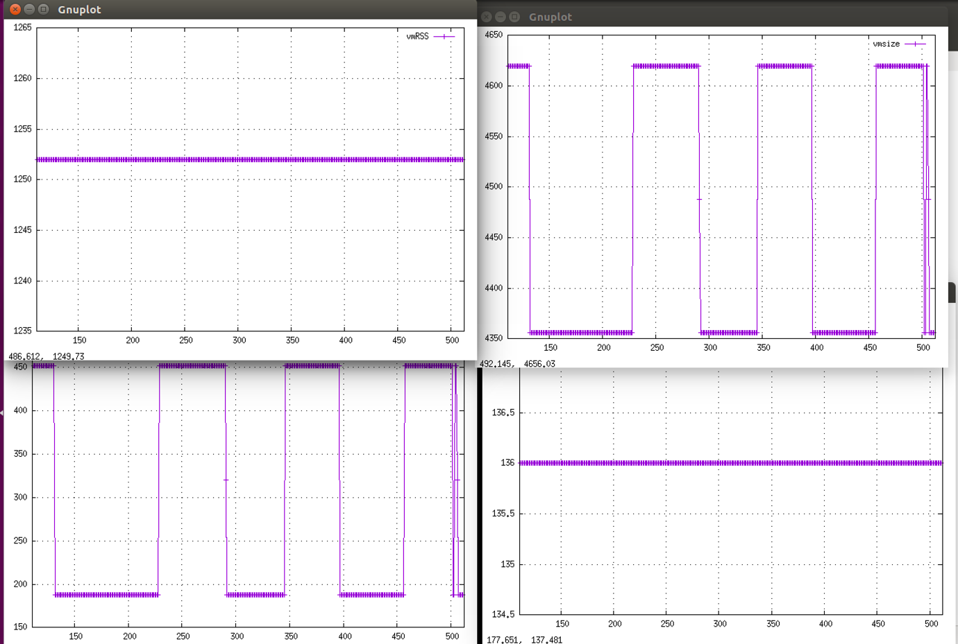

Ans:

Vmdata (Virtual Data Segment) and Vmsize (Virtual memory size) usage increases and decreases periodically. Since the malloc.c program asks for additional memory at runtime using function malloc() and releases memory with free() function. Heap size of this process changes at runtime, and since heap belongs to data segment in Process address space, the size of virtual data segment (Vmdata) and memories usage (Vmsize) changes periodically.

While no recursive function calls in malloc.c program, so stack size (Vmstk) remains steady.

1. The pseudo-app null makes modifications to the filename buffer after the sleeping for one second. Why does the VmRSS reading increase while the other 3 readings remain the same ? 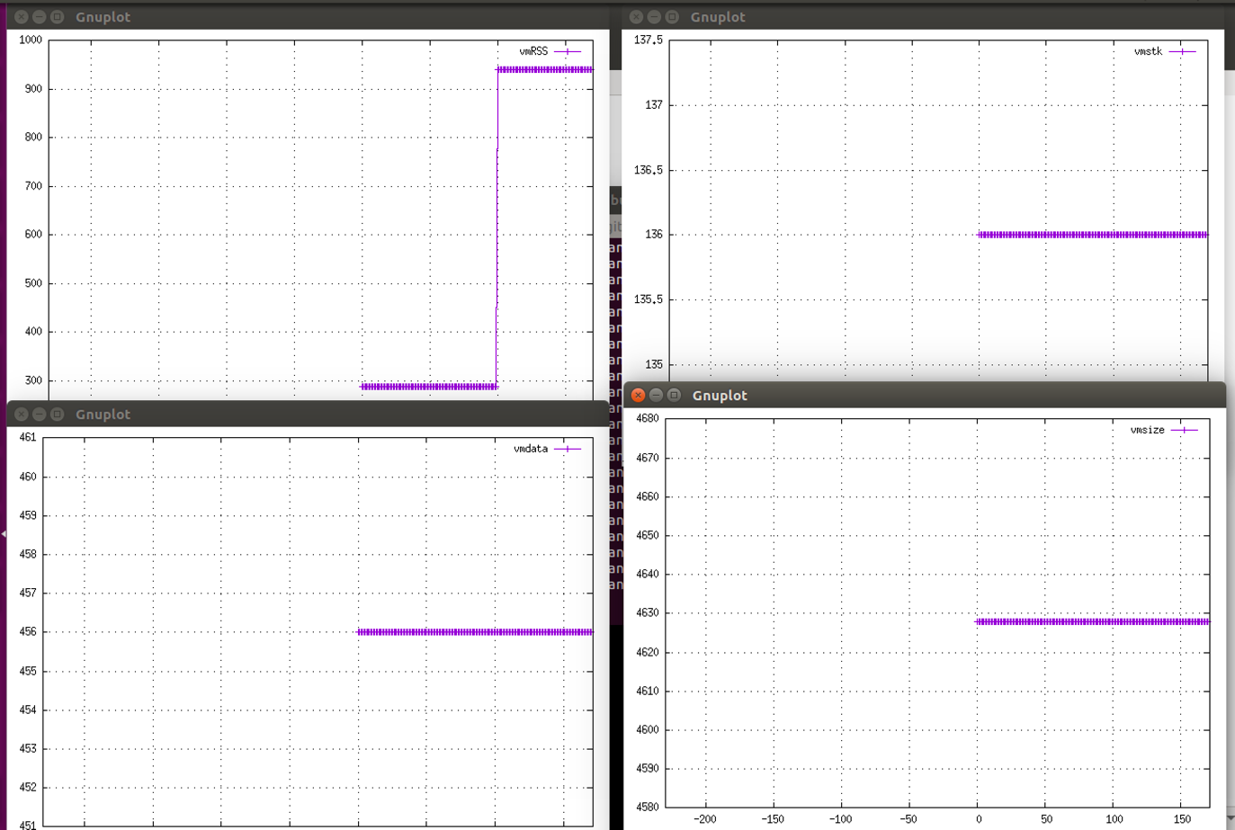

Ans: VmRSS stands for resident set size, which is the portion of memory of a process used in physical memory (RAM). The filename buffer has to be loaded into physical memory (RAM) before it can be modified. Therefore, VmRSS increases because null() function is modifying filename buffer with size (1 byte \* 204800 = 204800 bytes ). While null() is not calling function recursively or asking for additional data; therefore other readings remain the same.