Solution TUTORIAL 2 March 2017
(Embedded Systems EEE60603)

(i). In how many ways can you write the hex number 1F?
Answer: 1FH, 0x1F, 1Fh, 0X1F

(ii). Name the main components of a generic microcontroller and explain their functions.
Answer:
- On-chip RAM (data) and ROM (program)
- Support external program and data memory
- I/O ports for direct interfacing with other digital devices
- On-chip timer/counter
- Parallel and serial communication capabilities
- Interrupt from external stimuli

(iii) Describe the role of ALU, Instruction Decoder (ID), PC, and Registers in a generic CPU?
Answer:
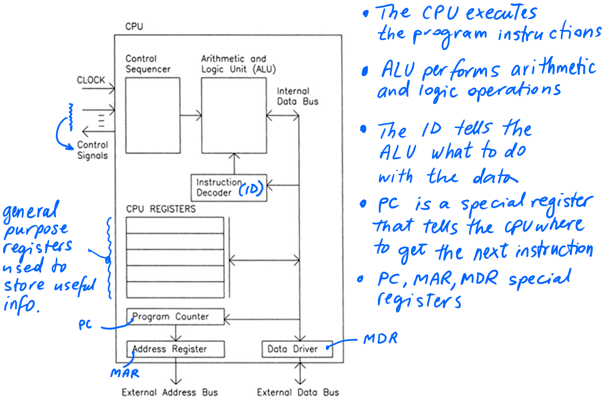

(iv). How are the instructions run in CPU?
Answer:
- Program (instructions) and Data are stored in Memory
- Each instruction is read (fetched) from memory, interpreted (decoded), and executed
- Arithmetic Logic Unit (ALU) performs operations on data
- Data is transferred (register, memory, I/O)
- Program Counter (PC) indicates current location of program in Memory and is automatically incremented after each instruction.

v) What is the role of Stack in a microcontroller?
Answer: Stack stores the address of the PC when a subroutine is called

vi) Describe the roles of WREG and SFR registers in PIC microcontrollers.
Answers
WREG- Temporary Register in ALU
SFR – For implementing the various features of the microcontroller
2. Based on the lecture two slide number 33, find the following in PIC16F84 Program memory
  - Bit length of Program counter.
Answer: 13
  - Depth of Stack
Answer: 8
  - Reset Vector address
Answer: 0000h
  - Interrupt Vector Address
Answer: 0000h
  - The size of Program Memory
Answer: 0000h to 1FFFh
3. Based on the lecture two slide number 34 find the following in PIC16F84 Data memory

- Address of TMR0 ---> 01h
- Address of PORTA ---> 05h
- Address of TRISA --> 85h
- Identify the bank of TRISB and PORTB --> 1 and 0
- The range of GPR registers --> 0Ch to 4Fh
- Address bit width. --> 8

4. Download PIC16F877 and PIC18F452 Datasheets and find 3 differences between them.

- Flash (8KB ) and enhanced Flash (32KB)
- RAM 368B and 768B
- Instructions 35 and 75

5. Identify the addressing modes for the following assembly language statements.

i) MOVLW 0X55 -->Immediate Addressing

ii) CLRF TRISB
MOVWF PORTB -->Direct Addressing

iii) MYREG EQU 0X37
MOVWF MYREG --> Direct Addressing
iv) MOVLB 0X05 --> Immediate Addressing

v) BSF STATUS, IRP
MOVLW 0x20
MOVWF FSR -->Indirect Addressing
CLRF INDF

