TUTORIAL 1 (part 1) March 2017
(Embedded Systems)
1.
(i). What are the main components of a microcontroller?
Answer:
CPU, I/O, Bus, Memory

(ii).What is the difference between a microcontroller and a microprocessor?
Answer:
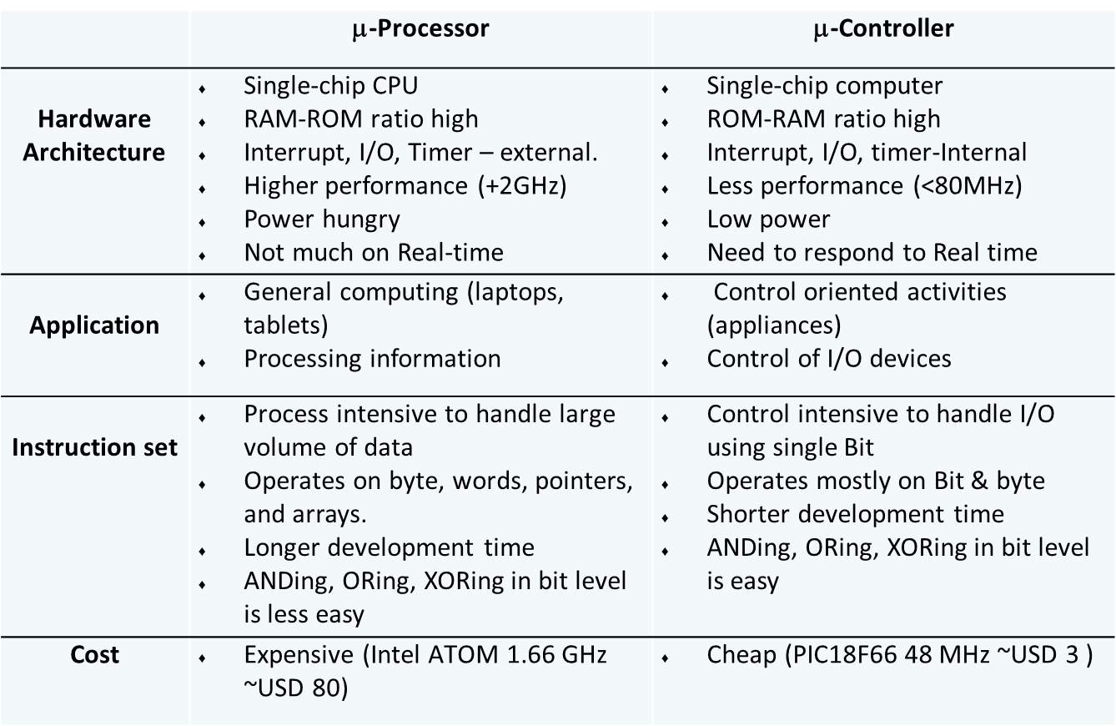

(iii). Name 5 criteria for selecting a specific microcontroller for a project.
Answer:
  - I/O requirement:
    - Number of general purpose I/O ports/pins
    - Special interfaces (UART, A/D, D/A)
  - Size of RAM and ROM (type of ROM)
  - On-chip peripherals (timers, counters)
  - Speed requirement
  - Cost
  - Availability (now and future)
  - Development support:
    - Assembler, compiler, linker
    - Debugging tools
    - Support from manufacturer and users (forums)

(iv). Compare machine language, assembly language, and high-level language.
Answer: Machine language – binary code, directly understood by the CPU. Assembly language – mnemonic representation of the binary code, a one-to-one direct translation (assemble) to the binary code. High-level language – more human-readable instruction and easy-to-understand programming concept (if-then-else, and loops), one instruction normally translates (compiles) to multiple binary instructions.

(v). Compare address bus and data bus.
Answer: Address bus – to send (from CPU) the address of the memory requested to the memory module, unidirectional. Data bus – to send or receive binary data, bidirectional.

(vi). Compare RAM, EEPROM, and Flash in terms of volatility, rewriting speed, and uses.
Answer: Data RAM – volatile, instant rewrite, store data. EEPROM – non-volatile, slow in rewriting, store data/program. Flash – non-volatile, reasonably fast in rewriting, store program.

