Cygwin
http://www.cygwin.com/

下载
Current Cygwin DLL version

The most recent version of the Cygwin DLL is 1.7.17-1. Install it by running setup.exe.

http://www.redhat.com/services/custom/cygwin/

http://www.onlinedown.net/softdown/517553_2.htm 国内

安装cygwin

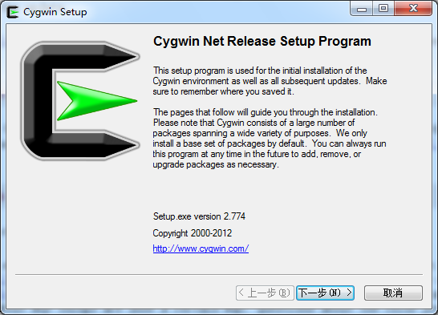

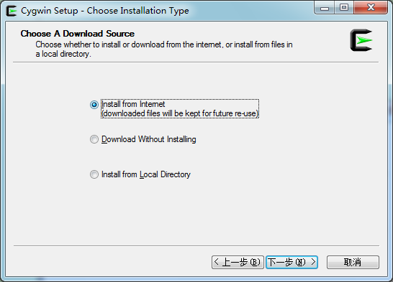

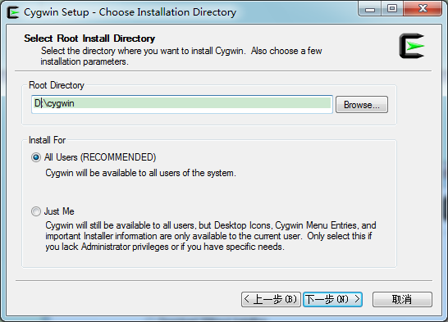

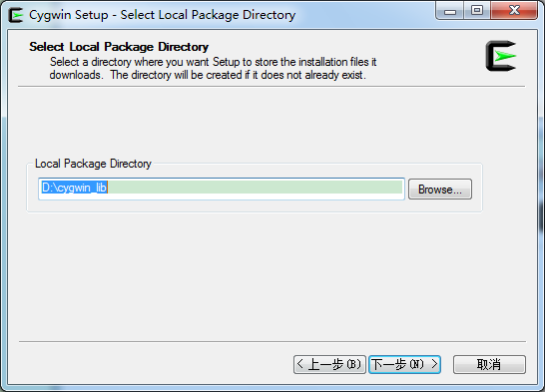

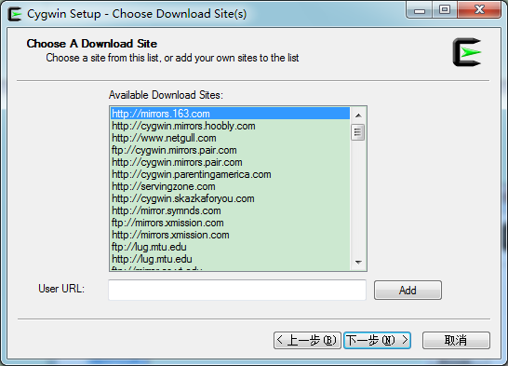

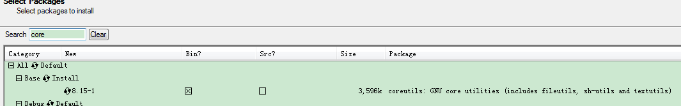

点击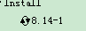、

官方网址：http://www.cygwin.com/ 下载setup.exe
安装时选择相应的安装包：
Base-->sed
Editors-->vim
Libs-->
Net-->OpenSSH

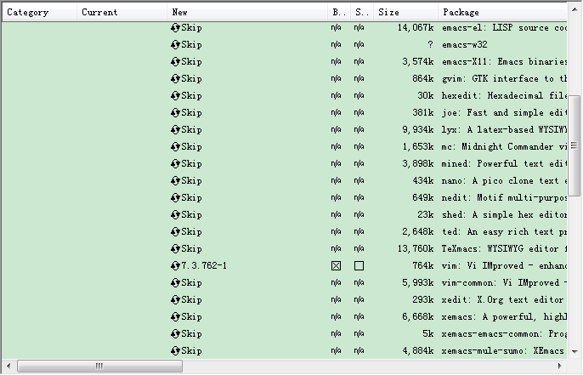

运行
Cygwin Terminal自动安装
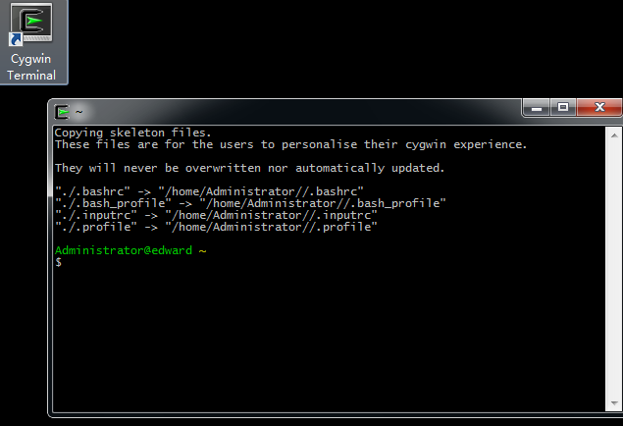

库下载
重新运行setup.exe
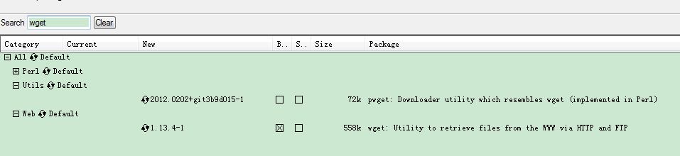

自动下载依赖
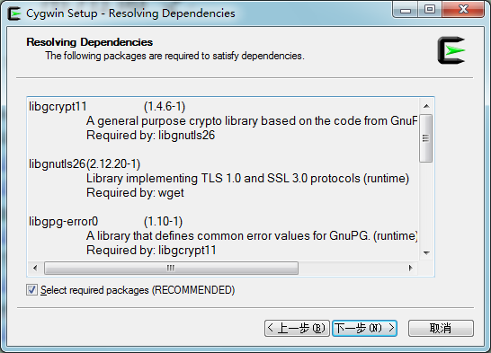

基本操作
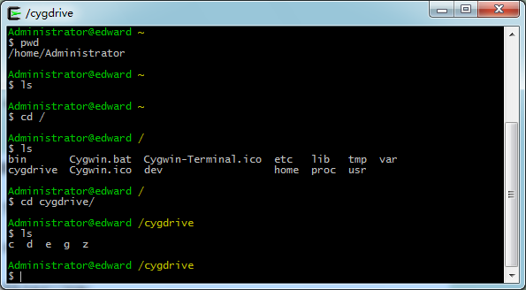

SSHD安装
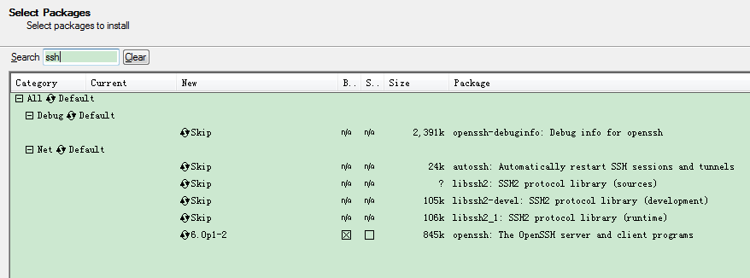

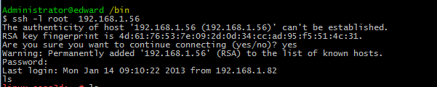

典型应用

Windows上测试sh脚本
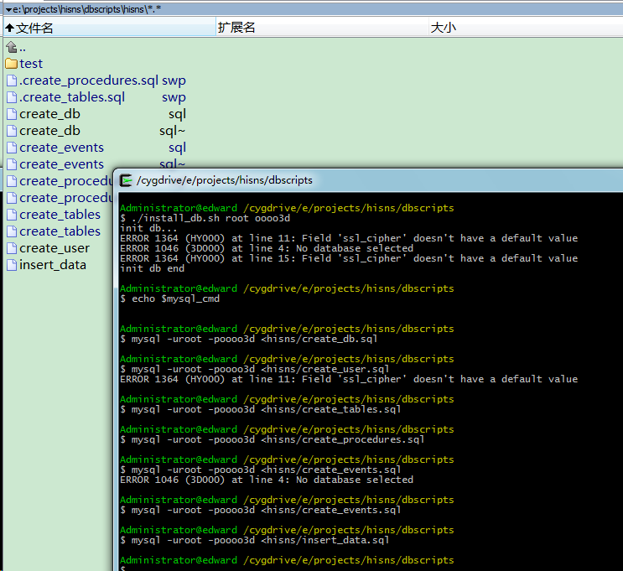

设置
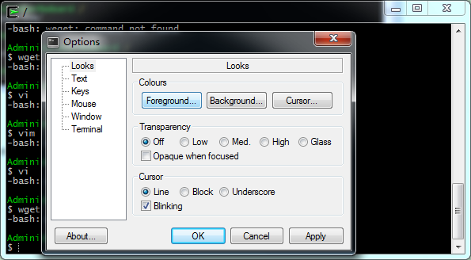

设置path

grep

netstat -an | grep TCP

tail

head

vim， winows下有 edit

windows的命令 more 可以显示文件内容

bash

cmd

windows版本

gnu32

http://gnuwin32.sourceforge.net/

http://gnuwin32.sourceforge.net/packages/coreutils.htm

mingw

http://www.mingw.org/ 我都不知道如何打包，真烦

或者使用 code::blocks中的minGW gcc等

http://www.codeblocks.org/

cygwin

http://www.cygwin.com/

环境变量
# 让ls和dir命令显示中文和颜色
alias ls='ls --show-control-chars --color'
alias dir='dir -N --color'
# 设置为中文环境，使提示成为中文
export LANG="zh_CN.GBK"
# 输出为中文编码
export OUTPUT_CHARSET="GBK"
cygwin\home\username\.inputrc
# 可以输入中文
set meta-flag on
set output-meta on
set convert-meta off

cygwin terminal gui增强
http://mintty.github.io/
In Cygwin,
it is installed as the default "Cygwin Terminal".
In MSYS, the mintty package can be installed with the command "mingw-get install mintty".

http://c2.com/cgi/wiki?BetterCygwinTerminal

If you use CygWin, the default terminal (which is a Windows console program) will give you the following problems:
- Resizing the window rarely works
- Termcap-based apps over ssh don't work
- Lame scrolling
- Can't select text on multiple lines; it makes a box instead of wrapping the selection
- Characters from only one 8-bit code page can be output (e.g., it isn't possible to output Central European and Cyrillic non-us-ascii characters at the same time, at least in the default configuration)

MinGW - Minimalist GNU for Windows

A native Windows port of the GNU Compiler Collection (GCC)

