实验4：Neo4j

1. 阅读“知识存储与查询-书稿.pdf”的“5.2.2 Cypher语言”，执行其中的查询20-31：
（新建知识图谱的语句见文件code-5-pg.txt）

(1) 查询20 MATCH (b:Battle)
RETURN b.name AS battleName
查询结果截图：
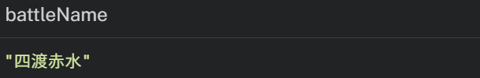
(2) 查询21 MATCH (b:Battle)-[:LOCATION]->(r:Basin)
RETURN b, r
查询结果截图：
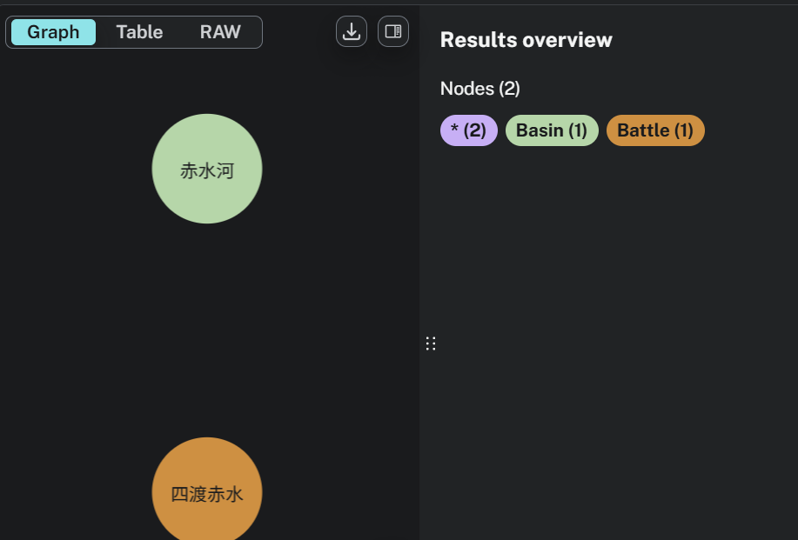

(3) 查询22 MATCH (p:Person)-[:COMMAND]-(b:Battle)-[:PART_OF]->(c:Campaign)<-[:EXECUTE]-(o)
RETURN p, b, c, o
查询结果截图：
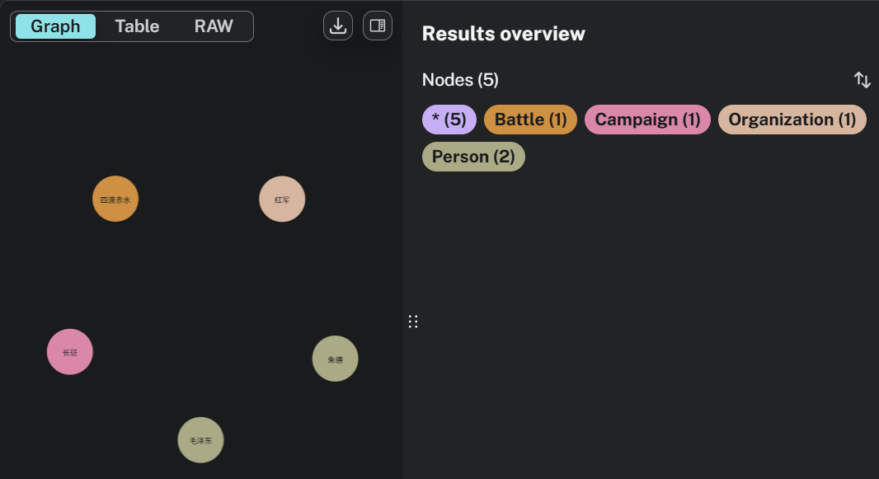
(4) 查询23 MATCH (b:Battle)
WHERE b.startDate >= "1935-01-01" AND b.startDate < "1936-01-01"
RETURN b.name AS battleName, b.startDate AS start
查询结果截图：
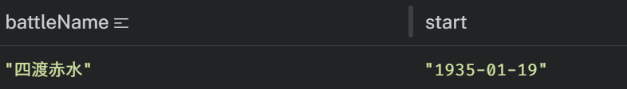
(5) 查询24 MATCH (b:Battle {name: "四渡赤水"})
MATCH (p:Person)-[c:COMMAND]->(b)
OPTIONAL MATCH (p)-[e:EXECUTE]->()
RETURN p.name AS commander, c.role AS role, e
查询结果截图：
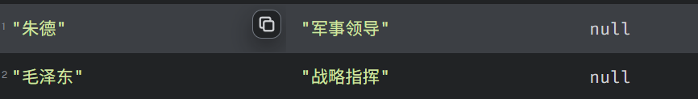

(6) 查询25 MATCH (b:Battle)
RETURN b.name AS entityName
UNION
MATCH (c:Campaign)
RETURN c.name AS entityName
查询结果截图：
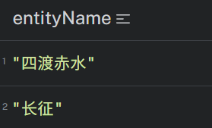

(7) 查询26 MATCH (b:Battle { name: "四渡赤水" })
RETURN
b.name AS originalName,
substring(b.name, 0, 2) AS shortName,
duration.inDays(date(b.startDate), date(b.endDate)).days AS daysElapsed
查询结果截图：
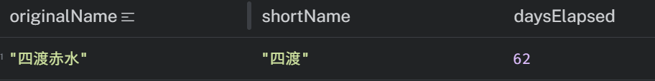

(8) 查询27 MATCH (b:Battle)-[:LOCATION]->(r:Basin)
MATCH (r)-[:LOCATED_IN]->(p:Province)
WITH p, COUNT(b) AS battleCount
RETURN p.name AS province, battleCount
ORDER BY battleCount DESC
查询结果截图：
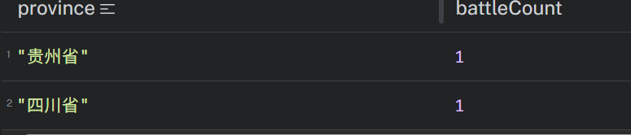
(9) 查询28 MATCH (r:Basin {name: "赤水河"})
SET r.length = 440.0
RETURN r.name AS basinName, r.length AS newLength
查询结果截图：
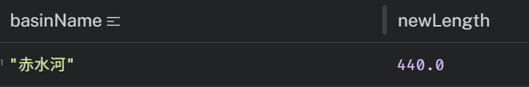
(10) 查询29 MATCH (b:Battle)
RETURN b.name AS battleName, b.startDate AS start
ORDER BY b.startDate DESC
SKIP 5
LIMIT 5
查询结果截图：
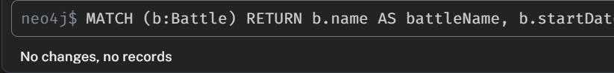
(11) 查询30 MATCH path = (crossing:Battle)-[]->{3,}(other)
WHERE crossing.name = "四渡赤水"
RETURN path
查询结果截图：
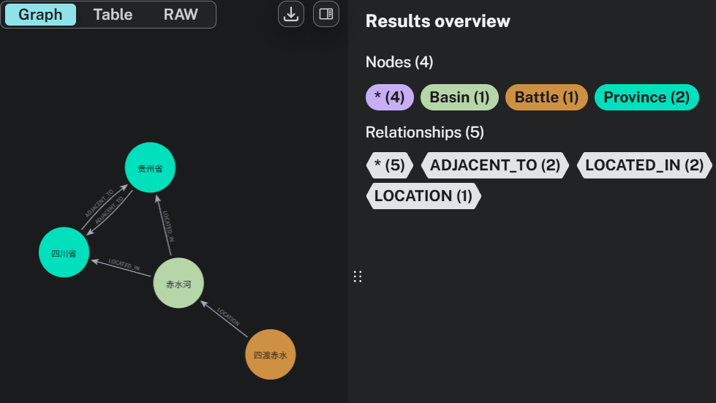
(12) 查询31 MATCH (start:Battle {name:"四渡赤水"})-[]->+(end)
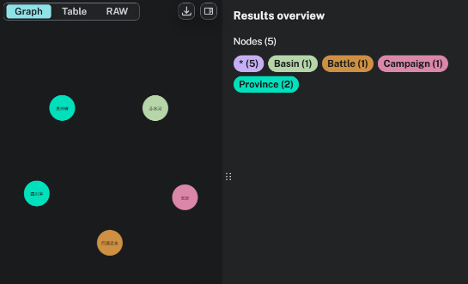
RETURN start, end
查询结果截图：

2. 使用Neo4j导入IMDB电影知识图谱数据集（imdb-data）的actors.csv、movies.csv、roles.csv（imdb-data.zip压缩包解压，具体导入命令见文件“neo4j import cmd.txt”），执行课程视频“实战-Neo4j.mp4”中所演示的所有Cypher查询，并给出查询结果截图。

给出执行neo4j-admin import批量导入数据集成功截图：

(1) 查询1
Cypher语句：MATCH (n) RETURN labels(n) AS labels,keys(n) AS properties,COUNT(*) AS total ORDER BY total DESC

查询结果截图：
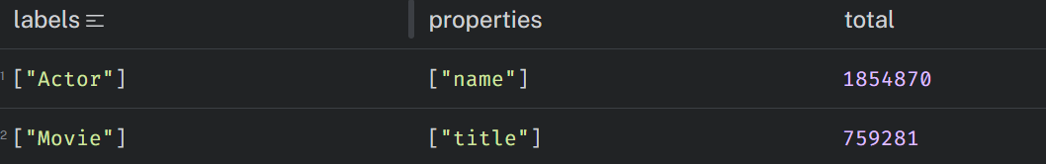
(2) 查询2
Cypher语句：
MATCH (x:Actor{name:"Cruise, Tom"}) RETURN x;
查询结果截图：
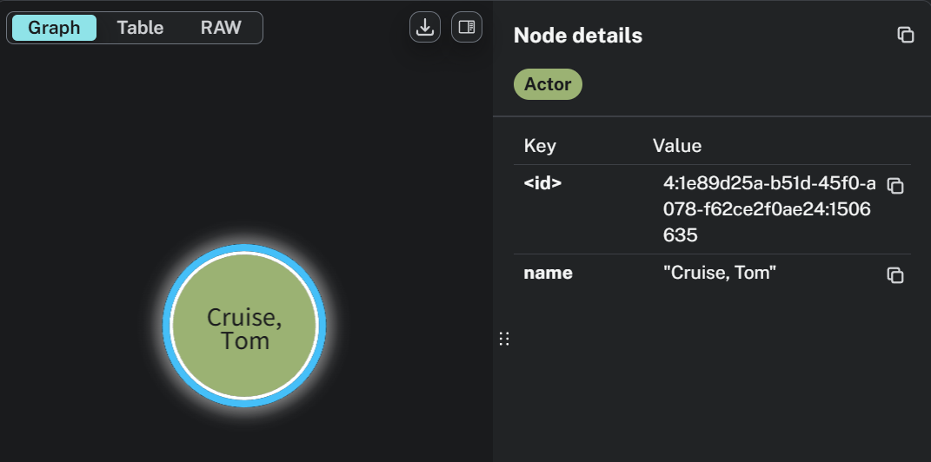
(3) 查询3
Cypher语句：MATCH (x:Actor) RETURN COUNT(x);

查询结果截图：
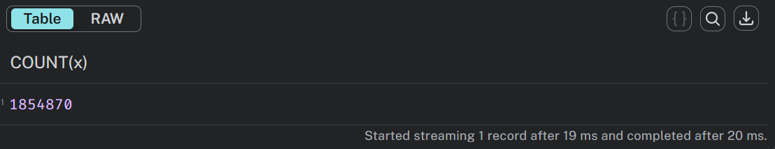
(4) 查询4
Cypher语句：match (m)-[r]->(n) RETURN labels(m),type(r),labels(n),count(*) as total order by total desc;

查询结果截图：
(5) 查询5
Cypher语句：MATCH (x:Actor{name:"Cruise, Tom"})-[:PLAYED_IN]->(m:Movie) RETURN x,m

查询结果截图：
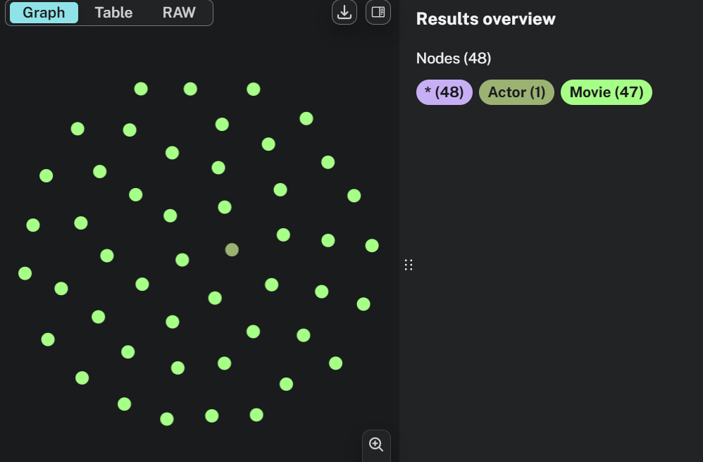
(6) 查询6
Cypher语句：MATCH (x:Actor{name:"Cruise, Tom"})-[:PLAYED_IN]->(:Movie)<-[:PLAYED_IN]-(y:Actor) WHERE x.name <> y.name RETURN x.name as name1, y.name as name2, COUNT(*) AS total ORDER BY total DESC;

查询结果截图：
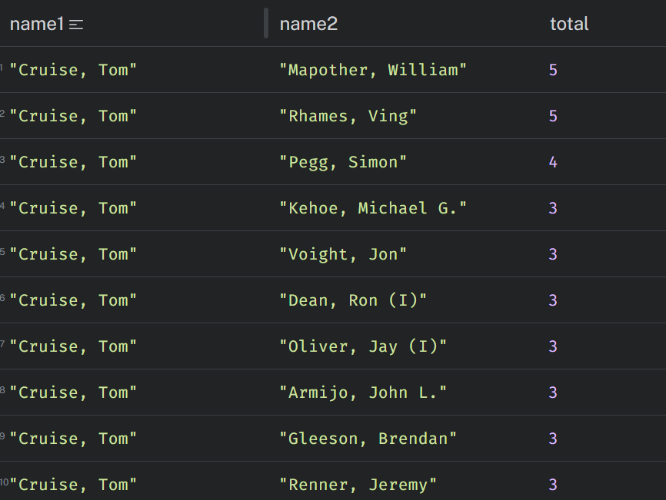

3. 在上题基础上，继续执行下列查询，编写Cypher语句并给出查询结果截图。

(1) 两个演员共同出演一部电影可以用如下关系表示：
(a)--[:PLAYED_IN*2]--(b)
称为演员a和b之间的合作距离为1，
“贝肯数”是指与演员Kevin Bacon（在IMDB数据集中name为“Bacon, Kevin (I)”）之间的合作距离。
查找贝肯数是5的10名演员，并输出由演员Kevin Bacon到这些演员的路径。

Cypher语句：MATCH path = (kevin:Actor {name: "Bacon, Kevin (I)"})-[:PLAYED_IN*10]-(actor:Actor) WHERE actor <> kevin RETURN DISTINCT actor.name AS `贝肯数=5的演员`, path AS `Kevin Bacon → 演员 合作路径` LIMIT 10;
查询结果截图：
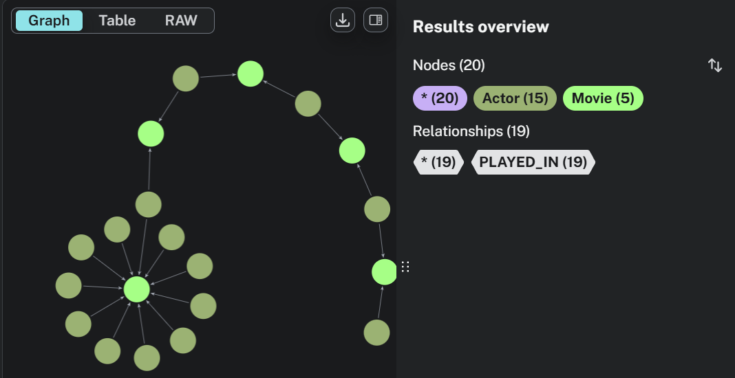

(2) 查询出演电影数量最多的（降序排列）10名演员及其出演的电影名称。
Cypher语句：MATCH (actor:Actor)-[:PLAYED_IN]->(movie:Movie) RETURN actor.name AS `演员姓名`, COUNT(DISTINCT movie) AS `出演电影总数`, COLLECT(DISTINCT movie.title) AS `出演的电影名称` ORDER BY `出演电影总数` DESC LIMIT 10;
查询结果截图：
