General motion optimization scheme for stereo camera and rgbd camera

1. The unification of stereo camera and rgbd camera.

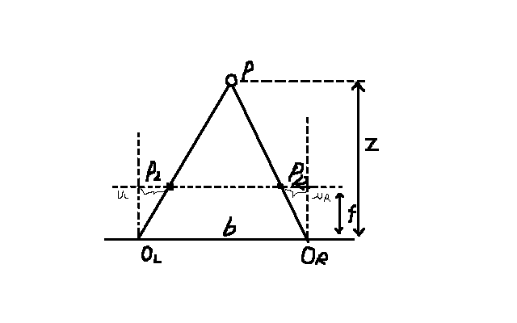

We can get the relationship in the model through similarity theorem of triangles.

Therefore, we can easily exchange the stereo model and rgbd model. Stereo camera can measure the disparity d between left and right images. And the solve out the depth z of the point P. And the rgbd camera can measure the depth z straightly. But we can get a disparity via a virtual baseline b.

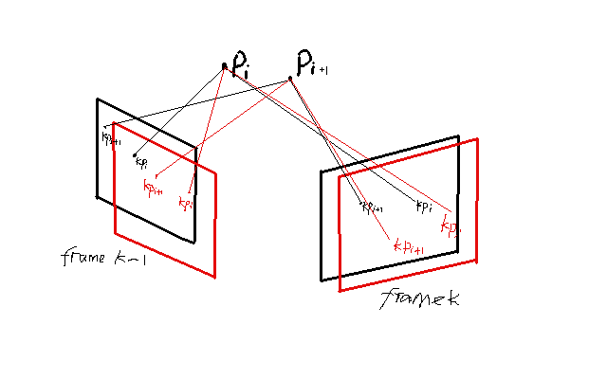

1. Construct optimization model

The optimization model can be expressed by the image above. We observe the point and at frame k-1 and frame k, which appeared at both left and right image. And now, we want to calculate the pose of frame k , frame k-1, and . Define the frame’s pose with , ( *，) ,*which can be expressed as Lie algebras , . The point , can expressed as . The intrinsics of camera is .

Then the projection coordinates of the camera on the normalized plane can be expressed as:

Model description:

Let us assume that the left and right camera has the same scalar, which means .

Let ,

Take the front three dimensions,

Update the model description in rotation matrix and translation:

Thus, . And we also assume that .

And the system states can express as: .

We have already got the result of above, now we derive the .