SUPERSEDE

Developer manual

# Prerequisites

* Gradle 2.10 ( <http://gradle.org/gradle-download/> )
* PostgreSQL 9.4 ( <http://www.postgresql.org/download/> )
* Git (<https://git-scm.com/downloads> )
* Redis 2.8 (<http://redis.io/download> or <https://github.com/MSOpenTech/redis/releases/tag/win-2.8.2104> for windows)
* Apache httpd 2.4 (<http://www.apachelounge.com/download/> for windows)
* STS - Spring Tool Suite (https://spring.io/tools/sts/all)

In the following, it is assumed that you have a basic understanding of Spring.

# Set up workspace

1. Clone the SUPERSEDE frontend Git repository (<https://github.com/supersede-project/frontend>). The directory where you extracted the distribution will be indicated in the following as <supersede_dir>.
2. Create one or more Postgres databases (one per tenant in your installation) with the same owner for all of them.
3. Run the following scripts to configure the databases ($user, $password, $DB1, …, $DBn are the parameters that you used in step 2):

<supersede_dir>/conf/postgreSql/schema/restore_schema.sh $user $password $DB1 $DB2 $DBn

<supersede_dir>/conf/postgreSql/schema/ apply_updates.sh $user $password $DB1 $DB2 $DBn

1. Build all the projects:

cd <supersede_dir>/applications/

./build_all.sh

1. In STS, import all the gradle projects from <supersede_dir>/applications.
2. Configure the Apache httpd server to reverse proxy to the microservers. A basic configuration file is located in <supersede_dir>/conf/httpd/httpd.conf .
3. Configure <supersede_dir>/multitenancy.properties and if.properties based on your databases and integration framework configurations.
4. In STS, choose to “run as Spring Boot App” (or debug) the supersede-frontend and admin-user-manager-app projects.
5. Open your browser and go to <http://localhost:80>, or other port you configured in your httpd.conf file.

# Make your first application

1. Create an “applications” folder at same depth of the “frontend” and “integration” folders.  
   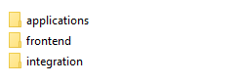
2. In STS, create a new Spring Starter Project. The application will be called “supersede_first_app” and it’s purpose is to show in a page the logged user’s name.  
   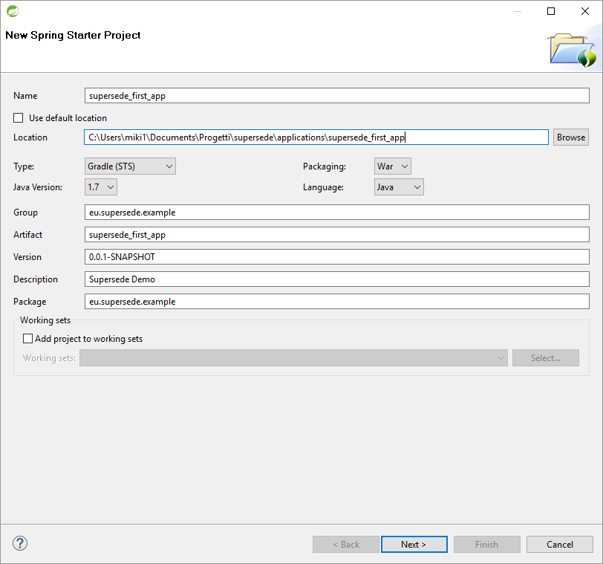
3. Open the build.gradle file and add the following required dependencies:

compile('org.springframework.boot:spring-boot-starter-security')

compile("org.springframework.boot:spring-boot-starter-jdbc")

compile("org.springframework.boot:spring-boot-starter-data-jpa")

compile("org.postgresql:postgresql:9.4.1208.jre7")

compile("org.springframework.boot:spring-boot-starter-mail")

compile("org.springframework.session:spring-session:1.2.0.RELEASE")

compile("org.springframework.boot:spring-boot-starter-redis")

compile files('../../frontend/applications/supersede-client/build/libs/supersede-client-0.0.1-SNAPSHOT.jar')

//required by integration

compile files('../../integration/IF/API/eu.supersede.if.api/build/libs/eu.supersede.if.api.jar')

compile ("org.apache.axis2:axis2:1.6.1")

compile ("org.apache.axis2:axis2-transport-http:1.6.1")

compile ("org.apache.axis2:axis2-transport-local:1.6.1")

compile files('../../integration/IF/API/eu.supersede.if.api.test/lib/org.wso2.carbon.um.ws.api.stub_4.2.2.jar')

compile files('../../integration/IF/API/eu.supersede.if.api.test/lib/org.wso2.carbon.um.ws.api_4.2.2.jar')

compile files('../../integration/IF/API/eu.supersede.if.api.test/lib/org.wso2.carbon.user.api_4.2.0.jar')

compile files('../../integration/IF/API/eu.supersede.if.api.test/lib/org.wso2.carbon.user.core_4.2.0.jar')

compile files('../../integration/IF/API/eu.supersede.if.api.test/lib/org.wso2.carbon.utils_4.2.0.jar')

compile ("ca.juliusdavies:not-yet-commons-ssl:0.3.9")

1. Delete “.gradle” and “.setting” folders and “.classpath” and “.project” files.
2. Run “gradle eclipse” from command line to update the project dependencies.
3. Open the application.properties file and add the following lines:

server.port=8083

logging.level.eu.supersede.example=DEBUG

spring.jpa.database=POSTGRESQL

spring.jpa.show-sql=false

spring.jpa.hibernate.ddl-auto=none

spring.redis.host=localhost

spring.redis.port=6379

security.sessions=NEVER

1. Create the file “wp5_application.properties” in src/main/resources and add the following lines:

application.name=supersede_first_app

application.unsecured.urls=/open_apis/**

application.multitenancy.models.packages=eu.supersede.example.model

application.label=Supersede first app

application.label.it=Supersede prima applicazione

application.pages=example

application.home=example

application.page.example.profiles=ADMIN

application.page.example.label=Example

application.page.create_user.label.it=Esempio

application.gadgets=example_gadget

application.gadgets.example_gadget.profiles=ADMIN

1. Delete the “ServletInitializer.java” file.
2. Replace the content of “SupersedeFirstAppApplication.java” with the following:

package eu.supersede.example;

import org.springframework.boot.SpringApplication;

import org.springframework.boot.autoconfigure.SpringBootApplication;

import org.springframework.boot.autoconfigure.jdbc.DataSourceAutoConfiguration;

import org.springframework.boot.builder.SpringApplicationBuilder;

import org.springframework.boot.context.web.SpringBootServletInitializer;

import org.springframework.context.annotation.ComponentScan;

import org.springframework.data.jpa.repository.config.EnableJpaRepositories;

import org.springframework.security.config.annotation.method.configuration.EnableGlobalMethodSecurity;

import org.springframework.session.data.redis.config.annotation.web.http.EnableRedisHttpSession;

import eu.supersede.fe.configuration.ApplicationConfiguration;

@SpringBootApplication(exclude = DataSourceAutoConfiguration.class)

@ComponentScan(basePackages = {"eu.supersede.example", "eu.supersede.fe"})

@EnableGlobalMethodSecurity( securedEnabled = true, prePostEnabled = true )

@EnableJpaRepositories(basePackages={"eu.supersede.example.jpa"})

@EnableRedisHttpSession

public class SupersedeFirstAppApplication extends SpringBootServletInitializer {

@Override

protected SpringApplicationBuilder configure(SpringApplicationBuilder application) {

ApplicationConfiguration.init();

return application.sources(SupersedeFirstAppApplication.class);

}

public static void main(String[] args) {

ApplicationConfiguration.init();

SpringApplication.run(SupersedeFirstAppApplication.class, args);

}

}

1. Create the “eu.supersede.example.model” package, where you can put all the model classes based on your database schema.
2. Create a User class in “eu.supersede.example.model”, then add the following lines:

package eu.supersede.example.model;

import javax.persistence.Entity;

import javax.persistence.GeneratedValue;

import javax.persistence.GenerationType;

import javax.persistence.Id;

import javax.persistence.Table;

import javax.persistence.Transient;

import com.fasterxml.jackson.annotation.JsonIgnore;

import com.fasterxml.jackson.annotation.JsonIgnoreProperties;

import com.fasterxml.jackson.annotation.JsonProperty;

@Entity

@Table(name = "users")

@JsonIgnoreProperties({"hibernateLazyInitializer", "handler"})

public class User {

@Id

@GeneratedValue(strategy = GenerationType.AUTO)

private Long userId;

private String username;

private String firstName;

private String lastName;

private String email;

@Transient

private String password;

public User() {

}

public Long getUserId() {

return userId;

}

public void setUserId(Long userId) {

this.userId = userId;

}

public String getUsername() {

return username;

}

public void setUsername(String username) {

this.username = username;

}

public String getFirstName() {

return firstName;

}

public void setFirstName(String firstName) {

this.firstName = firstName;

}

public String getLastName() {

return lastName;

}

public void setLastName(String lastName) {

this.lastName = lastName;

}

public String getEmail() {

return email;

}

public void setEmail(String email) {

this.email = email;

}

}

1. Create the “eu.supersede.example.jpa” package, where you can put all the JPA classes based on your database schema.
2. Create a UsersJpa interface in “eu.supersede.example.jpa” and add the following lines:

package eu.supersede.example.jpa;

import org.springframework.data.jpa.repository.JpaRepository;

import eu.supersede.example.model.User;

public interface UsersJpa extends JpaRepository<User, Long> {

}

1. Create the “eu.supersede.example.rest” package, where you can put all the REST classes used to map REST services.
2. Create the UserRest class in “eu.supersede.example.rest”, then add the following code:

package eu.supersede.example.rest;

import org.springframework.beans.factory.annotation.Autowired;

import org.springframework.security.core.Authentication;

import org.springframework.web.bind.annotation.RequestMapping;

import org.springframework.web.bind.annotation.RestController;

import eu.supersede.example.jpa.UsersJpa;

import eu.supersede.example.model.User;

import eu.supersede.fe.security.DatabaseUser;@RestController

@RequestMapping("/user")

public class UserRest {

@Autowired

UsersJpa users;

@RequestMapping("")

public User getUser(Authentication authentication)

{

DatabaseUser currentUser = (DatabaseUser) authentication.getPrincipal();

User u = users.getOne(currentUser.getUserId());

return u;

}

}

1. Create the “example.html” file and add the following lines:

<script src="supersede_first_app/js/example.js"></script>

<div ng-controller="example">

Hello {{user}}

</div>

1. Create the “js/example.js” file and add the following lines:

var app = angular.module('w5app');

app.controllerProvider.register('example', function($scope, $http) {

$scope.user = "";

$scope.getUser = function()

{

$http({

url: "supersede_first_app/user",

method: 'GET'

}).success(function(data){

$scope.user = data.firstName + " " + data.lastName;

}).error(function(err){

console.log(err);

});

};

$scope.getUser();

});

1. Configure Apache httpd, adding a new reverse proxy to your project:

ProxyPass /supersede_first_app <http://localhost:8083/>

ProxyPassReverse /supersede_first_app http://localhost:8083/

1. Restart Apache httpd.
2. At the same depth of “supersede_first_app” folder create a “conf” folder and copy multitenancy.properties and if.properties inside it, then configure the copied files.
3. In STS, “run as Spring Boor App” supersede_first_app and supersede-frontend.

# WP5_APPLICATION.PROPERTIES file

A configuration file is used to let supersede-frontend known how to map your application settings.

application.name= your application name

application.unsecured.urls= application urls accessible without authentication (comma separated)

application.multitenancy.models.packages= list of packages defining where your models are placed (comma separated)

application.label= default language application label name

application.label.en [.de .es .it]= specific language application label name

application.pages= list of accessible html pages (comma separated)

application.home= application homepage, should be in pages list

application.<page>.profiles= user profiles that can have access at specific page (comma separated)

application.<page>.label= specific page default language label

application.<page>.label.en [.de .es .it]= specific page specific language label

application.gadgets= list of accessible gadget (comma separated)

application.gadgets.<gadget>.profiles= user profiles that can have access at specific gadget (comma separated)

# How Access Integration Data

In any @Component, @Repository, @Service and @Controller classes you can have access to ProxyWrapper utility class defining an “autowired” global variable “ProxyWrapper proxy” like in the example below:

import org.springframework.beans.factory.annotation.Autowired;

import org.springframework.security.core.Authentication;

import org.springframework.web.bind.annotation.RequestMapping;

import org.springframework.web.bind.annotation.RestController;

import eu.supersede.fe.exception.NotFoundException;

import eu.supersede.fe.integration.ProxyWrapper;

import eu.supersede.fe.security.DatabaseUser;

import eu.supersede.integration.api.datastore.fe.types.User;

@RestController

@RequestMapping("/user")

public class UserRest {

@Autowired

private ProxyWrapper proxy;

@RequestMapping("/current")

public String getUser(Authentication authentication)

{

DatabaseUser currentUser = (DatabaseUser) authentication.getPrincipal();

Long userId = currentUser.getUserId();

User proxyUser = proxy.getFEDataStoreProxy().getUser(currentUser.getTenantId(), userId.intValue(), true, currentUser.getToken());

if(proxyUser == null)

{

throw new NotFoundException();

}

return proxyUser.getFirst_name() + " " + proxyUser.getLast_name();

}

}

# How Access Database

You can @Autowired your Jpa interfaces to read and write database data when you receive a request from a logged-in user, for example in a REST request:

import java.util.List;

import org.springframework.beans.factory.annotation.Autowired;

import org.springframework.http.HttpHeaders;

import org.springframework.http.HttpStatus;

import org.springframework.http.ResponseEntity;

import org.springframework.web.bind.annotation.RequestBody;

import org.springframework.web.bind.annotation.RequestMapping;

import org.springframework.web.bind.annotation.RequestMethod;

import org.springframework.web.bind.annotation.RestController;

import org.springframework.web.servlet.support.ServletUriComponentsBuilder;

import eu.supersede.fe.jpa.ProfilesJpa;

import eu.supersede.fe.jpa.UsersJpa;

import eu.supersede.fe.model.Profile;

import eu.supersede.fe.model.User;

@RestController

@RequestMapping("/user")

public class UserRest {

@Autowired

private UsersJpa users;

@Autowired

private ProfilesJpa profiles;

@RequestMapping(value = "", method = RequestMethod.POST)

public ResponseEntity<?> createUser(@RequestBody User user) {

// re-attach detached profiles

List<Profile> ps = user.getProfiles();

for (int i = 0; i < ps.size(); i++) {

ps.set(i, profiles.findOne(ps.get(i).getProfileId()));

}

user = users.save(user);

HttpHeaders httpHeaders = new HttpHeaders();

httpHeaders.setLocation(ServletUriComponentsBuilder.fromCurrentRequest().path("/{id}")

.buildAndExpand(user.getUserId()).toUri());

return new ResponseEntity<>(null, httpHeaders, HttpStatus.CREATED);

}

}

# How Access Database With MultiJpaProvider

You can work with database data without a user request using an @Autowired MultiJpaProvider, for example in a @Scheduled function:

@Autowired

private MultiJpaProvider multiJpaProvider;

@Scheduled(fixedRateString = "${notifier.mail.sender.checkRate}")

public void checkNotifications()

{

Date now = new Date();

Date limit = new Date(now.getTime() - SENDER_DELAY);

Map<String, NotificationsJpa> notificationsJpa = multiJpaProvider.getRepositories(NotificationsJpa.class);

for(NotificationsJpa nJpa : notificationsJpa.values())

{

//get all notifications not read and not sent via email and created before

List<Notification> ns = nJpa.findByReadAndEmailSentAndCreationTimeLessThan(false, false, limit);

for(Notification n : ns)

{

sendEmail(n);

n.setEmailSent(true);

nJpa.save(n);

}

}

}

# Send Emails

You can send email to users using SupersedeMailSender APIs.

@Autowired

private SupersedeMailSender supersedeMailSender;

private void sendEmail(Notification n)

{

supersedeMailSender.sendEmail(subject,   
 String.format(emailTemplate, n.getUser().getFirstName() + " " + n.getUser().getLastName()),  
 n.getUser().getEmail());

}

# Create Notifications

It’s possible send notifications to users or groups of users.

The notification’s receiver will see an envelope with a number (the number of notifications to read) inside the navigation bar in supersede-frontend website.

To send notifications you can use NotificationUtil Component:

@Autowired

private NotificationUtil notificationUtil;

@RequestMapping(value = "/alert", method = RequestMethod.POST)

public void notifyAlert(@RequestBody Alert alert) {

notificationUtil.createNotificationsForProfile("DECISION_SCOPE_PROVIDER", alert.getMessage(), "");

return;

}

The final result is shown below, when there are notifications to read the number next the envelope will change, all the notifications (read and not read) are listen in the datatable.

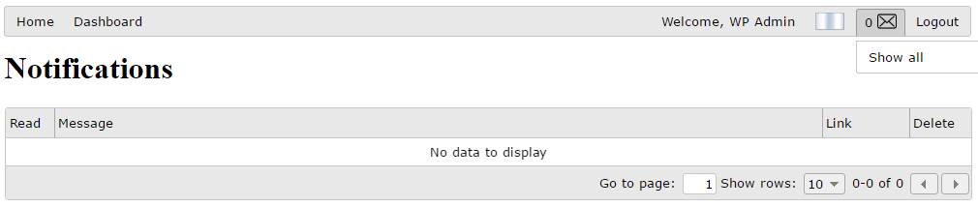

# Publish Pages To Navigation Bar

To access your application pages is required to publish them to the supersede navigation bar, here it’s explained how you can do that.

First of all you need to edit wp5_application.properties file and add you public pages like in the example below:

application.pages=create_user,list_users,edit_user

application.home=list_users

application.page.create_user.profiles=ADMIN

application.page.create_user.label=Create User

application.page.create_user.label.it=Crea Utente

application.page.list_users.profiles=ADMIN

application.page.list_users.label=Users List

application.page.list_users.label.it=Lista Utenti

application.page.edit_user.profiles=ADMIN

application.page.edit_user.label=Edit User

application.page.edit_user.label.it=Modifica Utente

In this example we are exposing three pages: create_user, list_users and edit_user.

These pages have to have an “html” extension and have to be placed in root folder of application.

All of them required “ADMIN” user profile to be accessed.

At last we set a label for this pages, the label will be shown in the supersede navigation bar. The available languages for labes are: English (default), German (de), Italian (it), Spanish (es).

The example result is the following:

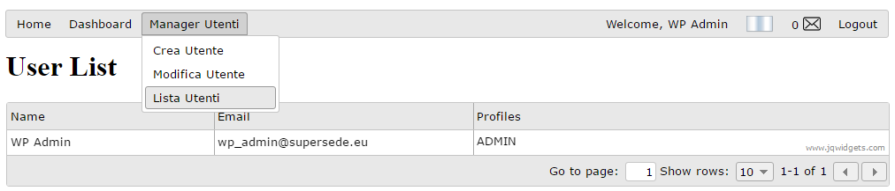

# Publish Gadgets

You can publish gadgets in a similar way you publish pages.

Gadgets work exactly like pages but they are shown inside a single page (dashboard), and users can subscribe to them.

application.gadgets=list_users

application.gadgets.list_users.profiles=ADMIN

In this example we publish only one gadget.

A single html page can serve as a page and as a gadget at the same time, like in this case.

You can add the gadget in this way:

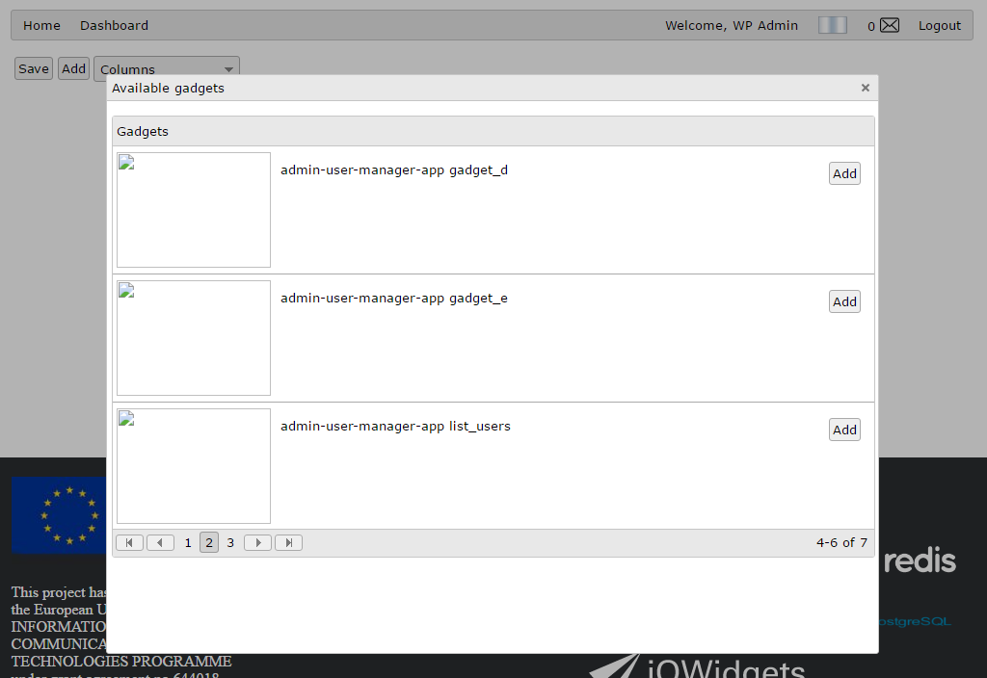

And this is the result:

