**Setting up your environment**

**Assistants**

**Xing Wang & Moloud Kaviani**

Room: N216

Email: [xing.wang@dcb.unibe.ch](mailto:xing.wang@dcb.unibe.ch), [moloud.kaviani@dcb.unibe.ch](mailto:moloud.kaviani@dcb.unibe.ch)

1. **First open the MobaXterm program.**

Click the following buttons in order:

Session --> SSH --> Remote host: <username>@submit.unibe.ch

Click OK, and input your password (Your password is not visible when you are typing).

1. **Download file**

Please run the following command in the terminal:

git clone https://github.com/superstar54/pc2-practical-cc.git

This will download the files needed for our practical from Github website.

1. **Set up Jupyter-lab**

Please run the following command in the terminal:

cd pc2-practical-cc

sh set_ssh.sh

Please click “Enter” key several times when the terminal ask you input.

Choose your a number between 10000 to 60000, and replace the “10001” in the following command with your number, and run the command:

sh set_jupyter.sh 10001 4

Wait few seconds, and check the output file by runing:

cat jupyter.out

When you see the following information in the output file, copy the text after “token=” and save it.

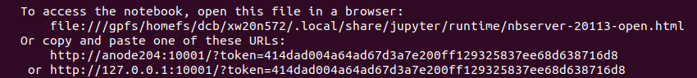

1. **Create an SSH Tunnel to the High Performance Computing Center**

In MobaXterm window, press button “Tunneling”. In the new window, press the button “New SSH Tunnel”. A new window opens, as shown here:

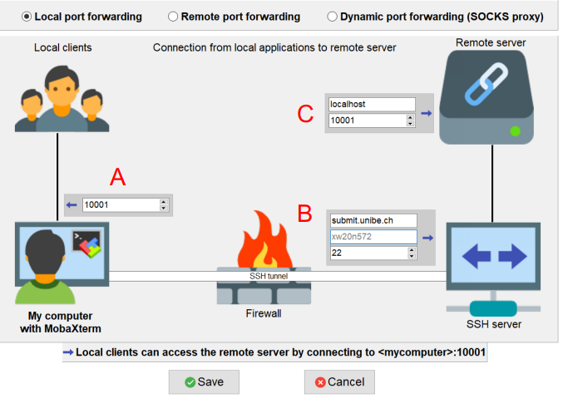

A

In the field marked with a red A on the figure you should write your port number xxxxx.

In the field marked B you should write submit.unibe.ch. You also need to enter user name (Your Campus Account, for example xw20n572 in the figure).

In the field marked C you write localhost, and your port number xxxxx. Now press the button Save. You will now see a window like the one shown here:

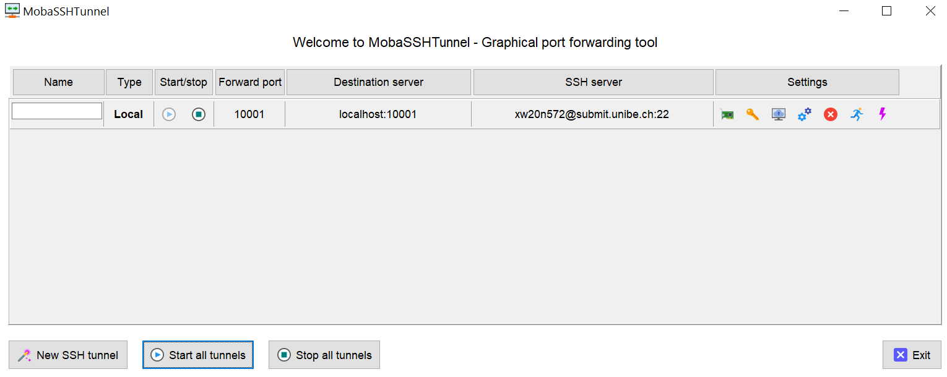

Start the tunnel by pressing the small “play” button (with a right-pointing triangle). If you are asked for a password, it is the Ubelix password.

1. **Open your browser (Chrome or Firefox)**

Input address: localhost:xxxxx, xxxxx is your port number. Copy your token (Step 3) into your browser. You should see a page similar to:

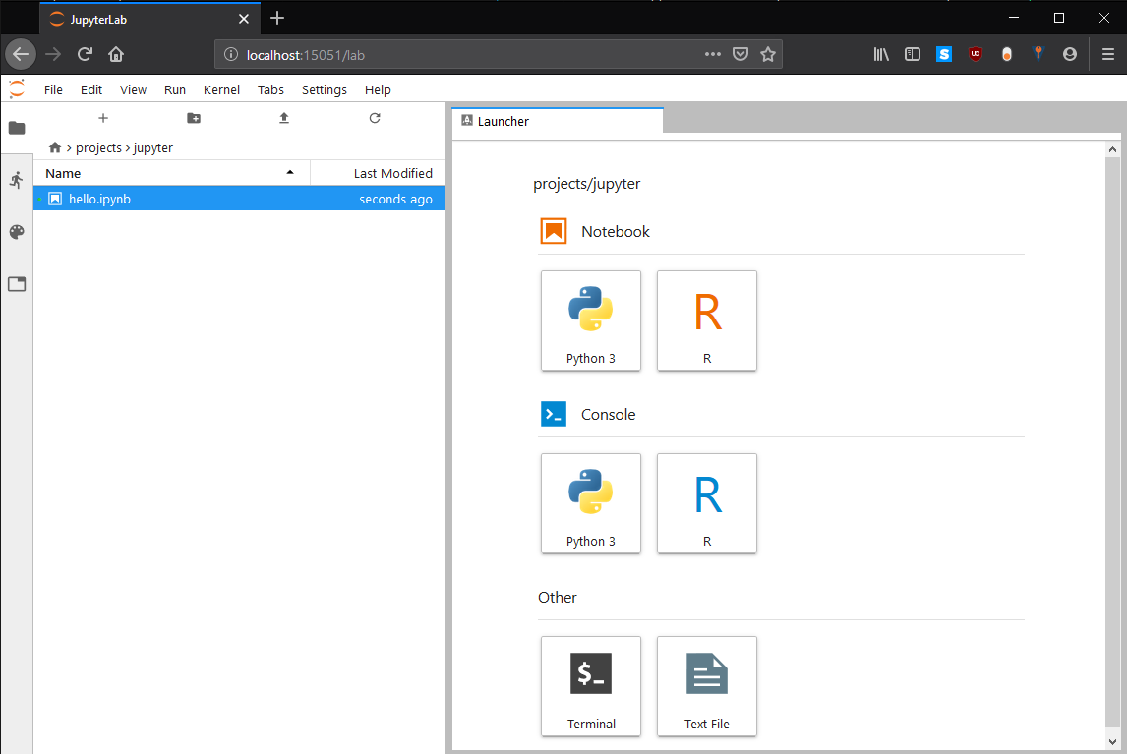

1. **Work on Jupyter-notebook**

Start from 0_Background.ipynb, follow the instruction step by step. Enjoy it!