PRODUCT DETAILS 문구

NEW COLLECTION

8.00in x 31.25 in

Monsquad Master

complete Skateboard

Monsquad Skateboards pre-built completes feature wider shapes

for easy foot placement and shorter wheelbases for easy turning

with a sizing guide that makes buying a new entry level complete

straight forward for beginners of any age or gender.

Description

High quality components include:  
  
Deck: Lightweight & strong 7-ply birch construction

Trucks: Strong, lightweight cast aluminum trucks w/ either 85a cushions (super-micro, micro, & mini) or 90a cushions (mid-large sizes) for easy turning.  
  
Wheels: Smooth riding, durable wheels w/ either 83a hardness (super-micro, micro, & mini) or 95a hardness (mid-large sizes) high-rebound urethane.  
  
Grip tape: High quality professional grade grit and adhesive.  
  
Bearings: Durable high speed precision steel bearings with oil lubricant for easy rolling.

Details

**Brand MONSQUAD**

**Complete Size**8.00in x 31.25in

**Deck Concave**Medium

**Deck Construction**7-ply

**Deck Length (Inches)**31.25

**Deck Noselength (Inches)**6.80

**Deck Taillength (Inches)**6.50

**Deck Wheelbase (Inches)**13.75

**Deck Width (Inches)**8.00

**SKU**11116214

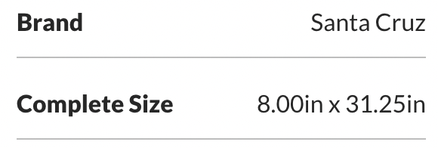

Color

Size

7.80IN X 31.00IN

SIZE GUIDE

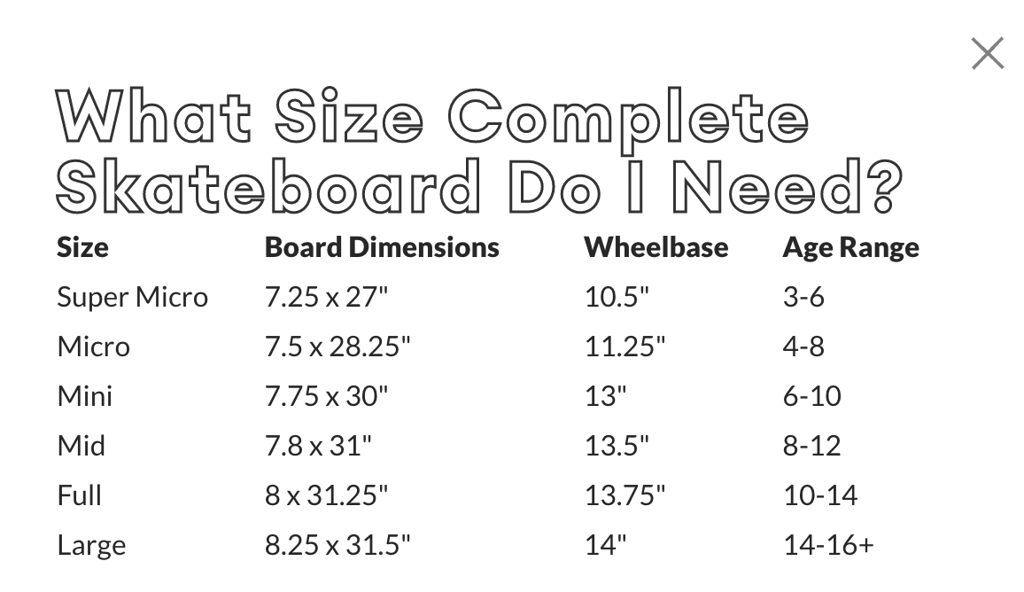

QTY

-1+

stock is available at Amazon

$109.95

GO SHOP

You May Also Like

Monsquad heart master

Skateboard Complete

SEEMORE

Screaming Hand Street

Cruiser Skateboard

SEEMORE

Screaming Hand Santa

Cruz Skateboard Complete

SEEMORE

Classic Dot Santa Cruz

Skateboard Complete

SEEMORE

Online-Shop FAQ Terms Privacy About @Monsquad

Copyright MONSQAUD All Rights Reserved