**Features of bias software (Statistic) using Python, django, Mysql, cpanel**

I created an application that analyze the bias of financial instruments. Pratically by my application it is possible to do some analysis, using some settings, for example, the year and months of analysis and some settings, for example the average of the opening data in%. After input the filter and options the sofware show a chart. it use python, django and mysql.

The application is made for the 80% but have some errors and it is necessary make some features and verify if al filter and formulas work. So it is necessary solve all and at the end install al inside my cpanel.

I attach an image of actual situation of application. It have already the structure with all features.

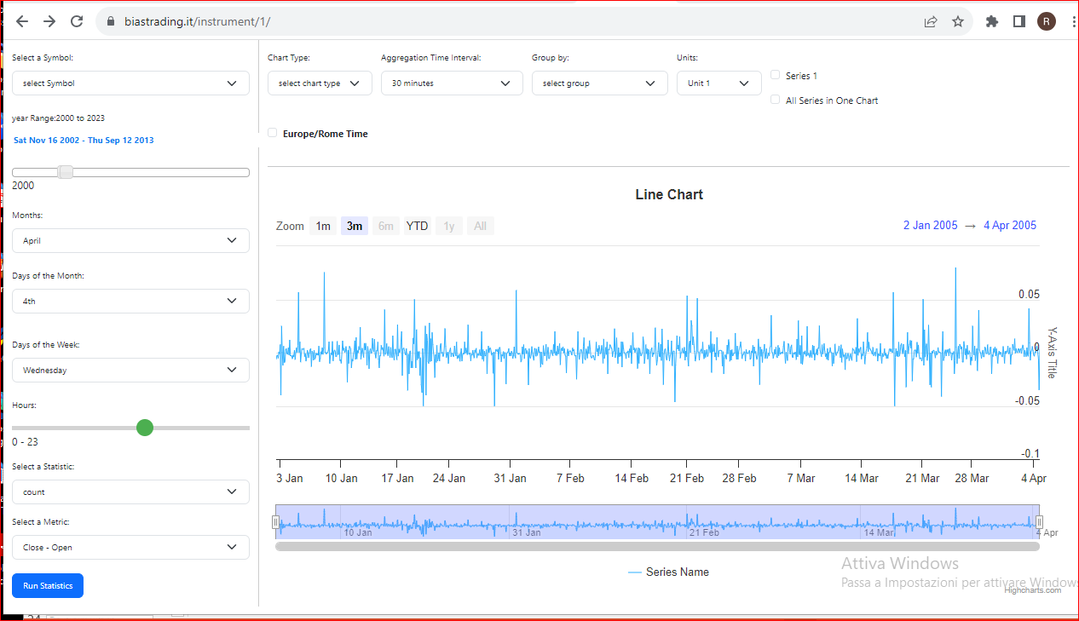

I attach also an image of actual txt file of history of stocks, and explain them.

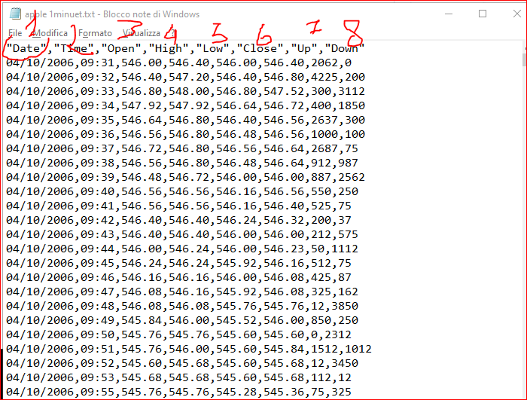

pratically the value are the data, the Time (every minute), open price (3), close price (6), low price (5) and 8 are the volume upand teh volume down, so to have the total volume it is necessary mae the sum of 7 and 8.

Now I explain in detail the points.

1. **Database**
2. 1. Now the application use mysql but the history data aren’t good because use only a table (now use django). It is necessary create the conncetion of history data to a separate mysql database that can have all history stocks. It must have one table for one stocks. It is necessry have a table for every stock because the history will be of 20 year minute for minute, so big dimention, but the sofware msut go fast.

1.2 Other problem is that I can’t add or dele**te manually and** without coding other symbol (stocks) or update them, so it is solve this features in admn panel. So, it is necessary modify the admin to import other symbol, delate or make the manually update;

1.3 the software must do the download also of csv file

1. **login**

The login to the software how user must have something to control the access. The goal is avaid that more persons from other pc and oder ip adrress use the sofware by the same login and password.

Pratically, if a person want make the login from an other pc the software must block the access.

The job is made buti it is necessary verify if work correctly and add something in admin to guaratee to user to use an other computer if he want use an oher pc.

it is also necessary add the save login and password authmatically

**3. Filter statistic and other options**

Regard filter and statistic it is necessary verify if all filter, statistic and other options work correctly, so it is necessary verify the formulas and the code. To do this you can watch the following video. Th application must do perfectly the filter and the statisti chow vieo. Many of them already work perfectly but it is necessary …….

https://www.youtube.com/watch?v=-NDba49lsNA&t=1783s

4. Chart

It is necessary use a free charts script because this aren’t beautiful (we can vaue togehr what it is better use). Other feature: it is necessray verify if the chart show correctly the vaalue and the chart must have: time, legend, different type of chart, **zoom fast, so drill down. To understand better the navigation of charts you can see the video that I attached.**

Type of charts: now there are line, column and Histogram

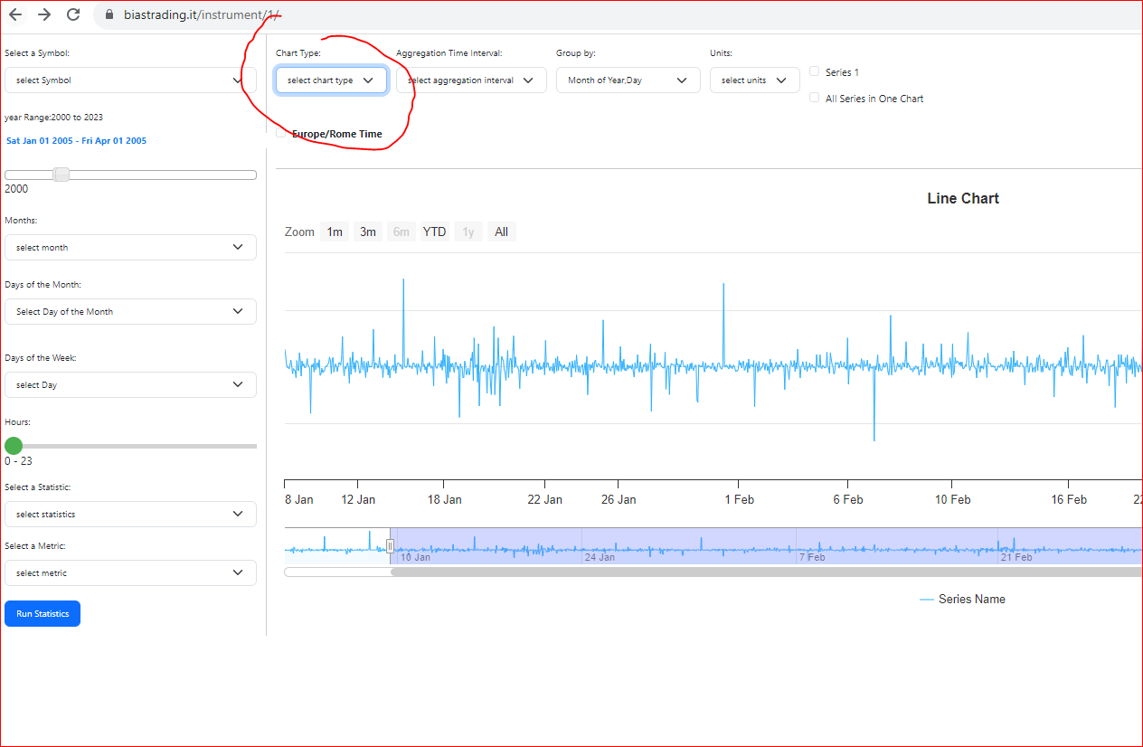

I attach some example of actula charts of competitor, but you can see also the video.

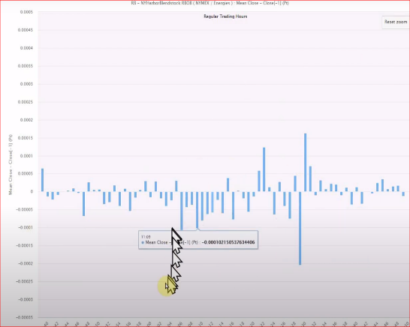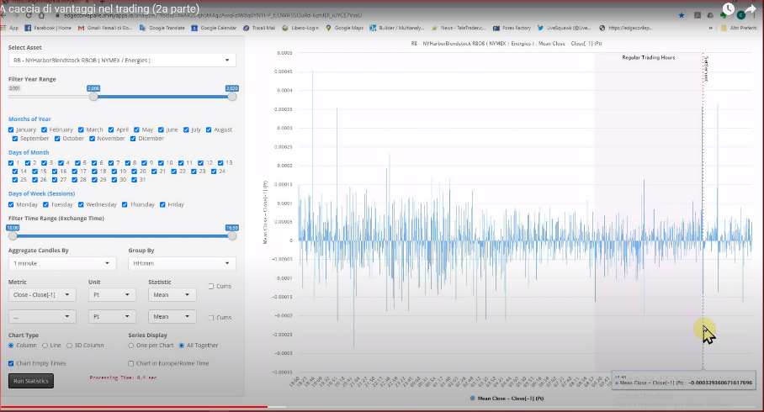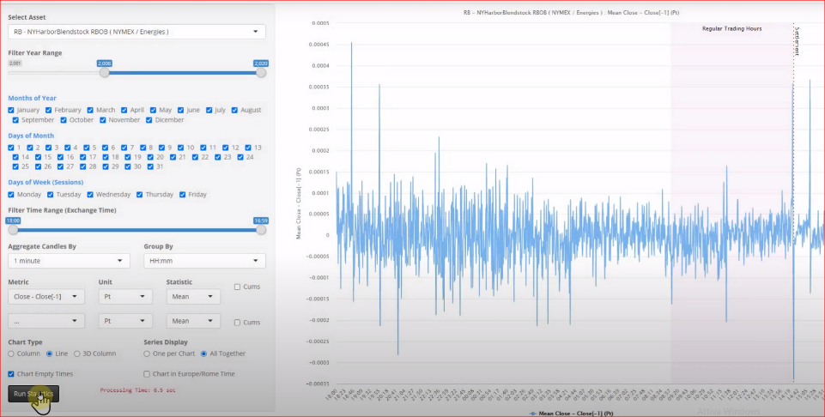

here see the hour filter and the zoom of chart by mouse

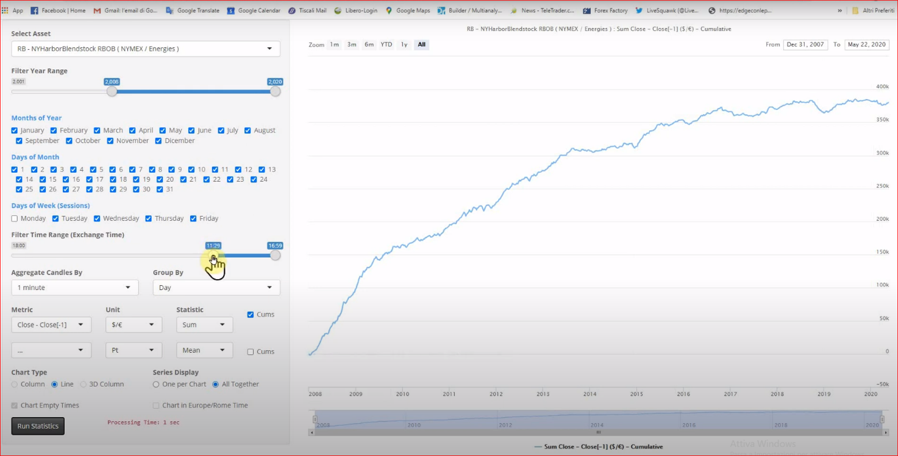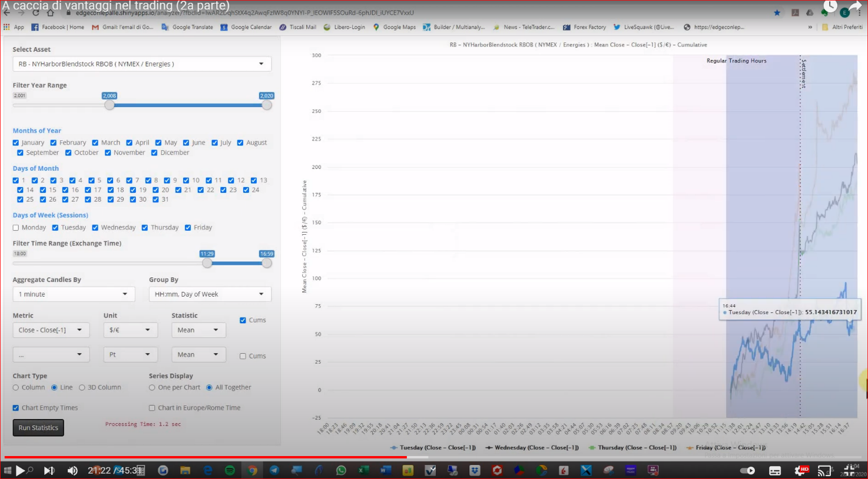

- here see the option to see the chart , so more chart on one image or more charts

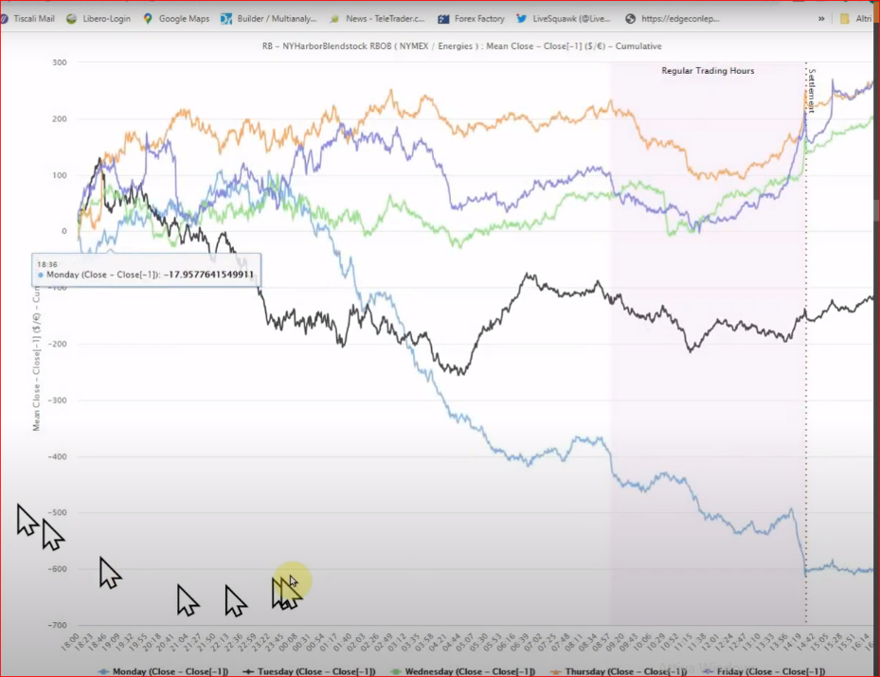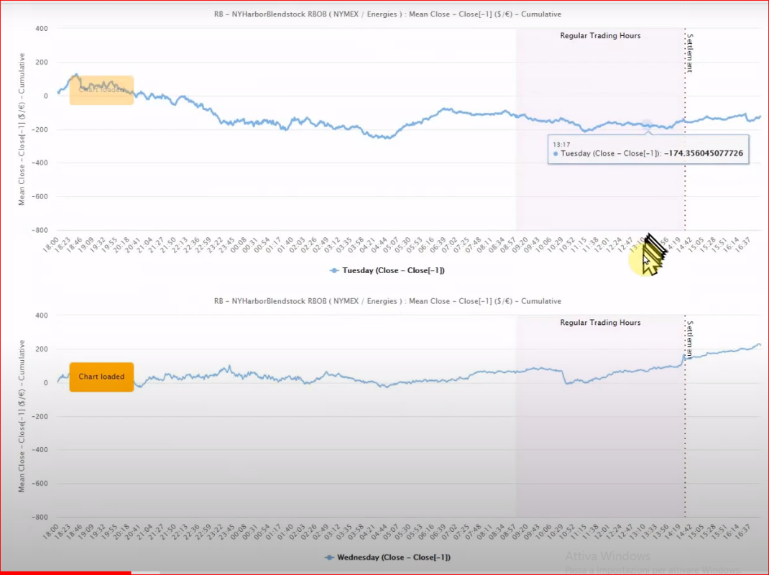

To see where I copied this application, see this video.

So you can understand better all features, so filter, formulas and other I advice you to see all this video. All features must work identical to video.

https://www.youtube.com/watch?v=-NDba49lsNA&t=1783s

**5. layout, design, css**

It is necessary make better the layout and the design. I attacha my paint of correct layput. It is already made in this way buti t is necessary make a little changes. 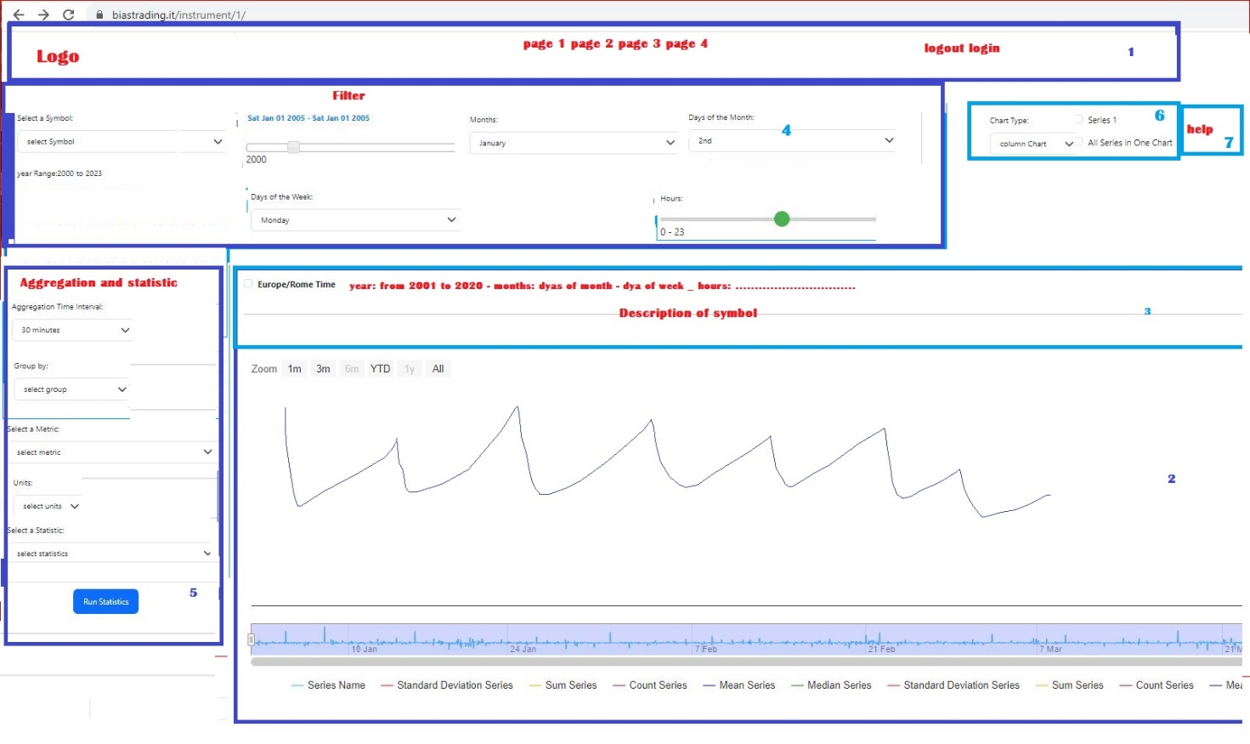

Some detail regard the layout:

5.1 don’t have the header with Logo, link of web, logout, help. So it is necessary add them.

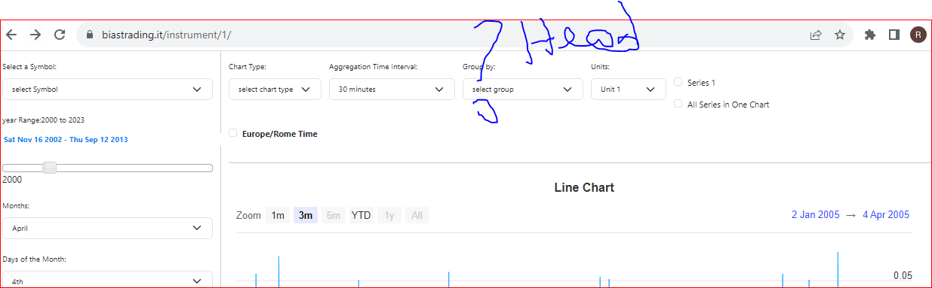

5.2 up of charts it is necessry add a title of symbol and write better the other informations (don’t useteh “,” .

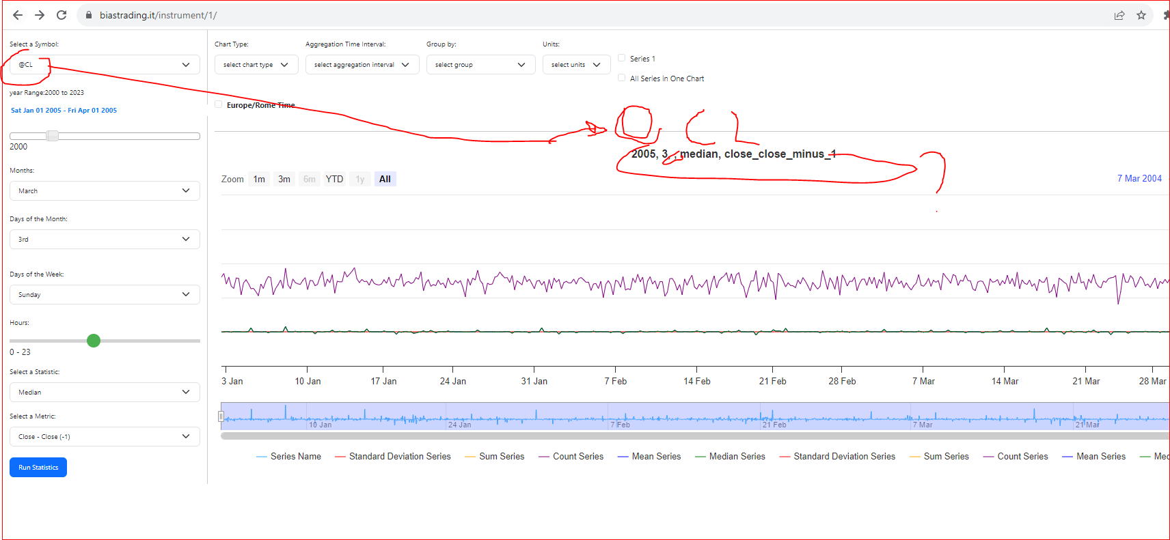

5.3. it is necessary make better the design and css

I attach a link and an image of style of design that i want..

<https://www.webank.it/webankpub/wbresp/calcolatore_mutuo.do?gad=1&gclid=CjwKCAjwseSoBhBXEiwA9iZtxivuBFPx-LzBkKtM0RyJLaBwZ3b4zoQm0YGy3LKNVZrNAxoEzQsi3xoC87cQAvD_BwE&gclsrc=aw.ds>

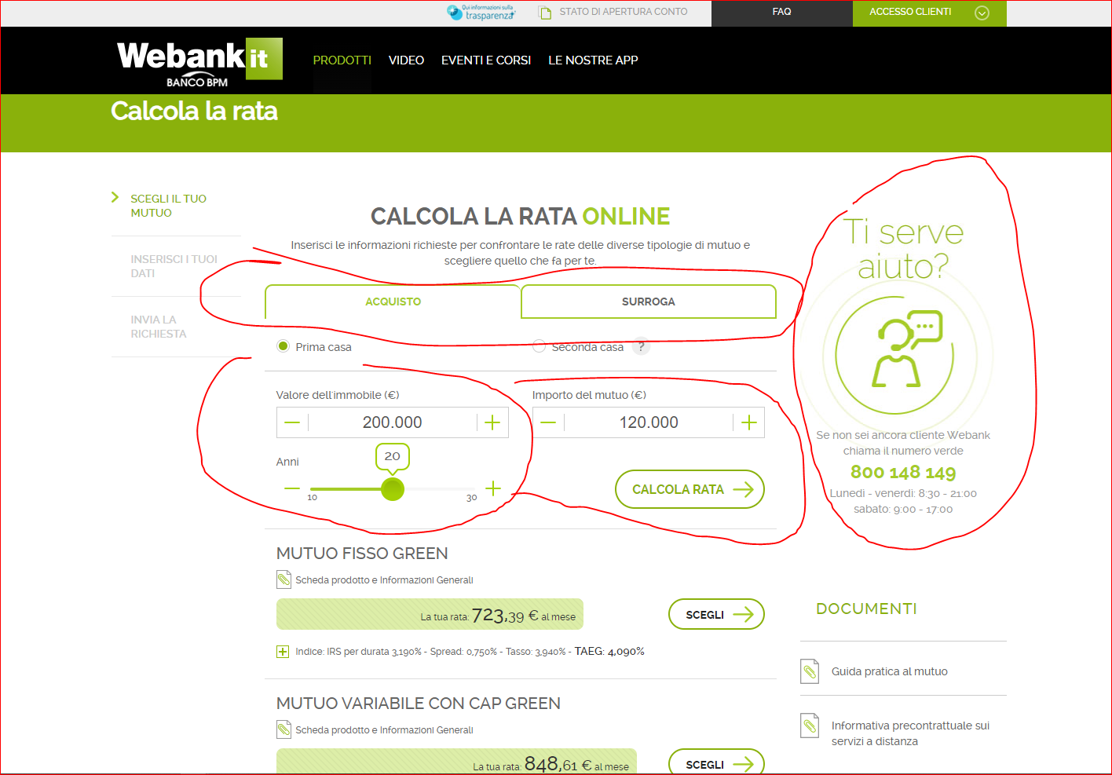

I attach also a link of a competetitor that have a good design. https://www.seasonax.com/

6. **Api (**This featues must be make at the end of all otherfeatures)

**T**he history data and daily upadate must be imported from a subscription of service (API) by CGQ or Tradestation company. The data authomatically imported must be saved inside the host (the history are didvided for minute) but it is enough to update once a day. To see how work the api you can see the web of company that sell the history data and realtime data

https://api.tradestation.com/docs/

<https://partners.cqg.com/api-resources/cqg-data-and-trading-apis>

<https://partners.cqg.com/api-resources/web-api/documentation>

<https://partners.cqg.com/api-resources/technical-documentation>

New features (optional and didn’t incluse inside my actual budget)

A. add st**atis**tic regard the volume. I attach some statistic buti t is neecssary value at the end:

Other statistic using the volume, formulas and time that it is necessary add.

Praticaly first the software must be these formula:

- poc:……

-value area hight (VaH):….

- value are low (VaL):…

- initial balance low (IBl)

-initial balance H

- O - POC

- O- Val

- O-vaH

- O- Ib- low

- O-IbH

- C - poc

- C- Val

- CvaH

- C - Ibl

-C-IBH

**Very Important conditions:**

1. max budget 100$ (the price is fixed, so it is not possible increase) to do all points. The payment must be in one solution at the end, so after put the code on my server and after that the test is ok (so no intermedian payment). The budget include all, so the application must withour error and must have perfect design. The budget include the installation on my server. The payment will do only if the test on my server is perfect. The budget is rigid.
2. job deadline: stimate time a week (the deadline is flexible, but I want see every day the progress).
3. I can award only after demostration that have that the developer have the competence. So it is necessary make a proof (solve some points of project). If the proof is ok, I will award
4. before acept it is necessary to study every detail of document and project and ask me doubts, because after acept I don't want to read any kind of excuses and lies and I don't accept requests of more money
5. If all conditions are ok, I will send the code to start the proof