# LAB Journal Serie 1

Thomas Baumann & Tobias Weissert

## Exercise 1 Static Routing

* Set up Git repo
* Set up LAB-Journal
* Group assingment nr: n113
* Familiarize with the virtual lab setup
* Search RHEL 7 Networking guide
* Router VM edit config of ENS4

Router:

Update /etc/resolve.conf

search n113.nslab.ch nslab.ch

search netlab.nslab.ch

nameserver 193.5.80.80

Router:

Update /etc/hostname

router.n113.nslab.ch

Router:

Update file: /etc/sysconfig/network-scripts/ifcfg-ens4

DEVICE=ens4

NM_CONTROLLED=no

TYPE=Ethernet

ONBOOT=yes

BOOTPROTO=none

IPADDR=193.5.80.113

PREFIX=27

GATEWAY=193.5.80.1

IPV4_FAILURE_FATAL=yes

Name="System eth0"

Router:

Update file: /etc/sysconfig/network-scripts/ifcfg-ens3

DEVICE=ens3

NM_CONTROLLED=no

TYPE=Ethernet

ONBOOT=yes

BOOTPROTO=none

IPADDR=193.5.82.129

PREFIX=27

GATEWAY=193.5.82.1

IPV4_FAILURE_FATAL=yes

Name="System eth0"

Router:

Update /etc/sysctl.conf

Net.ipv4.ip_forward = 1

sysctl -p /etc/sysctl.conf

systemctl restart network

Router:

ping 8.8.8.8 ✓

traceroute 8.8.8.8 ✓

ping google.com ✓

Client:

* Set IP to manual: 193.5.82.128/27 Gateway: 193.5.82.129
* Set DNS Server to 193.5.80.80

Network capture

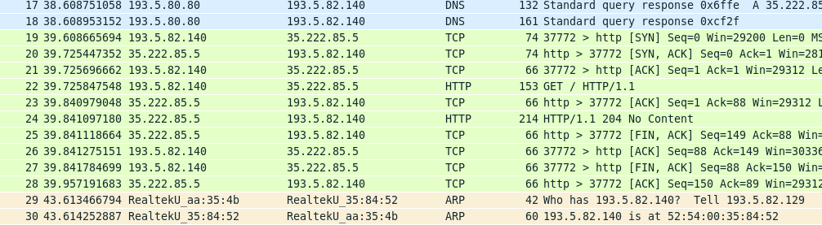

ARP capture

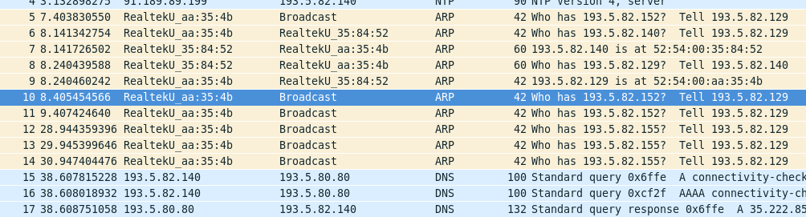

## Exercise 2 Static routing – routing tables

Router: ping 193.5.82.100 [Redirect host, nexthop: 193.5.80.112]

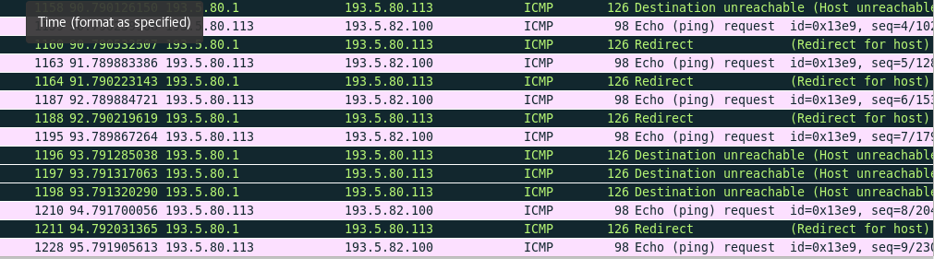

Router: ip route add 193.5.82.96/27 via 193.5.80.112 dev ens4

Make route persistent create file /etc/sysconfig/network-scripts/route-ens4 193.5.82.96/27 via 193.5.80.112 dev ens4

## Exercise 3 Dynamic routing – zebra service

Router: change /etc/sysconfig/network-scripts/ifcfg-ens3 and ifcfg-ens4

ONBOOT=no

Router: add to /etc/quagga/zebra.conf

log file /var/log/quagga/zebra.log

systemcpl start zebra

vtysh:

conf t

interface ens3

ip address 193.5.82.129/27

interface ens4

ip address 193.80.113/27

ip route 193.5.82.96/27 193.5.80.112

ip route 193.5.82.96/27 ens4

ip route 0.0.0.0/0 193.5.80.1

write mem

vtysh:

conf t

no ip route 193.5.82.96/27 193.5.80.112

no ip route 193.5.82.96/27 ens4

no ip route 0.0.0.0/0 193.5.80.1

no ip address 193.5.82.129/27

ip address 193.5.82.129/24

ping 8.8.8.8 ✓

## Exercise 4 Dynamic routing – RIPv2

Router: add to /etc/quagga/ripd.conf

log file /etc/quagga/ripd.conf

systemctl start ripd

Log contains: RIPd starting

chown quagga.quagga /var/log/qzagga/ripd.conf

vtysh

no ip route 0.0.0.0/ 193.5.80.1

conf t key chain demonet

key 1

key-string demo$rip

interface ens4

ip rip authentication mode md5

ip rip authentication key-chain demonet

router rip

redistribute connected

network 193.5.80.0/24

network ens4

distance 100 193.5.80.0/24

ping 8.8.8.8 ✓

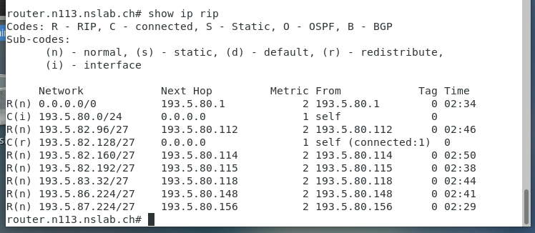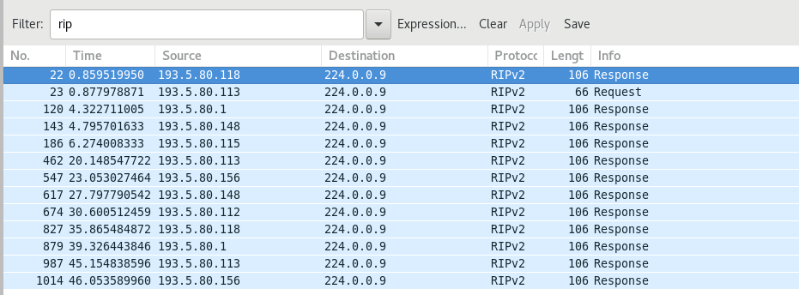

## Exercise 5 Dynamic routing – OSPFv2

Router: add to /etc/quagga/ospfd.conf

log file /var/log/quagga/ospfd.conf

systemctl start ospfd

ospf starting

chown quagga.quagga /var/log/qzagga/ospfd.conf

vtysh coinf t

router ospf

ospf router-id 193.5.80.113

interface ens4

ip ospf authentication message-digest

ip ospf message-digest-key 1 md5 demo$ospf

redistribute connected

network 193.5.80.0/24 area 0.0.0.0

area 0.0.0.0 range 193.5.80.0/24

area 0.0.0.0 authentication message-digest

systemctl enable ospfd

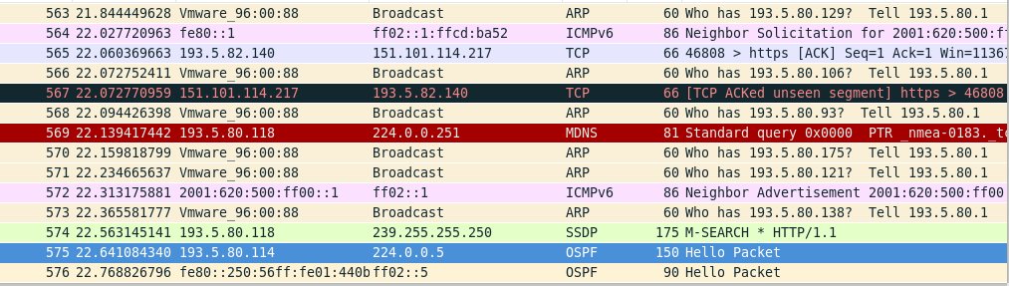

## Exercise 6 Dynamic routing – RIPv2 and OSPFv2

 RIP has a higher priority

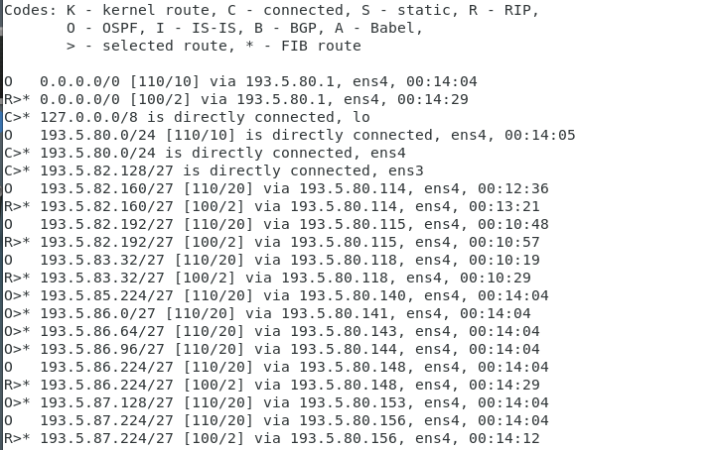

router rip

distance 120 193.5.82.160/27

ip route 192.5.80.1 0.0.0.0/0 130

# LAB Journal Serie 2

## Exercise 7 IPv6 Connectivity

ip -6 addr

ping6 www.switch.ch ✓

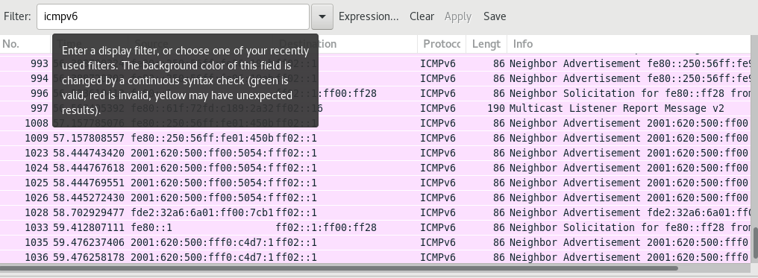

Source address in the router advertisment is the virtual network adapter of the VM host.

## Exercise 8 IPv6 Static Routing – routing tables

vtysh conf t interface ens4

ipv6 address 2001:620:500:FF00::FF0D/64

ipv6 address FE80::FF0D/64

vtysh conf t interface ens3

ipv6 address 2001:620:500:FF0D::1/64

ipv6 address FE80::1/64

write mem

vtysh conf t interface ens4

ipv6 route ::/0 FE80::FC54:FF:FEE7:8557 250

write mem

ping6 switch.ch ✓

ping6 -i ens4 fe80::1 ✓

## Exercise 9 IPv6 Router Advertisement

we prefer quagga

vtysh conf t interface ens3

no ipv6 ns suppress-ra

ipv6 nd prefix 2001:620:500:FF0D::/64

write mem

edit /etc/sysctl.conf

net.ipv6.conf.all.forwaring = 1

client

ip a

ipv6: 2001:620:500:FF0D:1116:6EE0:E63F:5D24/64 ✓

ping6 2001:620:FF00::FF0D ✓

ntptime

ifconfig ens3

echo e0576a5c5d45a0005054fffeaa354b | sha1sum - | cut -c31-40

vtysh interface ens3

ipv6 address fdf8:f06a:90f5::/48

ipv6 nd prefix fdf8:f06a:90f5::/48

## Exercise 10 IPv6 dynamic routing - RIPng

edit /etc/quagga/ripngd.conf

log file /var/log/quagga/ospf6.conf

chown quagga.quagga /var/log/quagga/ripngd.conf

vtysh

router ripng

redistribute connected

# Serie 3 DHCP and DNS

## Exercise 12 DHCP server

edit /etc/sysconfig/network

NETWORKING=yes

NETWORKING_IPV6=yes

NOZEROCONF=yes

GATEWAY=193.5.82.129

IPV6_DEFAULTDEV=ens3

IPV6_DEFAULTGW=FE80::1

edit /etc/sysconfig/network-scripts/ifcfg-ens3

BOOTPROTO=static

DEVICE=ens3

ONBOOT=yes

PREFIX=27

IPADDR=193.5.82.130

IPV6INIT=yes

IPV6_AUTOCONF=no

IPV6ADDR=2001:620:500:FF0D::20/64

NM_CONTROLLED=no

hostnamectl set-hostname ns.n113.nslab.ch

rpm -qa | grep dhcp

edit /etc/dhcp/dhcpd.conf

option domain-name "ns113.nslab.ch";

option domain-name-servers 193.5.82.130, 193.5.80.80;

default-lease-time 300;

max-lease-time 7200;

log-facility local7;

subnet 193.5.82.128 netmask 255.255.255.224 {

range 193.5.82.144 193.5.82.158;

option routers 193.5.80.113;

}

systemctl start dhcpd

systemctl enable dhcpd

Change Client 1 from fix IP address to DHCP Client 1 got the first IP address in the range 193.5.82.144

edit /etc/dhcp/dhcpd.conf

host client1 {

hardware ethernet 52:54:00:35:84:52;

fixed-address 193.5.82.150

}

Client 1 got the new IP address 193.5.82.150

## Exercise 13 DHCPv6 server

edit /etc/dhcp/dhcpd6.conf option dhcp6.name-servers 2001:620:500:ff0d::20; option dhcp6.domain-search "n113.nslab.ch";

subnet6 2001:620:500:ff0d::/64 {

range6 2001:620:500:ff0d::40 2001:620:500:ff0d::2000;

}

dhcp6 start

client1 got a ipv6 address

vtysh conf interface ens3

ipv6 nd managed-config-flag

ipv6 nd other-config-flag

ipv6 nd ra-invervall 60

no ipv6 nd suppress-ra

write mem

host client1 {

hardware ethernet 52:54:00:35:84:52;

fixed-address6 2001:620:500:ff0d::50;

}

dhclient -6 -r

dhclient -6

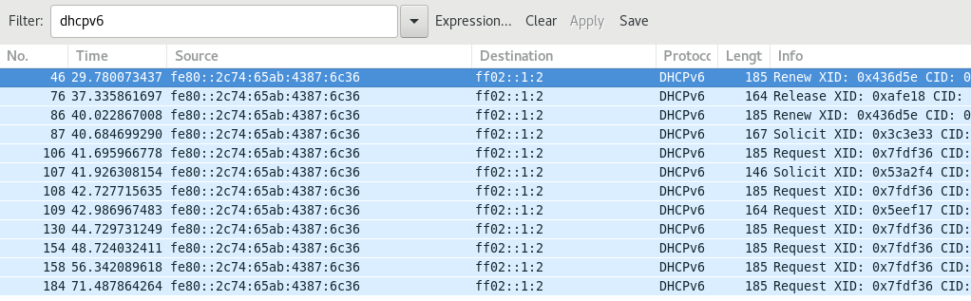

## Exercise 14 DNS Server - Basic Configuration

Add /var/named/named.conf

zone "." IN{

type hint;

file "/var/named/named.cache";

};

zone "n113.nslab.ch" {

type master;

file "/var/named/fwd-n113.nslab.ch";

};

update fwd-n113.nslab.ch

;

; BIND Zone File

;

$TTL 300

@ IN SOA ns.n113.nslab.ch root.n113.nslab.ch (

2018050301 ; Serial

600 ; Refresh

300 ; Retry

7200 ; Expire

1200 ) ; Negative Cache TTL

@ IN NS ns

ns IN A 193.5.82.130

ns IN AAAA 2001:620:500:ff0D::20

systemctl named start

less var/log/messages > all zones loaded and running

add to named.conf

listen-on port 53 {any}

listen-on-v6 port 53 {any}

client01

dig any ns.n113.nslab.ch

## Exercise 15 DNS Server - Zones

create file /var/named/rev-n113.nslab.ch

;

; BIND Zone File

;

$TTL 300

@ IN SOA ns.n113.nslab.ch root.n113.nslab.ch (

2018050301 ; Serial

600 ; Refresh

300 ; Retry

7200 ; Expire

1200 ) ; Negative Cache TTL

IN NS ns.113.nslab.ch.

130 IN PTR ns.113.nslab.ch.

create file /var/named/rev6-n113.nslab.ch

;

; BIND Zone File

;

$TTL 300

@ IN SOA ns.n113.nslab.ch root.n113.nslab.ch (

2018050301 ; Serial

600 ; Refresh

300 ; Retry

7200 ; Expire

1200 ) ; Negative Cache TTL

;D.0 IN NS ns.113.nslab.ch.

;D.0 IN PTR ns.113.nslab.ch.

@ IN NS ns.113.nslab.ch.

0.2.0.0.0.0.0.0.0.0.0.0.0.0.0 IN PTR ns.n113.nslab.ch.

client01

dig any 193.5.82.130

## Exercise 16 DNS Server – adjust the resolver

already done earlier

## Exercise 17 DNS Queries – Recordings

nslookup sbb.ch

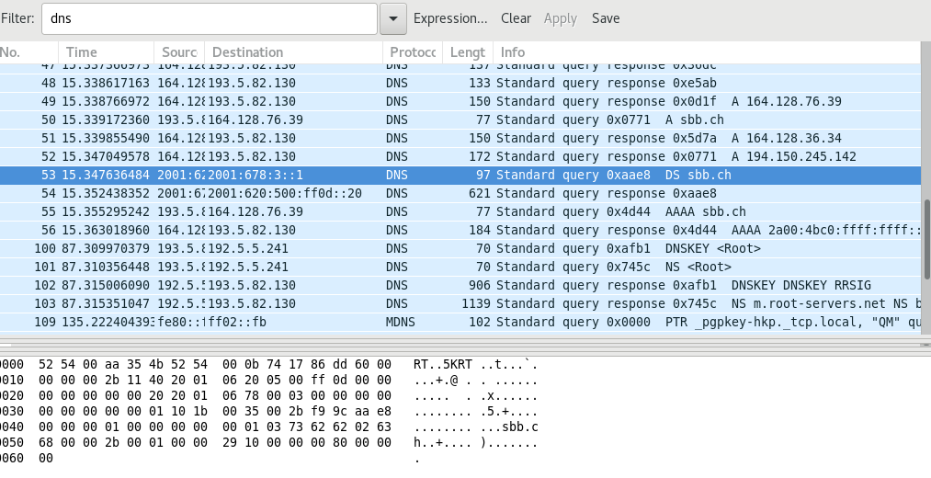

named.conf

include "/etc/rndc.key";

controls {

inet 127.0.0.1 allow { localhost; } keys { "rndc-key"; };

};

systemctl restart named

rndc status

rndc dumpdb -cache

cat /var/named/data/cache_dump.db

## Exercise 18 DNS/DHCP – Dynamic Updates

add to /etc/dhcpd.conf

update-optimization false;

update-static-leases false;

create rndc.conf

server localhost {

key "rndc-key";

};

key "rndc-key" {

algorithm hmac-md5;

secret "<key>";

};

rndc dumpdb -cache

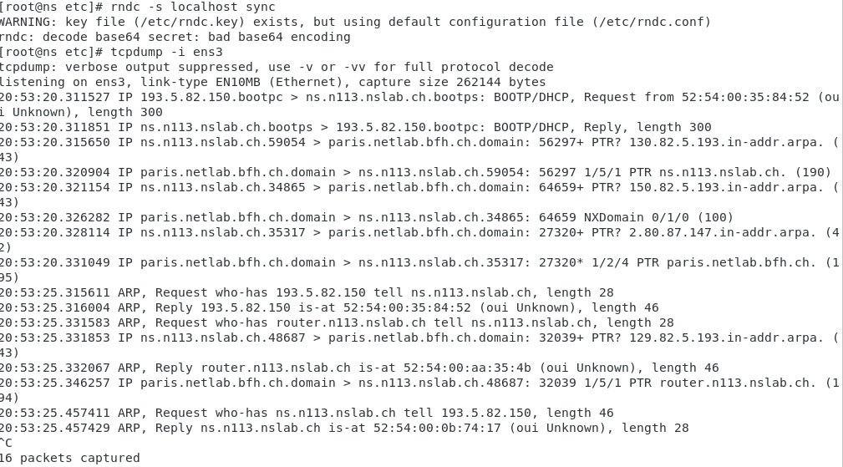

update dhcpd.conf

# update dns config each time

update-optimization false;

update-static-leases true;

key DHCP_UPDATER {

algorithm hmac-md5;

secret Qq6gGm8yExOc7ltYRutSV47prHBMiG2Ty9okFt1zEvLmwfBGZ8UEO3VyG5uq;

};

zone n113.nslab.ch. {

primary 193.5.82.130;

key DHCP_UPDATER;

}

zone 128.82.5.193.in-addr.arpa. {

primary 193.5.82.130;

key DHCP_UPDATER;

}

add ipv6

zone D.0.F.F.0.0.5.0.0.2.6.0.1.0.0.2.ip6.arpa. {

primary ns.113.nslab.ch;

key DHCP_UPDATER;

}

# Exercise 4

## Exercise 19 MTA – Receiving mails

Edit etc/sysconfig/network-scripts/ifcfg-ens

BOOTPROTO=static

DEVICE=ens3

ONBOOT=yes

NM_CONTROLLED=no

IPADDR=193.5.82.131

NETMASK=255.255.255.224

GATEWAY=193.5.82.225

IPV6_DEFAULTDEV=ens3

IPV6_DEFAULTGW=FE80::1

IPV6ADDR=2001:620:500:FF0D::25

IPV6INIT=yes

IPV6_AUTOCONFIG=no

NETWORKING_IPV6=yes

NOZEROCONF=yes

hostnamectl set-hostname mail.n116.nslab.ch

systemctl restart network

Add DNS Server to Server2 Add to sysconfig/resolf.conf

nameserver localhost

Check internet connection ✅

Add DNS entry for Mail fwd-ns113.nslab.ch

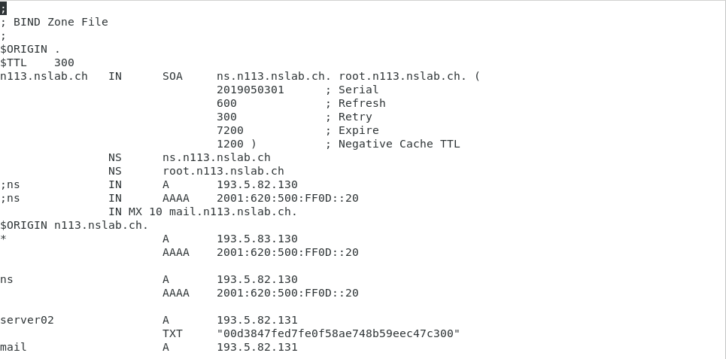

Edit main.cf

myhostname = mail.n113.nslab.ch

mydomain = n113.nslab.ch

inet_interfaces = all

mydestination = $myhostname, localhost.$mydomain, localhost, $mydomain, mail.n113.nslab.ch

telnet localhost 25

Trying 193.5.82.131...

Connected to mail.

Escape character is '^]'.

220 mail.n113.nslab.ch ESMTP Postfix

EHLO n113.nslab.ch

250-mail.n113.nslab.ch

250-PIPELINING

250-SIZE 10240000

250-VRFY

250-ETRN

250-ENHANCEDSTATUSCODES

250-8BITMIME

250 DSN

MAIL FROM: user@n113.nslab.ch

250 2.1.0 Ok

RCPT TO: user@n113.nslab.ch

250 2.1.5 Ok

DATA

354 End data with <CR><LF>.<CR><LF>

Subject: test

test test

.

250 2.0.0 Ok: queued as 6E4F723977E7

QUIT

221 2.0.0 Bye

Connection closed by foreign host.

## Exercise 20 MTA – Sending mails

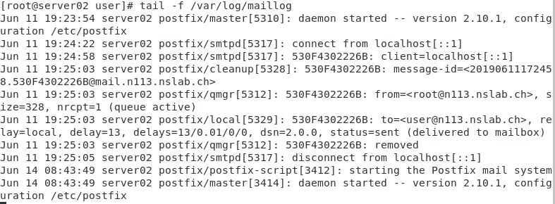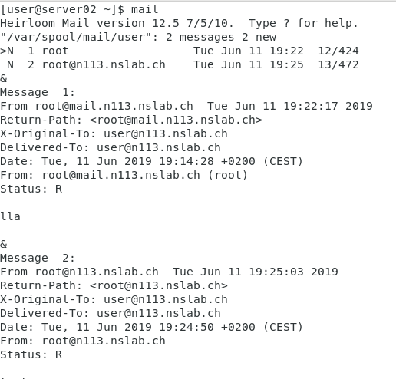

sudo apt install mailutils Install satelite system with n113.nslab.ch as relay

echo test | mail -s "das ist ein Test" thomas.baumann@students.bfh.ch

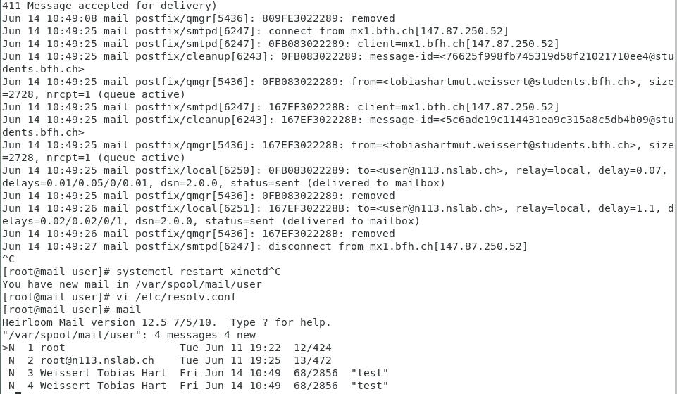

## Exercise 21 MTA – Access to mailboxes via IMAP3 (and POP3)

dovecot already installed create file /etc/dovecot/local.conf

systemctl start dovecot

telnet mail.n113.nslab.ch 110

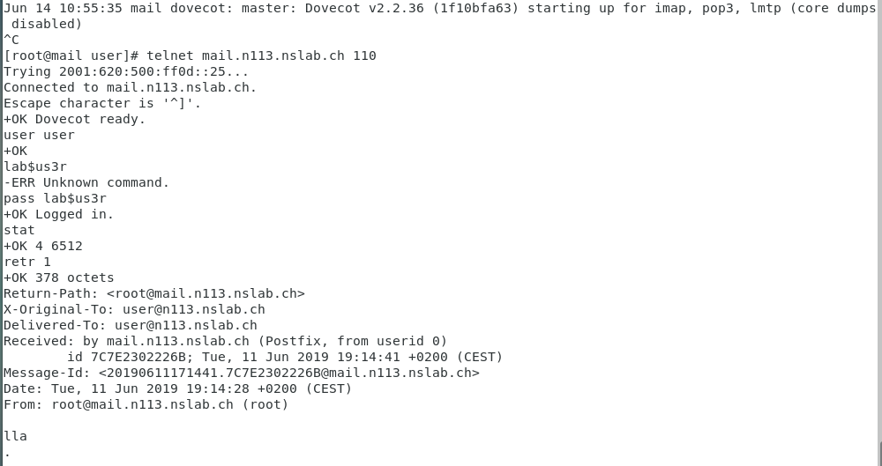

systemctl enable dovecot

edit /etc/dovecot/conf.d/10-ssl.conf

ssl = no

disable_plaintext_auth = no

## Exercise 22 MTA – Configuration of a MUA

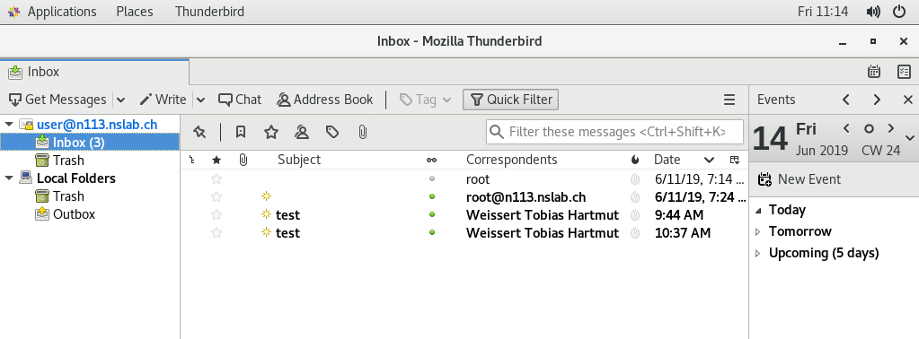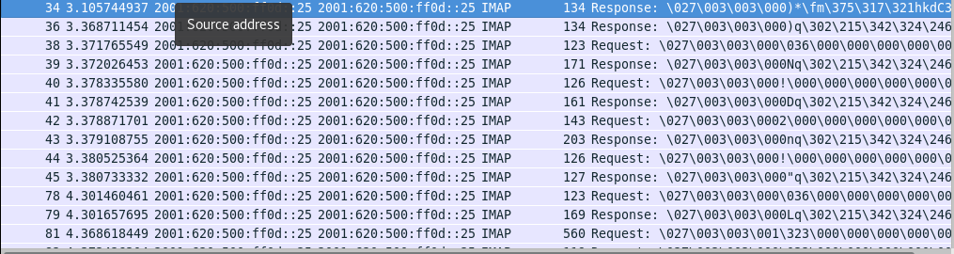

## Exercise 23 Install and configure a web server with LE certificates

install https, php mod_ssl

create file mail.conf in /etc/https/conf.d systemctl start httpd [http://mail.n113.nslab.ch](http://mail.n113.nslab.ch/) works

install certbot python2-certbot-apache

get lets encrypte certificate

[https://mail.n113.nslab.ch](https://mail.n113.nslab.ch/) works

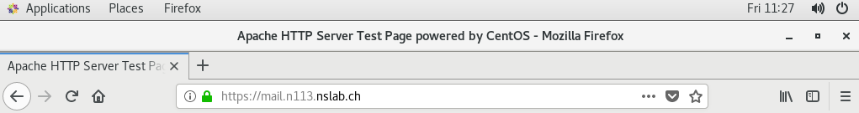

edit /etc/postfix/master.cf and enable

## Exercise 24 Securing the communication

systemctl enable saslauthd systemctl restart postfix

* swaks -tlso -t [user@n113.nslab.ch](mailto:user@n113.nslab.ch)

[root@mail postfix]# swaks -tlso -t user@n113.nslab.ch

=== Trying mail.n113.nslab.ch:25...

=== Connected to mail.n113.nslab.ch.

<- 220 mail.n113.nslab.ch ESMTP Postfix

-> EHLO mail.n113.nslab.ch

<- 250-mail.n113.nslab.ch

<- 250-PIPELINING

<- 250-SIZE 10240000

<- 250-VRFY

<- 250-ETRN

<- 250-STARTTLS

<- 250-ENHANCEDSTATUSCODES

<- 250-8BITMIME

<- 250 DSN

-> STARTTLS

<- 220 2.0.0 Ready to start TLS

=== TLS started with cipher TLSv1.2:ECDHE-RSA-AES256-GCM-SHA384:256

=== TLS no local certificate set

=== TLS peer DN="/CN=mail.n113.nslab.ch"

~> EHLO mail.n113.nslab.ch

<~ 250-mail.n113.nslab.ch

<~ 250-PIPELINING

<~ 250-SIZE 10240000

<~ 250-VRFY

<~ 250-ETRN

<~ 250-ENHANCEDSTATUSCODES

<~ 250-8BITMIME

<~ 250 DSN

~> MAIL FROM:<user@mail.n113.nslab.ch>

<~ 250 2.1.0 Ok

~> RCPT TO:<user@n113.nslab.ch>

<~ 250 2.1.5 Ok

~> DATA

<~ 354 End data with <CR><LF>.<CR><LF>

~> Date: Fri, 14 Jun 2019 13:01:28 +0200

~> To: user@n113.nslab.ch

~> From: user@mail.n113.nslab.ch

~> Subject: test Fri, 14 Jun 2019 13:01:28 +0200

~> Message-Id: <20190614130128.005228@mail.n113.nslab.ch>

~> X-Mailer: swaks v20170101.0 jetmore.org/john/code/swaks/

~>

~> This is a test mailing

~>

~> .

<~ 250 2.0.0 Ok: queued as 6F5DC32A9DE7

~> QUIT

<~ 221 2.0.0 Bye

=== Connection closed with remote host.

* Edit /etc/dovecot/local.conf
* systemctl restart dovecot
* Test TLS

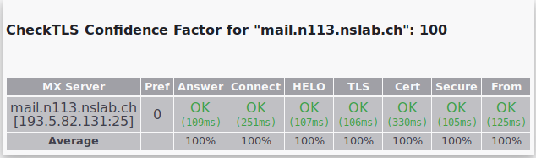

* To limit access to "dovecot" to POP3S/IMAP4

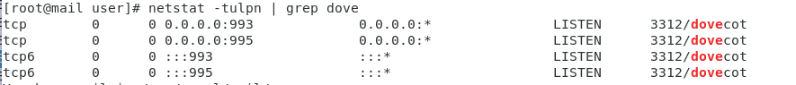

* Edit /etc/dovecot/local.conf and check log

Jun 14 13:49:36 mail dovecot: master: Dovecot v2.2.36 (1f10bfa63) starting up for imap, pop3 (core dumps disabled)

* Wireshark TLS

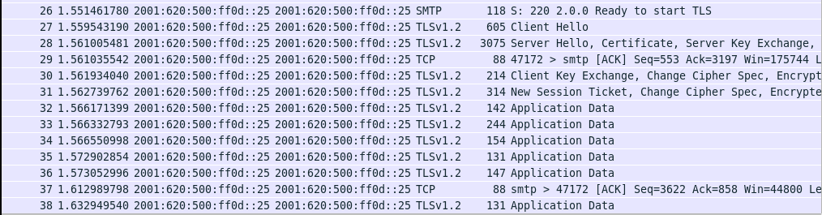

* Receive Mail works

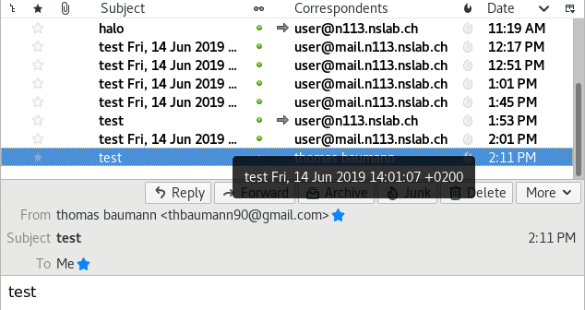

* Config MUA

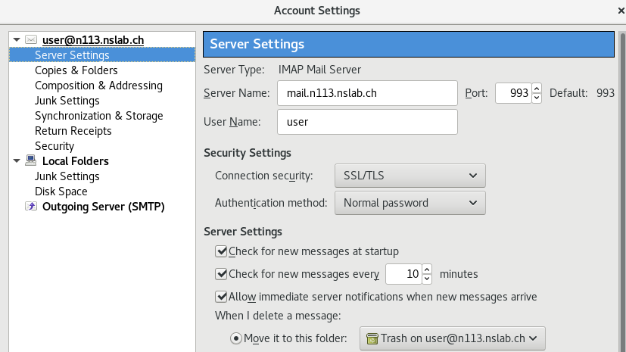

* Sending and receving Mails works!

# 25

yum install --enablerepo=epel roundcubemail

* Edit /etc/httpd/conf.d/roundcubemail.conf and verify if it works

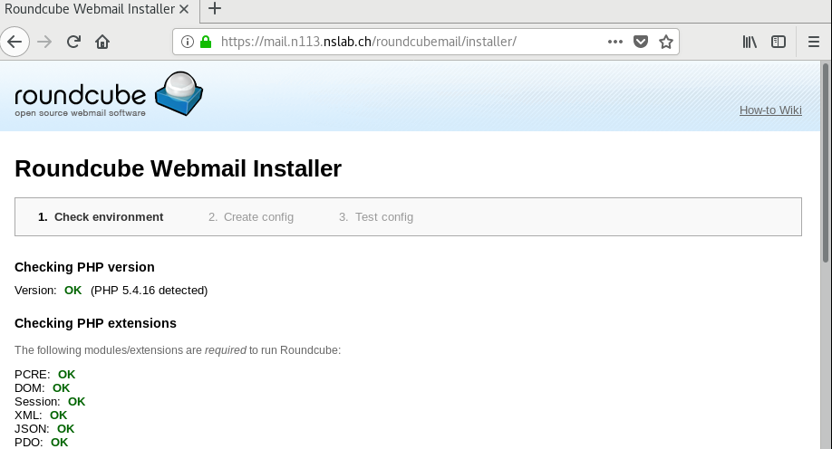

* Generate Roundcube conf and check if everything is ok:

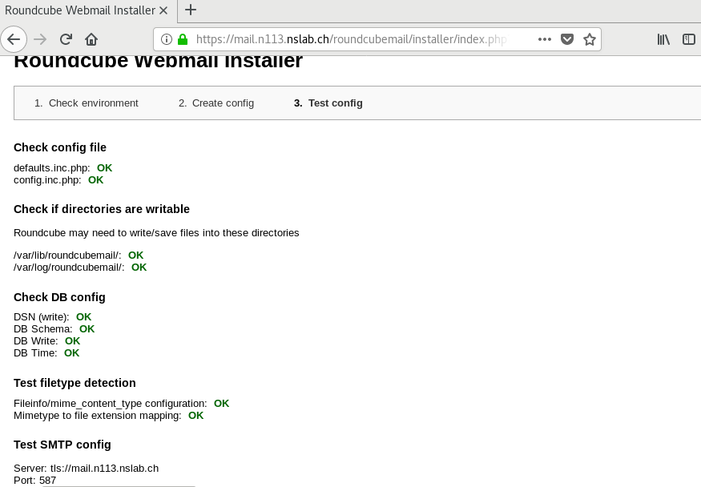

* Login to: <https://mail.n124.nslab.ch/roundcubemail/>
* Test Send and receive Mails
* Ingoing

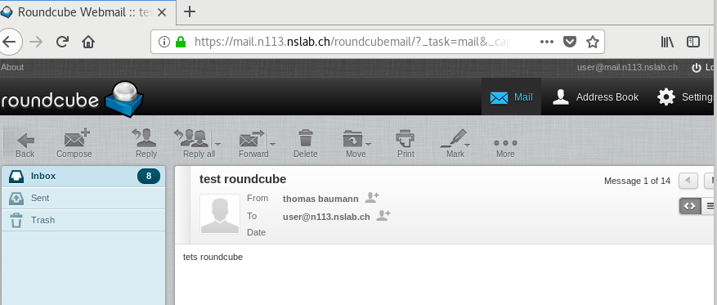

* Outgoing

