Abstract. Out-of-context (OOC) misuse of authentic images with misleading contextual narratives poses a growing challenge for verification systems, yet a clear comparative picture of existing approaches remains limited. We conduct a structure review of studies published between 2021 and early 2026, sourced from arXiv, IEEE Xplore, and Google Scholar, selected through multi-stage screening against predefined criteria. The extracted data are then systematized using a constructed 10-criterion analysis matrix. We synthesize the landscape into three paradigms: (1) Image–text consistency, (2) external evidence retrieval, and (3) MLLM-based agentic reasoning. The analysis reveals persistent gaps in genuine cross-modal reasoning, architectural efficiency, robustness, and multilingual applicability in low-resource settings. As a lightweight supplementary probe, we implement a simple pipeline combining all three paradigms, achieving a modest accuracy of 75.39% on the VERITE dataset. Overall, this work contributes a structured taxonomy of OOC detection methods, identifies underexamined challenges, and outlines explicit directions for future research, particularly in low-resource languages and robust evaluation protocols.

Keywords: Out-of-context misinformation, Literature review, Cheapfakes, External evidence retrieval, Multimodal Large Language Models.
- Discussion and Proposed Pipeline
  - Findings
Our review of 15 selected papers reveals that internal checking is a widespread mechanism in multimodal misinformation detection, particularly for the out-of-context (OOC) problem, appearing in 12 out of 15 studies. This is hardly surprising given that most early systems directly exploit the image–caption relationship. We find a clear difference in the role of internal checking across method groups: studies such as COSMOS, Twitter-COMMs, SSDL, MMFN, and DT-Transformer/Synthetic Misinformers treat it as a central component, implemented through image–text representation learning, image–caption contradiction detection, or alignment of image regions with textual content. In contrast, CCN, SNIFFER, EXCLAIM, HiEAG, and M&M-RAG employ internal checking as a module within a broader detection pipeline; SEN and DeceptionDecoded only exploit this mechanism indirectly or in an evaluation context. Overall, internal checking represents the foundational approach in the early days of OOC detection. In modern systems, it is maintained and further developed, but rather than serving as the sole detection mechanism, it has become a supporting component within more complex pipelines.

Regarding external evidence retrieval, CCN collects visual and textual evidence from the web via reverse image search, while SEN inherits this direction and adds stance analysis. More recent methods, such as SNIFFER, HiEAG, and M&M-RAG, extend retrieval by integrating MLLM/RAG, using evidence for reasoning and explanation generation rather than mere matching. EXCLAIM performs hierarchical retrieval by entity, object, location, and event, and verifies claims through a multi-agent setup; EGMMG transforms evidence into graphs and compares them with claims via GNNs. Although external retrieval helps systems overcome the limitations of internal checking by providing context beyond the image and caption, its effectiveness heavily depends on retrieval quality, evidence relevance, and the ability to filter out noise.

With respect to MLLM-based reasoning, this has become a prominent direction in recent studies. Unlike methods that rely solely on image–text representation learning or evidence retrieval, this group employs MLLMs/VLMs to reason over multiple information sources, including images, captions, evidence, and sometimes the broader article context. SNIFFER is a representative example, fine-tuning InstructBLIP to combine internal and external checking and produce both a prediction label and an explanation. HiEAG further extends this direction by selecting and rewriting evidence before feeding it into the MLLM, making the evidence more suitable for the OOC detection task. M&M-RAG uses Qwen2-VL in a multilingual RAG setting, enabling the model to reason over image–claim pairs and evidence retrieved from diverse sources. Notably, EXCLAIM develops reasoning within an agentic architecture, where the Retrieval Agent, Detective Agent, and Analyst Agent handle retrieval, contradiction checking, and conclusion synthesis respectively. Overall, MLLM-based and agentic reasoning methods show a shift from simple image–text classification towards pipelines capable of explanation, context-aware verification, and handling multiple evidence types. However, this very group of methods also introduces challenges related to computational cost, latency, reasoning stability, and dependence on the quality of input evidence. Therefore, we argue that more research is needed to develop efficient reasoning techniques that are less reliant on external data, aiming for OOC detection pipelines that offer both strong explainability and robust performance in real-world settings.

Regarding data, our research reveals that current OOC benchmarks still focus heavily on NewsCLIPpings, a dataset that appears directly in six studies thanks to its large scale, balanced labels, and standardized structure. However, most OOC samples in NewsCLIPpings are synthetically generated, whereas VERITE offers higher real-world fidelity by drawing on fact-checked cases, yet has a small scale and is more suitable for evaluation than for training. Several other datasets extend the problem in specific directions, such as COSMOS with a two-caption setup, Twitter-COMMs with topic-based social media data, MuMiN with a multilingual social graph, DeceptionDecoded with misleading creator intent, and Multi-Ax-to-Grind with Urdu data. Overall, the field still lacks OOC datasets that are both sufficiently large and sufficiently realistic for model training. At the same time, the vast majority of existing OOC methods are built and evaluated primarily on English data, meaning their effectiveness in multilingual or low-resource language settings remains largely unverified. We therefore call on the research community to invest in building realistic, multilingual OOC datasets and to develop methods that can generalize more effectively across different languages and cultural contexts.
  - Preliminary proposal of our pipeline
Based on the above rationale, we develop an OOC verification pipeline that integrates external evidence retrieval, evidence processing, and multimodal reasoning within a unified workflow. The pipeline consists of two main stages. In Stage 1, external evidence is retrieved through the procedure illustrated in Fig. 1. In Stage 2, the retrieved evidence is processed, multimodal reasoning is performed, and the final verification decision is generated, as shown in Fig. 2. To evaluate the proposed pipeline, experiments are conducted on the VERITE dataset, with the detailed results reported in Table I.

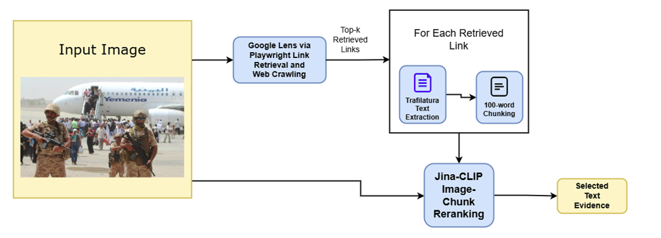
Fig. 1. Overview of the external evidence stage
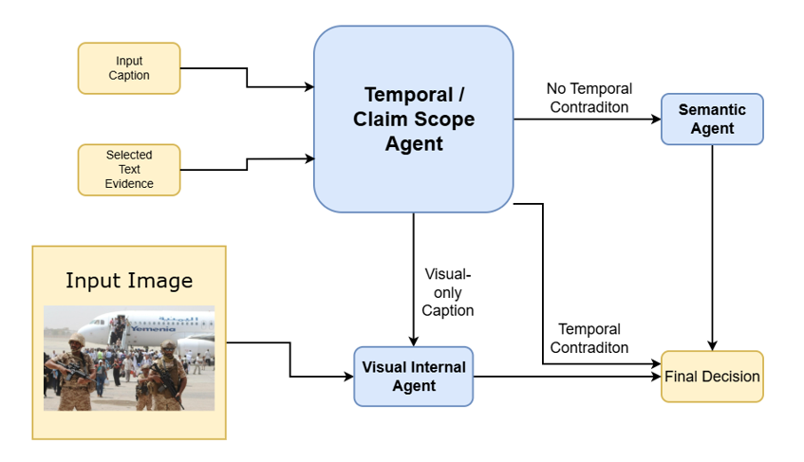
Fig. 2. Overview of the evidence processing, multimodal reasoning, and verification decision-making stage
Table 1. Preliminary evaluation results on the VERITE dataset
Class | Precision | Recall | F1-score
FAKE | 75.23% | 93.82% | 83.51%
TRUE | 76.13% | 38.94% | 51.54%
Macro avg | 75.68% | 66.38% | 67.52%
Accuracy |  |  | 75.39%
  - Limitations
Despite our best efforts to conduct a comprehensive search and review of the literature, we point out several limitations of this review. First, the scope of the literature primarily focuses on representative works from the 2021–2026 period, some of which are still in preprint form, meaning that the degree of academic verification remains limited. Second, the search scope was mainly based on arXiv, IEEE Xplore, and Google Scholar, which may have resulted in omitting important works appearing in other academic databases. Third, all surveyed papers are in English, which implies that valuable studies published in other languages may have been overlooked. Furthermore, the proposed pipeline is still at a preliminary experimental stage and has not yet been extensively evaluated across multiple datasets, subject domains, and real-world deployment contexts. Nevertheless, this review provides important insights into modern approaches for multimodal out-of-context misinformation detection and lays the groundwork for a preliminary verification pipeline that can be further developed and rigorously evaluated in future work.

Conclusion
In response to the growing prevalence of out-of-context multimodal misinformation, this study provides a structured review of recent approaches to detecting the misuse of authentic images with misleading contextual narratives. Drawing on 15 representative studies published between 2021 and early 2026, selected from arXiv, IEEE Xplore, and Google Scholar, we systematized the literature using a 10-criterion analytical matrix.
The review identifies three dominant methodological paradigms: image-text consistency checking, external evidence retrieval, and MLLM-based or agentic reasoning. The findings indicate that internal consistency checking remains a foundational strategy, yet it is constrained by unimodal bias and limited contextual awareness. Evidence retrieval extends verification beyond the input image-caption pair, but remains sensitive to retrieval noise, evidence relevance, and source reliability. More recent MLLM-based approaches offer stronger potential for explanation and multi-step reasoning, while introducing challenges related to computational cost, reasoning stability, and dependence on external evidence quality.
Beyond the review, this study introduces a preliminary OOC verification pipeline integrating evidence retrieval, evidence processing, and multimodal reasoning, achieving 75.39% accuracy on the VERITE dataset. Overall, the findings suggest that future research should prioritize realistic multilingual benchmarks, robust evidence filtering mechanisms, controllable reasoning frameworks, and evaluation protocols that better approximate real-world verification conditions.

